Unit Name : Programming Concepts (CMV6107)
Assessment number : 2
Deadline : 02/Apr/2004 by 16:00
Weighting : 15%

Part A – Short Questions (20%, each carries 1 mark)

- What is a database?
- What is a table?
- What is a record?
- What is a field?
- What is a flat-file database?
- What is the function of the Microsoft FlexGrid Control?
- What is a “Relational Database”?
- Briefly describe the term “Primary Key”?
- Briefly describe the term “Foreign Key”?
- What database engine does the VB Data Control use to connect Access database?
- What data control properties of the VB Data Control needed to set before we can use it?
- What Intrinsic Data-aware Control Properties (e.g. a textbox) needed to set before we can use it?
- What is a “Database Front-end”?
- What is a “Database Back-end”?
- What is a Recordset?
- What are the three types of Recordsets?
- What are the four Recordset Methods used to navigate through the database?
- What are the four Recordset Methods used to find a record in the database?
- What is the Recordset Method used to add a new record to a database?
- What is the Recordset Method used to delete a record from the database?

PART B - Write a quiz program. (80%)

Given a database file Assignment2.mdb and a table QuestionBank with the following structures:

Number | AutoNumber
Chapter | Number
Option1 | Text
Option2 | Text
Option3 | Text
Option4 | Text
Answer | Text

Your program must include the following tasks:

- Extract FIVE RANDOM question from the database. (25%)

- Display your question with a single form, the following is only an example. (20%)

- Display the result (i.e. Correct / Wrong) before going to next question. (15%)
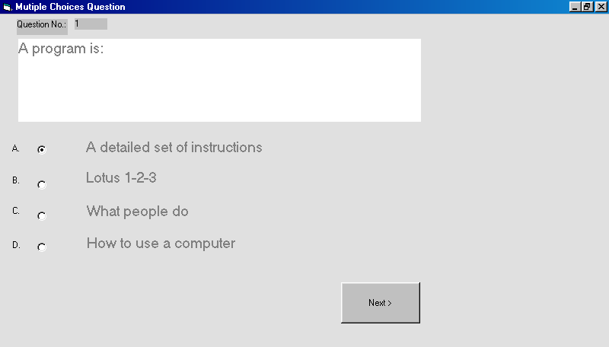

- Bonus will be given to additional features, e.g. a timer to display the elapsed time or change the quiz program to a time limited one, statistics of the quiz, the number of right answer…etc (20%)

