Evaluating the Reading Habit (Magazine) of HKU SPACE Students

Abstract 2
Background Information 2
Objectives 2
Methodology 3
Result 3
Part one: Reading magazines habit 3
Part Two: How they think about the magazine(s) they read usually? 7
Conclusion 8

Abstract
Hong Kong people like to read magazines, particularly on the public transport. However, what is/are the main criteria(s) they may think when choosing magazines? What the publishers can do so as to attract more people to read? Using quantitative methods, this paper examines the reading habit (magazine) of HKU SPACE students. The data derive from a questionnaire, 30 Life science and Physical science students, expressed their awareness of reading and choosing magazines. Results show that most of them agree that the magazines’ content is substantial, and most of them like to read fashions and idols news. No matter which kinds of people reading the magazines, publishers have a number of improvements can do so as to make the magazine become more attractive.

Background Information
In Hong Kong, when you get into the public transports, you may find many people are reading their magazines. Some of them may buy their favorite magazines regularly. Besides, the research from the Commission On Youth indicated that teenage often interested in violent, action etc. topic. In addition, they bought the magazines as it contained their idols news on it. However, the passages about local news or education were seldom read. The general aims of the research are to determinate what factors are the students most concern when choosing and reading magazines.
In particle, we attempt to understand what are the main criteria when people choosing magazines and what the important information they want to get when reading magazines. The focus we concern will mainly of the HKU SPACE Life Science and Physical Science students in Admiralty Center.

Objectives
- What are the major factors students will concern when choosing magazines?
- Why do students thinking about the current magazines?
- What the publishers can do so as to make the magazines more attractive?

Methodology
Questioners were used to collect the data. The total 30 questioners were distributed to HKU SPACE life science and physical science students which is randomly selected in Admiralty Center on 20th and 21st and half of the number of questioners were did on each day respectively.
The questioners designed had 10 questions and divided into three parts. The first part was the students’ reading habit. The second part was what students think about the magazines they usually read and the last part was the personal information of the interviewee.

Result
The survey was done on 20th and 21st in Admiralty Center and 30 students were successful interviewed. There were 56.6% male and 43.4% female interviewed and 60.0% of them were in Life Science and 40.0% of them were in Physical Science.

Part one: Reading magazines habit
1.1 According to the data obtained, most people bought the magazine(s) every week (28%); 26% would buy magazine(s) twice a week or more than two times in a week. Only 23% of them would buy magazine(s) every month and half of month.
Fig 1. How often students will buy magazines in a month

1.2 We could find out most of the students (46.6%) would buy two to four magazines in a month. Students who didn’t or even buy one magazine in a month have 33.3%. The number of students who bought four to five and six to seven magazine(s) a month had 13.3% and 6.6% respectively. However, none of them would buy more than eight.
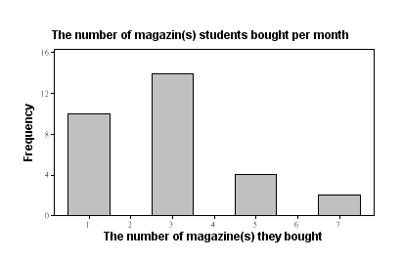
Fig.2 The number of magazine(s) students bought per month

1.3 We found most of the students would spend $20 or below on buying magazine(s) per month but none of them would like more than $80.
Fig.3 The money students would spend on magazines in a month

1.4 The percentage that student would spend on buying magazine(s) indicated that 21 of students would spend 2% or below of their money on magazine(s). The others 4 of them would spend about 3% - 4% and 5% - 6% on buying magazine(s). 1 of students may spend 9% or higher on magazine(s).

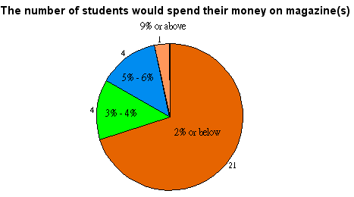

Fig.4 The number of students would spend their money on magazine(s)

1.5 We found that most of the HKU SPACE students would like to read “New Monday” (43.33%) usually; “Week8” only a few (3.33%) of students may read. The others magazines they may read included Mike, computer magazines and car magazines.

Fig 4. The magazines that students like to read most

1.5 Here is the percentage of different criteria(s) that students will concern when choose the magazine. 51.06% of students would concern the Topic, to see whether it was interesting or not when choosing the magazines; 21.77% may think about the appearance of the books; 13.89% would concern the cost of the magazine. When it comes to the gifts offered and well known, there are 8.51% and 4.77%. However, none of them would concern the number of pages included.

Criteria | Percentage
Cost | 13.89%
Appearance | 21.77%
Number of pages | 0.00%
Topic interested | 51.06%
Gifts | 8.51%
Well-known | 4.77%
Fig.5 The criteria students concern when choosing magazines

1.6 Idols News (20.51%), Fashion (20.51%) and Best Buy product (19.23%) may be the most topic students would concern when choosing magazine(s); however, none of them would concern the Business topic (0.00%).

The topic will concern most | Percentage
News | 11.54%
Business | 0.00%
Idols News | 20.51%
Fashion | 20.51%
Traveling | 8.97%
Cooking/Food | 3.85%
Beauty | 10.26%
coupons | 5.13%
Best Buy | 19.23%
Fig 6 The topic students concern most when choosing magazines

Part Two: How they think about the magazine(s) they read usually?
2.1 Most of the students may think the magazine(s) they usually read had the content substantial had 31.43%. Students though the content was interesting had 20.00%. The price was acceptable had 20.00%. It had the most up-to-date information 17.14%. The magazine was enlightened had 11.43% which is the lowest.
In concluded, the quality of the magazines they usually read were higher than the average.

Factors | 1 (Agree) | 2 | 3 | 4 | 5 | 6 (Disagree)
內容充實 | 11 | 9 | 8 | 1 | 0 | 1
富有趣味 | 7 | 16 | 3 | 3 | 0 | 1
價錢合理 | 7 | 17 | 4 | 1 | 0 | 1
最新最齊 | 6 | 14 | 7 | 1 | 1 | 1
有啟發性 | 4 | 13 | 9 | 1 | 2 | 1

2.2 43.33% of students think that the purchased magazines are pertinent enough. However, 56.67% think it is not true.

Conclusion
We can see that most of the students used to buy magazine every week and they usually spend around $20 or below (about 2% or below) of their money on buying. In a month, they may buy around two to three magazines.
The most famous one the students always read is “New Monday”. When it comes to choosing magazine, they may think the topic is the main criteria they will concern. The topics they are most interested in are fashion and Idols News.
In concerning the quality of magazines they read, most of the students believe that the content are quite substantial. However, half of them may think the magazines are not pertinent enough.
Obviously, not all the current magazines are really reflecting the true to the readers. It is because they have to show the “Big News” in order to attract more people to buy. Whether the cases they mentioned are true or not is less important.
According to the data obtained, there are a number of improvements the publishers can do so as to make the magazines become more attractive. First, publishers should focus on the topic on the first page. The top of the page should show the idols news and most up-to-date fashions.
Besides, the appearance of the cover page should make more attractive as it is the second thing people will concern when choosing magazines. The information on the books has to keep up-to-date and publishers have to put more effort on it.

The research was about “How the media affect teenage” which was done in 1998

