Calculus:
Chapter 9 Geometric Applications of Definite Integrals – Appendix

Special Plane Curves

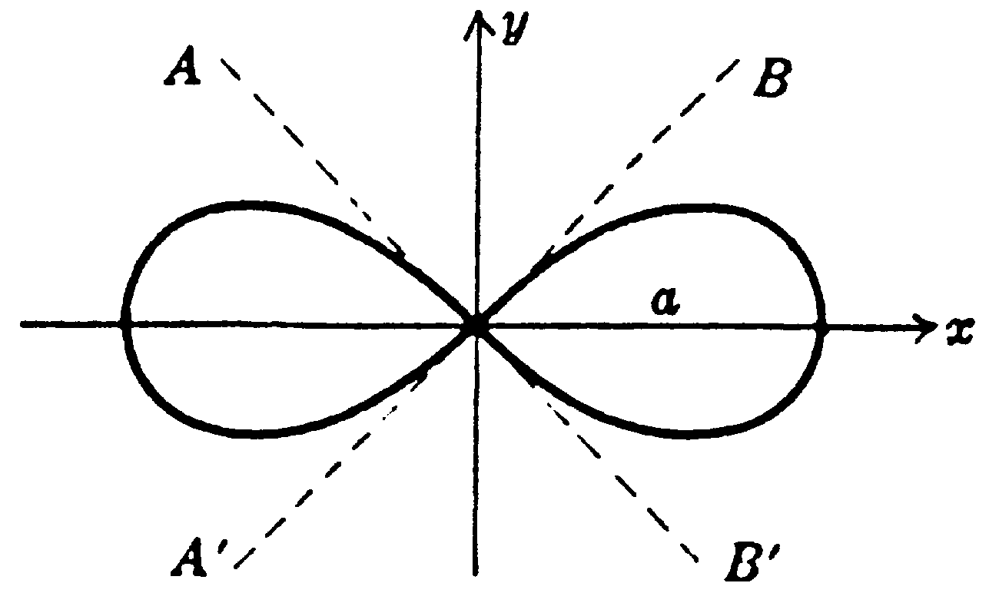
Leminscate
- Equation in polar coordinates: r² = a²cos 2θ.
- Equation in rectangular coordinates:
${\left(x^{2}+y^{2}\right)}^{2}=a^{2}\left(x^{2}−y^{2}\right)$.
- Angle between AB' or A'B and x-axis = 45°.
- Area of one loop =$\frac{a^{2}}{2}$.
Figure 1

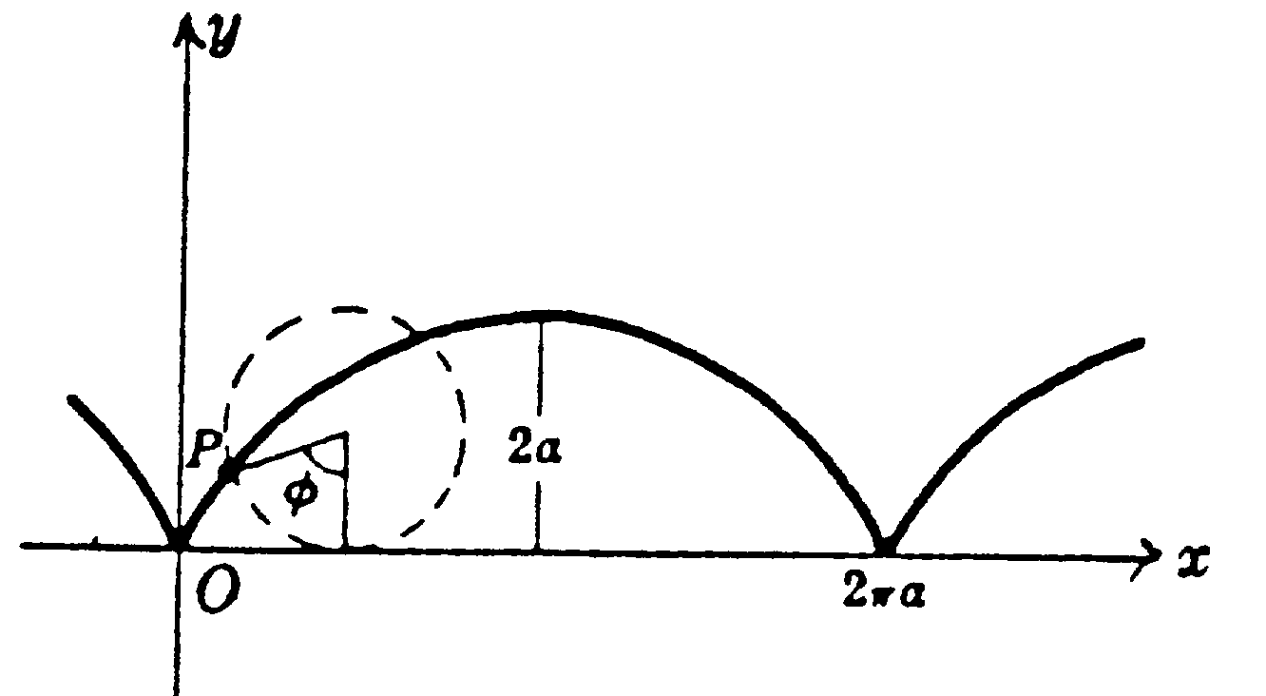
Cycloid
- Equations in parametric form: $\begin{aligned}\left\{x=a\left(φ−\text{sin}φ\right) | \right.\end{aligned}$.
- Area of one arch = 3πa².
- Arc length of one arch = 8a.
This is a curve described by a point P on a circle of radius a rolling along x-axis.
Figure 2

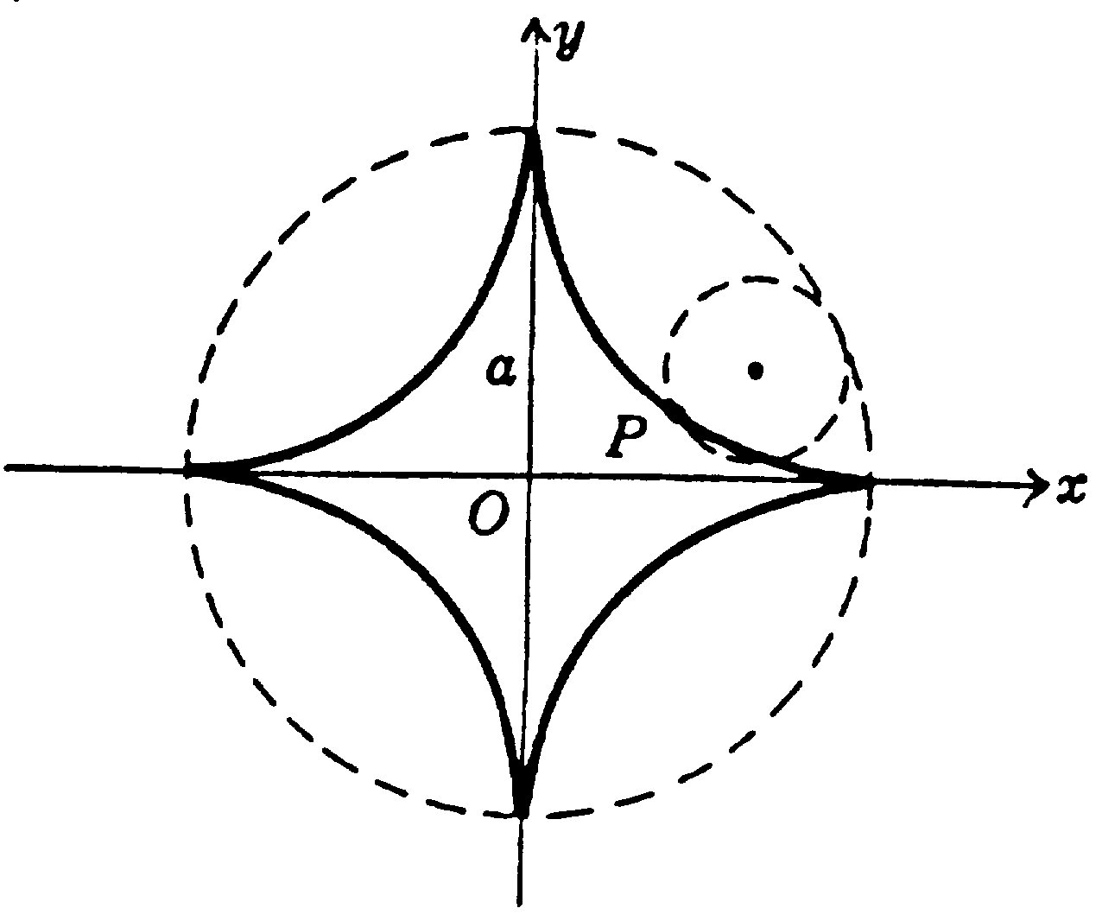
Hypocycloid with Four Cusps
- Equation in rectangular coordinates: $x^{\frac{2}{3}}+y^{\frac{2}{3}}=a^{\frac{2}{3}}$.
- Equations in parametric form: $\begin{aligned}\left\{x=a{\text{cos}}^{3}θ | \right.\end{aligned}$.
- Area bounded by curve =$\frac{3}{8}{πa}^{2}$.
- Arc length of entire curve = 6a.
This is a curve described by a point P on a circle of radius $\frac{a}{4}$ as it rolls on the inside of a circle of radius a.
Figure 3

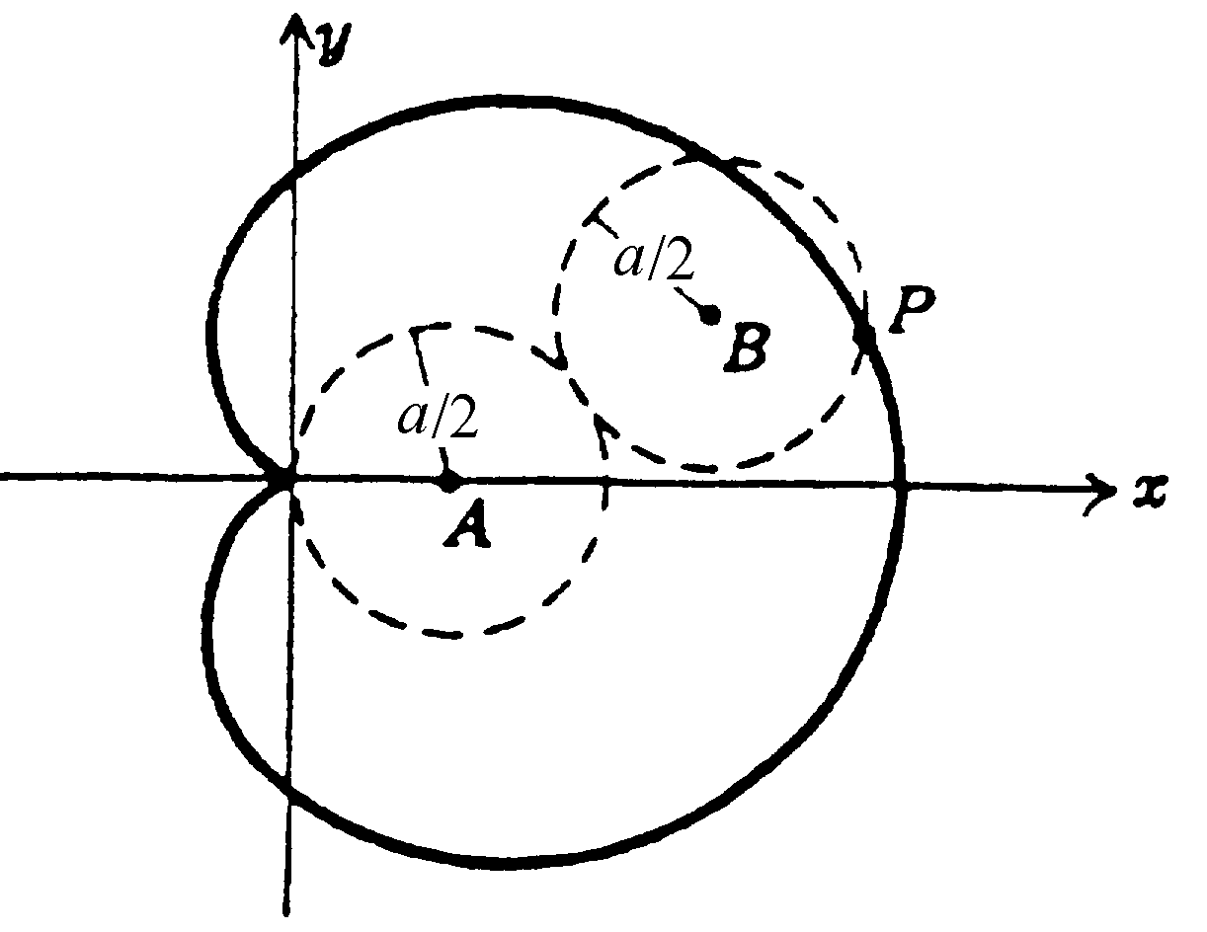
Cardioid
- Equation: $r=a\left(1+\text{cos}θ\right)$.
- Area bounded by curve =$\frac{3}{2}{πa}^{2}$.
- Arc length of curve = 8a.
This is the curve described by a point P on a circle of radius $\frac{a}{2}$ as it rolls on the outside of a fixed circle of radius $\frac{a}{2}$.
Figure 4

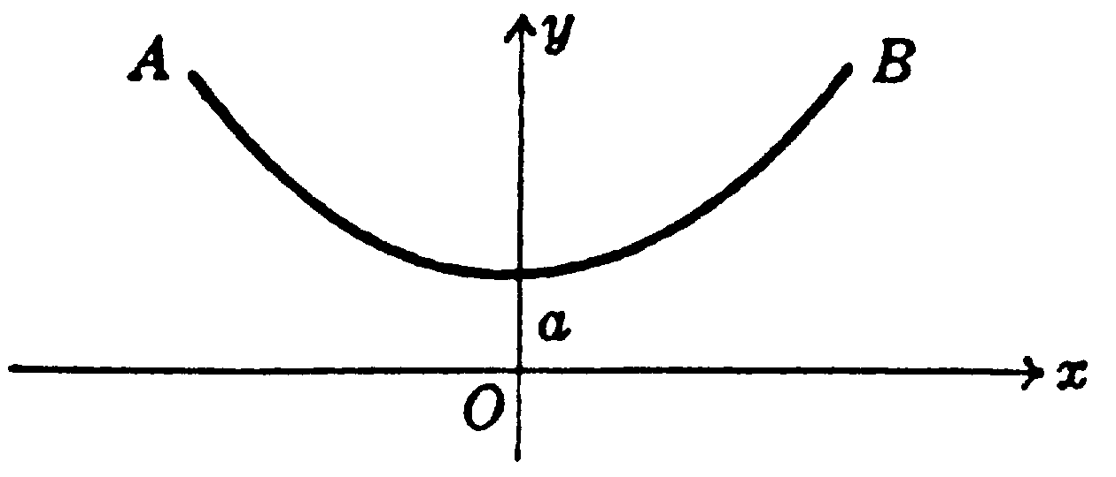
Catenary
- Equation: $y=\frac{a}{2}\left(e^{\frac{x}{a}}+e^{−\frac{x}{a}}\right)=a\text{cosh}\frac{x}{a}$.
This is the curve in which a heavy uniform chain would hang if suspended vertically from fixed points A and B.
Figure 5

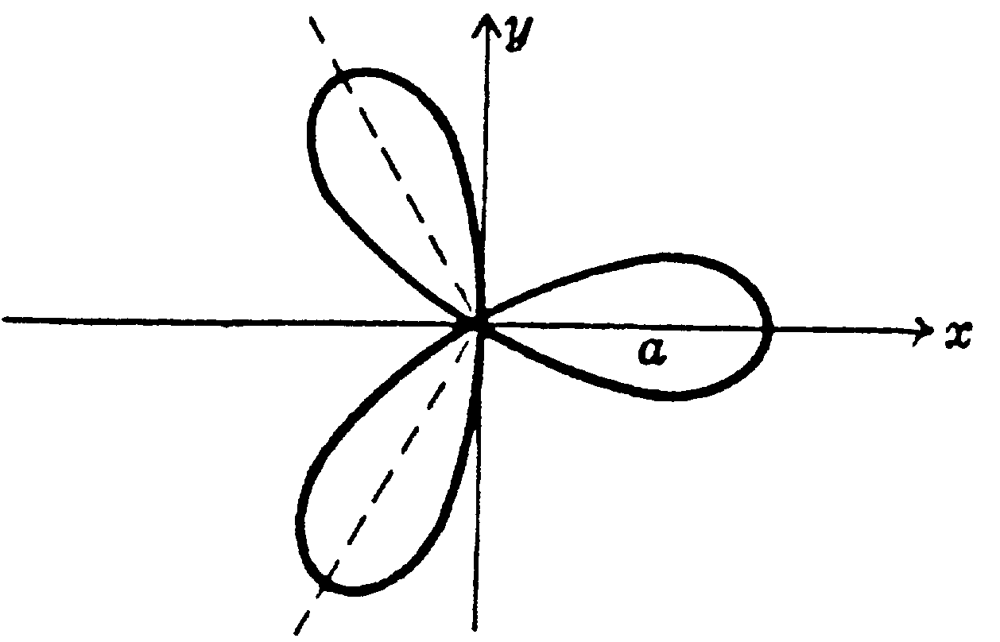
Three Leafed Rose
- Equation: r = acos 3θ.
The equation $r=a\text{sin}3θ$ is a similar curve obtained by rotating the curve of Figure 6 counterclockwise through 30° or $\frac{π}{6}$ radians.
In general r = acos nθ or r = asin nθ has n leaves if n is odd.
Figure 6

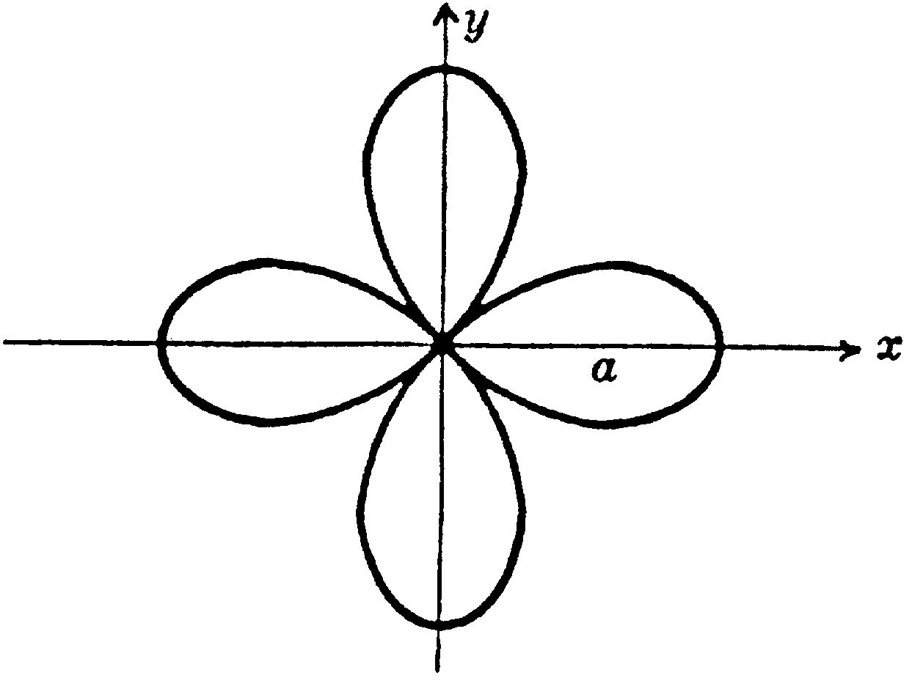
Four Leafed Rose
- Equation: r = acos 2θ.
The equation $r=a\text{sin}2θ$ is a similar curve obtained by rotating the curve of Figure 7 counterclockwise through 45° or $\frac{π}{4}$ radians.
In general r = acos nθ or r = asin nθ has 2n leaves if n is even.
Figure 7

Epicycloid
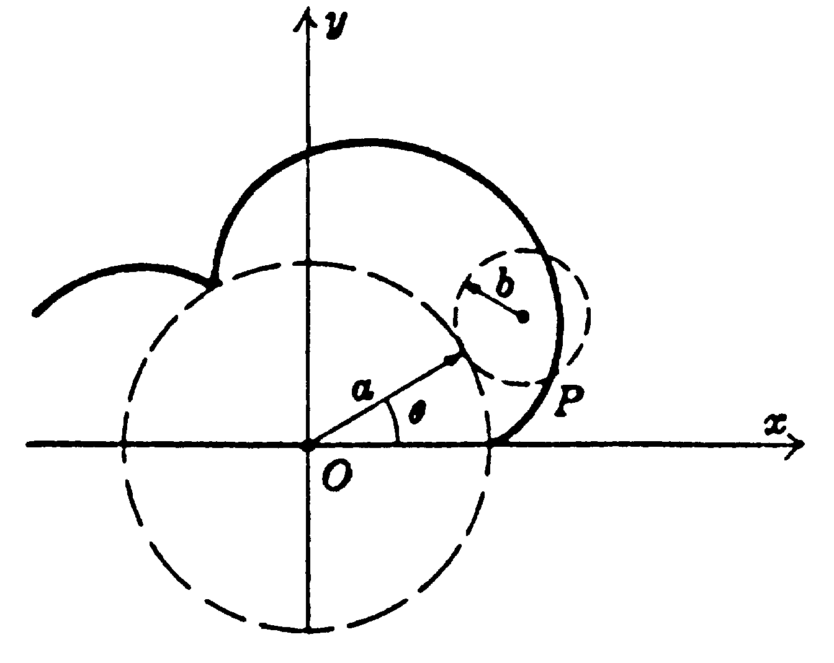
- Parametric equations: $\begin{aligned}\left\{x=\left(a+b\right)\text{cos}θ−b\text{cos}\left(\frac{a+b}{b}\right)θ | \right.\end{aligned}$.
This is the curve described by a point P on a circle of radius b as it rolls on the outside of a circle of radius a.
The cardioid (Figrue 4) is a special case of an epicycloid.

Figure 8

General Hypocycloid
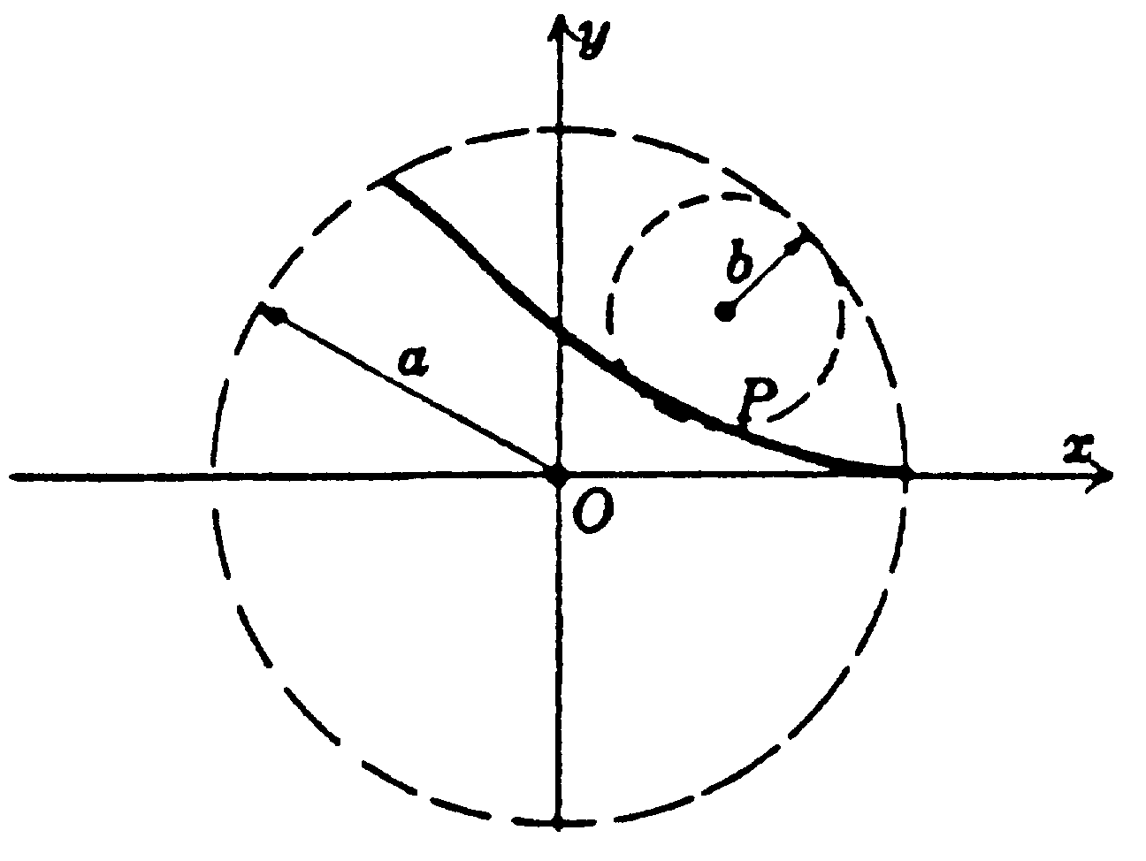
- Parametric equations: $\begin{aligned}\left\{x=\left(a−b\right)\text{cos}φ+b\text{cos}\left(\frac{a−b}{b}\right)φ | \right.\end{aligned}$.
This is the curve described by a point P on a circle of radius b as it rolls on the inside of a circle of radius a.
If b =$\frac{a}{4}$, the curve is that of Figure 3.
Figure 9

Trochoid
- Parametric equations: $\begin{aligned}\left\{x=aφ−b\text{sin}φ | \right.\end{aligned}$.
This is the curve described by a point P at a distance b from the centre of a circle of radius a as the circle rolls on the x-axis.
If b < a, the curve is as shown in Figure 10(a) and is called a curtate cycloid.
If b > a, the curve is as shown in Figure 10(b) and is called a prolate cycloid.
If b = a, the curve is the cycloid of Figure 2.
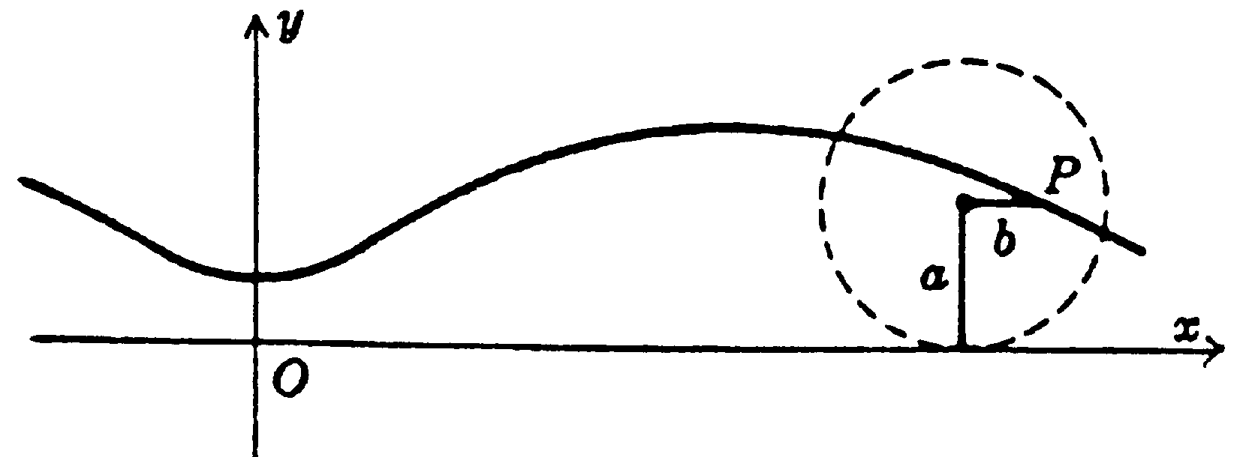
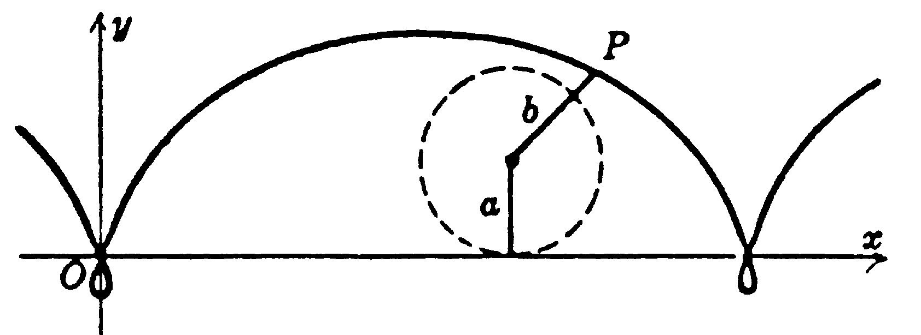

Figure 10(a)
Figure 10(b)

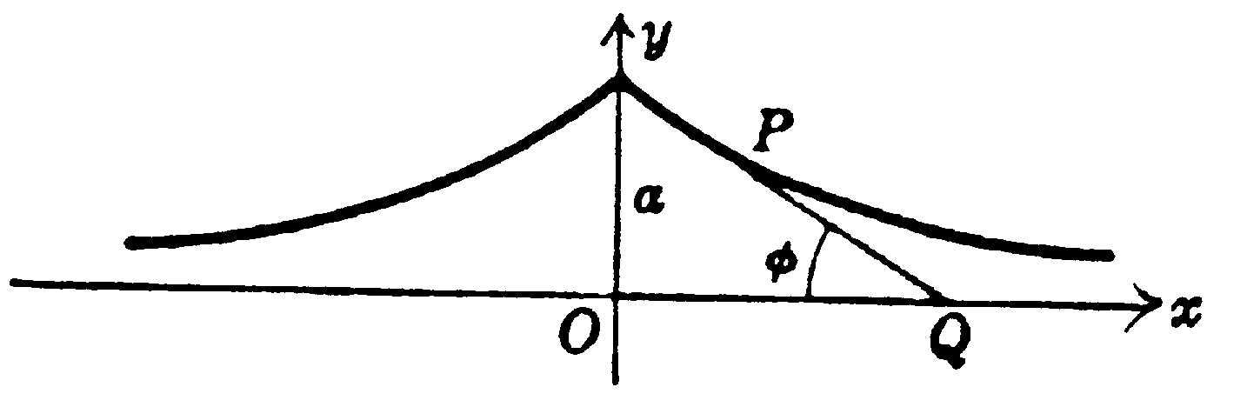
Tractrix
- Parametric equations: $\begin{aligned}\left\{x=a\text{ln}\left(\text{cot}\frac{φ}{2}−\text{cos}φ\right) | \right.\end{aligned}$.
Figure 11
This is the curve described by endpoint P of a taut string PQ of length a as the other end Q is moved along the x-axis.

Witch of Agnes
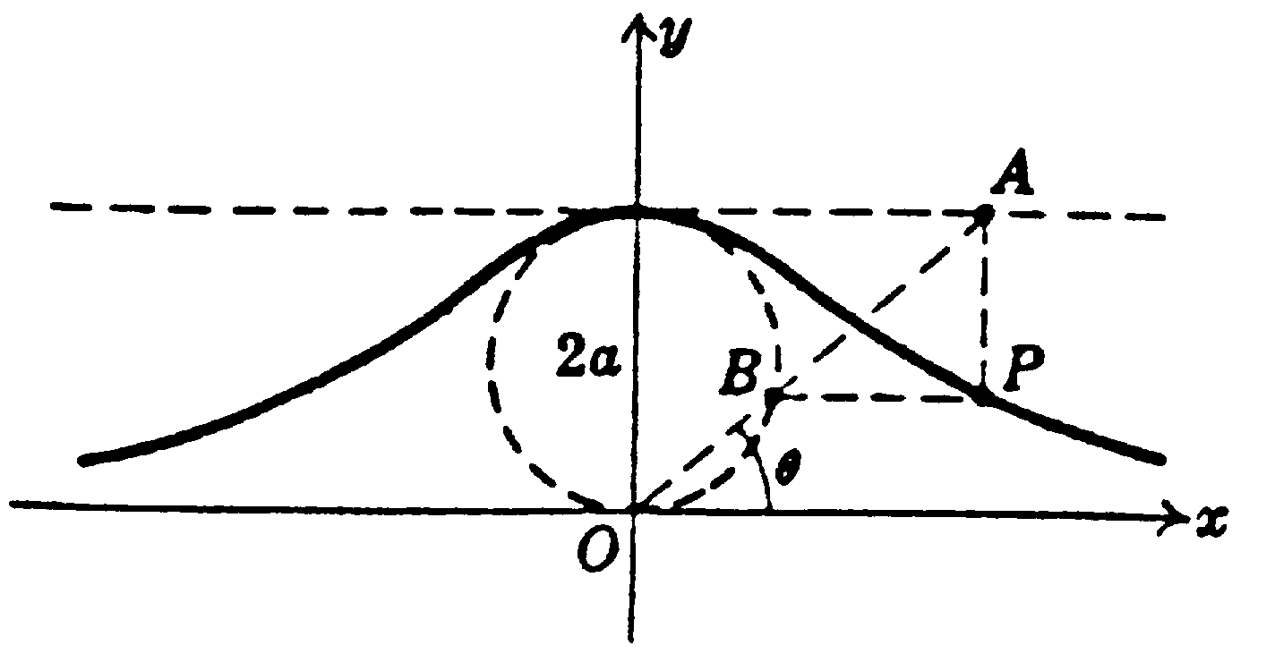
- Equation in rectangular coordinates: $y=\frac{8a^{3}}{x^{2}+4a^{2}}$.
- Parametric equations: $\begin{aligned}\left\{x=2a\text{cot}θ | \right.\end{aligned}$.
In Figure 12 the variable line OA intersects y = 2a and the circle of radius a with centre (0, a) at A and B respectively. Any point P on the “witch” is located by constructing lines parallel to the x and y-axes through B and A respectively and determining the point P of intersection.
Figure 12

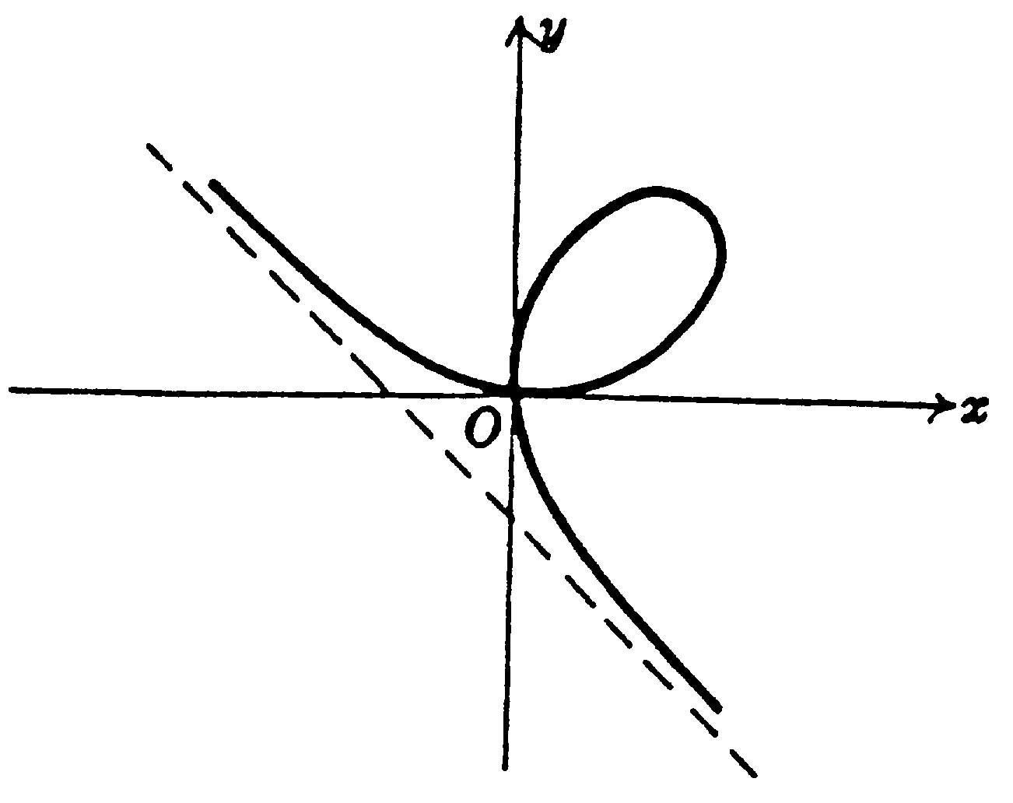
Folium of Descartes
- Equation in rectangular coordinates: x³ + y³ = 3axy.
- Parametric equations: $\begin{aligned}\left\{x=\frac{3\text{at}}{1+t^{3}} | \right.\end{aligned}$.
- Area of loop =$\frac{3}{2}a^{2}$.
Figure 13
- Equation of asymptote: x + y + a = 0.

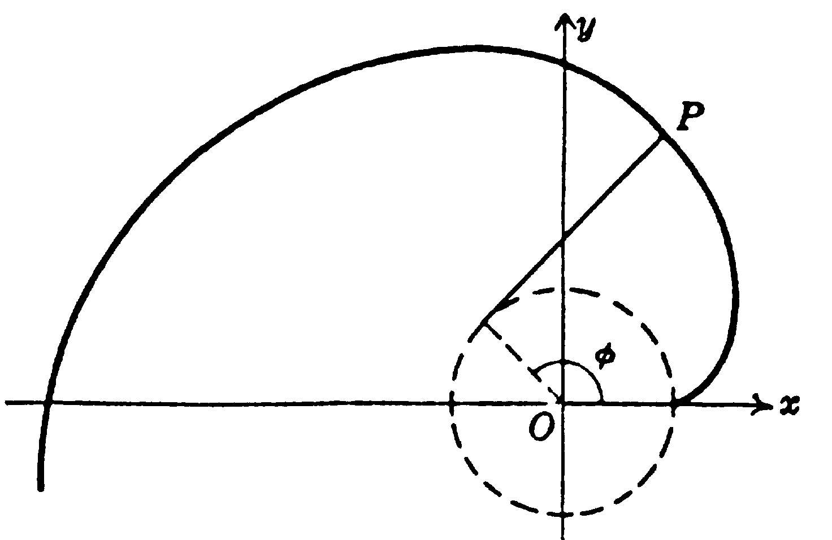
Involute of a Circle
- Parametric equations: $\begin{aligned}\left\{x=a\left(\text{cos}φ+φ\text{sin}φ\right) | \right.\end{aligned}$.
This is the curve described by the endpoint P of a string as it unwinds from a circle of radius a while held taut.

Figure 14

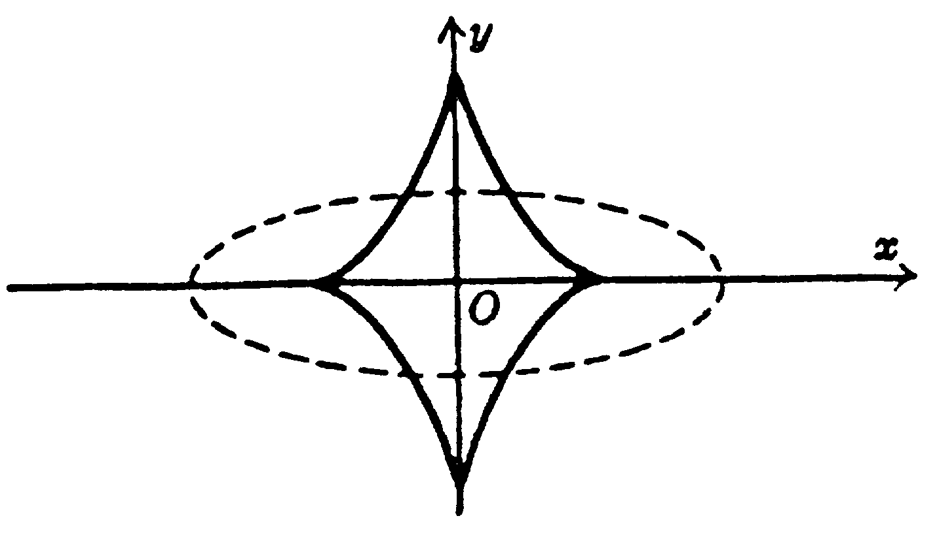
Evolute of an Ellipse
- Equation in rectangular coordinates: ${\left(\text{ax}\right)}^{\frac{2}{3}}+{\left(\text{by}\right)}^{\frac{2}{3}}={\left(a^{2}−b^{2}\right)}^{\frac{2}{3}}$.
- Parametric equations: $\begin{aligned}\left\{\text{ax}=\left(a^{2}−b^{2}\right){\text{cos}}^{3}θ | \right.\end{aligned}$.
This curve is the envelope of the normals to the ellipse $\frac{x^{2}}{a^{2}}+\frac{y^{2}}{b^{2}}$= 1 shown dashed in Figure 15.
Figure 15

Ovals of Cassini
- Polar equation: r⁴ + a⁴ – 2a²r²cos 2θ = b⁴.
This is the curve described by a point P such that the product of its distances from two fixed points (distance 2a apart) is a constant b².
The curve is as in Figure 16(a) or Figure 16(b) according as b < a or b > a respectively.
If b = a, the curve is a lemniscate (figure 1).
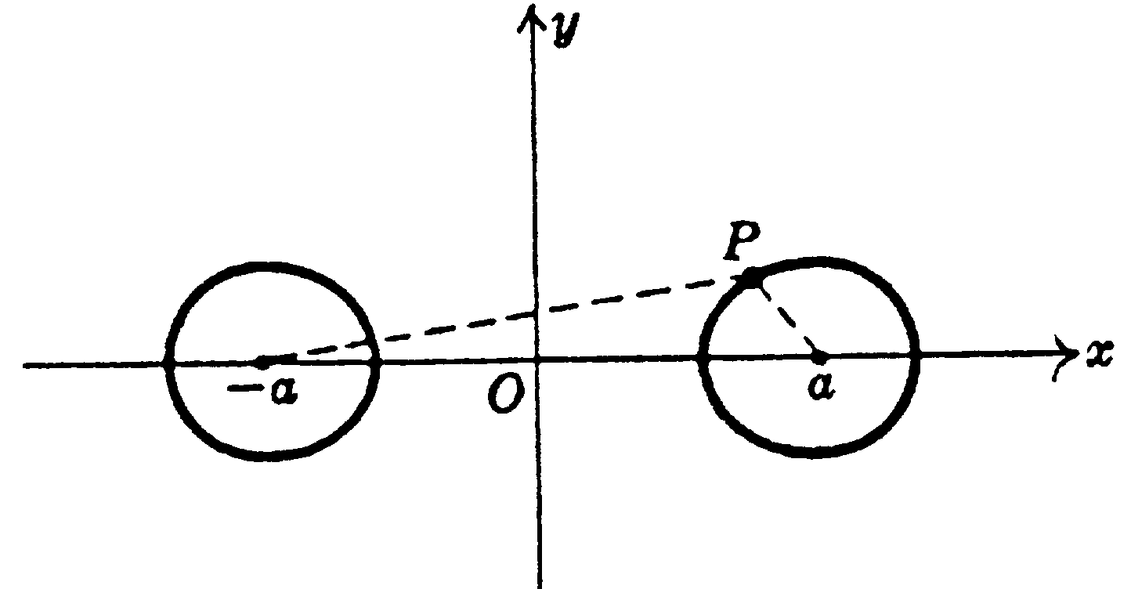
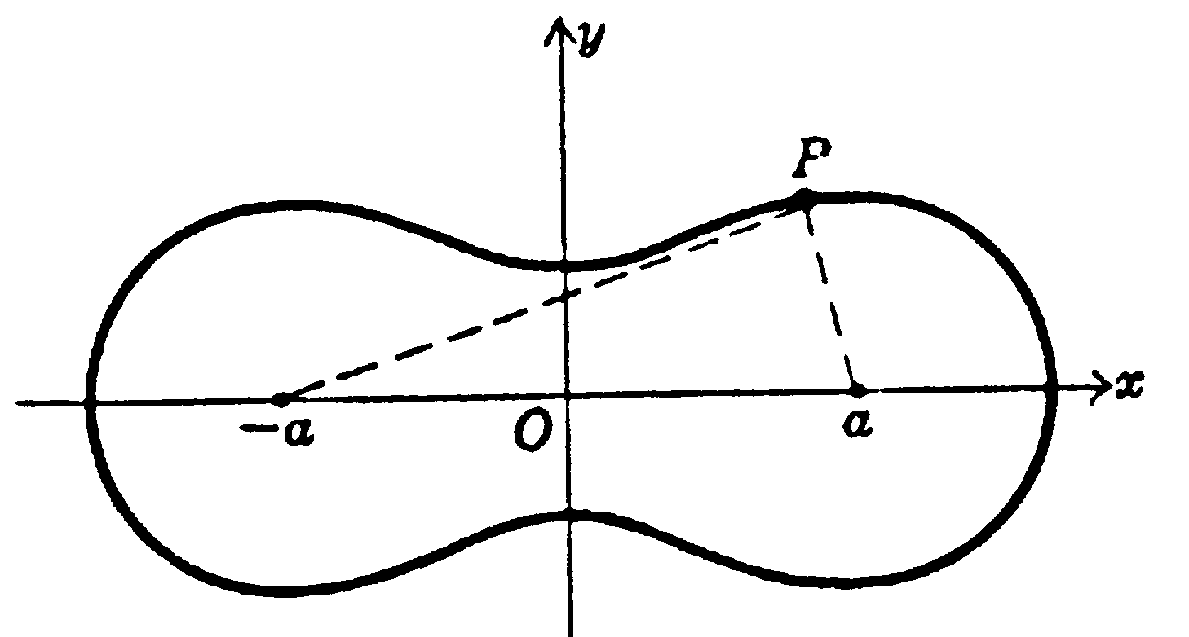

Figure 16(a)
Figure 16(b)

Limacon of Pascal
- Polar equation: r = b + acosθ.
Let OQ be a line joining origin O to any point Q on a circle of diameter a passing through O. Then the curve is the locus of all points P such that PQ = b. The curve is as in Figure 17(a) or Figure 17(b) according as b > a or b < a respectively. If b = a, the curve is a cardioid (figure 4).
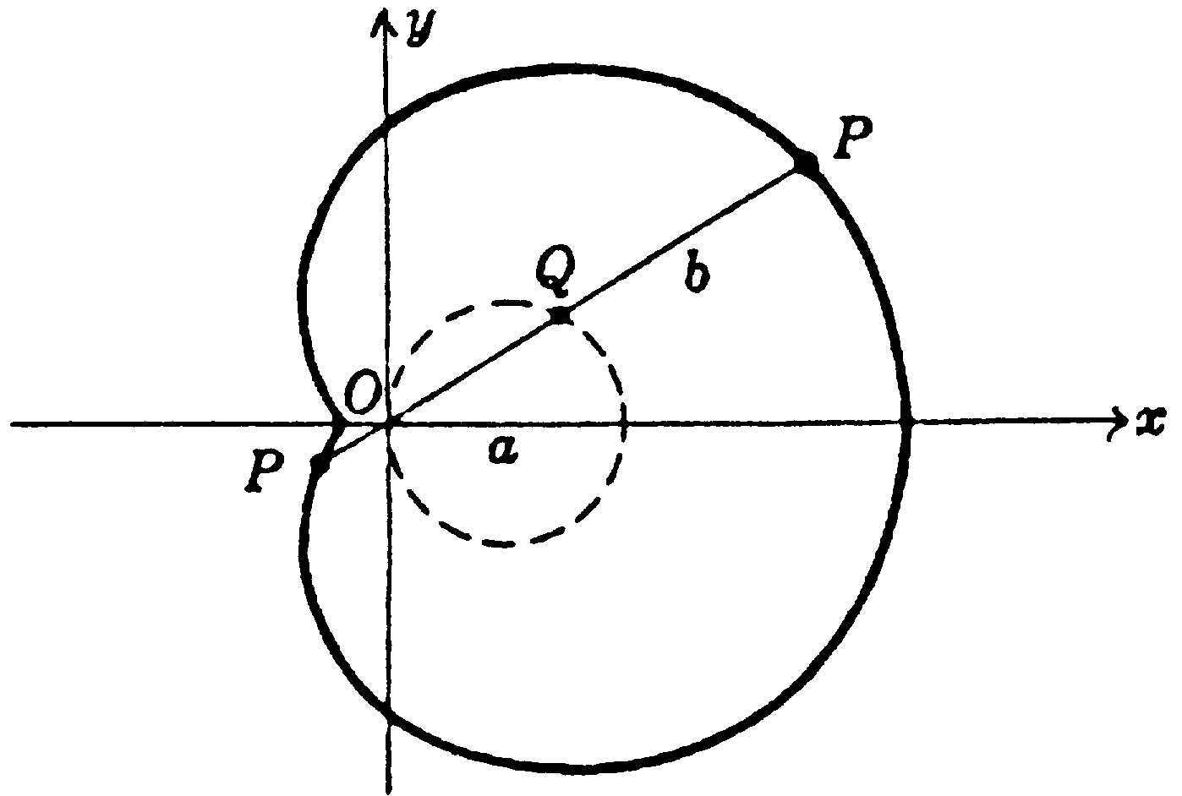
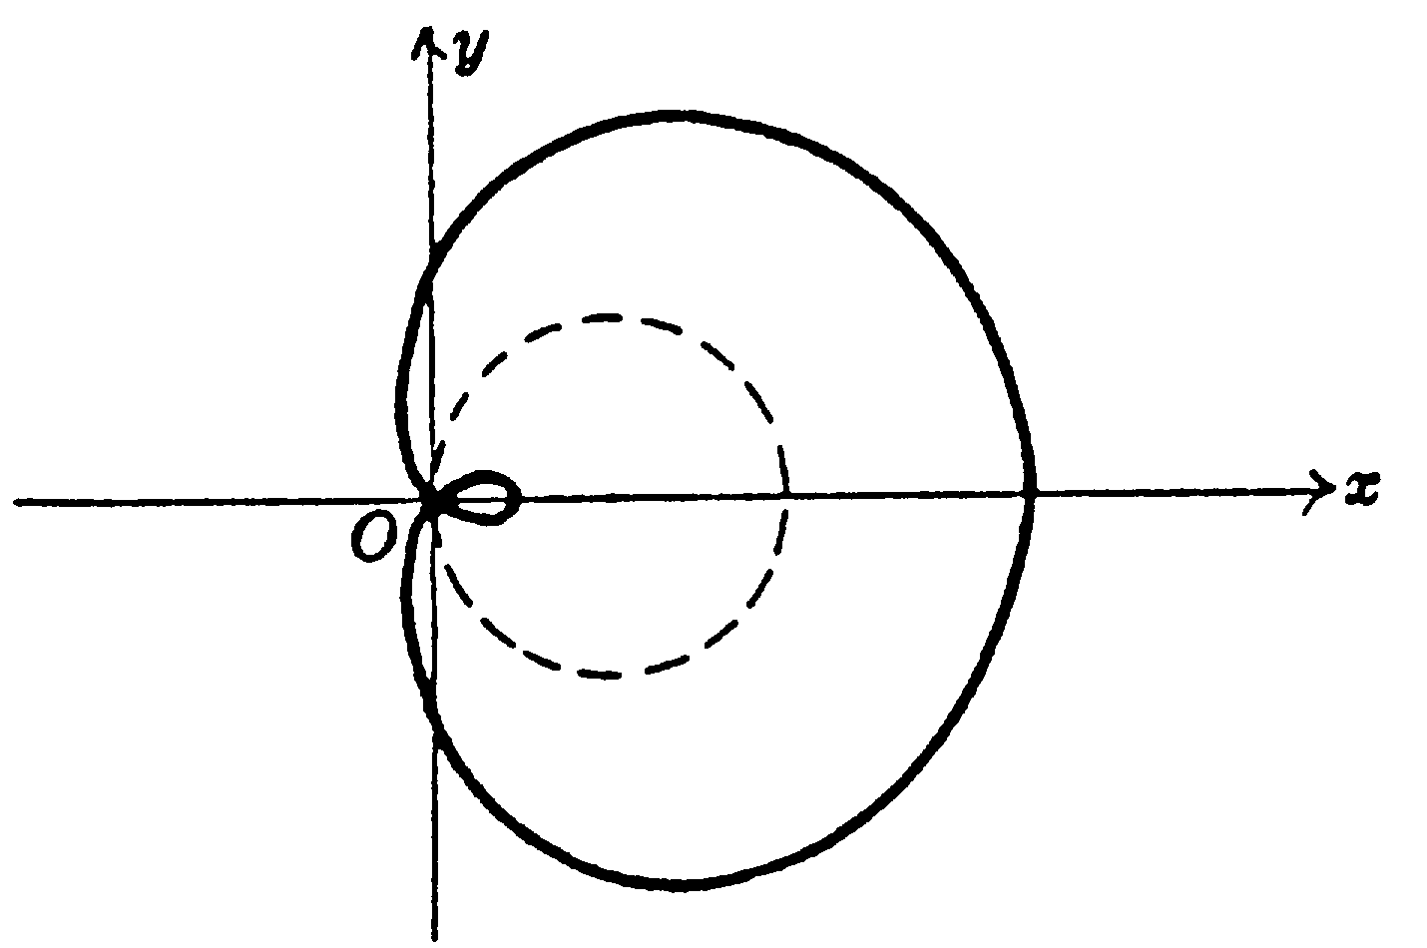

Figure 17(a)
Figure 17(b)

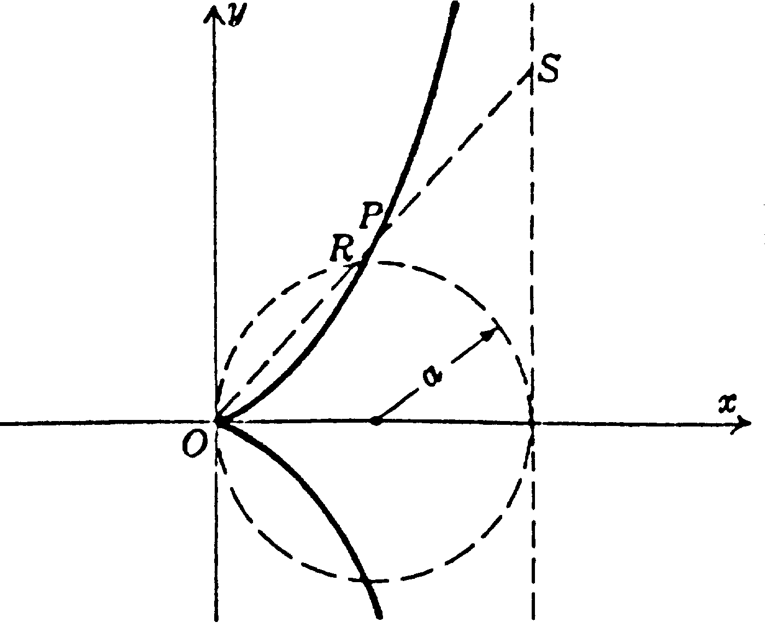
Cissoid of Diocles
- Equation in rectangular coordinates: $y^{2}=\frac{x^{3}}{2a−x}$.
- Parametric equations: $\begin{aligned}\left\{x=2a{\text{sin}}^{2}θ | \right.\end{aligned}$.
This is the curve described by a point P such that the distance OP = distance RS. It is used in the problem of duplication of a cube, i.e. finding the side of a cube which has twice the volume of a given cube.
Figure 18

Spiral of Archimedes
Figure 19
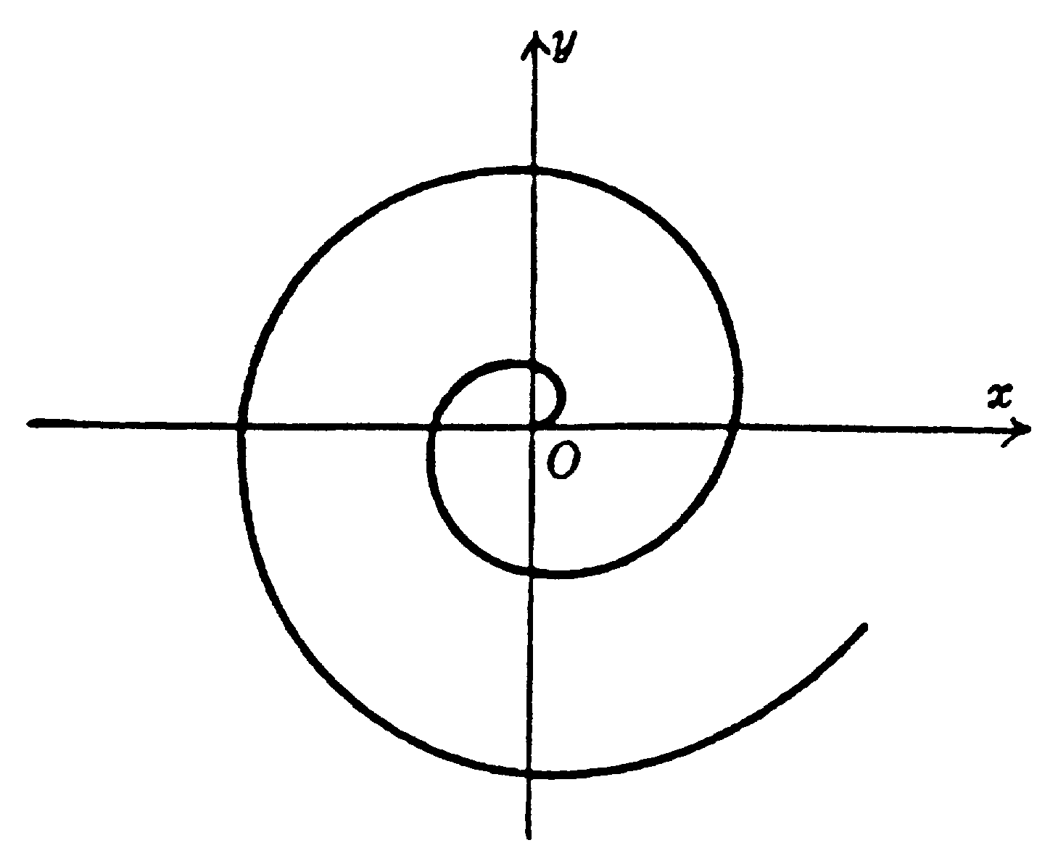
- Polar equation: r = aθ.

<END>

