Content

Characteristics of Classical Period …………… P. 1

Information of Beethoven ………………………. P. 2

A work of Beethoven – Moonlight ……….. P. 3 - 7

The characteristic of Moonlight ……………….. P. 8

Characteristics of Classical Period
The period between the death of J.C. Bach in 1750 and 1820 is called Classical period. Its style is different from the Baroque period and the romantic period. The followings are the characteristics in the Classical period:
- It is homophonic and the melody sound symmetrical.
- Their melodies are the most tuneful and easy to remember.
- There is a flexibility of rhythm. The classical style includes unexpected pauses (suddenly stopping), syncopations (omit some syllables) and frequent changes from long notes to shorter notes.
- There is a widespread use of gradual dynamic change, crescendo and diminuendo.
- Forte-piano started to replace harpsichord because of the gradual dynamic change.
- More and more instruments were added to the orchestra, including the flute, clarinet, oboe, and bassoon.
- Symphony, Chamber Music, Opera, concerto, sonata and string quartet developed in the classical period.
  - Sonata form is the most important form used in the Classical period. It is also called the ABA form. The beginning and the ending sections of Sonata form are very similar but the middle section is different.
  - Chamber Music means only a few performers play music in a small area or a room. Lately, Chamber Music was defined that each part of the music only has one performer.
  - String Quartet performance includes two violins, a viola and a cello. Because the four instruments have the similar sounds, therefore they can match together and the sound given out is very smooth.
  - Opera is a mixture of music and drama. Performers are responsible for acting and singing with the accompaniment of an orchestral.
- The use of broken chord started to develop and it is called Alberti Bass.
- Major and minor started to grow.
- There is greater variety and contrast of mood.
--- Page 1 ---

Information of Beethoven
The full name of Beethoven is Ludwig van Beethoven. He was born in a musical family in Bonn, Germany in 1770 and died in 1827, at the age of 56.
His father and grandfather were professional musicians. His father wanted his son to be successful like Mozart. Therefore, he cruelly made young Beethoven practice for long hours. When he was eight years old, he gave his first public performance. At age 13, he was an assistant organist and violist in the court orchestra. At 17, he was sent to Vienna, then the musical center of Europe to study. However, he had to return home soon to see his dying mother. Beethoven had to take care of his family. He played the viola in the chapel and theatre orchestra.
In 1792, he went to Vienna again to study with Haydn. After one year, he studied under J.G. Albrechtsberger. He then rapidly became famous because of his remarkable skill at the piano.
However, in 1800, when he was 28, he began to notice a hearing loss. At first it was slight but when he was 40, he became completely deaf. He was so angry and sad over his deafness that he thought of killing himself. Fortunately, he would accept his handicap and would go on to write some of the world’s greatest music until his death in Vienna, in 1827.
Beethoven composed 9 symphonies, 32 piano sonatas, 5 piano concertos and 17 string quartets. His earlier works show the influence of Classicism while his later works shows Romanticism.

His famous works:
Symphonies: No.3, Eroica, No.5, Fate
No.6, Pastoral, No.9, Choral
Piano Sonatas: Op.13, Pathetique, Op.27, Moonlight
Op.57, Appassionato, Piano Concerto No.5
Opera: Fidelio

--- Page 2 ---

A work of Beethoven -- Moonlight
We chose one of the piano sonatas of Beethoven, Moonlight to investigate the characteristics of Classical Period. As the piece is too long, we only take Movement No.1 of the Moonlight Sonata to represent. The piece is about five minutes long.

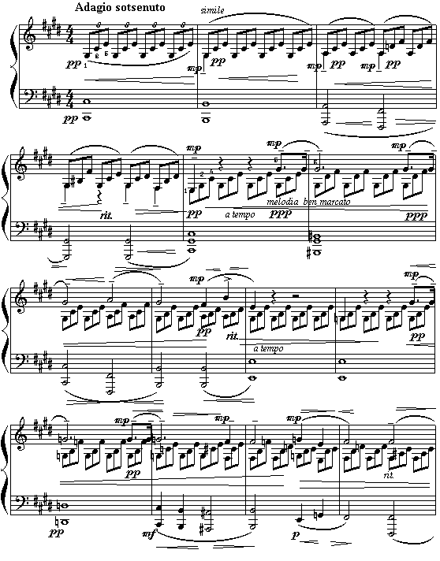
--- Page 3 ---
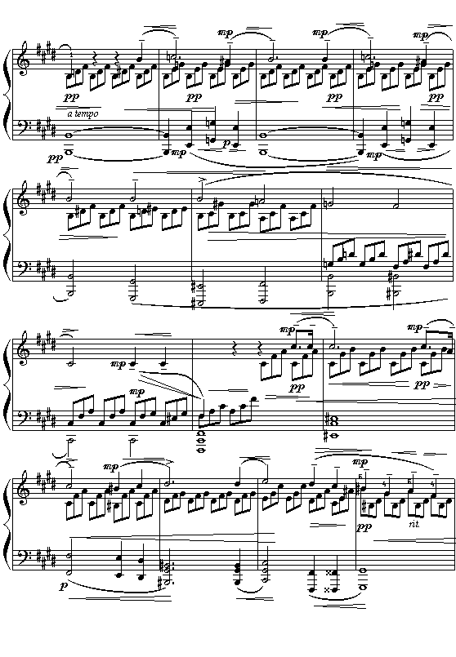

--- Page 4 ---

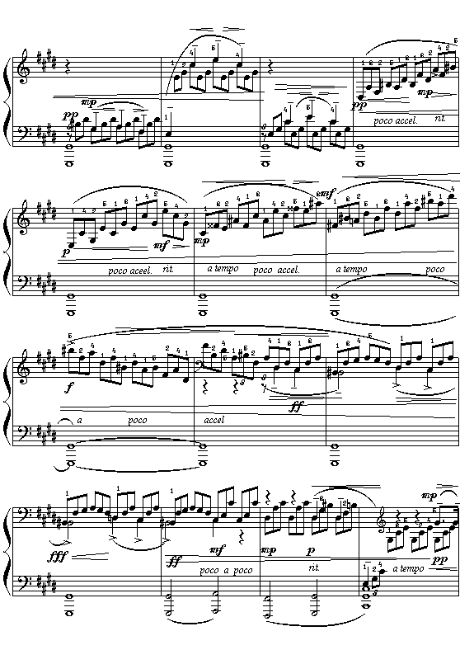

--- Page 5 ---

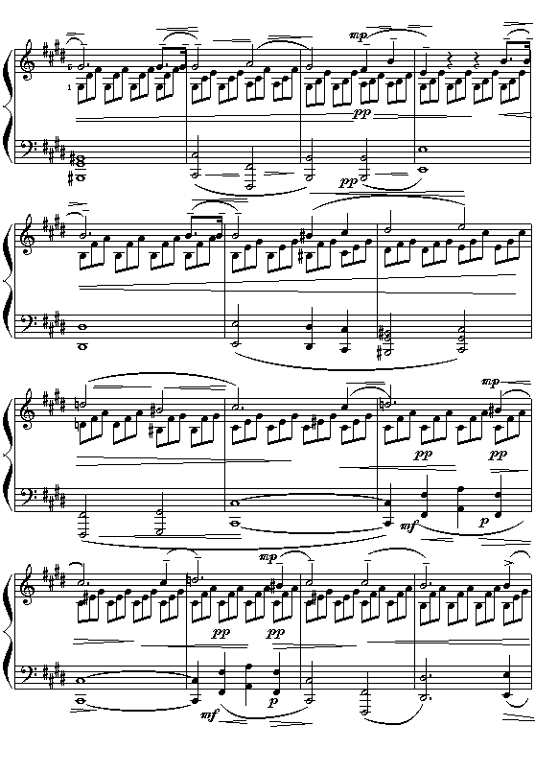
--- Page 6 ---

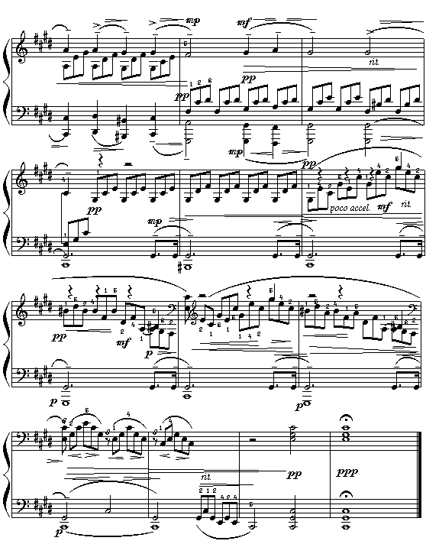
The movement is ended

--- Page 7 ---
The characteristic of Moonlight
From the Moonlight Sonata, we can see lots of the characteristics of the music of the Classical period. Here are them:
- Its texture is homophonic. The melody is in the right hand. The left land is only accompaniment and it has no melody at all.
- There are lots of use of broken chord in the right hand.
- It is a Sonata form. First and the second minutes are the first part (A). The third and forth minutes are the middle part (B). It is different from the first part. The forth and fifth minutes are the last part (A). It is similar to the first part.
- It is used for piano. It shows that piano became more important.
- There is a gradual dynamic change. There are lots of crescendo and diminuendo in the piece. The difference can be as large as ppp to fff
- It sounds harmonic and melodious.
- The rhythm is extremely similar, all are triplet.
- There is a great change in tempo. There are lots of ritardando (slower speed) and in tempo (back to the original speed) in the first, third and fifth minutes.
- The melody is tuneful and sophisticated.
- This piece is C# minor. This means the development of major and minor is nearly completed.

--- Page 8 ---
Group member: Sonia Chan (4), Sonia Cheng (7)
Hazel Lee (24), Ivy Poon (33), Erica Tai (34), Angel Tam (35)
--- Page 4 --- --- Page 5 --- --- Page 6 ---

The movement is ended
--- Page 7 ---

