City University of Hong Kong

Department of Electronic Engineering

EE2070 Fundamental Electronics Laboratory

Lab09: Sequential Logic Circuit Design

Name: Tam Kin Cheung
Student ID#: 51075869
Lab Section: L04
Date performed: 16-11-07
Date of report delivery: 30-11-07
Objective:

The purpose of experiment is to design a sequential circuit for specific application and implement the circuit practically with electronic components.

Introduction:

This experiment is to design a circuit following the logic of three traffic lights. By applying a signal to the circuit, three LEDs would light following the logic. First, a state diagram could be constructed and number of flip-flops used depends on how many states are. Second, it could be converted into state truth table and the connection of circuit is shown on the table. For completed the circuit, it could perform as traffic lights.

Equipment and Components:

74LS00 quad 2 input-NAND gate, 74LS74 dual D flip-flop, LEDs × 3, Resistors (330Ω) × 3, Breadboard, Power Supply, DMM, Signal Generator

Theory:

- 74LS00 quad 2 input-NAND gate

NAND gate is a common logic gate. It is universal gate to implement other logic gates, so that a logic circuit can be only used NAND gates to construct same logic output. The logic output is following its truth table, two HIGH inputs can results LOW output and HIGH output comes from other cases of inputs.[2]

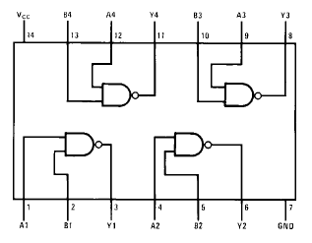
Figure 1 Connection diagram of 74LS00 [3]

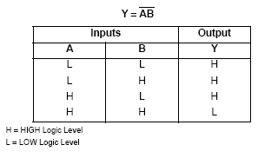
Table 1 Truth table of 74LS00 [3]

74LS00 is consisted of four NAND gates. It should be applied power to it before using in the circuit. The structure of 74LS00 is showed in figure 1, and the truth table is following as figure 2.[3]

- 74LS74 dual D flip-flop

Flip-flop is a binary storage device, which works clock dependent, and it mainly consists of NAND gate and transistors. Number of inputs depends on each type of flip-flops. For example, D-flip-flop has one input and two outputs. Each type of flip-flop could give out different output with specific logic, such as the output (Q) of D-flip-flop equals to its input (D). The state of flip-flop changes on the transition of input clock, so positive and negative edge-triggered flip-flops give out respond at change of signal. The use of D-flip-flop is basic on its truth table. [4]

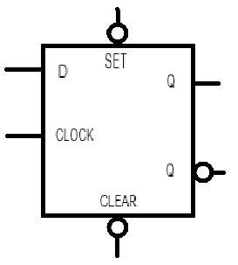
Figure 2 Typical positive edge-triggered D-flip-flop [3]

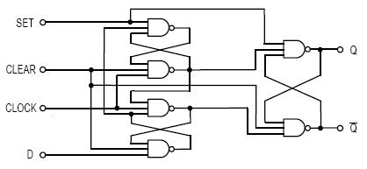
Figure 3 Structure of D-flip-flop [3]

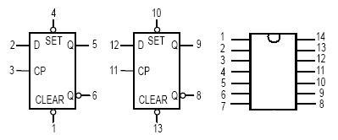
Figure 4 Connection diagram of 74LS74 [3]

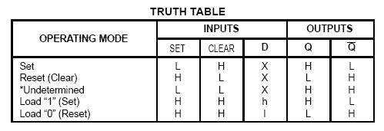
Table 2 Truth table of 74LS74 [3]

74LS74 is consisted of two positive edge-triggered D-flip-flops. It should be applied power to it before using in the circuit. The structure of 74LS00 is showed in figure 4, the connection pins is displayed on figure 5 and the truth table is following as figure 6. [3]

- Light emitted diode (LED)

Light emitting diode (LED) is a semi-conductor device, which can emit narrow-spectrum light. LED could light by applying small current, so it is energy saving device. Anode of LED should be connected to positive voltage and cathode of LED is connected to ground/ negative voltage, then it can light properly. [2]

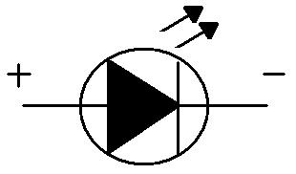
Figure 5 Structure of LED

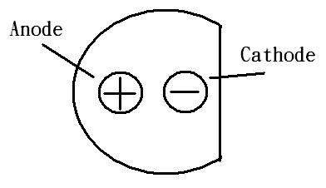
Figure 6 Two legs of LED

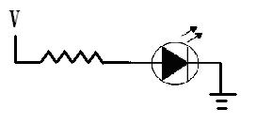
Figure 7 Practical use of LED

LED should be connected to resistor in series, because it can protect the LED for too large current. The connection of LED also cannot be reversed. If not, LED would not light.

- Mealy machine

Mealy machine is a machine of number of states. It can be used to perform the flow of specific logic, and it can be converted into state diagram. Afterward, state diagram can be expanded to be state truth table and the connections of the circuit are shown clearly. [1][2]
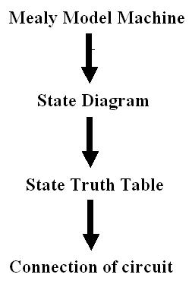
Figure 8 Procedure of Mealy Machin1

Procedure and Data:

- Procedure

First, logic of traffic light is divided into four meaningful states using Mealy machine. Red lighted, yellow lighted, green lighted and yellow and red lighted are four distinct states, and the state diagram is shown as figure 9.
Second, state truth table is transformed to state diagram. The outputs of traffic lights are shown as table 3. Using these data, whole sequential circuit can be constructed.

- Data and Results

Mealy Machine Model

00
01
11
10
1
1
1
1
0
0
0
0

Figure 9 State diagram of traffic light

Present state (PS) | Next state (NS) | Output
Q₁Q₂ | Q₁Q₂ | Green light (G) | Yellow light (Y) | Red light (R)
00 | 01 | 1 | 0 | 0
01 | 11 | 0 | 1 | 0
11 | 10 | 0 | 0 | 1
10 | 00 | 0 | 1 | 1
Table 3 State table of traffic light

G = Q₁’Q₂’
Y = Q₁Q₂’ + Q₁’Q₂
R = Q₁
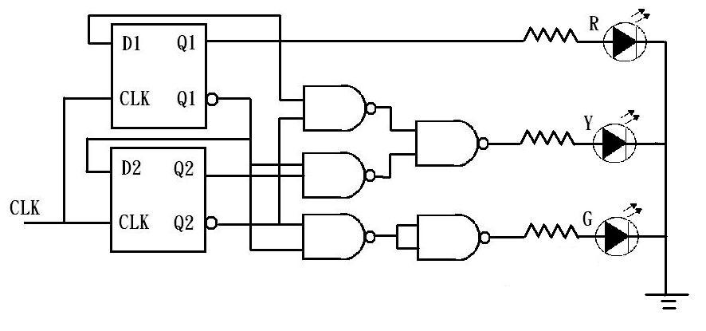
Figure 12 Sequential circuit of traffic light

Discussion:

- It is because NAND gate is universal logic gate, so it can become different logic gates. For example, XOR gate can be transformed into as figure 13.
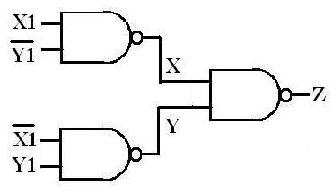
Figure 13 New XOR gate

X₁ | Y₁ | X₁’ | Y₁’ | X | Y | Z
0 | 0 | 1 | 1 | 1 | 1 | 0
0 | 1 | 1 | 0 | 1 | 0 | 1
1 | 0 | 0 | 1 | 0 | 1 | 1
1 | 1 | 0 | 0 | 1 | 1 | 0
Table 4 Truth table of new XOR gate

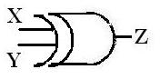
Figure 14 XOR gate

X | Y | Z
0 | 0 | 0
0 | 1 | 1
1 | 0 | 1
1 | 1 | 0
Table 5 Truth table of original XOR gate

Therefore, the truth table of new XOR gate equals to the original XOR.

- Five traffic lights for cars and passengers

Mealy machine

Present state (PS) | Next state (NS) | Output (Cars) |  |  | Output (passengers)
Q₁Q₂ | Q₁Q₂ | Green light (G_{C}) | Yellow light (Y_{C}) | Red light (R_{C}) | Green light (G_{P}) | Red light (R_{P})
00 | 01 | 1 | 0 | 0 | 0 | 1
01 | 11 | 0 | 1 | 0 | 0 | 1
11 | 10 | 0 | 0 | 1 | 1 | 0
10 | 00 | 0 | 1 | 1 | 1 | 0
Table 6 New state truth table of traffic light

G_{C} = Q₁’Q₂’
Y_{C} = Q₁Q₂’ + Q₁’Q₂
R_{C} = Q₁
R_{P} = Q₁’
G_{P} = Q₁

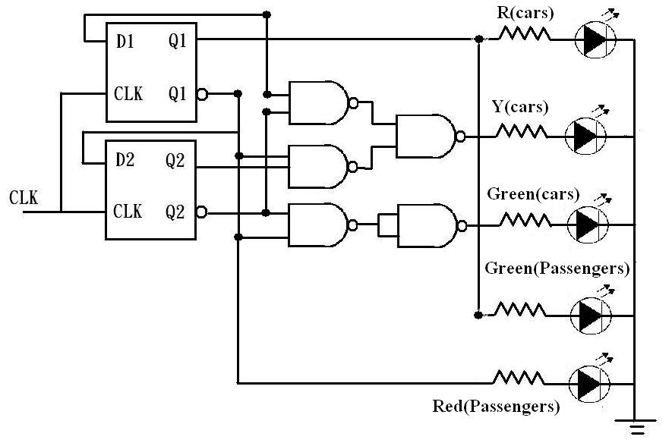
Figure 15 New sequential circuit of traffic light

- It is because the output of flip-flop is near 5V. If LED is applied 5V directly without connecting resistor, it will be burnt out due to thermal effect.

Conclusion:

In this experiment, a sequential circuit is constructed for specific logic. Using Mealy machine, state diagram and state truth table are produced and it can help to build the circuit easily.

Reference:

- Lecture notes
- http://zh.wikipedia.org/
- http://www.hanssummers.com/ electronics/datasheets/
- Introduction to logic design

