HTML Tags

<OL> 有次序排列的文字
<OL START="10"> START是開始值
<LI> 在次序內的文字事項
<UL> 沒有次序排列的文字
<UL TYPE="square"> TYPE是項目符號類別
<DL>
<DT> 段落
<DD> 換行
<IMG> 走馬燈
<IMG SRC="./IMAGE.JPG"
ALIGN="TOP"
WIDTH="300"
HEIGHT="400">

例子：
<HTML>
<TITLE>LESSON TWO</TITTLE
<BODY BGCOLOR="#CCFFCC">
<H1><MARQUEE>LESSON TWO</MARQUEE></H1>
<HR>
<IMG SRC="./PICS.JPG" WIDTH="200" HEIGHT="100">
<P>DIT CORE SUBJECTS:</P>
<OL START="I">
<LI>SYSTEM ANALYSIS & DESIGN
<LI>OPERATING SYSTEM
<LI>NETWORKING
</OL>

<P>OTHER SUBJECTS:</P>
<UL TYPE="square">
<LI>Business Writing
<LI>MS OFFICE
</UL>

<DL>
<DT>PRATICAL SUBJECTS:</P>
<DD>C PROGRAMMING
<DD>WEB PAGE DESIGN
</DL>

</BODY>
</HTML>

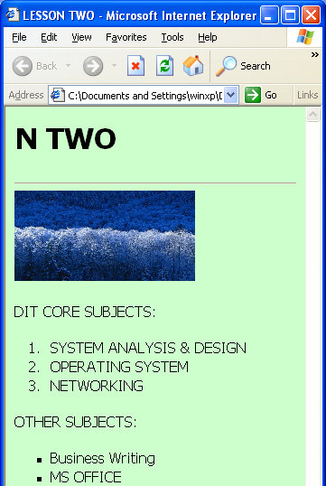
Try to write a HTML file (Ex01.html) that is similar with the following:



