HTML Tags

<A> 功能頗多的Tags, 一般用於超連結
<A HREF="http://www.yahoo.com/"> 對外超連結(網頁)
<A HREF="ftp://ftp.download.com/"> 對外超連結(檔案伺服器)
<A HREF="mailto:info@hotmail.com"> 超連結電郵
<A NAME="top"> 建立地標(用於超連結或其他功能)
<A HREF="#top"> 對內超連結(到某一地標)

Address:
. 現在目錄(資料夾)位置 "./image/pics.jpg"
.. 上一層目錄(資料來)位置 "../../index.html"

例子：
<HTML>
<TITLE>LESSON THREE</TITLE>
<BODY BGCOLOR="#996633">
<!-- 假設網頁基本路徑為http://www.myweb.com/lesson3/ -->
<A NAME="top"><H1><MARQUEE>LESSON THREE</MARQUEE></H1></A>
<HR>
<P>LINK TO OUTSIDE WEBPAGE:
<A HREF="http://www.yahoo.com/">www.yahoo.com</A>
<BR>LINK TO OUTSIDE FTP SERVER:
<A HREF="ftp://ftp.downloand.com/">ftp.download.com</A>
<BR>LINK TO E-MAIL:
<A HREF="mailto:mail@hotmail.com">mail@hotmail.com</A>
<BR>
<BR>LINK TO INTERNAL RESOURCE:
<A HREF="./images/">home.gif</A>
<!-- 完整路徑為http://www.myweb.com/lesson3/images/home.gif -->
<BR>LINK TO INTERNAL RESOURCE:
<A HREF="../index.html">index.html</A>
<!-- 完整路徑為http://www.myweb.com/index.html -->
<BR>LINK TO INTERNAL RESOURCE:
<A HREF="../lesson2/lesson2.html">lesson2.html</A>
<BR><BR><BR><BR><BR><BR><BR><BR><BR><BR><BR><BR><BR><BR><BR><BR><BR>
<BR>LINK TO INTERNAL WEBPAGE:
<A HREF="#top">Back to top</A>
</P>
</BODY>
</HTML>

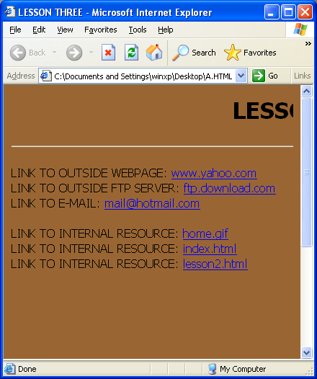
Try to write a HTML file (Ex03.html) that is similar with the following:



