HONG KONG INSTITUTE OF VOCATIONAL EDUCATION
(HAKING WONG)

Department: Electrical Engineering
Module Title: Engineering Science
Module Code: MMI6205

Assignment 2

Name: Ko Siu Tai
Class: 01601T-G
Student No: 020058936

- A 8 kg block is suspended by two strings as shown
in the diagram. The strings are assumed inextensible.
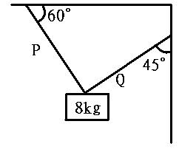
( a ) Calculate the weight of the block.
8 x 10 = 80N
( b ) Find the tensions along the strings.
- Four co-polar forces act at a point O, the values and
directions of the forces being as shown in figure.
Calculate the value and direction of resultant force. 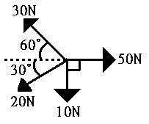
 | F x | F y
F 1 | 50 | 0
F 2 | F 2cos60∘= 0.5 | F 2sin60∘= 0.87
F 3 | F 3cos30∘= 0.87 | F 3sin30∘= 0.5
F 4 | 0 | -10
 | ΣFx = 51.37 | ΣFy = - 8.69
R² = 51.37² + (- 8.69)²
R = 52.09

- According to question no. 2, check the answer by means of a force polygon drawn
to scale.
- A uniform lever is pivoted at is its mid-point C. A body having a mass 5kg is suspended a point E, 180MM to the right of C. Calculate the mass to be suspended at point D, 400MM to the left of C to maintain the lever in balance.
400mm X mkg = 180MM X 5kg
mkg = (180 X 5) / 400
mkg = 2. 25
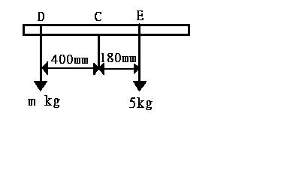
- A uniform horizontal beam, 6m ling, rests on two supports A and B, 4m apart, A being
at one end of the beam. The mass of the beam is 20kg. Calculate the reactions of the supports on the beam.
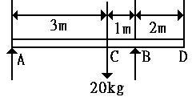
( a ) Take moment at B
FA X 4 = 20 X 1
FA = 20 / 4
FA = 5kg
( b ) Take moment at A
FB X 4 = 20 X 3
FB = 60 / 4
FB = 15kgf
- If a mass of 8kg be hung from the beam of Question (5) at a distance of 1m from A, calculate the reaction the reaction of the supports.
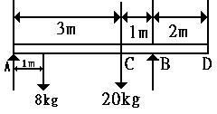
( a )Take moment at B
FA X 4 = (8 X 3) + (20 X 1)
FA = (24 + 20) / 4
FA = 44 / 4
FA = 11
( b )Take moment at A
FB X 4 = (8 X 1) + (20 X 3)
FB = (8 + 60) / 4
FB = 17kgf
17 X 10 = 170N

