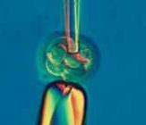


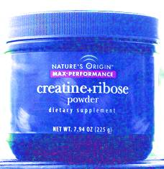

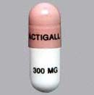
Have the children being valued in their own right during the Genetic diagnosis?
It is very controversial
Why Creatine Supplements Work?
Downstream from the the reduced blood flow found in the brains of HD carriers (ref) is the reduction of cell energy. The currency of cell energy is a molecule, adenosine triphosphate (ATP). Our brains, muscles and every cell need ATP to function. Cells have a limited ability to make ATP. As ATP levels drop we become tired and disabled. Some will remember that depleted LA Olympic marathon runner shown on national TV. She struggled on with severe HD like movements. Eventually she was forcefully removed from the event. Endurance runners know what it is like to not be able to tie a shoe lace. When ATP is recycled we are restored to health.

The ATP reduction in HD is striking. Here is what a landmark study showed, "... Muscle ATP at rest was significantly reduced in symptomatic and presymptomatic HD subjects. During recovery from exercise, the maximum rate of mitochondrial ATP production was reduced by 44% in symptomatic HD patients and by 35% in presymptomatic HD carriers." Ann Neurol 2000 Jul;48(1):72-6 Lodi R, et al.

Creatine supplements speed up the recycling of depleted ATP to make new ATP.

Cells often have more than one pathway for a vital function. There is no function more vital than the cells ability to make ATP.

Creatine is in a metabolic pathway that restores ATP to muscles and brain. Creatine supplementation makes that pathway more available. There is also a ribose dependant pathway that restores ATP. Ribose supplementation makes that pathway more available. Like creatine, ribose is proven to enhance sports performance by increasing cell energy. The effect should be additive for the more effective treatment of HD.

http://www.hdlighthouse.org/
http://www.hdsa.org/

