RTS suggested solution (00/01)
A1. Refer to slide 2 of TV2.
A2. Lines/sec=525x30=15750Hz. Time duration of 1 line is 1/15750 (sec).
A3. Refer to slide 53 of TV2.
A4 time delay = D/c where D=36000x2 Km, c=velocity of light. Thus time delay=0.24Sec.
Time delay causes echo in voice communication.
A5 Image freq=fs+2IF=1000+2x455 KHz=1910KHz
Local oscillator freq=fs+IF=1000+455KHz=1455KHz
A6 Refer to slide 34 & 35 of Tx&Rx 2.
A7 Ht=4x(45)^{1/2} =26.83Km, Hr=4x(25)^{1/2}=20Km
Total radio horizon=26.83+20Km=46.83Km
A8 Power radiated=1.2²x60=86.4W, efficiency=60/(10+60)x100%=85.7%
A9
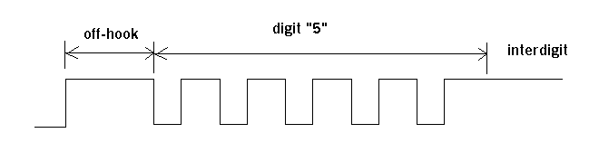

A10 Refer to slide 20 of Mobilephone 06
