Basic Geometrical Constructions and Regular Polygons
Pencils

 | To achieve the best results, pencils are sharpened in two forms:
 | (i) | chisel-edged | use to draw straight lines
 | (ii) | conical pointed | use to draw continuous irregular lines, arrowheads, and lettering
 | When drawing with cartridge paper, use the following grade of pencils:
 | (i) | HB pencils | for lettering and arrowheads
 | (ii) | H pencils | for outlines and all thin lines
 | (iii) | 2H, 3H pencils | for construction lines

General rule  pencil work | The more abrasive the drawing paper the harder the pencils should be used.
General rule  pencil work | Sharpen the pencils frequently to produce bold, black and dense lines.
Compasses

1. | To achieve the best results, compass leads should be sharpened by rubbing one side (inside for small compasses and outside for large compasses) to produce a sharp, curved edge.
2. | Use a softer lead to compensate less pressure being applied when drawing arcs or circles, e.g. F pencil lead.
3. | Compasses should be fitted with a shouldered needle point which should project a little way beyond the lead when the compasses are closed.

General rule on  compass work | use two sizes of compass for drawing small and large circles or arcs separately
General rule on  compass work | draw circles or arcs in a clockwise direction with the instrument inclined slightly forward.
Tee-square

Tee-square is mainly used for drawing horizontal lines. It is also used as a guide for set-squares when drawing vertical and inclined lines.

General rule on the use of tee-square | lines are drawn along the top of the straight edge
General rule on the use of tee-square | hold the tee-square head against the left edge of the drawing board to slide the tee-square
General rule on the use of tee-square | apply little pressure toward the right to slightly adjust the tee-square position

Set-squares

Set-squares are used, in combination with a tee-square, for drawing vertical lines. It is also used to draw:
 | (i) | inclined lines of 15 ⁰, 30 ⁰, 45 ⁰, 60 ⁰, or 75 ⁰
 | (ii) | parallel lines
 | (iii) | perpendicular lines

General rule on the use of set-squares: draw vertical lines upward along the edge of the set-square which is supported by the tee-square place the set-square to the right of the line being drawn use set-squares singly or in combination to draw inclined lines, parallel lines or perpendicular lines
Geometrical constructions
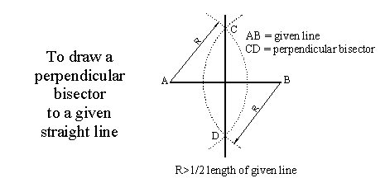(i)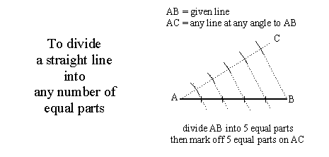(ii)
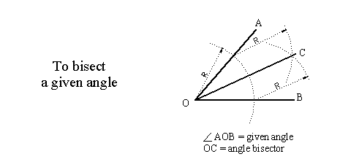(iii)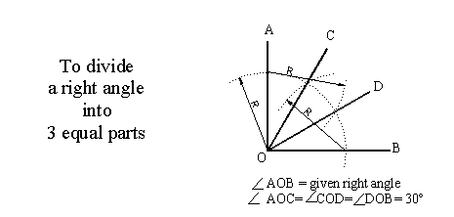(iv)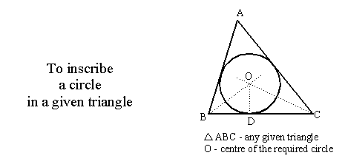(v)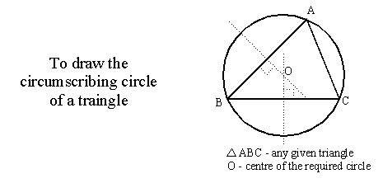(vi)

LINE PERFERRED
i) | visible outlines
ii) | hidden outlines
iii) | cutting planes
iv) | centre lines
v) | outlines and edges of adjacent parts
vi) | projection lines

