Introduction to Assembly Drawing
 | 1. | To appreciate the need for assembly drawing.
 | 2. | To recognise the layout and format of an assembly drawing.
 | 3. | To draw assembly drawing and sub-assembly drawing of simple machines / jigs in first angle and third angle projections.
Defining assembly drawing

BS ISO 10209-1 Technical product documentation - Vocabulary - Part 1: Terms relating to technical drawings: general and types of drawing states that
"an assembly drawing is a drawing representing the relative position and/or shape of a high-level group of assembled parts."
"a sub-assembly drawing is a drawing on a lower structural level showing only a limited number of groups or parts."
Generally an assembly drawing of a machine shows the parts of the machine in their relative working positions. According to the use of the drawings and the complexity of the machine, there are several types of such drawings:

 | i)Working  assembly drawing | shows each part completely dimensioned; applicable to simple mechanisms
 | ii)sub-assembly drawing | shows a group of related parts that form a sub-assembly in a more complicated machine
 | iii)installation assembly drawing | gives useful information for putting the parts together;  the names of parts, location dimensions, special instructions, etc. for operation may be shown

Parts list

A parts list is a table which records every individual part of the assembly. The list is usually placed just above the title block and contains the part number, descriptive name, material and quantity (no. off) of each assembled part.
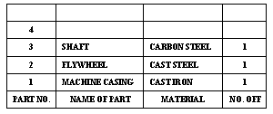

A balloon reference system is used to relate the items in the parts list to the drawing. The system contains a leader radiating from a circle, or "balloon". The part number is indicated in the balloon for cross reference.
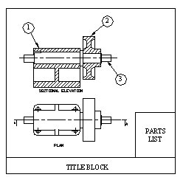
Drawing format

The format of an assembly drawing is similar to other types of drawings. There are a number of features that can be found in an assembly drawing.

i) | drawing orientation | landscape (horizontal) or portrait (vertical)
ii) | trimming mark | it is provided in the borders at the four corners of the drawing paper to facilitate trimming of the blue print
iii) | border and frame | it encloses the drawing area together with the title block and other information
iv) | grid reference | it facilitates location on the drawing of details, changes, etc.
v) | centring mark | it facilitates positioning of the drawing for reproduction processes (e.g. printing)
vi) | orientation mark | it is located on the centring mark adjacent to and pointing toward the intended position of the drawing user
vii) | scale bar | it should be figure-less and preferably be located symmetrically about a centring mark
viii) | title block | it provides an efficient system of labelling a drawing and contains essential information required for the identification, administration and interpretation of the drawing
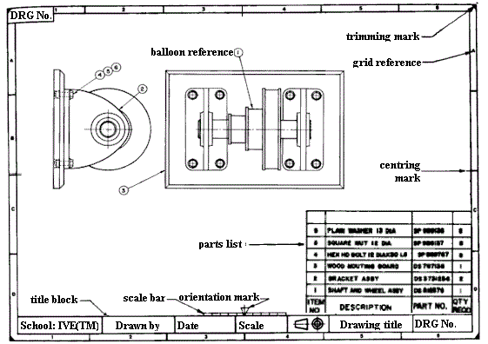
Drawing hints

Assembly drawing incorporates all of the principles relating to orthographic projection, sectioning, dimensioning, drafting conventions and standards to BS8888. As the drawing is required to show the arrangement of parts so that the assembly can be fitted together in the correct order and for this reason, mastering skills in assembly drawing depends on:

i) | a comprehensive understanding of principles and standards relating to engineering drawing
ii) | knowledge of machine elements in mechanical design
iii) | broad knowledge of workshop practices and assembly method
Before starting an assembly drawing, it is recommended to:

i) | select the views that can complete the assembly description
ii) | decide a scale that will allow, without overcrowding, a balanced arrangement of all necessary views, dimensions, notes, etc.
iii) | study the individual part of the assembly
iv) | determine the mating and fitting of adjacent parts (considering and comparing the dimensions of adjacent parts or any interference when assembled, functions of the parts in the assembly, etc.)
v) | judge whether the assembly is functional when all parts are in position
vi) | sketch to a reduced scale simplified views of the assembly
vii) | draw the main centre lines and block in the general outline of the views
viii) | build up the drawing features, work back and forth from view to view until the assembly is completed
ix) | check for correctness of the assembly drawing, parts list, title block, special notes, etc.

