THE HONG KONG POLYTECHNIC UNIVERSITY

EIE 261

LOGIC DESIGN

LAB REPORT

Dicky Au

04913492D

42075

CONTENT

- Report on Lab 1 question 1 …………………………………………….……P.3

- Report on Lab 1 question 2…………………………………………….…..P.4-5

- Report on Lab 1 question 3…………………………………………….……P.6

- Report on Lab 1 question 4…………………………………………….……P.7

- Report on Lab 1 question 5…………………………………………….……P.8

- Waveform of Lab 1 question 1 …………………………………………….P.9

- Waveform of Lab 1 question 2 ……………………………………………..P.10

- Waveform of Lab 1 question 3 …………………………………………….P.11

- Waveform of Lab 1 question 4 ……………………………………………..P.12

- Waveform of Lab 1 question 5 …………………………………………….P.13

- Answer of Lab 1 question 6 …………………………………………….P.14

- Answer of Lab 1 question 7 …………………………………………….P.15

- Conclusion …………………………………………….………………….P.16

Report on question 1

- Ripple up counter.

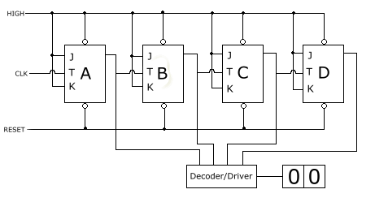

In question one, there is four flip-flops formed a Ripple up counter.
It counts from 0000 to 1111. Because of the 7-segment display cannot display well. Then the display of from A to F has some problems. It displays from 0 to F are the followings.

0 1 2 3 4 5 6 7 8 9 A B C D E F

Report on question 2

Ripple up-down counter.

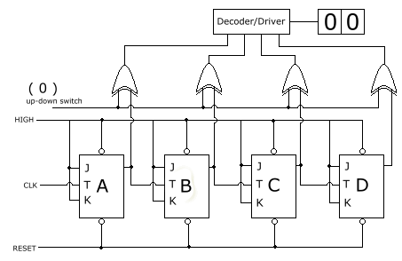

In question two, there is a Ripple up-down counter.
It counts from 0000 to 1111. It displays from 0 to 1, 1 to 2, 2 to 3, 3 to 4, 4 to 5, 5 to 6, 6 to 7, 7 to 8, 8 to 9, 9 to , to , to , to , to , to .

Report on question 2

But if when up-down counter switch equal to 0, the counter will count down from F to 0. It displays from to , to , to , to , to , to 9, 9 to 8, 8 to 7, 7 to 6, 6 to 5, 5 to 4, 4 to 3, 3 to 2, 2 to 1, 1 to 0.

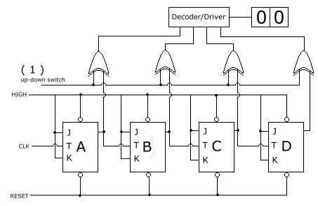

The truth table of the EX-OR gate:
Inputs |  | Output
A | B | O/P
0 | 0 | 0
0 | 1 | 1
1 | 0 | 1
1 | 1 | 0

One extra question is, there is not enough exclusive OR gates. We need to connect NOT gate and AND gate. That can form a NAND gate. And NAND gate can formed an EX-OR gate.
Report on question 3

Asynchronous counter

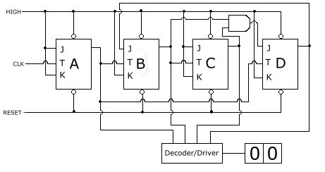

There is an Asynchronous counter.
It is a modulus 10 counter. That means it counts from 0 to 9. There are 4 flip-flops. And their clock is not the same. That is Asynchronous counter.

Report on question 4

Synchronous counter

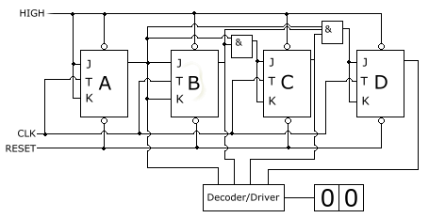

Design and construct a binary counter (in synchronous mode) that will recycle to zero after 16 clock pulses (i.e. from 0000 > 1111 > 0000)

This is a Synchronous counter. 4 flip-flops use the common clock.
It counts from 0000 to 1111. This is a Mod 16 counter.

Report on question 5

BCD counter
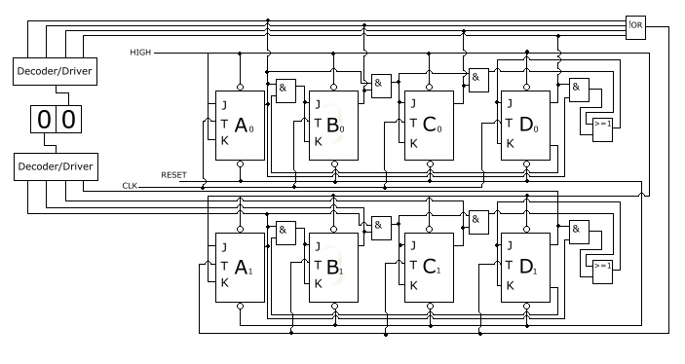
Design and construct a two digit BCD counter. Connect the output to the decoder/drivers and prove that the counter will go from 00 to 99 then return to 00 again.

This is a BCD counter. There are two mod 10 counter in the figure.
The first mod 10 counter use the common clock. Then it counts from 0 to 9. The second mod 10 counter use the first mod 10 counter’s output to its clock. So, after the first mod 10 counter count 9 to 0, then a one digit adding to the second mod 10 counter. As a result, the BCD counter can count from 00 to 99.

Waveform of question 1

Ripple counter

Waveforms
 |  |  | 0 |  | 1 |  | 2 |  | 3 |  | 4 |  | 5 |  | 6 |  | 7 |  | 8 |  | 9 |  | 10 |  | 11 |  | 12 |  | 13 |  | 14 |  | 15
CLK
Q_{A}
Q_{B}
Q_{C}
Q_{D}

We use SET to turn on the flip-flops. And use RESET to turn off the flip-flops.
The first flip-flop uses the common clock to count. The second flip-flop uses the first flip-flop’s output to count. The third flip-flop uses the second flip-flop’s output to count. The fourth flip-flop uses the third flip-flop’s output to count. Then the flip-flops start counting from 0000 to 1111. The flip-flops will reset after it counted to 1111. So, this is the Ripple counter.

Waveform of question 2

Ripple-up counter
If the switch equal to 0, it is a Ripple-up counter.

Waveforms (switch is off)
 |  |  | 0 |  | 1 |  | 2 |  | 3 |  | 4 |  | 5 |  | 6 |  | 7 |  | 8 |  | 9 |  | 10 |  | 11 |  | 12 |  | 13 |  | 14 |  | 15
CLK
Q_{A}
Q_{B}
Q_{C}
Q_{D}

Ripple-down counter
If the switch equal to 1, it is a Ripple-down counter

Waveforms (switch is on)
 |  |  | 0 |  | 1 |  | 2 |  | 3 |  | 4 |  | 5 |  | 6 |  | 7 |  | 8 |  | 9 |  | 10 |  | 11 |  | 12 |  | 13 |  | 14 |  | 15
CLK
F_{A}
F_{B}
F_{C}
F_{D}

Waveform of question 3

Mod 10 Asynchronous counter’s waveform

It uses HIGH to control the SET and RESET.

Waveforms
 |  |  | 0 |  | 1 |  | 2 |  | 3 |  | 4 |  | 5 |  | 6 |  | 7 |  | 8 |  | 9 |  | 10 |  | 11 |  | 12 |  | 13
CLK
F_{A}
F_{B}
F_{C}
F_{D}

Waveform of question 4

Mod 16 synchronous counter

All the 4 flip-flops use the common clock to count. It counts from 0000 to 1111. It will RESET after it counted to 1111.

Waveforms
 |  |  | 0 |  | 1 |  | 2 |  | 3 |  | 4 |  | 5 |  | 6 |  | 7 |  | 8 |  | 9 |  | 10 |  | 11 |  | 12 |  | 13 |  | 14 |  | 15 |  | 0
CLK
Q₀
Q₁
Q₂
Q₃

Waveform of question 5
BCD counter

BCD stands for Binary Coded Decimal. A BCD counter has four outputs usually labeled A, B, C, and D. By convention A is the least significant bit, or LSB. When pulses are delivered to the CLOCK input (and all the other connections needed for basic operation are made), the outputs of the BCD counter follow a sequence starting from 0 0 0 0 up to 1 0 0 1, the binary equivalent of the decimal number 9. The next pulse causes the RESET and counting starts again from 0 0 0 0

Waveforms
 |  |  | 0 |  | 1 |  | 2 |  | 3 |  | 4 |  | 5 |  | 6 |  | 7 |  | 8 |  | 9 |  | 10 |  | 11 |  | 12 |  | 13 |  | 14 |  | 15 |  | 16 |  | 17 |  | 18 |  | 19 |  | 20
CL
A₀
B₀
C₀
D₀
A₁
B₁
C₁
D₁

Answer of question 6
Question 6a, all the CLEAR inputs are connected together, so that a single pulse can clear all the flip-flops before counting starts. The clock pulse fed into FF0 is rippled through the other counters after propagation delays, like a ripple on water, hence the name Ripple Counter. The 2-bit ripple counter circuit above has four different states, each one corresponding to a count value. Similarly, a counter with n flip-flops can have 2 to the power n states. The number of states in a counter is known as its mod (modulo) number. Thus a 2-bit counter is a mod-4 counter.(http://www.eelab.usyd.edu.au/digital_tutorial/part2/counter02.html)
Ripple counter is an asynchronous counter whose output increases by 1 on every clock pulse and its clock is ripple through the flip-flops. The output of one flip flop is the input to the next; the state changes consequently “ripple through” the flip-flops, requiring a time proportional to the length of the counter. (http://web.cs.mun.ca/~paul/cs3724/material/web/notes/node20.html).
Question 6b, up-down counter is synchronous counters, which separate count up, and count down clocks is used and in either counting mode the circuits operate synchronously. It output state synchronous with the Low- to- High transitions on the clock input. When up-down switch equal to one, the counter will count up from 0 to F or from F to 0. When up-down counter switch equal to 0, the counter will count down from F to 0.
Question 6c, The asynchronous counter takes a clock input and increments one register until it rolls over from 2 to 0. That event is detected by a piece of logic similar to the de-mux select logic. One uses it to tell the next register to increment its count. This continues as long as clock pulses come in. Asynchronous counter is a counter where the clocks of the flip-flops come from different sources and change state asynchronously.(http://www.trinary.cc/Tutorial/Counters/Counters.htm)

Question 6e, BCD counter consists of negative edge
triggered BCD counters that are cascaded synchronously. A quad latch
at the output of each counter permits storage of any given count. The
information is then time division multiplexed, providing one BCD
number or digit at a time. Digit select outputs provide display control.
All outputs are TTL compatible.
Answer of question 7

Compare the advantages and disadvantages of synchronous and asynchronous counters.

Speed:
Asynchronous counter is slower than Synchronous counter. Even for larger number of bits, delay by successive of Asynchronous counter stages may become undesirably large.

Power consumption:
Asynchronous counters consume less power than synchronous counters.

Circuit Construction:
Asynchronous counter are simpler than Synchronous counter.

Cost:
Asynchronous counter are generally cheaper than Synchronous counter.
Conclusion

This Lab let us know how to apply the J-K flip-flops to different counter. There are a lot of counters. Such as, Ripple counters, Ripple-up counter, Ripple-down counter Asynchronous counter, Synchronous counter and BCD counter. Ripple-up counter count from 1 to 0, then 0 to 1. Ripple-down counter count from 0 to 1, then 1 to 0. Asynchronous counter use different clock to count. Synchronous counter use the common clock to count. BCD counter use decimal counting. I can found some reference in the web site and some reference book.

