Hong Kong Institute of Vocational Education
Department of Electronics and Information Engineering
Diploma in Computer and Information Engineering 2003-2004
Final Year Engineering Project

REMOTE HOME CONTROL USING TELEPHONE

71202/2A Group 3
Au Dicky (1)

Introduction

Nowadays, high technology is popular. Everybody likes convenience. While the summer comes, air-conditional is necessary. Therefore, we decide to do a project to use phone call to control electronic appliances. So, we chose this title – Infrared Remote Home Control. It refers to telephone, multi-function remote control, dual tone decoder and micro-controller.

Architecture
Phone In

Auto hook off

Keypad
input

Control appliance switching

Phone In: People use mobile telephone dial in home telephone when they outside.
Auto hook off: Telephone of home hook off line for outside telephone call.
Keypad input: Input number (0-9) for mobile phone or telephone
Control appliance switching: Control home appliance turn on or off

Design Process Overview

First, our group member had some suggestions about our project topic. So, we had many choices about it. But, we need to consider many factors, such as materials, successful ratio and our technology. After they had been found some information on the Internet and reference book, and during discussing.

Second, we decided to build up a remote home control system. It was because our members had attended some practice about how to build up a telephone circuit, testing and debug it. Otherwise, we are also interested in this topic, we also think that it is a quite useful system in real world.

Third, we had used an assembly program with input function, output function, table and delay loop. But, we found that we need not used the delay loop when during testing. Therefore, we removed the delay loop and reprogrammed the 89C51 micro-controller.

Fourth, after we had built up a testing circuit by using 89C51 micro-controller. We could not get a reasonable result so we had still to during testing and debugging. After that, we found pin1 could not function but this problem was not case by human and systematic errors. Therefore, we used a new one 89C51 micro-controller to replace an old one.
Lastly, we had found a one special testing result on MT8870 decoder. When we pressed a keypad ‘0’ on mobile phone, the output port of the decoder could output ‘0101’ binary pattren. It means that the hexadecimal value ‘A’.

0
0
0
1
8
1
0
0
1
9
1
1
1
0
7
0
1
1
0
6
1
0
1
0
5
0
0
1
0
4
1
1
0
0
3
0
1
0
0
2
1
0
0
0
1
0
1
0
1
0
Q1
Q2
Q3
Q4
Key number
Output (binary patterns)
Input (Dual-Tone signals)
Special
Result

Testing result of MT8870 decoder

CPM CHART

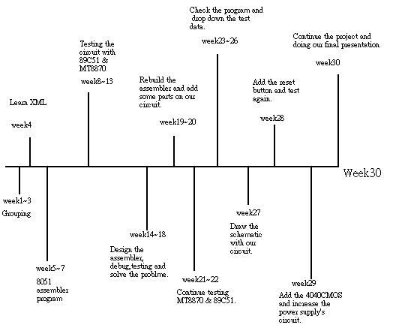

Problems and Solutions

1) Problem: The 89C51 micro-controller port3 could not receive the input signals for MT8870 decoder properly?

Solution: Connected the reset button in the 89C51 micro-controller pin9. This action can make the micro-controller received the input signals when the reset button had been pressed first.

- Problem: MT8870 decoder does not have any auto hook off function on telephone?

Solution: Connected the 4040 counter with RY6WFZ-K relay to the MT8870 decoder.4040 counter could count up the number of any 2 to power n (2-12) ringing value in 12 pins. After count up, the counter can make the relay common shorts with normal open to auto hook off the phone.

- Problem: Voltage of telephone ringing signal is between +1.4V to –1.4V, it is an unstable and not enough power signal; it will make the MT8870 non-function?

Solution: Connected a 4040 counter with amplifier (transistor) and rectifier (diode) to MT8870 decoder. It can pull high the voltage and rectified the current.

4) Problem: Can we remove the reset button?
Solution: The reset button is used to make sure the 89C51 and MT8870 connect to 5V stably. If we remove the reset button, it may cause the 5V cannot connect to 89C51 and MT8870.

5) Problem: Why LEDs cannot work?
Solution: The LEDs should be pulled high by 5V. Because the 89C51 do not has enough current to make the LEDs work.
Innovation

If the technology accepts, we want to have a voice-control function rather than dual tone signals. Then, we can say the words “ Turn on”, it turns on, or “Turn off”, it turn off.

We want to control more electric appliance, such as, TV-recorder. Sometimes if we do not remember recodes the television program, we can phone back home and use dual tone to control the television recorder to recodes the television program.

Also, if we learn, we want to create a little robot. It can use the baby’s father and mother’s phone to call the robot to care the baby. And the robot can call back, tells what baby want, and the baby’s father and mother can use telephone to send back the signal to the robot to care the baby. Then, the baby’s father and mother can go to work freely.

Technology
PCB layout design:
Use EAGLE4.11r to design the schematic with our project and Printed Circuit Board (PCB).

Assembler programming:
Use Table for output control signal

Soldering
Soldering the parts on broad.

IC application
Using match telephone control’s IC—89C51, MT8870, 4040CMOS.

Year one Electronic
Electronic Engineering Practices is useful in our project and the Digital Electronic also in 8051 program application.

Conclusion

I have learnt more about 89C51 micro-controller, MT8870 decoder, 4040 counter, relay, write program, soldering and routing board. In addition, I want to use telephone to control electric appliances. Also, I know the application for this project. It has a large various application area. Moreover, I can have a good communication skill with my group members. Finally, I hope my project will be popular and helpful.

Recommendation

We used too much time to decide the title. We try to do the XML, electronic spider, etc. It wastes us too much time. The title should be decided before Week 2.
We waste too much time to debug from the breadboard. Every time, we found a problem. We were going to remove all the components and rebuild the circuit again. Although, that is not a bad method, it waste too much time to rebuild. The circuit should be soldered into the board before Week 15, and then we have much more time to do our project.

We will connect to the infrared remote control to control the home electronic appliances if the time allow. We will try to control the air-conditional while the summer came.

End

