BABIES
(Delivery)

CLASS: 41306-1D
NAME: Yeung Hoi Lam (40) --- Group Leader
Lo Pui Ting Teresa (25)
Tsang Man Ting (34)
Wong Lai Ting (38)
Wu Wai Hung (39)
Yuen Ka Yi (42)

CONTENT

Company Summary --------------------------------------------------P.1-2

Product and Service --------------------------------------------------P.3-4

Market Analysis -------------------------------------------------------P.5-7

Marketing Strategies -------------------------------------------------P.8-9

Management ---------------------------------------------------------P.10-13

Financial Plan -------------------------------------------------------P.14-15

Our company is called BABIES being owned by a group of six shareholders. It is a Limited company. It provides delivery service for customers who order babies products and food. It aims to give a fast and convenient way to parents who have no time to buy their babies’ needs.

We will improve our services to suit for most parents’ wants, and deliver the ordered products as soon as possible.

Address of our company: Flat 11D, Tai Lung Industrial Building, San Po Kong, Kln
E-mail address: bbdelivery@hkem.com
Homepage: http://www.geocities.com/bbdelivery/

The following is our facilities:
1 Warehouse (2000sq)
1 Car park
1 second-hand Van
Computer Components (seven computers, one 4 in 1 printer, fax machine and etc.)
2 EPS paying machines (Hired)
Tools in warehouse (e.g.積車)
Other useful materials (e.g. stationery, desks, chairs and etc.)

Figure1:
A flat diagram of the office of BABIES (Delivery) Company Ltd.
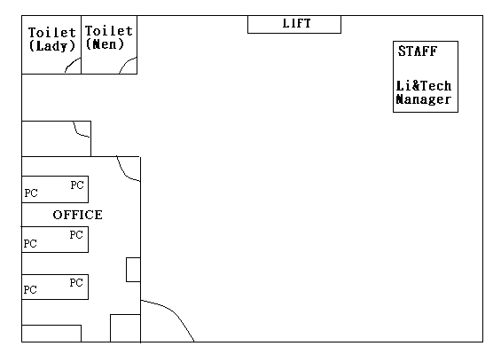

BABIES offers a delivery service of baby accessories and baby food. Our products include: feeding bottles, bottle sterilizer, bottle tongs and brush, bottle warmer, milk powder case, bottle detergent, ear thermometer, milk powder, diapers and wipes, diaper stacker, pacifiers, nail scissors, nasal aspirator, bath thermometer, baby bath and shampoo, bath tub, bath net, bath sponge, lotion and baby oil, baby powder, cotton swabs and buds, bath hooded towel, cloth cleanser, bibs, handkerchiefs, washcloths, socks, booties and baby mittens. Our products provided are hot sale brand in the market, such as Pigeon, Pampers, Huggies, Johnson’s etc. We also provide some baby food for our customers.
Our competitive companies
Park ‘N’ Shop, Welcome, 7-11 (24 hours) and other supermarkets are our competitive companies. Our products will attract customers at lower price. The sources of the product are the agents of those brand names and some wholesale companies.

Working hours:
Receive orders by phone call or fax: 24 hours
Delivery time: 8:00am – 10:00pm
(Delivery will be delayed if a typhoon signal No.8 is raised or a black rainstorm warning is in effect.)

BABIES accepts the following payment methods:
- Credit Card (Visa and Master Card)
- Cash On Delivery
- EPS
Some technology are involved in our business:
- Internet Homepage
- Showing product in the homepage
- Fax
- EPS
- Credit card

In the future, we hope to sell more kinds of products, and change our business to online business. We also plan to set up a membership system.

Market Segmentation
The segmentation we focus on is demographic. Demographic segmentation consists of dividing markets into groups on the basis of demographic variables such as age, sex, family size and income etc. Our segment could be a combination of categories, i.e. married with babies, has their own job, middle class to upper class.

Target market
Group of people that has wants to buy babies’ accessories but do not have time to buy them in person. And the customers are willing to spend more on babies. When they phone to our service hotline and make an order, then the goods will be delivered to the destination. It is very convenient for one who is at work.

Market Trends
In the future market, it is mainly focus on the improvement of babies’ product, such as making it more users friendly. For most of our customers are in work, so they prefer to use more convenience products to save their time.
Besides, babies’ protections are important, for examples there is an increase of adding more components on the products such as aloes marrow in diapers, nutrition on babies’ food. Therefore, it makes babies more comfortable and healthier.

Hong Kong Current Economic Condition of Retail Sales
2001 | Jan | 4.1
 | Feb | -1.2
 | Mar | 4.1
 | Apr | 1.9
 | May | 6.6
 | Jun | 6.0
 | Jul | 1.3
 | Aug | 1.8
 | Sep | -1.6
 | Oct | -3.7

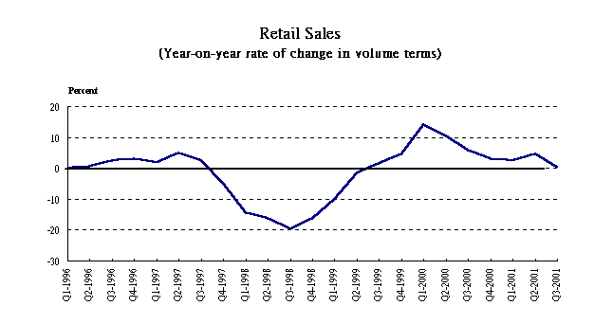

Pricing
We think that the pricing of the goods is not the most important thing. The most important thing is the service of our company and the convenience for the customers. Since a lot of parents need to go to work so they do not have enough time to choose or to buy the product to their child, so we will deliver the products to them if they ordered. So the pricing of our goods will not very expensive, we will have a reasonable price, about a little bit lower than the supermarket and some charge for the delivery service.
Delivery Charge:
Below HK$199-----------------HK$30
HK$200 – HK$399------------HK$10
Over HK$400------------------Free of charge

Promotion
Our promotion is very simple but very efficient, we will have about 10000 leaflets then put it in the babies’ clinic or some supermarket for the parents to take, and then they can have a reference. We also will have 1000 posters post in the shopping center, babies’ clinic or supermarket, so that parents of the babies will know our company and our service. We also will through the mass media to promote our services. Babies’ magazines are also the best way for us to promote our services. So, we will have some advertisements posted on the babies’ magazines. Finally, we also have advertisement on the bus through the “road show” and through radio. We are sure that the parents of the babies will know our services very soon through these advertisements.

Distribution
Our company will deliver all the goods to the customers. Our distribution covers the entire place in Hong Kong Island, Kowloon and New Territories. (Except the islands and extra charge $50 for delivering to Tung Chung and Discovery Bay.)

CEOs --- Yeung Hoi Lam: BABIES’s top manager who response for the overall performance and effectiveness of the firm
MIS & Logistics Manager --- Wu Wai Hung: responsible to manage BABIES’s homepage and other technical supporting & to manager of the warehouse flowing
Purchasing & Marketing Manager --- Lo Pui Ting: responsible to bargain the product price on the whole market and to decide which products we needs
Operation Manager --- Tsang Man Ting: responsible on administrative work to let the firm runs smoothly
Human Resources Manager --- Yuen Ka Yi: responsible to all the recruitment and the relationship between management team and staffs
Accountancy Manager --- Wong Lai Ting: responsible to company’s budget

CEOs

Management
Purchasing & Marketing Manager
MIS & Logistics Manager

Warehouse Staffs

Operation Manager
Human Resources Manager
Accountancy Manager

Recruitment will be published in the Labour Department
Positions: (1) Storekeeper – 2 Full-time
(2) Delivery Worker – 2 Full-time
(3) 2 Part-time – shift jobs of storekeeper and delivery worker

General Requirements
      - Need to shift job (A. 8:00am – 4:00pm B. 2:00pm – 10:00pm)
      - Holiday is being accessed

Requirements of such positions:
(1) Storekeepers: - Working inside warehouse
- Salary: $6,000/month

- Delivery Workers: - MUST HAVE DRIVING LICENCE OF VAN
- Need to outdoor work to delivery goods
- Salary: $7,000/month

- Part-time: - MUST HAVE DRIVING LICENCE OF VAN
- Need to work in pair of full-time workers
- Need to work of storekeeper and delivery when necessary
- Can work in one period a day
- Salary: $30/hour

When we set up this business, all of them take out about $1,200,000 to run it.

Set Up Cost | Units | Amount ($)
Set Up Cost | Warehouse Rental including car park ( 2000sq ) | 20,000
Set Up Cost | 2nd Hand Van | 80,000
Set Up Cost | Computer Components (7 computers, a 4 in 1 printer, fax machine and etc.) | 70,000
Set Up Cost | 2 EPS paying machine (Hired) | 6,000
Set Up Cost | Business Licenses (for 1 year) | 2,250
Set Up Cost | Promotion Cost | 100,000
Set Up Cost | Tools in warehouse (e.g.積車) | 20,000
Set Up Cost | Other useful materials | 30,000
Set Up Cost | Stocks of products | 350,000
Set Up Cost | Total | 678,250

Operation Cost for the first few months (monthly)
Items | Amount ($)
Rental | 10,000
Staff salary | 37,520
Van & other expenditure | 12,480
Promotion Cost | 50,000
Input Products | 170,000
Total | 280,000

In the first 6 months, our business will not good enough, since we are not well known. So that, our company is have no profit in the period.
After a year, we will decide whether continue or shut down our business according to our number of customers per month. Although we have not got any profit in the first year, we got some customers to use our services. We need to do more promotion to attract more people to know our business!

Operation Cost after half a year (monthly)
Items | Amount ($)
Rental | 10,000
Promotion Cost | 20,000
Staff salary | 37,520
Van & other expenditure | 20,000
Input Products | 100,000 – 200,000
Total | 187,520 – 287,520

After 2 to 3 years, our business may begin to get a little profit. At this moment, we will try to expand our business towards an e-commerce.

