What is VoD?
A Video-on-Demand (VoD) system provides the ultimate flexibility in video services by allowing users to select any video programs, at any time, and to perform any VCR-like user interactions.
To allow VoD, one approach is to have a dedicated video stream for each customer. This is expensive, especially when multiple identical video streams are sent to multiple customers accessing the same video. To be commercially viable, VoD service must be priced competitively with existing video rental services.
Batching may be used to reduce this cost. It allows multiple users accessing the same video to share the same video stream. The batching approach, however, complicates the provision of user interactions.

How Does VOD work?
Under VOD's system, movies are stored on a video server and delivered digitally to the home via telephone wire or other varieties of cable networks.
A set top box allows subscribers to access the movies they want and to control all playing functions - stop, pause, rewind, fast forward- using a remote control - just like on a VCR.
The picture is equivalent to DVD quality, and the number of movies which can be stored on a server is limited only by Hard Disk real estate.
Using on Vod?
VoD can be used for entertainment (ordering movies transmitted digitally), education (viewing training videos), and videoconferencing (enhancing presentations with video clips).
Obstruction on Vod?
VoD's biggest obstacle is the lack of a network infrastructure that can handle the large amounts of data required by video.

Licence On VoD
In October 1997, Hong Kong Telecom IMS starts to provide VoD service and makes Hong Kong the first site of launching a commercially available VoD service. Broadcasting, Culture and Sport Bureau (BCSB) announced today (Wednesday) that the Chief Executive in Council (CE in C) had formally granted a video-on-demand Programme Service Licence to Hong Kong Telecom VOD Limited (HKTVOD). The licence will take effect from 13 February 1998 for a period of 12 years.

The Conveyance Facilities for HKTC's VOD Trial
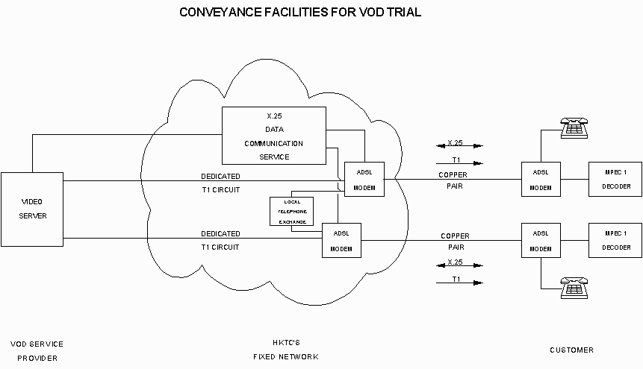
Conveyance Facilities for HKTC's VOD Trial
Each customer participating in the VOD trial will be provided with a downstream data output at T1 speed for television signals and a X.25 data communication link for control signals. For a customer not residing in a building to which an optical fibre cable has been laid, the connection between the customer's premises and the nearest local telephone exchange will be provided using a copper pair over which the ADSL transmission technique is used.
Between the local exchange and the video server site, the connections over HKTC's network are provided by dedicated T1 circuits for the downstream television signals and the X.25 packet-switched data communication service for the control signals. The T1 circuits are terminated at the video server.
The above configuration is shown in the Attachment to this Annex.
Offer of Conveyance Facilities for a Service Provider Carrying Out VOD Trials over HKTC's Network
For a service provider who wishes to carry out a VOD trial over the HKTC network, HKTC offers to provide a T1 circuit and a X.25 packet-switched data communication link between the customers' premises and the nearest local exchange.
HKTC will provide dedicated T1 circuits and X.25 data communication service between the local exchanges and the switch and video server site of the other service provider.
When considered desirable by the service provider carrying out the VOD trial, HKTC shall provide ADSL lines or other non-standard facilities and services between the customers' premises and the nearest local telephone exchange at the same price it charges itself.
Charges for Use of the HKTC Network
Standard tariffs will apply to T1 circuits and X.25 links for both HKTC's own use or other operators. For non-standard services, HKTC will charg e other service providers the s s its own VOD cost centre for the same services, based on the principle of cost recovery plus a reasonable margin of return.

