Video on Demand System
The Berkeley Distributed Video-on-Demand (VOD) system is the product of a research project that is designed to provide access to a large quantity of video information over computer networks. Clients across the Internet can submit requests to the VOD system to view audio, video and graphical streams. Playback is accomplished by streaming data from a media file server through the network to the client's computer.
We are currently working on web-based front-end tools for the VOD System. These will include tools for on demand web playback, and a graphical user interface to the database for remote video content authoring. These tools will allow any user to add media elements to the storage system and access them later.
Asset Management Database
A large part of this project is the development of an asset management database that can track a variety of different data types (e.g. audio, video, animations, images and hypertext) with possibly multiple representations and versions through the authoring and editing processes. This database must provide version control functionality and handling of various meta-data associated with different representations and must also link seamlessly to several large media services, such as streaming media servers and archive servers. BMRC researchers continue to work on the storage systems, databases and interfaces to deal with these problems.
Carousel Video Tool
The Carousel tool is an authoring tool designed to allow the end-user to author web page video galleries. The video gallery web page has key frames and other information about the video layed out in a two-dimensional table. Users can view the collection and play selected videos by clicking on the key frame. With Carousel a user can quickly create web pages to access and display existing video content. Users can access a variety of templates and settings using dialogs and other GUI elements to create their custom video gallery pages. The system eliminates the complexity involved in handling a variety of different video formats.
Ref by http://bmrc.berkeley.edu/index.html

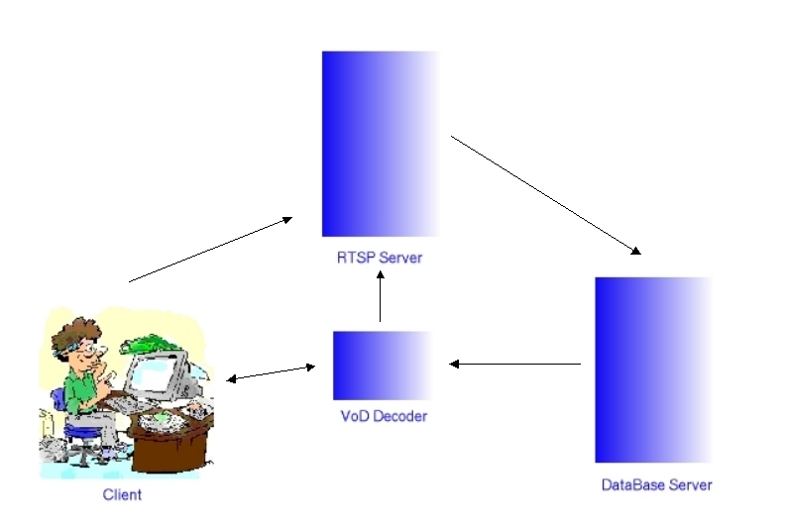How the VoD system will work when finished:
The user will navigate through our site, deciding on what to watch, e.g. yesterday's news report. A request is then sent to the RTSP server. The server then sends a SDP file ( Session Description Protocol ) back to the client stating protocol versions, media format++. If then the clients still want to watch the film in question, the RTSP server will fetch the media file from the database server. The DB server then establishes a connection to the client through the VoD decorder, sending RTP packages. What this decoder does, is to parse the RTP packets from the DB to HTTP, since this is the only language the end clients ( RealPlayer, MediaPlayer, AviPlay, QuickTime, MTV++ ) understands. After buffering for 2-3 seconds, the client will start playing the media file.
When the client wants to interact ( i.e. pause, fast forward, record, rewind ), the HTTP requests are sent to the VoD decorder that translates these reqests to RTSP requests and passes these on to the RTSP server, which sends commands to the DB.
This is only sketch of the system desing, and may be changed several time during the project process.

Ref by http://vod.sourceforge.net/pre_project_report.shtml

Overview
With Video On Demand (VOD), the user can start the video when he wants, make pauses, go forward and back in the video. It is of course the best in video streaming and the dream for every user.
VOD is a very big consumer of resources for the server and the network. VOD is unicast, not multicast : this means that the network and server resources needed are directly proportional to the number of clients.
The design of VideoLAN's VOD solution is very simple. The idea is to do HTTP streaming, i.e. stream an MPEG video encapsulated in HTTP. The regulation of the bitrate between the client and the server is done automatically by TCP. With HTTP version 1.1, there is the possibility to seek in a file downloaded, that's what we use to seek in the video.

On the server side
On the VOD server, you need a running Web server. For example, you can use a Linux server running Apache. Other operating systems and other Web servers should work too, but we have never tested.
Make your MPEG-1, MPEG-2 or MPEG-4 / DivX files available to the clients on the Web server.
For example, we have a Web server whose DNS name is localserver. On this server, we put an MPEG file video1.mpg which will be available to the clients at the URL http://localserver/video1.mpg.

On the client side
% vlc -vvv http://localserver/video1.mpg
VLC starts to read the stream nearly immediately and you can seek in the stream, make pauses, etc... as if the stream was a local file.
Ref by http://infobase.ibase.com.hk/linux/LDP/REF/VideoLAN-Quickstart/index.html

Video-On-Demand (VOD) has long been thought of as the ultimate consumer video application and is increasingly becoming a reality. A service that allows subscribers to watch what they want, when they want, some form of VOD is now available through approximately 40% of all US cable TV systems. Currently almost four million cable TV subscribers are regularly using the service to watch movies, packaged premium programming, and even "free" shows and events.
http://www.vodnews.tv brings the world of Video-On-Demand together at the internet's first VOD portal, offering industry professionals and consumers alike a place to view the latest breaking news, streaming stock market data and discuss VOD manufacturers, MSO's, hardware, software and programming.
Ref by http://www.prweb.com/releases/2003/9/prweb78434.htm

http://citeseer.nj.nec.com/hua03range.html
http://www.vodnews.tv/

