Section 1: Wide Area Network

The Wide Area Network (WAN) will connect all school and administrative offices with the District Office for the purpose of delivering data. It based on a two-layer hierarchical model. Three regional hubs will be established at the District Office/Data Center, Service Center and Shaw Butte Elementary School for the purpose of forming a fast WAN core network. TCP/IP and Novell IPX will be the only protocol to traverse the district WAN. Other protocol will be filter by the router. High-end, powerful routers will also be installed at each WAN core location. Access to the Internet or any other outside network connections will be provided through the District Office/Data Center through a Frame Relay WAN link.
Section 2: Local Area Network & Wiring Scheme

Local Area Network
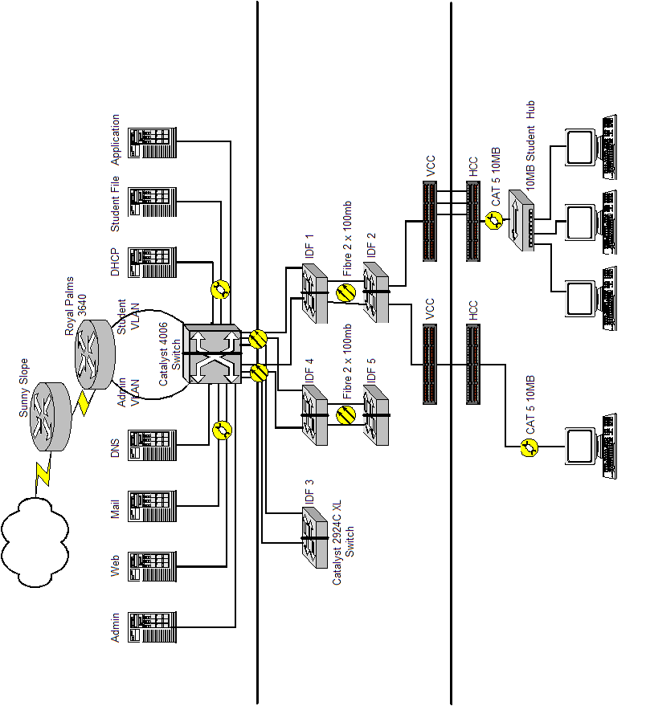
Logical Diagram

Here is the Logical Diagram; District Office will be the only Internet connection for entire network. You can see that there have a router connect to Internet and have another router connect to it, it is because to be a firewall to block some other protocol.

This is a double firewall technology the protocol will be Ethernet, and the network media will use 10BASE-T, 100BASE-T, and 100BASE-FX. Horizontal cabling will be CAT5 UTP and the Backbone will be the Fiber Optic cable. The Cabling infrastructure will comply with TIA/EIA-568-A and TIA/EIA-569 standards. Two LAN segment will be design, one is for student /curriculum usage and another is for administration usage.

Two LAN segment will be implemented in each school and the District Office. ACLs (Access Lists) on routers will ensure that traffic from the curriculum LANs will not be allowed on the admin LAN. ACLs will be controlled at the District Office. Both routers in the firewall technology will be running ACLs.

Each room connected to the network will support 24 student hosts off 4 CAT5 UTP runs. However one of these run is terminated at the teachers’ machine (another host on top of the 24 student hosts.). Cabling from rooms will be terminated at nearest MDF/IDF. CAT5 UTP will be tested end to end for 100mbps capacity.

To avoid tampering by students/teachers each room will give a lockable closet containing the POP and any electric components, such as hubs are required. Data services will be distributed throughout the room via decorative wire molding. Network 1 will be the student network; Network 2 will be for admin.

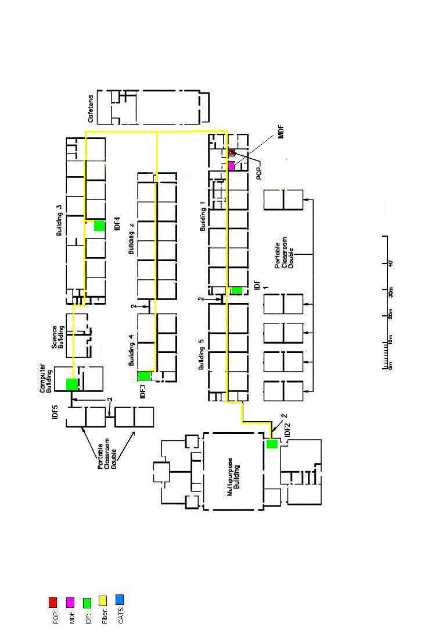
Wiring Scheme

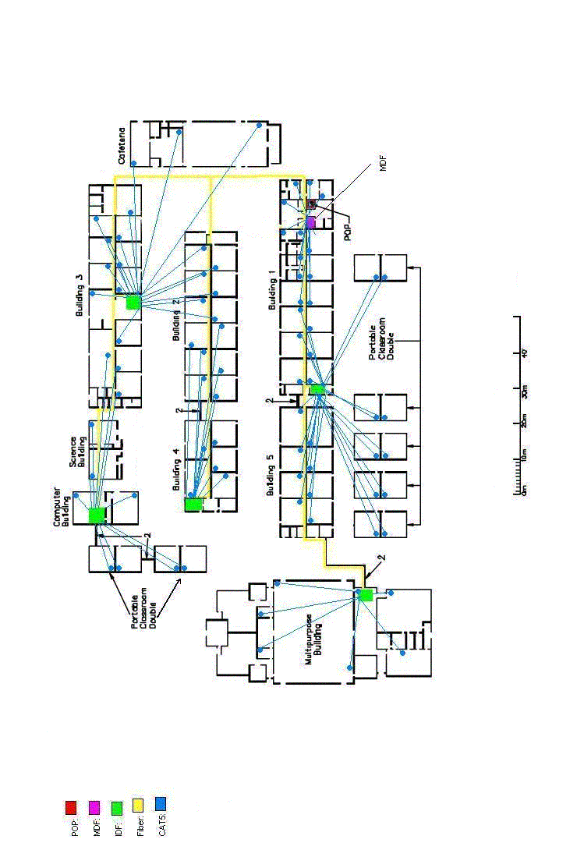

Section 3: District Supplied Servers and Functions

There are seven servers including one domain names sever, one email server, one administrative server, one library server, one DHCP server and two application servers in the college. They are all located at POP except the DHCP server. The Dynamic Host Configuration Protocol (DHCP) is a Internet protocol for automating the configuration of computers that use TCP/IP.DHCP can be used to automatically assign IP addresses, to deliver TCP/IP stack configuration parameters such as the subnet mask and default router, and to provide other configuration information such as the addresses for printer, time, and news servers, Therefore, the DHCP server should located near the classrooms that provide a better service for all students.

Domain Names Service and Email Service
Each Hub will contain a DNS server to support individual schools serviced via that location (Royal Palm is serviced by Shaw Butte). Royal Palm itself will have DNS and email services. The email services will contain all student and staff personnel. Royal Palm will have a local post office for all email, including on server storage. All regional servers will have the capacity to communicate within themselves to build redundancy in case master server is unavailable.

Administrative Server
Royal Palm will possess an Administrative Server, which will be using TCP/IP. It will house all details referring to students. Will only be available to teachers and staff.

Library Server
Royal Palm is implementing an automated library information and retrieval system, which will house an online library for curricular research purposes. Running TCP/IP the library server (local at Royal Palm) will be readily accessible by anyone.

Application Server
Also available at Royal Palm locally the application server will be a method of providing students and teachers with Word Processing, Database etc. These applications will be retrieved from the application server. Provides and easy method of upgrading software. Will be running TCP/IP.

Other Servers
No other servers are planned at Royal Palm at present, will be implemented as needs dictate and will be categorized.
Section 4: Addressing and Network Management

Class A private address 10.3.48.0/20 is assigned. We will create 7 subnets for the administrative network (staff room, office and teacher’s computer in each classroom) and the student network. There are two subnets for administrative network and five subnets for student network. There are 510 hosts per subnet.

- 10.3.48.0/23 - Administrative Network
- 10.3.50.0/23 - Administrative Network
- 10.3.52.0/23 - Student Network
- 10.3.54.0/23 - Student Network
- 10.3.56.0/23 - Student Network
- 10.3.58.0/23 - Student Network
- 10.3.60.0/23 - Student Network
Administrative Network

All IP addresses for the administrative network and servers will be configured statically:

10.3.48.1/23 | Router Interface E0 (Admin LAN)
10.3.48.2->10.3.49.254 | Switches
10.3.49.10 | Domain Name Server
10.3.49.11 | Email Server
10.3.49.12 | Web Server
10.3.49.13 | Administration File Server
10.3.49.14 | Administration Server
10.3.49.20->10.3.49.254 | Staff PC's Static Addresses
10.3.50.1/23 | Router Sub-Interface E0 (Admin LAN)
10.3.50.20->10.3.51.254 | Staff PC's Static Addresses

Student Network

There are 83 classrooms and each classroom support maximum 24 computers. Therefore, 1992(83X24) IP addresses are needed for students’ computer in classrooms and library.

10.3.52.1/23 | Router Interface E1 (Student LAN)
10.3.52.10 | Library Server
10.3.52.11 | Application Server
10.3.52.12 | Student File Server
10.3.52.13 | DHCP Server
10.3.54.1 | Router Sub-Interface E1 (Student LAN)
10.3.56.1 | Router Sub-Interface E1 (Student LAN)
10.3.58.1 | Router Sub-Interface E1 (Student LAN)
10.3.60.1 | Router Sub-Interface E1 (Student LAN)
10.3.52.20->10.3.53.254 | DHCP addresses for IDF 1
10.3.54.2->10.3.55.254 | DHCP addresses for IDF 2
10.3.56.2->10.3.57.254 | DHCP addresses for IDF 3
10.3.58.2->10.3.59.254 | DHCP addresses for IDF 4
10.3.60.2->10.3.61.254 | DHCP addresses for IDF 5

Section 5: Security

In the network, Access Control Lists (ACLs) is suggested to be implemented the security on the routers. Follow ACLs is used to deter traffic from the student/curriculum (interface e1) LAN to administrative LAN (interface e0).

Router commands to implement ACL's

Access Lists 101:
- Student VLAN has no access to admin server or admin file server
- Permit Web Server (port 80), DNS(port53) and SMTP(port 25) to be accessible from the student VLAN

-- E0 in –
router(config) # access-list 101 permit ip 10.3.48.0 0.0.3.255 any
router(config )# acces-list 101 deny ip any any
router(config )# interface e0
router(config-if) # ip access-grop 101 in

Access Lists 102:
- Any traffic leaving administration VLAN not from a valid address on that VLAN is denied

--E0 out –
router(config) # access-list 102 permit tcp any any eq 80
router(config) # access-list 102 permit tcp any any eq 25
router(config) # access-list 102 permit tcp any any eq 53
router(config) # access-list 102 permit udp any any eq 53
router(config) # access-list 102 deny ip 10.3.0.0 0.0.255.255
router(config) # access-list 102 permit ip any any
router(config) # interface e0
router(config-if) # ip access-group 102 out

Access Lists 103:
- Any traffic leaving student VLAN not from a valid address on that VLAN is denied

--E1 in—
router(config) # access-list 103 permit ip 10.3.52.0 0.0.3.255 any
router(config) # access-list 103 permit ip 10.3.56.0 0.0.3.255 any
router(config) # access-list 103 permit ip 10.3.60.0 0.0.3.2555 any
router(config) # interface e1
router(config-if) # ip access-group 103 in
Section 6: Internet Connectivity

District Office is only one single point of connection to all schools and organizations in the district network. In the network of Royal Plams, some services such as Domain Name Service (DNS), E-mail and World Wide Web Server should be exposed to the internet. For the internet connection, double firewalls are implemented in order to filter the packets from the internet. Apart from the firewalls, ACLs is utilized in routers for protection from connectivity initiated from the internet. Normally, all hosts can communicate with the internet freely excepting individual web hosting. However, students can host their sites in the central web servers in their own schools located at the public backbone.

By using ACLs, the tcp 53, 80 and 110 are available only for the dns services, individual hosting and e-mail services. All other ports are banned to be exposed to the internet for security reasons. Thus, all hosts in the internal district network cannot be totally exposed to the internet. For the intranet, admin server and admin file server can not be accessed by the student VLAN. These are the services that ACLs can provide in the Royal Plam’s LAN.

Nevertheless, the ACL’s increase the latency of traffic through the routers and increase the CPU utilization of the routers. The ACL’s latency effect will slow down the access to e-mail, it will slow down any internet or intranet browsing since requests to the DNS Server will have to traverse an ACL through the router, and the log on process will be slowed as each workstation requests an IP address from the DHCP server.

Section 7: User Counts

In the campus, there are 83 data media termination points and each of can support up to 24 computers (23 computers for students and 1 for administrative/teachers). However, the school will not set up all the equipment at once. It will expand the size of the network within 7-10years.

Therefore, the total number of computers/users in the entire network is equal to 332, which each classroom or office just has 4 computers in the maximum at this stage. And the distribution is as the following: --

Location | Student/Curriculum Runs | Administrative/Teacher Runs | Total Runs
Building 1 | 60 | 20 | 80
Building 2 | 36 | 12 | 48
Building 3 | 33 | 11 | 44
Building 4 | 15 | 5 | 20
Building 5 | 24 | 8 | 32
Science building, | 6 | 2 | 8
Computer building | 6 | 2 | 8
7 double portable classroom | 42 | 14 | 56
Multipurpose building | 18 | 6 | 24
Cafeteria | 9 | 3 | 12
 |  | Total | 332

~~~~ END ~~~

