ST. STEPHEN’S COLLEGE

FIRST TERM EXAMINATION (2004-2005)

Subject/Paper : Mathematics Paper 2 Exam Seat No.: __________

Form : Four

Time allowed : 60 minutes

Instructions to Students:

1. Total mark for this paper is 36.

2. This paper consists of 36 questions in 7 pages.

3. Answer ALL questions. All the answers should be marked on the Multiple Choice Answer Sheet provided.

4. Note that you may only mark ONE answer to each question. Two or more answers will score NO MARKS.

5. The figures in this paper are not necessarily drawn to scale.

6. Each question carries one mark. No marks will be deducted for wrong answers.

7. Only permitted calculators may be used.

1. Which of the following is an irrational number?
A. $1\text{.}\overset{˙}{3}2\overset{˙}{7}$ B. 3.1415926…
C. $−\frac{3}{7}$ D. $\sqrt{\text{36}}$

2. Solve $x(x+3)=1$.
A. $x=−2$ or $x=1$ B. $x=−3$ or $x=0$
C. $x=\frac{−3+\sqrt{\text{13}}}{2}$ or $x=\frac{−3−\sqrt{\text{13}}}{2}$ D. $x=\frac{−3+\sqrt{5}}{2}$ or $x=\frac{−3−\sqrt{5}}{2}$

3. Solve $\sqrt{x+3}=x+3$.
A. $x=0$ or $x=1$ B. $x=−3$ or $x=−2$
C. $x=2$ or $x=3$ D. $x=−1$ or $x=6$

4. Solve $(x+2)(x−5)=(a+2)(a−5)$ for x.
A. $x=a$ or $x=3−a$ B. $x=−a$ or $x=a−3$
C. $x=−2$ or $x=5$ D. $x=2$ or $x=−5$

5. Which of the following must be true about the graph of $y={\text{ax}}^{2}+\text{bx}+c$?
x
y
A. $a>0$
B. $c>0$
C. $Δ<0$
D. $y<0$ for all real values of x

6. If the graph of $y=(3a+4)x^{2}−2\text{ax}+1$ touches the x-axis, find the possible values of a.
A. $a=−1$ or $a=4$ B. $a=−4$ or $a=1$
C. $a=0$ or $a=2$ D. Cannot be determined

7. Solve $4(4^{2x})−5(4^{x})+1=0$.
A. $x=\frac{1}{4}$ or $x=1$ B. $x=−1$ or $x=−\frac{1}{4}$
C. $x=0$ or $x=1$ D. $x=−1$ or $x=0$

8. Find the range of values of m such that $3x^{2}−7x+m=0$ has real roots.
A. $m≥\frac{\text{49}}{\text{12}}$ B. $m>\frac{\text{49}}{\text{12}}$
C. $m<\frac{\text{49}}{\text{12}}$ D. $m≤\frac{\text{49}}{\text{12}}$

9. Determine the number of roots that the quadratic equation $x^{2}−2\text{kx}+k−1=0$ has.
A. 0 B. 1
C. 2 D. Cannot be determined

10. The product of three positive consecutive even integers is equal to 20 times their sum. Find the three numbers.
A. 2, 4, 6 B. 4, 6, 8
C. 6, 8, 10 D. 8, 10, 12

11. Given that f(x) = $x^{3}$−$3^{x}$. Find the value of f(0).
A. 1 B. 0
C. −1 D. −3

12. If f(3x) = 6, then f(x+3) =
A. 2 . B. 3 .
C. 5 . D. 6 .

13. The figure shows the graph of the function y = $\frac{A}{x}$. Which of the following is true?
O
x
y
y =
A. A is an integer.
B. A < 0
C. A = 0
D. A > 0

14. Given a quadratic function g(x) = 9 − x². Find the range of values of x such that g(x) > 0.
A. x > 3 B. x < −3
C. x > 3 or x < −3 D. −3 < x < 3

15. Find the axis of symmetry of the quadratic function $y=−x^{2}−2x+8$.
A. $x=−1$ B. $x=1$
C. $x=−2$ D. $x=2$

16. Find the vertex of the quadratic function $y=2x^{2}−4x−1$.
A. $\left(−1,−3\right)$ B. $\left(1,−3\right)$
C. $\left(−1,−1\right)$ D. $\left(1,−1\right)$

17. If the graph of the function $y=x^{2}$ undergoes two transformations to become $y=3x^{2}−2$. Describe the two transformations.
A. The graph has enlarged 3 times along the x-axis and then translated 2 units downward.
B. The graph has reduced 3 times along the x-axis and then translated 2 units upward.
C. The graph has enlarged 3 times along the y-axis and then translated 2 units downward.
D. The graph has reduced 3 times along the y-axis and then translated 2 units downward.

18. It is given that the function $y=2x^{2}−x−3$ is reflected in the x-axis and then translated 3 units to the right. What is the function represented by the final graph?
A. $y=−2x^{2}+\text{13}x−\text{18}$ B. $y=−2x^{2}−\text{11}x−\text{12}$
C. $y=2x^{2}−\text{11}x+\text{12}$ D. $y=2x^{2}+\text{13}x+\text{18}$

19. The graph of the function $y=f\left(x\right)$ undergoes two transformations to become the graph of the function $y=g\left(x\right)$. Which of the following may represent $g\left(x\right)$?
x
y
A. $f\left(−2x\right)$
B. $−f\left(2x\right)$
C. $2f\left(−x\right)$
D. $−2f\left(x\right)$

20. The graph of the function $f\left(x\right)=−2x^{3}$ is enlarged along the y-axis to become the graph of the function $y=g\left(x\right)$. Find the function $g\left(x\right)$.
x
y
O
A. $g\left(x\right)=6x^{3}$
B. $g\left(x\right)=−6x^{3}$
C. $g\left(x\right)=8x^{3}$
D. $g\left(x\right)=−8x^{3}$

21. Which of the following is / are true?
I. $\text{log}(x+y)=(\text{log}x)(\text{log}y)$
II. $\text{log}(x−y)=(\text{log}x)(\text{log}y)$
III. ${\text{10}}^{\text{log}x}=x$
A. I only B. III only
C. I and II only D. II and III only

22. If a > b > 0, which of the following is / are true?
I. $\text{log}\frac{a}{b}$ > 0
II. $\text{log}\frac{a}{b}$ > 1
- log a > log b > 0
A. I only B. III only
C. I and II only D. II and III only

23. If $\text{log}m=b−\text{log}n$, then m =
A. ${\text{10}}^{\frac{b}{n}}$ . B. $\frac{{\text{10}}^{b}}{n}$ .
C. ${\text{10}}^{b}−n$ . D. $b−{\text{10}}^{n}$ .

24. If $\text{log}x^{2}+\text{log}x=9$, then x =
A. 3 . B. 9 .
C. 10 . D. 1000 .

25. Given ${\text{10}}^{a−b}=c^{2}$. Find b.
A. $a−\frac{c^{2}}{\text{10}}$ B. $a−2\text{log}c$
C. $a−\frac{\text{log}c}{5}$ D. ${\text{10}}^{a}−c^{2}$

26. Given ${\text{10}}^{k}=2$. Find $\text{log}\frac{\text{32}}{5}$.
A. 4k – 1 B. 5k – 1
C. 6k – 1 D. $\frac{3k}{5}$

27. Which of the following shows the graph of $y=\text{log}(x−1)+2$?
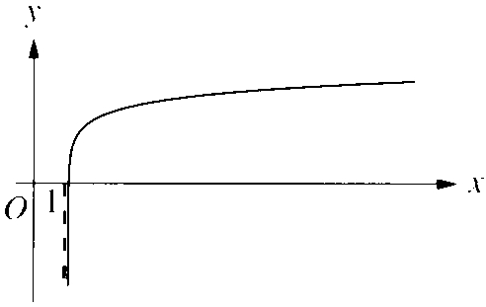
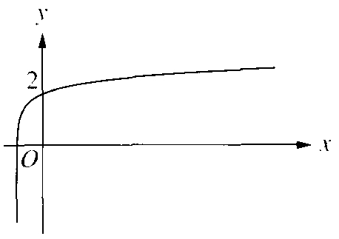
A. B.

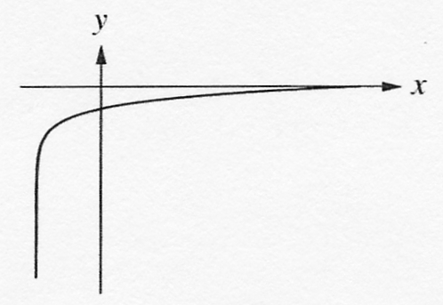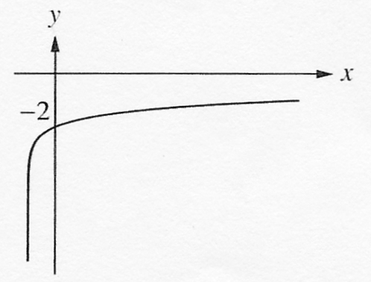C. D.

- The relationship between the magnitude (M) of an earthquake and the maximum amplitude
of the seismic wave measured (A) is given by$M=\text{log}A+K$, where K is a constant. One
day after an earthquake of magnitude 7.9 in Richter scale occurred in Peru, a less destructive
earthquake occurred and the maximum amplitude of the seismic wave produced was
one-third that of the previous one. What is the magnitude, in Richter scale, of the second
earthquake correct to 1 decimal place?
A. 2.6 B. 5.8
C. 7.4 D. 9.3

29. In the figure, O is the centre of the circle, OM is perpendicular to the chord AB. N is the mid-point of the chord CD. Which of the following must be true?
I. $\text{AM}=\text{MB}$
II. $\text{ON}⊥\text{CD}$
III. $\text{OM}=\text{ON}$
A. I and II only
B. I and III only
C. II and III only
- I , II and III

30. In the figure, O is the centre of the circle, $\text{OM}⊥\text{AB}$, MB = BC. If AO = 5 and AB = 8, find OC.
A. 8
B. 10
C. $\sqrt{\text{73}}$
D. 2$\sqrt{\text{73}}$

31. In the figure, O is the centre of the circle. Find a + b.
A. ${\text{180}}^{o}−\frac{x}{2}$
B. ${\text{180}}^{o}−2x$
C. $\frac{x}{2}$
D. $2x$

32. In the figure, ABCD is inscribed in a circle. a + b + c + d =
A
B
C
D
a
b
c
d

A. 90°.
B. 180°.
C. 210°.
D. 255°.

33. In the figure, $∠\text{ABC}=$
A. ${\text{86}}^{o}$.
B. ${\text{90}}^{o}$.
C. ${\text{94}}^{o}$.
D. ${\text{98}}^{o}$.

34. In the figure, O is the centre of the circle and $∠\text{AOE}={\text{80}}^{o}$. Find $∠\text{ABC}\text{+∠}\text{CDE}$.
A. ${\text{180}}^{o}$
B. ${\text{200}}^{o}$
C. ${\text{215}}^{o}$
D. ${\text{220}}^{o}$

35. In the figure, AC is a diameter of the circle. If $∠\text{CAB}={\text{40}}^{o}$ and AB : AD = 2 : 3, find $∠\text{CAD}$.
A. ${\text{30}}^{o}$
B. ${\text{25}}^{o}$
C. ${\text{20}}^{o}$
D. ${\text{15}}^{o}$

36. In the figure, AE : ABC = 6 : 7, find x.
A. ${\text{124}}^{o}$
B. ${\text{119}}^{o}$
C. ${\text{114}}^{o}$
D. ${\text{109}}^{o}$

***** END OF PAPER *****

Answers:
1. | B | 2. | C | 3. | B | 4. | A | 5. | B
6. | A | 7. | D | 8. | D | 9. | C | 10. | C
11. | C | 12. | D | 13. | D | 14. | D | 15. | A
16. | B | 17. | C | 18. | A | 19. | A | 20. | B
21. | B | 22. | A | 23. | B | 24. | D | 25. | B
26. | C | 27. | A | 28. | C | 29. | A | 30. | C
31. | C | 32. | B | 33. | B | 34. | D | 35. | D
36. | A

