- Aquatic animals can be use as medicine

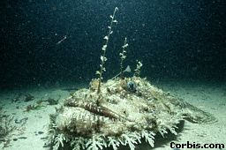

4. Other power resources
  - Nuclear fuel can be found in the ocean.
  - Tidal energy for electric generation.
  - Heat energy for electric generation.


Ocean


What are problems in the ocean?
Nowadays, ocean resources are using rapidly. This will cause many problems.

- Ecological Problem
  - Catch too much aquatic life like fish, crab, whale will make these animals become endangered of extinct.
  - The food chain will destroy.


- Energy Problem
  - The oil will use up if over-drilling happens.

- Damage to ocean food resources
  - In some areas, seawater contains a lots of toxic substances like mercury, lead, chemical fertilizers, petroleum and so on. These seriously damage the coral and fish resources in the ocean.

- Fish Poisoning
  - Toxic substances in the seawater may accumulate in fishes. When people eat these fishes, they may be poisoned or even killed.

