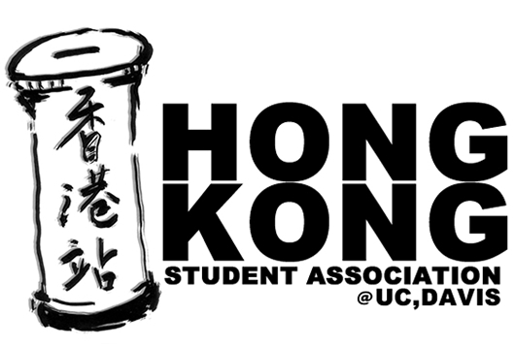
2007 Hong Kong Student Association
Intern Application

* Application deadline is March 9, 2007 11:59pm (through email)
* Interview will begin during 1st week of Spring Quarter (4/2 – 4/6/07)
Specific date, time, and location will be announced through email.

Name: _____________________________
Contact Number:_____________________
Email: _____________________________
Year In UCD: ______________________
Major: ____________________________
Intended Position in HKSA: _______________________
Reason for Applying:
____________________________________________________
____________________________________________________
Goals If you become a HKSA Officer :
____________________________________________________
____________________________________________________
How did you find our about HKSA Intern? (Circle One)
Email / Facebook / Current Officer, if so who: _____________________
Have you participated in any events of HKSA? If so, which event(s) did you attend?
_______________________________________________________________________
_______________________________________________________________________
Any comments or suggestions for the events mentioned above?
_______________________________________________________________________
Past experience of running a student association, club, organization, etc. Please provide all information to help us understand more about your interest and ability.
Year | Name of Associations/clubs | Position/ Types of work
Knowledge of Computer (Photoshop, PowerPoint, FrontPage, etc.):
________________________________________________________________________
Anything else you want us to know about you (Optional):
________________________________________________________________________________________________________________________________________________________________

