
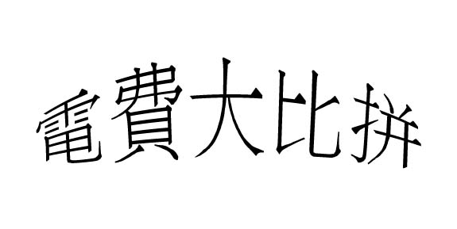
U-light高頻電子鎮流器 VS 傳統電感式鎮流器
慳足
30%
數量 | 1支 |  | 20支 |  | 50支 |  | 100支 |  | 200支 |  | 500支 |  | 1000支
种类  时间 | U-light | 電感 | U-light | 電感 | U-light | 電感 | U-light | 電感 | U-light | 電感 | U-light | 電感 | U-light | 電感
1hr. | $0.02 | $0.03 | $0.44 | $0.63 | $1.1 | $1.573 | $2.2 | $3.146 | $4.41 | $6.3 | $11.02 | $15.73 | $22.05 | $31.46
8hr | $0.17 | $0.25 | $3.52 | $5.04 | $8.82 | $12.6 | $17.64 | $25.16 | $35.28 | $50.4 | $88.2 | $126 | $176.4 | $251.6
12hr | $0.26 | $0.37 | $5.29 | $7.56 | $13.23 | $18.9 | $26.46 | $37.75 | $52.92 | $75.6 | $132.3 | $189 | $264.6 | $377.52
16hr | $0.35 | $0.5 | $7.05 | $10.08 | $17.64 | $25.2 | $35.28 | $50.33 | $70.56 | $100.8 | $176.4 | $252 | $352.8 | $503.36
以下資料以每天8小時計算
數量 | 1支 |  | 20支 |  | 50支 |  | 100支 |  | 200支 |  | 500支 |  | 1000支
1個月 | $5.29 | $7.56 | $105.84 | $152.2 | $264.6 | $378 | $529.2 | $756 | $1058.4 | $1512 | $2646 | $3780 | $5292 | $7560
3個月 | $15.87 | $22.68 | $317.52 | $453.6 | $793.8 | $1134 | $1587.6 | $2268 | $3175.2 | $4536 | $7938 | $11340 | $15876 | $22680
半年 | $31.75 | $45.36 | $635.04 | $907.2 | $1587.6 | $2268 | $3175.2 | $4536 | $6350.4 | $9072 | $15876 | $22680 | $31752 | $45360
一年 | $63.5 | $90.72 | $1270.08 | $1814.4 | $3175.2 | $4536 | $6350.4 | $9072 | $12700.8 | $18144 | $31752 | $45360 | $63504 | $90720
兩年 | $127 | $181.44 | $2540.16 | $3628.8 | $6350.4 | $9072 | $12700.8 | $18144 | $25401.6 | $36288 | $63504 | $90720 | $127008 | $181440
*.上述資料由本公司提供,如有任何問題歡迎向本公司香港辦事處查詢. 香港新界荃灣柴灣角街38-40號銓通工業大廈23樓C座 TEL: (00852) 2414 0944

