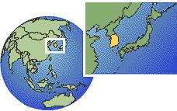
6/F, 299 Canton Road, Kowloon, Hong Kong
Tel : 852-2333 8888 Fax: 852-2333 8080

