CONCEPT DEVELOPMENT

Identify key product technical specification metrics

- We have set target specifications for our product, and it is based on customers needs, and we set a question paper on the web site, to collect some customer’s want which is about what they want us to do for our product, such as shape, color, function…

Eg: The telephone holder:

Metric \ Need | Total mass | Time to assemble to frame
Is light weight | *
Is easy to install |  | *

Generate multiple product concepts for review and analysis

- After the review and analysis, we know three main final specification, lower cost, lovely case, user friendly, the size of the product, is it suit for the customer need, and the colour is suit for all the customer, and it is easy to install or assemble, the cost of battery is expensive or not, how long to change the battery, is it hard to replace the new battery, the appearance is charming for popular.

Link customer requirements to technical specification metrics and values for the metrics

# | Need | Imp
1 | Is light weight | *****
2 | Is easy to install or assemble | **
3 | Is suit for desktop user | *
4 | Is suit for driver | *****
5 | Observe the signal easy | ***
6 | Hold the phone steady at the base | ****
Customer Needs

Establish Metrics and Units
Metric# | Need#s | Metric | Imp | Units
1 | 1 | Total mass | ***** | g
2 | 2 | Time to assemble all the parts | ** | Sec.
3 | 3,4 | Settle down the products | ***** | ------
4 | 6 | Distance between base and holder | **** | mm
5 | 5 | Light-emitting-diode frequency | *** | Times/sec.

Assign Marginal and Ideal Values
Metric# | Need#s | Metric | Imp | Units | M.V. | I.V.
1 | 1 | Total mass | ***** | G | 80 | 77.5
2 | 2 | Time to assemble all the parts | ** | Sec. | 4 | 10
3 | 3,4 | Settle down the products | ***** | ------ | --- | ---
4 | 6 | Distance between base and holder | **** | mm | 35 | 38.5
5 | 5 | Light-emitting-diode frequency | *** | Times/sec. | 2 | 5

4. Collect benchmarking information on competitive products
a. Compare competitive products with your product concepts on features, performance, and technical specifications

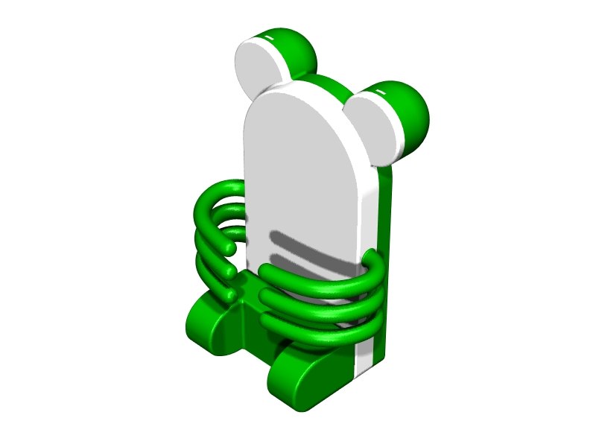

Our Product
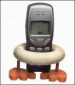
Pro. 2
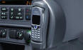
Pro. 3

My product is special for the shape, it is like a mouse, and we also design it to seems a mouse, and the arms is good for you to hold the mobile phone, and it also make you to pick up the phone easily.
The Pro.2 also have special circle round shape, but it is hard to pick out the mobile phone.
The Pro.3 can hold the mobile phone on the car, but it is fixed, less of portable.
For performance,
We have a signal, when the mobile phone have a vibration, the LED will light at the same time.
Pro.2 and Pro.3 have not alert when the mobile phone receive a signal.

b. Identify advantages, disadvantages, and opportunities for your product concepts

- Though the compare, we not only have an attractive appearance, we also have a special technology – magnetic field, the LED will light when the mobile phone receive the signal.

5. Develop a decision process for selecting a single product concept
- Integrate technical and market perspectives

Customer Needs
# | Need | Imp
1 | Is light weight | *****
2 | Is easy to install or assemble | **
3 | Is suit for desktop user | *
4 | Is suit for driver | *****
5 | Observe the signal easy | ***
6 | Hold the phone steady at the base | ****

- Though this table we know the mass of the product and the signal also is the important features, so we should make more concern about this two things.

Define selection criteria and evaluate all product concepts on how well they satisfy the criteria
- Though this two important features, we are also make more concern about the size, and the functional setting, so we should the components is suit for all the inside parts, such as circuit board, screw, and remain some space to make it together. When I try to design this product, I record the entire dimension for the inside parts, and make at the fixed place, and follow its dimension to design the outer shell part.

Product Specification

Items | Description
Product name: | Mobile Holder (Mouse style)
Style no.: | IVE001
Overall dimension: | 79mm (L) x 57mm (W) x 112.5mm (H)
Material: | PVC, Metal
Country of origin: | Made in Hong Kong
Battery power: | Silver cell (1.5V x 2)
Color: | Glass, Red, Yellow, Light Blue

