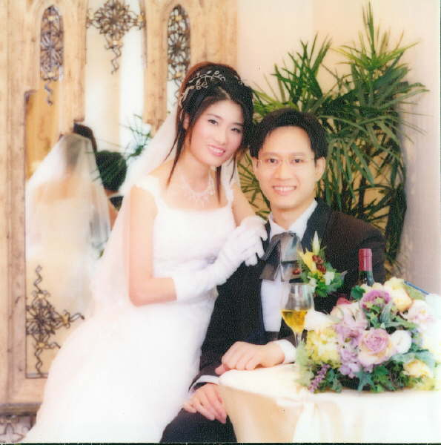
HELEN & ANDY WEDDING

1/你同強哥掂識?幾時開始拍拖?

As all know that, Andy & I know each other in Bayview.
We started our romance three years ago.

2/拍拖難忘事 ?

Actually, there are many touching & unforgettable scenes in the past three years, but if I have to give ONE only, i will say the following (quite touching for me).........

One rainy day, Andy & I went to 大尾篤 When we reach there, rain stopped. Andy said he had something to let me see and that sth was in another end of the 水霸. So, we just walked along. In the way, there were some children running around, some couples sat on the edge of the 水霸, some people was fishing. Walked and walked, I saw a very big rainbow across the水霸and the mountain (is it a mountain or hill...I don't know exactly). I was very happy and excited because it was the first time I saw rainbow.

After walking for a long time, we finally reached the end side. But it was as nothing special there, I searched what should be the "gift" that Andy was going to give me, but still no special. Then Andy asked me to turn around, to see how long the way we had walked together, to focus again the passer-by, and to recall the rainbow's beauty. Lastly, Andy said, ' We had walked a long way together, and should walk more in the future. We can experience together what a life is. Hope that I can have chance to take care of you for the rest of my life.'

....... i felt very touching at that moment ...........

3/強哥如何求婚?

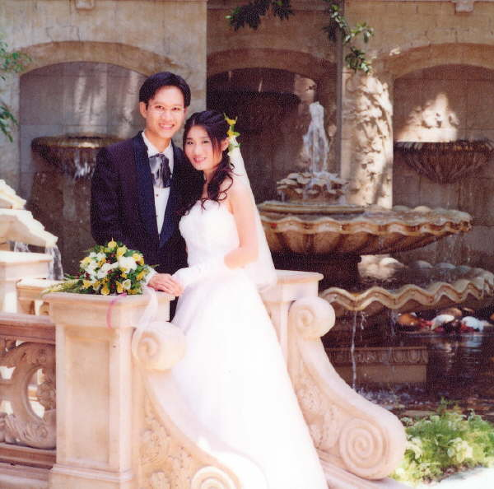
Location is a beach, time is last year May………………………………………..

4/你同強哥的大計?生多少個小朋友?

or..... not yet discussed with him detaily for this issue wor.... but with mutual consent that we would give a baby in few years' time, hopefully within three years...(this is a very rough plan..haha... u remind me to discuss with him this issue)

5/你估香島下一對新人係 Charriol ? Joe? Rachel?

Should pick up from your list? then, i elect Rachel & Allen la~
otherwise, as all know that, it should be Catherine & Charles lor (ex-bayviewers
亞JOE 你是Bayview九代單傳的男會長
我地歷屆會長一定支持你 ~~~~~~
Photo
(Waiting for Allen )

