1 Introducing Science

Part 1 Sectional Exercises

Link Up
(p.1) A A measuring cylinder
B filter funnel
C conical flask
D dropper
E glass rod
F reagent bottle
G gas tap
H thermometer
I beaker
J wire gauze
K tripod
L Bunsen burner
M heat-proof mat
N test tube
O test tube rack
P tongs
Q test tube holder
R sink

(p.2) B | 1.  2.  3.  4.  5.  6.  7.  8. | Name of equipment | Function
(p.2) B | 1.  2.  3.  4.  5.  6.  7.  8. | filter funnel | to filter liquids
(p.2) B | 1.  2.  3.  4.  5.  6.  7.  8. | Bunsen burner | to heat things
(p.2) B | 1.  2.  3.  4.  5.  6.  7.  8. | spatula | to transfer a small amount of powder
(p.2) B | 1.  2.  3.  4.  5.  6.  7.  8. | reagent bottle | to store solutions
(p.2) B | 1.  2.  3.  4.  5.  6.  7.  8. | test tube | to hold a small amount of liquids
(p.2) B | 1.  2.  3.  4.  5.  6.  7.  8. | safety glasses | to protect the eyes
(p.2) B | 1.  2.  3.  4.  5.  6.  7.  8. | glass rod | to stir a solution in a beaker
(p.2) B | 1.  2.  3.  4.  5.  6.  7.  8. | tongs | to pick up and hold hot solids

(p.2) C 1. C
2. D
3. A
4. E
5. F
6. B

(p.3) D 1. Always follow the instructions given by your teacher.
2. Clean up all apparatus and the bench after you have completed your experiments.
3. Tie long hair back when using a Bunsen burner.
4. Do not point test tubes towards your eyes and your fellow students when heating.
5. Fan the odour to your nose with your hands when you smell substances.

1.2 A 1. C
(p.3) 2. B
3. A
4. F
5. E
6. D

(p.4) B He/She uses microphone, computer, projector or ETV to teach science.

1.3 1a. observing
(p.4) b. measuring
c. recording
d. discussing

2a. It was 19:01.
b. There were 5 people in the picture. Two of them were male, three were female.
c. There is no Feb 31 in the calendar.
The bank would not stay open after 5 pm.
Staff in the bank do not wear hats.
Smoking is not allowed in the bank.
There was a boy holding a stethoscope.
Coffee or tea should not appear in the sign.

1.4 A 1. must not be
(p.6) 2. heating or mixing substances
3. spatula
4. reagent bottle

(p.6) B a. instructions
b. test tube
c. Report
d. chemicals
e. water
f. teacher
g. taste
h. bump
i. fire blanket

(p.7) C • He should wear safety glasses.
• He should use a test tube holder for heating.
• He should not point the test tube towards himself.
• The Bunsen burner should be put on a heat-proof mat.

  - A 1. chimney
(p.7) 2. collar
3. air hole
4. base
5. gas tap
6. rubber tubing
7. heat-proof mat

(p.8) B 1. (e)
2. (b)
3. (d)
4. (c)
5. (a)

(p.8) C a. luminous
b. irregular
c. yellow
d. Blue
e. yellow
f. strike back
g. green
h. blue
- yellow

1.6 1. i. (c)
(p.9) ii. (e)
iii. (a)
iv. (d)
v. (b)

2. The dropper should be washed in a beaker of water before putting into solution B.

3. (i). The test tube should be shaken from side to side.

1.7 A
(p.10)  1.  2.  3.  4. | Instrument | Name of the  instrument |  |  | What does it  measure? |  | The unit(s) of the  measurement
(p.10)  1.  2.  3.  4. | 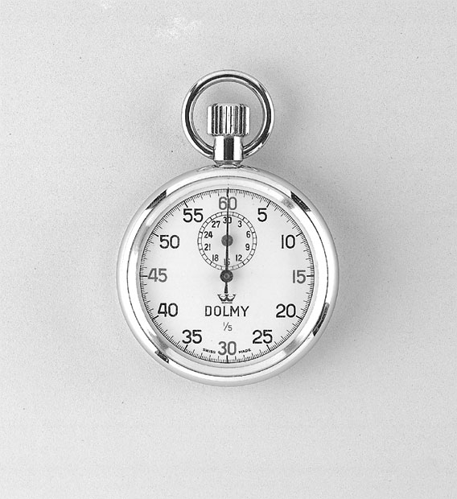 | stop-watch |  |  | time |  | seconds  minutes  hours
(p.10)  1.  2.  3.  4. | 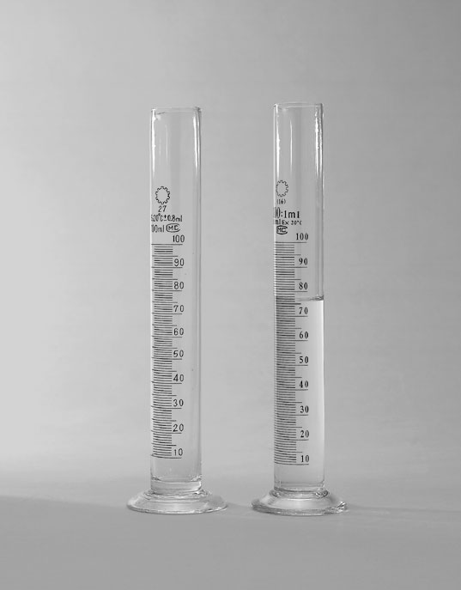 | measuring cylinder |  |  | volume |  | cubic centimetre
(p.10)  1.  2.  3.  4. | 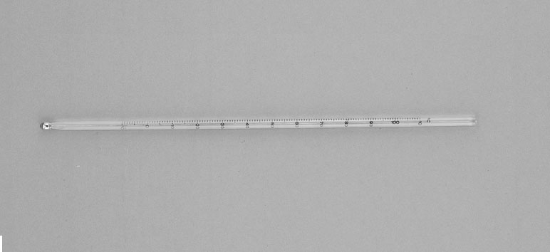 | thermometer |  |  | temperature |  | degree Celsius
(p.10)  1.  2.  3.  4. | 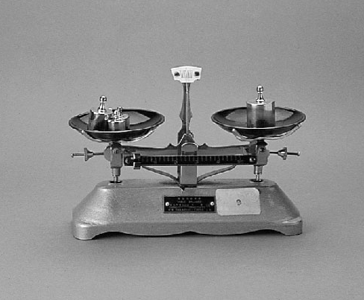 | balance |  |  | weight |  | gram  kilogram

(p.10) B a. temperature
b. mercury
c. coloured alcohol
d. expands
e. volume
(p.11) C Column X Column Y
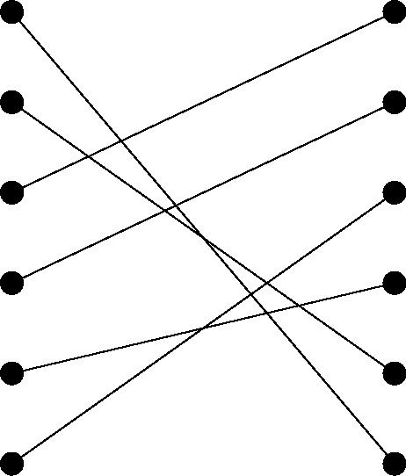
1. human body 20°C
2. boiling water –18°C
3. tap water 4°C
4. a freezer 2°C
5. ice water 100°C
6. refrigerator 37°C
(p.11) D a. 18.5
- 14
- 70

1.8 1. √
(p.11) 2. ×
3. ×
4. ×
5. √

1.9  (p.12)  1a.  b.  c.  d. | Variables | Which is/are controlled  variable(s)? | Which is/are independent  variable(s)?
1.9  (p.12)  1a.  b.  c.  d. | Amount of each  substance | √
1.9  (p.12)  1a.  b.  c.  d. | Amount of water | √
1.9  (p.12)  1a.  b.  c.  d. | Temperature of water | √
1.9  (p.12)  1a.  b.  c.  d. | Types of substances |  | √

2. Both the table salt and sugar should be in powder form.

