3 Cells and Human Reproduction

Part 1 Sectional Exercises

3.1 A 1. eyepiece
(p.51) 2. objective
3. clip
4. mirror
5. coarse adjustment knob
6. fine adjustment knob
7. arm
8. stage
9. base

(p.51) B Across 2 focusing
4 arm
6 microscope
8 clip
9 objective
11 coverslip

Down 1 eyepiece
3 stage
5 mirror
7 slide
10 base

(p.52) C 1. keep your unused eye open
2. living things
3. 5 X
4. 50
5. moves to the left
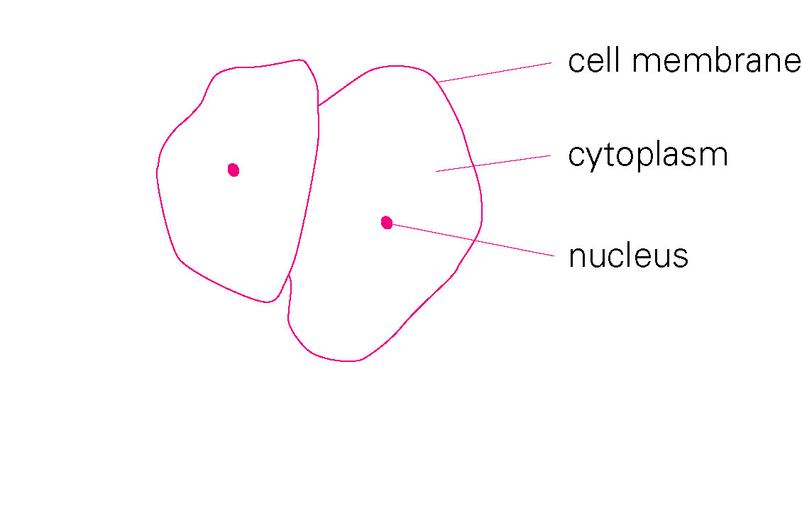
3.2 A 1.
(p.52)

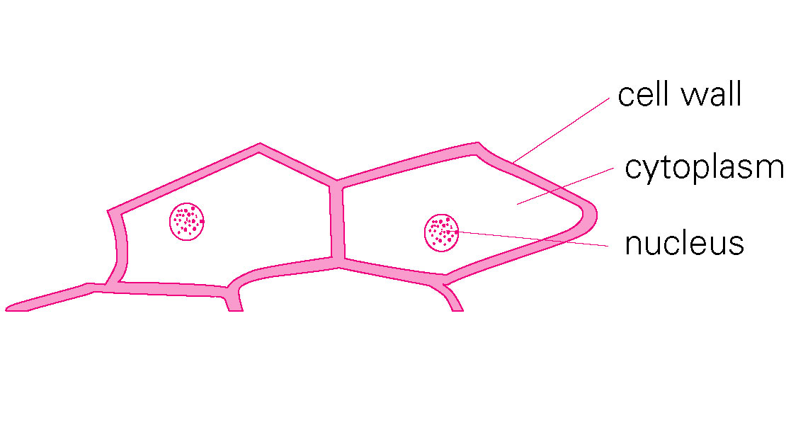
2.
(p.53) B 1. and a cell membrane
2. nucleus
3. nucleus
4. increase in number
5. 8 new cells

(p.54) C 1. It gives protection, support and shape to a plant cell.
2. It controls the movement of materials into and out of the cell.
3. It is the 'control centre' of the cell.
4. It is where many chemical reactions take place.
5. They carry out photosynthesis to make food.

3.3 a. offspring
(p.54) b. Amoeba
c. asexual
d. male sex cells
e. female sex cells
f. sexual
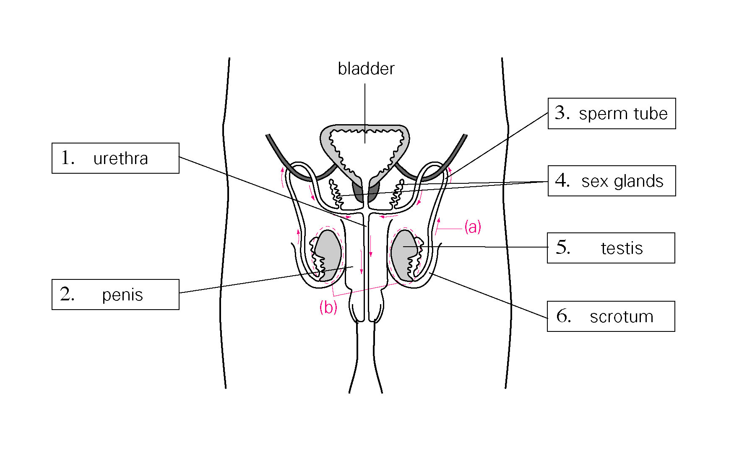
3.4 A
(p.55)

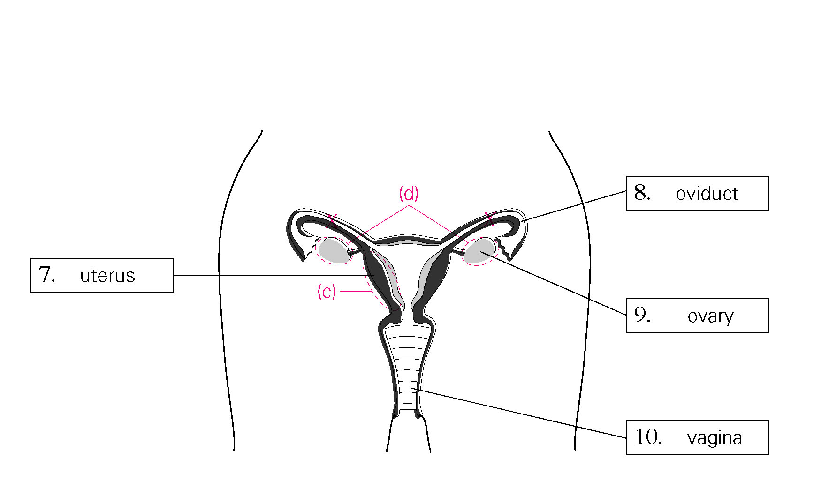
(p.56) B Male
a. sperms
b. testes
c. scrotum
d. sperm tubes
e. urethra
f. penis
g. sex glands
h. semen

Female
a. eggs
b. ovaries
c. oviduct
d. ovulation

(p.56) C 1. C
2. B
3. D
4. E
5. A

3.5 A 1. millions of sperms
(p.57) 2. head
3. the two eggs may be fertilised
4. uterus
5. may not look like each other

(p.57) B a. oviduct
b. fertilisation
c. embryo
d. implantation
e. pregnant
f. placenta
g. foetus
h. umbilical cord
(p.58) C 1. D
2. E
3. A
4. B
5. C

3.6 A a. puberty
(p.58) b. earlier
c. sex hormones
d. secondary sexual characteristics

(p.59) B 1. by the time when a baby is born
2. puberty
3. sex organs / testes or ovaries
4. both boys and girls

3.7 A 1. thicken
(p.59) 2. passes out through the vagina
3. 14 days
4. 5 days
5. stops

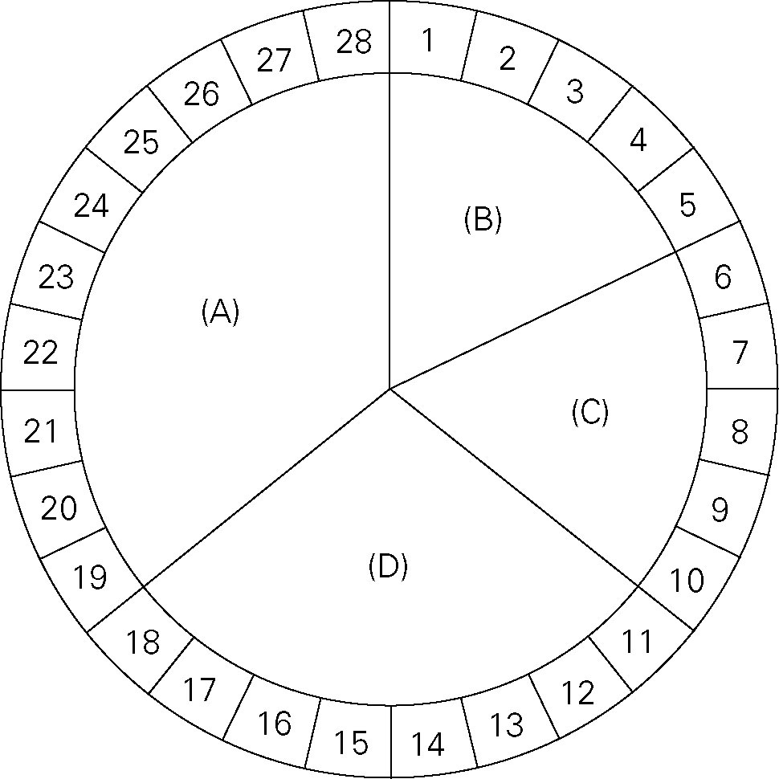
(p.60) B 1.

2. Menstruation
3. Shade the 14th day
4. 1. The uterine lining remains thick when pregnancy occurs.
2. It does not break down, so menstruation stops.

3.8 1. ×
(p.61) 2. √
3. ×
4. √
5. √
6. √
3.9 A 1. C
(p.61) 2. E
3. D
4. A
5. F
6. B

(p.62) B 1. √
2. ×
3. √
4. ×
5. √
6. √
7. √
8. ×
9. ×
10. ×

