7 Living Things and Air

Part 1 Sectional Exercises

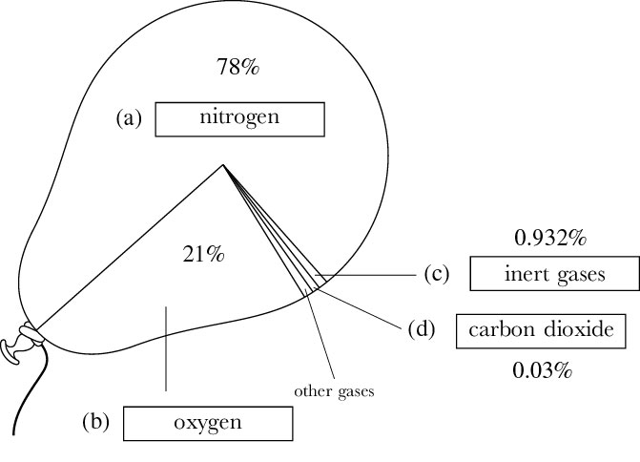
7.1 A
(p.1)

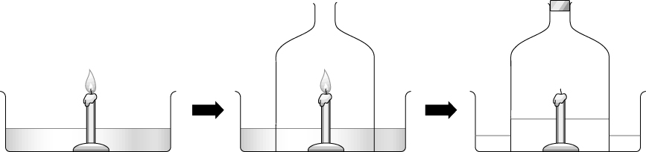
(p.1) B 1a.

b. This experiment shows that air contains about 20% of oxygen.
c. If the candle used is too short, the rising water may extinguish the candle.

2a. It is water.
b. It turns dry cobalt chloride paper from blue to pink.
c. It comes from the air.
d. Water vapour condenses on cold surface to form water.

3a. It changes from red to yellow.
b. The results show that breathed air contains carbon dioxide.

(p.3) C Gases Test methods
1. oxygen • • It turns lime water milky.
2. carbon dioxide • • There is no simple test for this gas.
3. water vapour • • It relights a glowing splint.
4. nitrogen • • It turns cobalt chloride paper from blue to pink.
(p.4) D |  | Breathed air | Unbreathed air
1.  2.  3.  4. | Oxygen | less | more
1.  2.  3.  4. | Carbon dioxide | more | less
1.  2.  3.  4. | Water vapour | more | variable
1.  2.  3.  4. | Temperature | higher | lower

7.2 A 1a. It turns from blue to pink.
(p.4) b. It turns milky.
c. The results show that water and carbon dioxide are formed by a burning candle.
2. | Burning fuel | How the fire is put out | Which part(s) of the fire  triangle is/are taken away
2. | Wood | water | heat
2. | Wood | water | oxygen
2. | Wax | carbon dioxide, foam, dry  powders, fire blankets | oxygen
2. | Oil | carbon dioxide, foam, dry  powders, fire blankets | oxygen

(p.5) B 1. √
2. √
3. ×
4. ×

7.3 1. Any four of the following: playing ball games, doing homework, studying, doing exercise,
(p.6) doing housework . . .

2. We still require energy while we are sleeping. The energy is used for keeping warmth, keeping the heart beating and continuing breathing.
3. | Food | Weight (g) | Energy (kJ) | Energy (kJ/100 g)
3. | Butter | 250 | 7 800 | 3 120
3. | Cabbage | 600 | 204 | 34
3. | Apple pie | 500 | 5 250 | 1 050
3. | Chocolate | 400 | 9 600 | 2 400
3. | Milk | 1 000 | 2 700 | 270

b. butter
- My body would store it as fat. The result is that my body weight would increase.

7.4 A a. photosynthesis
(p.7) b. carbon dioxide
c. water
d. sunlight
e. chlorophyll
f. light
g. sunlight
h. chemical
- starch

(p.7) B 1. √
2. √
3. ×
4. √
5. ×
6. ×

(p.8) C a. light energy
b. water
c. chlorophyll
d. carbon dioxide
e. starch
f. oxygen

(p.8) D 1. (3), (2), (1), (4)
2. step (2) - to remove chlorophyll from the leaf
step (3) - to kill the leaf cells and make the leaf soft
3. The leaf becomes blue-black in colour when iodine solution is added onto it.
4. The leaf has carried out photosynthesis.

7.5 A 1. ×
(p.9) 2. ×
3. √
4. ×
5. ×
6. √

(p.10) B 1a. It absorbs carbon dioxide.
b. The coloured liquid index moves towards the grasshopper.
c. When the worms breathe, oxygen is taken in and carbon dioxide is given out. The soda lime absorbs carbon dioxide.
d. The control has the same set-up without the worms.

2a. D – intercostal muscles E – air sac F – rib H – diaphragm
b. When breathing in, D moves upwards and H becomes flattened. This increases the volume of the chest and lowers the pressure inside it, so air passes into the lungs.
c. glass tube – B Y piece – C balloon – G rubber sheet – H

3a. increases
b. lowers
c. enters
d. decreases
e. raises
f. forced out

7.6 A 1. X – photosynthesis Y – respiration
(p.12) 2. Gas A is carbon dioxide.
The amount of carbon dioxide in the atmosphere increases because of deforestation and burning of too much fossil fuel.

(p.12) B a. sunlight
b. photosynthesis
c. producers
d. consumers
e. food chain
f. green plant

7.7 A 1.  (p.13) | Harmful substance  in cigarette smoke | Effect on our health
7.7 A 1.  (p.13) | Tar | • It sticks to the walls of trachea and air sac.  • It causes lung cancer.
7.7 A 1.  (p.13) | Nicotine | • It causes heart disease.  • It causes addiction to cigarette smoke.
7.7 A 1.  (p.13) | Carbon monoxide | • It lowers the amount of oxygen carried by blood.

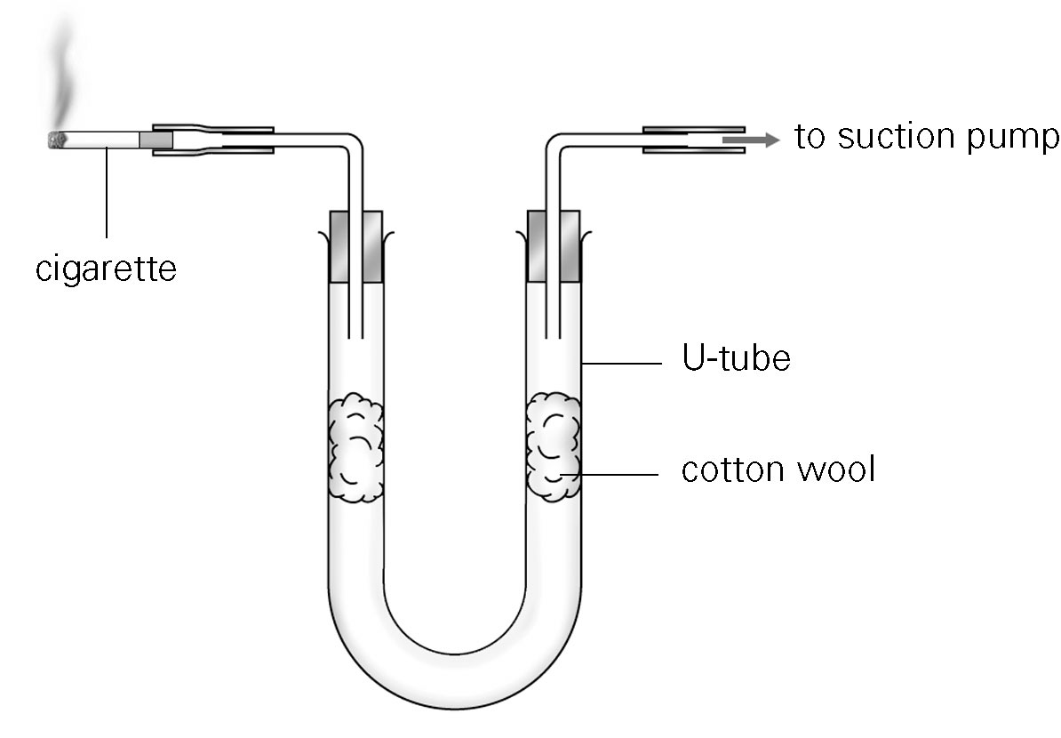
2.

(p.14) B 1. D
- C
3. A
4. B

(p.14) C 1. ×
2. ×
3. √
4. ×
5. √

