8 Making Use of Electricity

Part 1 Sectional Exercises

8.1 A 1. G
(p.27) 2. D
3. E
4. B
5. A
6. C
7. F

(p.27) B 1. 3
1
2

2. I would advise her to use a piece of sand paper to remove the rust because rust is a poor conductor of electricity.

(p.28) C | Substance | Insulator | Conductor |  | Substance | Insulator | Conductor
(p.28) C | Glass | √ |  |  | Candle wax | √
(p.28) C | Wood (wet) |  | √ |  | Carbon |  | √
(p.28) C | Wood (dry) | √ |  |  | Orange juice |  | √
(p.28) C | Living plant |  | √ |  | Oil | √
(p.28) C | Tin foil |  | √ |  | Air | √
(p.28) C | Paper | √

8.2 A 1. C
(p.29) 2. G
3. B
4. F
5. D
6. A
7. E

(p.29) B a. switch
b. closed/complete
c. current
d. chemical
e. cell
f. light
g. heat

(p.30) C 1a. 1.6
b. 0.8
c. 0.36

2. 5 mA = 0.005 A
10 mA = 0.01 A
0.1 A = 100 mA
0.05 A = 50 mA

3. (a) > (c) > (d) > (b)

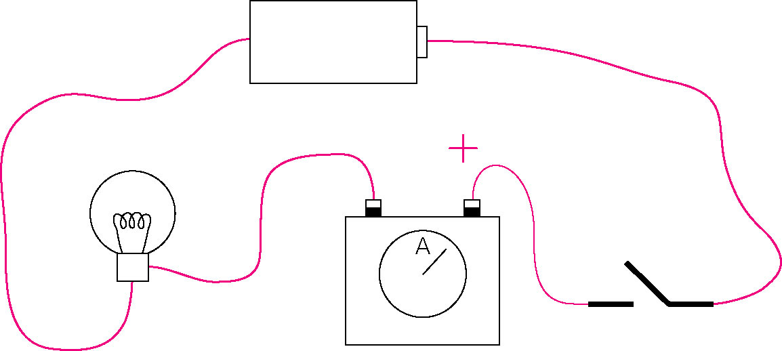
4.

8.3 A a. larger
(p.32) b. voltmeter
c. volts
d. V
e. red
f. black

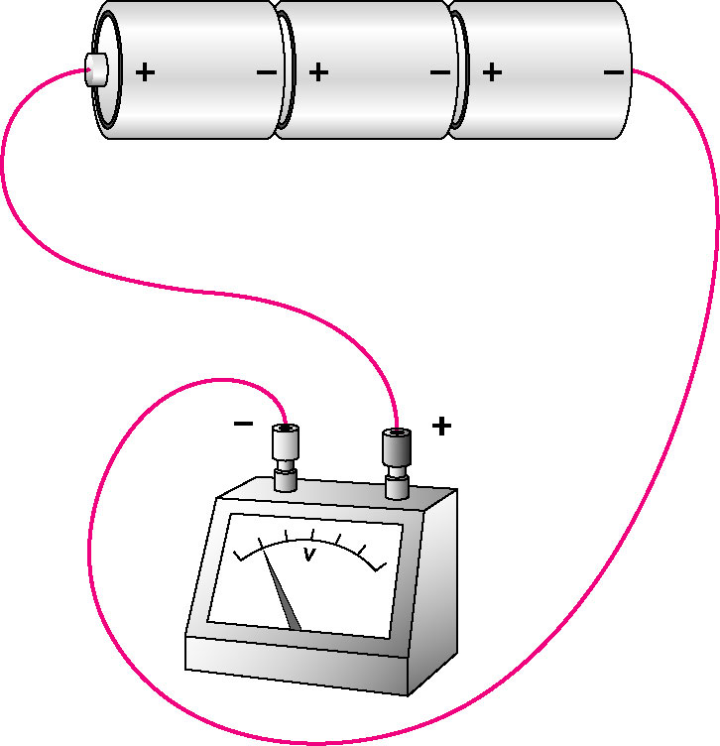
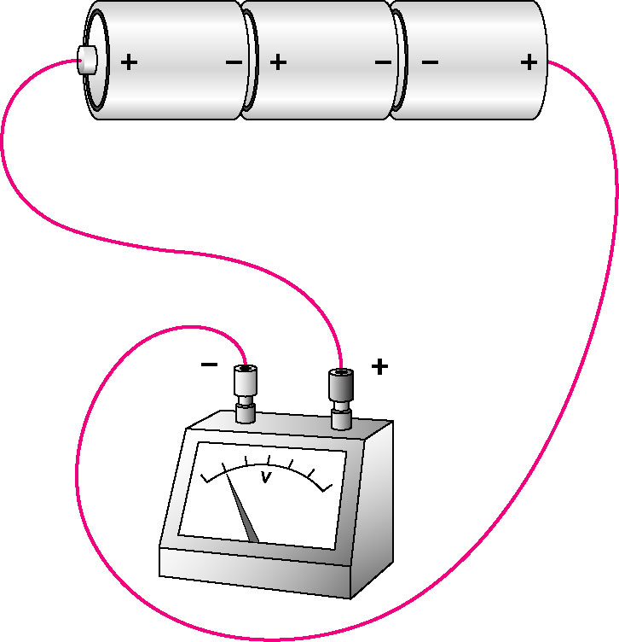
(p.32) B 1a. b.

reading = 4.5 V reading = 1.5 V

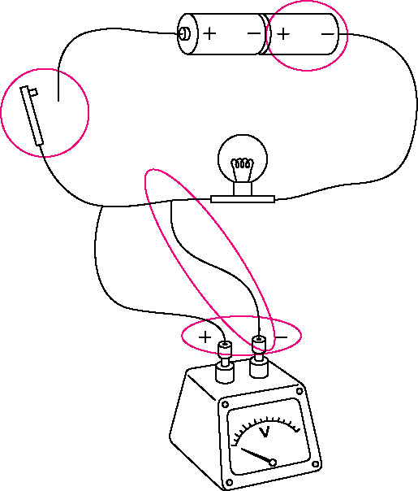
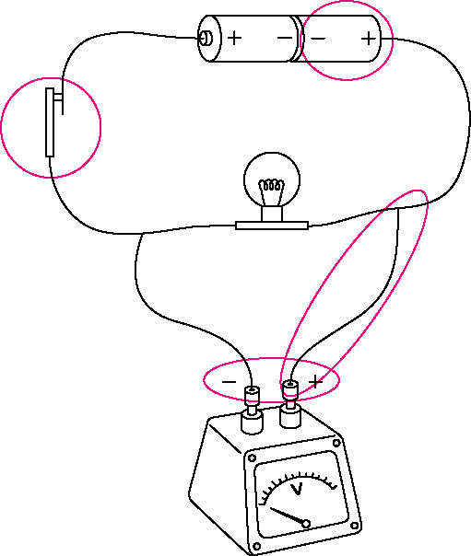
2a. b.

Both

8.4 A 1. ×
(p.33) 2. √
3. ×
4. √
5. ×
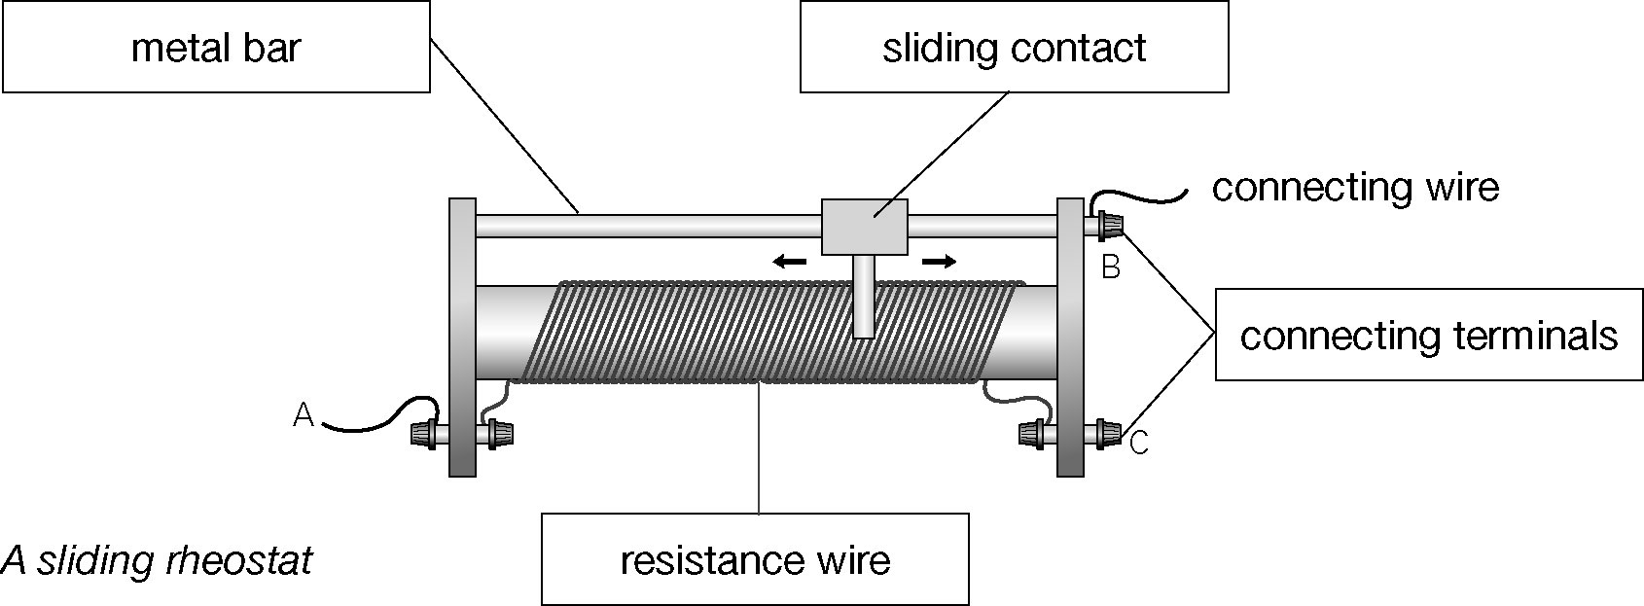
(p.34) B 1.

0 Ω; 10 Ω

2a. shorter
b. thicker

- Apparatus used: small light bulb (or ammeter), 1 dry cell and 2 connecting wires. Connect each resistor with a light bulb (or ammeter) and a dry cell. The one that makes the bulb glow brighter (or larger ammeter reading) has a smaller resistance.

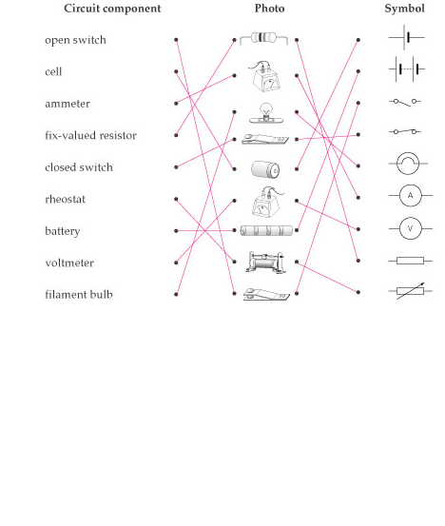
  - A
(p.35)

(p.36) B 1. | Circuit component | Number of times used
(p.36) B 1. | cell | 3
(p.36) B 1. | closed switch | 0
(p.36) B 1. | ammeter | 2
(p.36) B 1. | voltmeter | 1
(p.36) B 1. | fix-valued resistor | 2
(p.36) B 1. | junction of connecting wires | 4
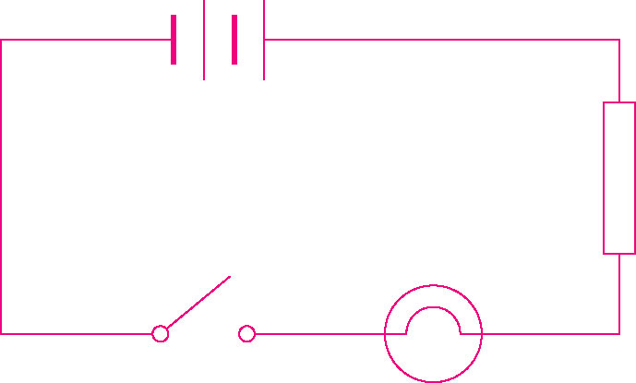
2a.

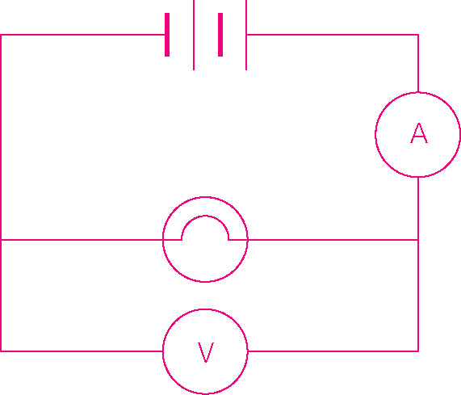
b.

8.6 A 1. √
(p.37) 2. ×
3. √
4. ×
5. ×
6. √
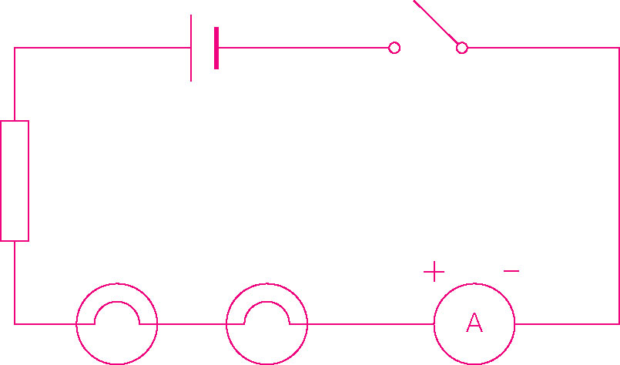
(p.38) B 1.

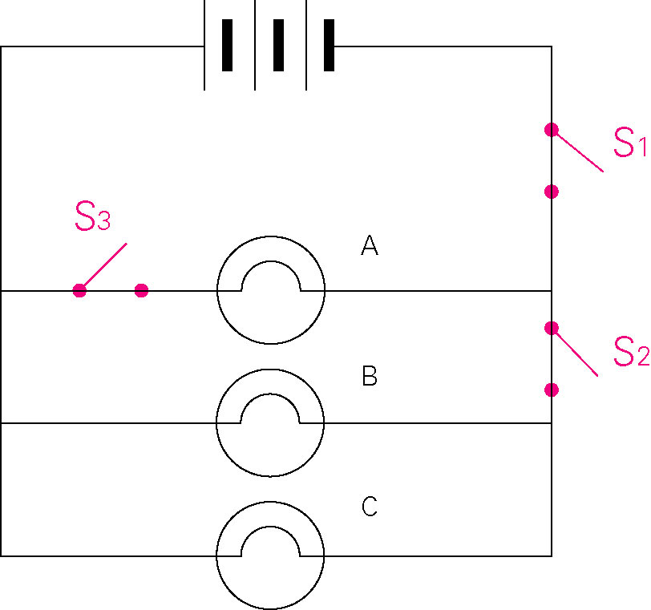
2. a, b, c

d. in a house

3a. A1 = 1.0 A
A2 = 0.5 A
A3 = 1.0 A
- A1 = 2.25 A
A2 = 1.50 A

4. It is because the resistance may be different in different branches of the circuit.

5. If there are more bulbs in a series circuit, the resistance of the circuit increases, the current therefore decreases.

8.7 A 1. √
(p.40) 2. √
3. ×
4. ×
5. ×
- 6. √
7. √
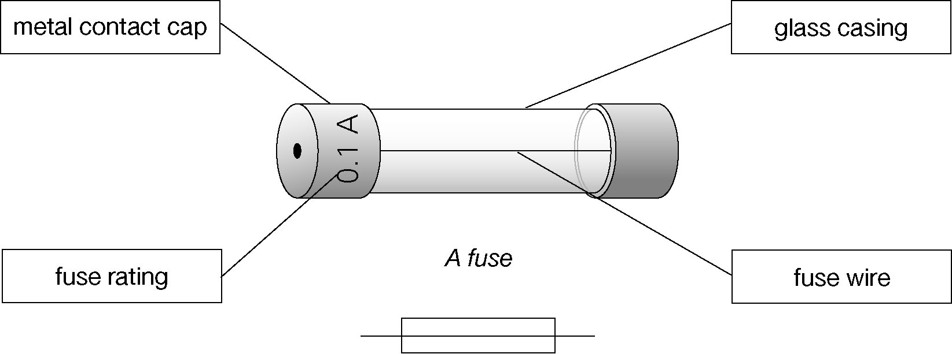
(p.40) B

(p.41) C 1a. brighter
b. will not light up
c. The reading will increase.
d. short circuit
e. yes
If short circuit happens, a large current results. The wires may get hot and the insulation may burn.
It can be prevented by adding a fuse in series to the circuit.

2. | Switch X | Switch Y | Bulb A | Bulb B
2. | open | open
2. | open | closed | √ | √
2. | closed | open
2. | closed | closed | √

3a. earth
- neutral
c. fuse
d. live
Wire | Colour code
Live | brown
Neutral | blue
Earth | yellow and green

4a. Never use a wet hand to close or open a switch.
b. Always replace a fuse with the correct fuse rating.
c. Never connect too many appliances to a mains socket.

5. • The electric iron does not have an earth wire.
• The fuse should be connected to the live wire.

8.8 A 1a. The Hong Kong Electric Co. Ltd.
(p.43) b. The China Light and Power Co. Ltd.
2. 220
3. kilowatt-hours
4. watts

(p.44) B 1. ×
2. √
3. ×
4. ×
5. √

(p.44) C 1a. 28 A
b. It will melt and break the circuit.
c. Do not connect too many appliances to the same socket.
2. Fig. 1
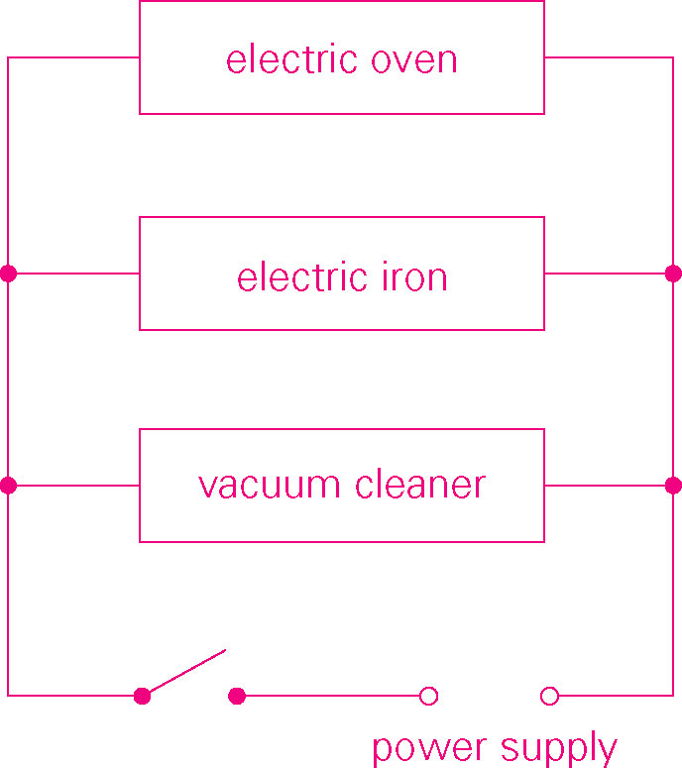
3a. in parallel
b.

c. 1 100/220 = 5 A
900/220 = 4.1 A
1 600/220 = 7.3 A
d. Current = 5 + 4.1 + 7.3 = 16.4 A
e. The 15 A fuse would melt and break the circuit.
f. overloading
g. The 15 A cable will become very hot and it may result in an electric fire.

(p.47) D | Appliances that make use of  heating effect of current | Appliances that make use of  magnetic effect of current
(p.47) D | electric iron | vacuum cleaner
(p.47) D | electric lamp | electric fan
(p.47) D | electric cooker | electric bell
(p.47) D | toaster | loudspeaker

