Warwick University Hong Kong Office Visit

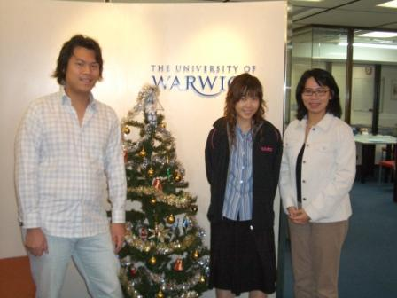

On 28th December, 2005, Prema Cheung, Jonathon Mok and Jose Wong, 3 of our Career Promotion Team (CPT) members visited the Warwick University Hong Kong Office (WHKO). The aspirations of the visit are the followings:

- to introduce the objectives, potential proposals and the team structure of the CPT
- to build liaison between the Warwick Graduation Association Hong Kong (WGAHK), striving to seek advises on career affairs for members of WHKS as well as discussing the possibility of any kind of sponsorships

Nancy Chui, the representative of WHKO and WGA, discussed a number of ways of co-operation with CPT with the intention to explore benefits and opportunities for current students, which comprise the followings:

- to organize future career talks, firm visits and gatherings with Warwick graduates
- to make available information of internship opportunities or job openings
- to establish a Mentorship Program to match alumni mentors with students according to career interests

The meeting lasted for approximately two and a half hours in a friendly atmosphere, and it was certainly a beneficial meeting with valuable suggestions of ideas and further improvements. Although some of the potential projects or activities need some time to propose and co-ordinate, but the initiative is there and the first step is taken, the CPT with keep contact with the WHKO and WGAHK regularly for all of the news and updates of the statements listed above, all of the WHKS members are also welcomed to express your opinion on CPT, your voice will be counted.

Jose Wong

