Abstract
As shrimp is one of the main seafood (Bouchon et al., 1994), shrimp farming becomes more and more important. Many shrimp farmers want to select high-value shrimp to farm, a reliable selection technique on species identification, therefore, is needed. Traditional method of shrimp species identification is mainly based on the morphological characteristics of shrimp (Cheung, 1960). However, this method highly depends on the experience of shrimp farmers. Moreover, shrimp species at larval stages are difficult to be identified (Cheung, 1963). This leads to one of the major loss to the farmers. Hence, a reliable method on species identification, which relies on the molecular technique, is required. Identification technique by using DNA marker, 16s rRNA gene, was carried out in our study.
Briefly, DNA from shrimp of unknown species was extracted. The shrimp was identified as Penaeus japonicus based on the morphological characteristics. The partial sequence of 16s rRNA gene was amplified by PCR. After purification and DNA sequencing, the sequence was detected and analyzed by searching for homology with the known sequences in GeneBank (<http://www.ncbi.nlm.nih.gov/BLAST/>, March 2004). Our result reveals that the sequence of 16s rRNA gene from the shrimp investigated shows 80% similarity to the same sequence of the Penaeus japonicus reported in GenBank of National Center for Biotechnology Information. The constructed phylogenetic tree also shows that our sample is very close to the Penaeus japonicus. However, the result is not as good as our expected, it most likely to be the problem from DNA sequencing.
1. Introduction
Background – Increasing significance of shrimp farming
Nowadays, people prefer eating healthier. As shrimp is one of the major protein source from the sea, the demand of shrimp increases rapidly (Bouchon et al., 1994) and shrimp becomes commercially important marine organism. Shrimp catch has reached to over 4,000,000 metric tones in year 2000 (<http://www.foodmarketexchange.com/>, April 2004). As shrimp caught from the wild cannot meet the demand, shrimp farming become more important. According to the statistics from GLOBEFISH, production of shrimp from aqualcultre has met 850,000 metric tones in year 2000. In order to make the greatest profit in shrimp farming, many farmers select the high-value species to farm, such as Penaeus japonicus, Penaeus monodon and Metapenaeeus ensis(<http://www.foodmarketexchange.com/datacenter/product/seafood/shrimp/dc_pi_sf_shrimp.php3>, April 2004). They are shrimp belongs to family Panaeidae (Cheung, 1960).

Penaeidae shrimp
There are more that 30 families and hundreds of species of shrimp in the world. Over 100 identified shrimp species are belonging to family Penaeidae whereas 34 of which are commonly found in Hong Kong (Cheung, 1960). Penaeus mondon, Penaeus japonicus and Metapenaeus ensis are most popular in market. Usually the body of shrimp can be divided into two parts, the cephalothorax (carapace) and abdomen(Fig1.1). The cephalothorax of shrimp, which is useful in species identification, usually have five pairs of appendices and a rostrum (Fig 1.2). The length and shape of the rostrum is different for each species. The eyes of shrimp are set on mobile stalks, which is placed at the two side of rostrum. At the buccal, there are a maxillae and two pair of maxilip, which use for feeding. The cephalothorax also contains the pereiopod (walking legs) which is use for locomotion. The abdomen contains the pleopods and tail. The pleopods are modified for swimming or burrowing. The tail contain three parts, the telson and a pair of uropods. The color of the abdomen can also be used for identification too (<http://www.sms.si.edu/IRLSpec/Penaeid_draw.htm> , April 2004, <http://www.hk-fish.net/>, April 2004).
The principal shrimp species used in aquaculture are described as follows:

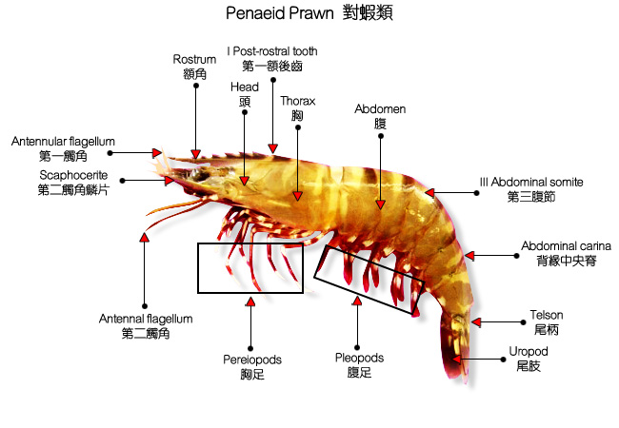
Fig 1.1 – Structure of a Penaeid shrimp. It is noted that the cephalothorax(carapace) consist of haed and thorax which is merged together in crustacean
(http://www.hk-fish.net/, April 2004).
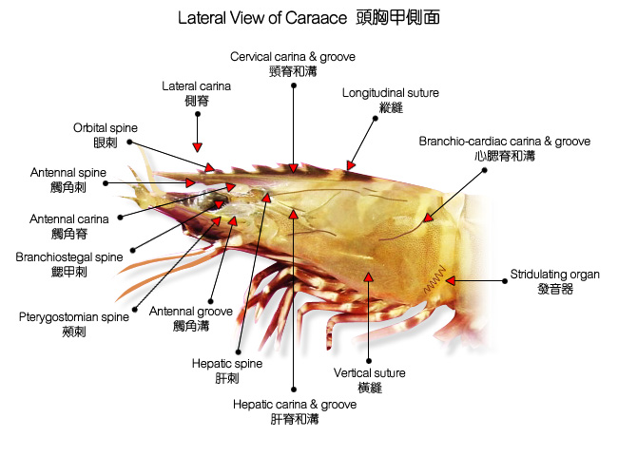
Fig 1.2 – The structure of the carapace of shrimp. The teeth / spine on rostrum and the groove on carapace are the useful keys for species identification. (http://www.hk-fish.net/, April 2004).
Penaeus japonicus
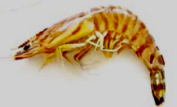
Fig 1.3 – Penaeus japonicus

The common name of Penaeus japonicus is bamboo prawn or Kurmaebi prawn. P. japonicus grows normally up to 22.5 cm, and rarely to 30 cm. The common weight is about 95 g. The catching season is from September to October (<http://www.fao.org/docrep/W2333E/>, December 2003).
There are 8-10 dorsal teeth and 1-2 ventral teeth on their rostrum. The groove is deep and broad, which extends to the posterior border of carapace. Antennal, hepatica and orbital spins are distinct. The color of its body is light brown to greenish brown, with dark brown bands and brown stripes. Thoracic and abdominal regions are yellow. Telson and uropods banded are red brown, bright yellow and blue (<http://www.hk-fish.net>, April 2004).
Penaeus monodon
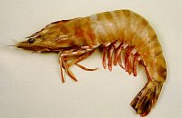
Fig 1.4 – Penaeus monodon

The other species Penaeus monodon is commonly known as giant tiger prawn. It grows normally up to 12 cm, and rarely to 35 cm. The common weight is about 100 g. The catching season is from April to June and August to November. These kinds of shrimp are naturally found in Asia and Africa. It was introduced to America and Europe since 1994 (<http://www.fao.org/docrep/W2333E/>, December 2003).
There are 6-8 dorsal teeth and 2-3 ventral teeth on their rostrum. The post-rostral has a very shallow groove, which extends to the posterior carapace. The carapace has an antennal and hepatic spins, but without orbital spine. The body color is green-brown to dark green with one yellow and dark-brown band at each abdominal segment. The pereiopods is in blue, yellow and white color. Pleopods are brown to blue with red tips. Antennular flagella have narrow white and dark green bands on it. And half of the uropods are red, blue and dark brown (<http://www.hk-fish.net>, April 2004).
Penaeus setiferus
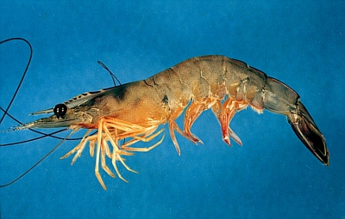
Fig 1.5 – Penaeus setiferus

Penaeus setiferus is commonly known as white shrimp. It grows normally up to 11.9 cm, and rarely to 16.5 cm. The common weight is about 20g. The catching season is from September to November. Penaeus setiferus is naturally found in North America (<http://www.fao.org/docrep/W2333E/>, December 2003).
There are 5-11 dorsal teeth and 1-2 ventral teeth on their rostrum. The carapace has a medial carina which is continuous with the rostrum at the anterior end, it extends posteriorly is about 2/3 length of its body. The color of its body is bluish white, speckled with black, with pink-tinged sides. Pleopods are often marked with dark red, while the margins of the uropods of the tail are green (<www.sms.si.edu/IRLSpec/ Penaeu_setife.htm>, April 2004).

Metapenaeus ensis
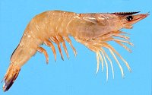
Fig 1.6 – Metapenaeus ensis

Metapenaeus ensis is the commonly known as endeavor shrimp or sand shrimp. It grows normally up to 7cm, and rarely to 19cm. The common weight is about 30g. The catching season is from March to November. This kind of shrimp is naturally found in Asia (<http://www.fao.org/docrep/W2333E/>, December 2003).
There are 6 - 10 dorsal teeth on their rostrum, which is straight, narrow and extends to the tip of antennular peduncle. The carapace contains 2 post-rostral teeth, the posterior is usually smaller than the other. The orbital, antennal and hepatic spins contain some hair. The color of its body is often in creamy white to yellow with no banding on body or antennae and speckled with reddish brown dots. Uropods are brown with yellow or blue tips. Pereiopods and pleopods are yellow, sometimes with brown spots (<http://www.hk-fish.net>, April 2004; Cheung, 1960).
Problem of traditional method of species identification
As described perviouly, the current method of identification of shrimp species mainly based on the morphological characteristic of shrimp (Cheung, 1960). However, the morphology of shrimp is not stable by many reasons. Such as Polymorphism is common in many shrimp species (Palumbi & Benzie, 1991). The differences depend on developmental stage, population, water region, water temperature in different season (Fingerman, 1970; Florey, 1966; Hoar, 1983; Prosser, 1973). Even in the same species, the characteristics may differ from each other (Fingerman, 1970; Florey, 1966; Hoar, 1983; Prosser, 1973). In contrast, shrimps at larval stages are very similar to each other even they belong to different species. So, the traditional method in identification of shrimp species relies on the experience of the aquaculturers. If they buy the shrimp wrong, the whole batch will be wasted. As the shrimp at larval stage is expensive, it can cause great loss to the aquaculturers. Hence, a more accurate and reliable identification technique is needed.
Significance of species identification using DNA marker
As same as other organisms, the most accurate method to do species identification is based on the molecular level. Although there are other kinds macromolecules used in species identification such as proteins and RNA, DNA is the best to perform this function. It is because protein and RNA are affected by gene expression at different developmental stages and gene expression may also differ under various environmental conditions. Hence, it is more reliable to use DNA to perform species identification (Bouchon et al., 1994).
DNA is one of the important components in a cell. Reading the entire sequence of the whole genome surely gives the greatest accuracy, it is not only low effective but also waste a lot of time and money. In addition, the genome size of shrimp, which is as complicated as the case in human, is thousand times more than that in prokaryotic cell. It is not practical to figure out the whole genome sequence. Therefore, a short sequence of DNA called DNA marker is currently used in species identification. DNA marker is a short DNA sequence usually with size of about 500-600 bp which unique in organisms and can be used in species identification (Schubart, 2000)
There are many DNA marker developed nowadays like COI and cyt-b. The DNA marker we used in our project is the DNA sequence of a mitochondrial DNA (mtDNA). It is a structural gene and not coded for a protein, but coded for the 16s RNA. This RNA is the transcript to form part of mitochondrial ribosome where they play important catalytic roles during translation of massager RNA into protein (Schubart, 2000). Only the partial sequence of the entire gene about 560 bp, was used as DNA marker to do identification. There are several advantages to use this marker it as the most commonly used sequence for molecular study of crustaceans. Firstly, this gene is independent from the genomic DNA, so it does not related to the morphological characteristic of the shrimp. Secondly, this gene mtDNA is maternally inherited, that is relatively more conservative and subjected to less varviation among populations. Thirdly, this gene presents in multiple copies in most cell. It make researcher easier to get the DNA extract. Beside, because of the important function perform by this gene, it would not change too much otherwise the shrimp will die. This gene allows trace mutation resulted in different species occurs different sequence in the long time of evolution (Schubart, 2000).
Hence, compare to the other DNA markers such as VNTR, using 16s rRNA gene will give a great interspecies divergence but less intraspecies divergence. It makes the identification more effective. As this marker is commonly used, it make us easy to compare with the other results on Internet (Schubart, 2000).
Identification of Penaeid shrimp species using 16s rRNA gene
The marker used in this project is the partial sequence coded for 16s ribosomal RNA which is found in mitochondria. The length we copied is about 560 bp long. In our study, four shrimp species were chosen for investigation. According to their morphological characteristics as described in previous section, they were classified as Penaeus japonicus, Penaeus monodon, Penaeus setiferus and Metapenaeus ensis. Then, DNA marker 16s rRNA gene was utilized to identify species based on molecular level and, hence, to verify the reliability of the traditional classification method.
Briefly, total DNA was extracted from muscle of peapod (swimming legs). The practial 16s rRNA gene was amplified using PCR (<http://encyclopedia.thefreedictionary.com/PCR>, November 2004). PCR allow a DNA to be amplitied in vitro to a million of fold after 30-40 amplification cycles in high selectivity. After PCR and the subsequenuent purification, the sequence was read by DNA sequencing. The approach of DNA sequencing used in our project is based on the Sanger method, which was developed by Fredick Sanger. This method actually is a controlled interruption of replication. There are two steps included in sequencing: sequencing PCR (cycle sequencing) and electrophoresis by polyacrylamide Gel (<http://encyclopedia.thefreedictionary.com/Gene+sequencing>,December2004; Palumbi & Benzic, 1991).
After DNA sequencing, the sequence was compared with all the known sequence in GenBank which is provided by National Center for Biotechnology Information (<http://www.ncbi.nlm.nih.gov/BLAST/>, March 2004). By comparing the similarity of the sequence investigated and those in GenBank, species can be identified as the one that shows the least genetic difference. Moreover, the evolutionary relationship can be reviewed by constructing phylogenetic tree diagram.

Objective
The objective of this study is to identify shrimp species on molar level by using DNA marker, 16s rRNA gene.
2. Materials and Methods
2.1 DNA Extraction
Totally three DNA extraction methods were carried out. They were phenol extraction and ethanol precipitation, extraction using DNAzol® Reagent and QIAamp® DNA Mini Kit.

2.1.1 DNA extraction by phenol extraction and ethanol precipitation
2.1.1.1 Materials
Shrimps
Sharp scissors
Water bath (set at 56℃)
Speed vacuum
Extraction buffer
Proteinase K (10μg/μl)
10% SDS
Phenol-chloroform- amyl alcohol (25:24:1)
3M sodium acetate
100% ethanol
70% ethanol
Sterile ultra pure water

2.1.1.2 Procedure
About 0.1 g of shrimp pleopod tissue was cut by using a sharp scissors. Tissue obtained was washed with extraction buffer, and then 380 μl extraction buffer was added into an eppendorf containing the washed tissue. Tissue was cut and minced by the same scissors. After that, 20 μl of proteinase K (10 μg/μl) and 100 μl of 10% SDS were added to the eppendorf, and the mixture was incubated at 56℃ for 2 hours.
After incubation, an equal volume of phenol-choroform-amylalcohol (500 µl) was added to the mixture and it was mixed by inverting the eppendorf tube for several times. Then the mixture was centrifuged at 12,000 rpm for 10 minutes and the upper aqueous phase was transferred to a new eppendorf.
The protein removing steps were repeated until no protein layer (the middle layer) was observed. After the proteins were removed, one-tenth volume of sodium acetate (3M) and 2 volume of absolute ethanol were added to the eppendorf. Then, the mixture was incubated at -80℃ for 30 minutes.
After incubation, the tube was centrifuged at 10,000 rpm for 15 minutes. The supernatant was removed. The pellet was washed by 350 μl of 70% ethanol and then incubated at room temperature for 10 minutes. After that, the mixture was centrifuged for 10 minutes at 10,000 rpm and the supernatant was removed. The pellet in the eppendorf tube was vacuum dried and then the DNA pellet was dissolved by addition of 20 μl sterile ultra pure water at 50℃ for 10 minutes. Finally, the extracted DNA was stored at -20℃.
2.1.2 DNA extraction by DNAzol® Reagent
2.1.2.1 Materials
DNAzol® Reagent (Invitrogen)
Shrimps
Sharp scissors
100% ethanol
75% ethanol

2.1.2.2 Procedure
About 25-50 mg of shrimp pleopod tissue was obtained and homogenized. Then, 1 ml of DNAzol Reagent was added, the mixture was centrifuged at 10,000 x g for 10 minutes at room temperature. The tissue fragments, RNA and excess polysaccharides were removed by transferring the viscous supernatant to a fresh eppendorf tube. 0.5 ml of 100% ethanol was added per 1 ml of DNAzol, and the mixture was mixed by inversions and incubated at room temperature for 1-3 minutes. Then the DNA was pelleted by centrifugation at 4,000 x g for 1-2 minutes at room temperature (or 4℃). The DNA pellet was washed with 0.8-1.0 ml of 75% ethanol. During washing, the tube was inverted 3-6 times to suspend the DNA in the ethanol. After DNA was settled down to the bottom of the tube, ethanol was removed by decanting.
DNA was air dried by open lid after ethanol was removed. The pellet was dissolved in sterile ultra pure water. Finally, the solution was stored at -20℃.
2.1.3 QIAamp® DNA Mini Kit
2.1.3.1 Materials
QIAamp® DNA Mini Kit (Qiagen)
Shrimps
Sharp scissors

2.1.3.2 Procedure
About 25 mg of shrimp pleopod tissue was cut into small pieces in a 1.5 ml eppendorf tube, and then 180 μl of Buffer ATL was added. After that, 20 μl of Proteinase K was added to the tube and mixed by vortexing. Then the mixture was incubated at 56℃ until the tissue was completely lysed. During incubation, the sample was dispersed by vortex occasionally. The tube was briefly centrifuged to remove drops from the inside of the lid after the incubation. 200 μl of Buffer AL was then added to the sample and mixed by pulse-vortexing for 15 seconds. After that, the mixture was incubated at 70℃ for 10 minutes and the tube was again briefly centrifuged to remove drops from inside the lid. 200 μl of ethanol (96~100%) was added to the sample and mixed by pulse-vortexing for 15 seconds. After mixing, the tube of sample was briefly centrifuged to remove drops from inside the lid.
Sample prepared in the last step was applied to the QIAamp Spin Column (2 ml collection tube) without wetting the rim. Then it was centrifuged at 6000 x g for 1 minute. The tube containing the filtrate was discarded and the QIAamp Spin Column was replaced in a clean 2 ml collection tube. After that, 500 μl of Buffer AW1 was added into the column without wetting the rim and centrifuged at 6000 x g for 1 minute. After that, collection tube containing the filtrate was discarded and 500 μl of Buffer AW2 was added to the column and centrifuged at full speed for 3 minutes. The collection tube containing the filtrate was discarded and the column was placed in a new 2 ml collection tube. After that, the column was centrifuged at 20,000 x g for 1 minute. After that, the column was placed in a clean 1.5 ml eppendorf and the collection tube was discarded. Next, 200 μl of sterile ultra pure water was added to the column and incubated at room temperature for 1 minute. After incubation, it was centrifuged at 6000 x g for 1 minute. The filtrate was the DNA solution. Another 200 μl of water was added to the column and the steps were repeated to increase the yield of DNA obtained. The DNA solution was used for PCR or stored at -20℃.

2.2 Polymerase Chain Reaction (PCR)
2.2.1 Materials
Primer 16S AR (12.5μM) 5'- CGC CTG TTT AAC AAA AAC AT -3'
Primer 16S BR (12.5μM) 5'- CCG GTC TGA ACT CAG ATC ATG -3’
Ready made 2X PCR master mix
Sterile ultra pure water

2.2.2 Procedure
25 μl of ready made 2X PCR master mix, 21 μl sterile ultra pure water, 1 μl 5’ 16S AR primer (12.5μM), 1μl 3’ 16S BR primer (12.5μM) and 2 μl of DNA sample were added into a PCR tube and mixed well. Then, the sample can be amplified by using thermal program in a automated polymerase chain reaction machine. The automated cycling program was 94℃ for 5 minutes followed by 34 cycles of 94℃ for 1 second, 48℃ for 50 seconds, 72℃ for 1 minute and the last cycle was 72℃ for 5 minutes. After the above 36 cycles, the amplified DNA was temporarily stored at 4℃ inside the machine or -20℃ in a refrigerator. The PCR product was visualized by agarose gel electrophoresis (Section 2.4).

2.3 PCR Product Purification
Before DNA sequencing, the PCR products were purified by either ethanol precipitation or Strata Prep® PCR Purification Kit. Since some minor fragments were observed in some samples that may adversely affect the result of DNA sequencing. An addition method by S.N.A.P. ™ UV-Free Gel Purification Kit was used to purify the amplified 16S DNA fragment.

2.3.1 Ethanol Precipitation
2.3.1.1 Materials
3M sodium acetate pH 5.2
95% ethanol
70% ethanol (pre-chilled at -20℃)
Sterile ultra pure water

2.3.1.2 Procedure
5 μl of 3M sodium acetate (pH 5.2) and 117 μl 95% ethanol was added into a 1.5 ml eppendorf tube. Then, the entire PCR product (approximately 45 μl) was added and mixed gently by vortexing. After that, the tube of sample was placed at -20℃ for 30 minutes. Next, the mixture was spun at maximum speed at 4℃ for 30 minutes and the supernatant was discarded. The pellet was rinsed with 125 μl of pre-chilled 70% ethanol and then placed at -20℃ for 30 minutes. After that, the mixture was spun at maximum speed at 4℃ for 30 minutes and the supernatant was removed. Then, the pellet was air-dried in room temperature and resuspended in 40 μl sterile ultra pure water. Finally, it was incubated at room temperature for about 30 minutes and stored under -20℃. The purified PCR product was visualized by agarose gel electrophoresis (Section 2.4).

2.3.2 Strata Prep® PCR Purification Kit
2.3.2.1 Materials
Strata Prep® PCR Purification Kit (Stratagene)
Ethanol (100%, 70%, 75%)
Micropipette
Sterile ultra pure water

2.3.2.2 Procedure
Equal volume of DNA-binding solution (approximately 45 μl) was added to the microcentrifuge tube containing the PCR product and mixed. The PCR product-DNA-binding solution mixture was transferred to a microspin cup which already seated in a 2 ml receptacle tube. After snapped the cap, the tube was spun at maximum speed for 30 seconds. The cap of 2 ml receptacle tube was opened, and the DNA-binding solution was discarded. One times (1X) wash buffer was prepared by addition of 5X wash buffer and 40 ml of 100% ethanol. Then 750 μl of 1X wash buffer was added to the microspin cup and the tube was spun at maximum speed for 30 seconds. After the centrifugation, the wash buffer was discarded. The microspin cup was placed back in the 2 ml receptacle tube and the cap of the receptacle tube was snapped. Next, the tube was spun at maximum speed for 30 seconds again. After all of the wash buffer was removed from the microspin cup. It was transferred to a fresh 1.5 ml microcentrifuge tube and the 2 ml receptacle tube was discarded.
On the top of the fiber matrix at the bottom of the microspin cup 50 μl of ddH₂O was added. Then, the tube was incubated at room temperature for 5 minutes. The cap was snapped and the tube was spun at maximum speed for 30 seconds. The microspin cup was discarded. The purified product was in the bottom of the microcentrifuge tube and was used for DNA sequencing.

2.3.3 S.N.A.P. ™ UV-Free Gel Purification Kit
2.3.3.1 Materials
S.N.A.P. ™ UV-Free Gel Purification Kit (Invitrogen)
Agarose gel electrophoresis apparatus
Agarose
1X TAE buffer, pH 8
100% ethanol
Sterile ultra pure water
Clean razor blade

2.3.3.2 Procedure

Preparation of the Gel
0.4 g of general purpose agarose was mixed with 100 ml 1X TAE buffer in a clean conical flask. The flask was placed in the microwave until agarose was heated just boiling. The flask of agarose was cooled for 3 minutes and then 80 μl of Crystal Violet solution (2 mg/ml) was added and mixed by swirling. The gel box and comb was rinsed with autoclaved TAE buffer. Gel was poured and the comb was set in the gel. After the gel was solidified, the gel was immerged with 1X TAE buffer in a gel tank and the comb was removed.

Gel loading and running
5 μl of 6X Crystal Violet loading dye was mixed with 30 μl of the DNA sample and loaded onto the gel. The gel was run at 100 V until the crystal violet in the gel had migrated to about a quarter of the way up the gel.

Excising DNA
TAE buffer was poured off. A new razor blade was used to excise the desired DNA fragment from the gel and the excised plug of agarose was transferred to a sterile 1.5 ml eppendorf tube. The excised gel was weighed and its volume was estimated (1mg≈1ml). After that, 2.5 times of the volume of Sodium Iodide Solution was added and mixed by shaking vigorously by hand or vortexing. Next, the agarose was incubated at 42℃ to 50℃ until it was completely melted and the solution was mixed periodically by vortexing. After the agarose was melted, the tube was placed at room temperature and 1.5 volumes of Binding Buffer was added and mixed well.

S.N.A.P.TM Column Purification of DNA
An S.N.A.P.TM purification column and collection vial was assembled and all of the mixture obtained from the previous procedure was loaded into the column. Then, the tube containing the mixture was centrifuged at 2,000 to 3,000 x g for 30 seconds at room temperature. The liquid in the collection vial was poured back into the column and repeat the centrifugation was repeated. The pouring and centrifugal steps were repeated for one more time to ensure all DNA was bound to the column.
After that, the liquid in the collection tube was discarded. 400 μl of 1X Final Wash buffer was added to the column and centrifuged as above. The previous washing step was repeated and the liquid in the collection tube was discarded after the second centrifugation. Then, the column was centrifuged again at maximum speed for at least 1 minute to dry the column resin and the collection vial was discarded. Next, the column was transferred to a new 1.5 ml eppendorf tube and 40 μl of sterile water was added directly to the column material and incubated for 1 minute at room temperature. The column was then centrifuged at maximum speed for 1 minute to elute the DNA into the eppendorf tube. After that, the column was discarded and the purified DNA was stored at -20℃ before DNA sequencing procedure.

2.4 Agarose Gel Electrophoresis
2.4.1 Materials
Agarose gel electrophoresis apparatus
Agarose
1X TBE buffer, pH 8
100% ethanol
Ethidium bromide
6X loading buffer
2.4.2 Procedure
To prepare 1% agarose gel, 0.5 g of agarose was weighed and put in a glass flask. After that, 1X TBE buffer was filled into the flask till 50 ml was reached. The flask with agarose and TBE mixture was heated in the microwave until the agarose powder was totally dissolved. The flask of agarose was allowed to cool for several minutes. Then, a drop of ethidium bromide was added into the agarose solution and mixed by swirling. The gel was poured into the casting tray which previously sealed with plastic tapes at both ends. After that, the comb was placed on the appropriate location. And the agarose gel was allowed to solidify. After the gel was solidified, the plastic tapes were removed from both ends, the tray was placed in the gel apparatus and covered with 1X TBE. After that, the comb was removed from the gel and 5 μl DNA sample was mixed with 6X loading buffer and the mixture was loaded into the gel. The gel was run at a constant voltage (~100 V) for an hour. After electrophoresis, DNA bands were visualized under UV light.
2.5 DNA Sequencing
2.5.1 Cycling Reaction
2.5.1.1 Materials
- Thermo Sequenase Cy5.5 Dye Terminator Cycle Sequencing Kit (AmershamPharmaciaBiotech)
- Deionized distilled water
- Speed Vacuum

2.5.1.2 Procedure
Four PCR tubes A, C, G and T were labeled for the respective termination reactions. 3 μl DNA template, 3.5 μl reaction buffer (concentrate), 2.0 μl primer (1 μM), 2.0 μl Thermo Sequenase DNA polyerase (10 U/μl) were mixed with 21 μl water for preparing master mix for each template to be sequenced. The content was mixed and centrifuged briefly. 7 μl of master mix was aliquot into each tube labeled A, C, G and T prepared at the beginning. 1 μl of the corresponding Cy5.5 ddNTP termination mix were dispensed into the appropriately labeled tube. The tubes were capped to prevent evaporation. Each sequencing reaction was mix thoroughly and the tubes were briefly centrifuged. The thermal cyclic program was started in a PCR machine at 95℃ for 5 minutes (Cycle 1); then repeating the cycle for 30 times, 95℃ for 30 seconds, 45℃ for 30 seconds and 72℃ for 4 minutes (Cycles 2 –31); lastly ended by 4℃ forever (Cycle 32). After completion, the tubes were briefly centrifuged and placed on ice.

2.5.2 Purification of sequencing reactions
2.5.2.1 Materials
- AutoSeqTM G-50 Columns (AmershamPharmaciaBiotech)
- Distilled water
- Formamide loading dye

2.5.2.2 Procedure
The resin was resuspended in column by vortexing gently. Four columns were prepared for each set of sequencing reactions performed. The cap was loosen one-forth turn on the column and snapped off the bottom closure. Each column was placed in a 1.5 ml screw cap microcentrifuge tube for support. The columns were pre-spinned at 2000 x g for 1 minute. The top caps were removed and each column was placed in a clean support tube. 12 μl distilled water were added to each sample to bring the final volume to 20 μl. Each sample was mixed thoroughly and then slowly applied to the center of the angled surface of the compacted resin bed. The columns were centrifuged at 2000 x g for 1 minute. The purified sample was collected in the bottom of the support tube. The samples were vacuum centrifuged to concentrate into a volume not more than 12 μl. 6 μl formamide loading dye was added to each tube. The concentrated sample were vortexed for 30 seconds to ensure thorough mixing. Just prior to loading the samples onto the gel, each sample were heat at 70℃ for 2 – 3 minutes to denature, and placed on ice immediately. 1.5 – 2 μl of each sample was loaded into separate lanes of the sequencing gel.

2.5.3 DNA sequencing
2.5.3.1 Materials
- Automatic sequencer
- Polyacylamide gel
- Deionized water
- 70% ethanol
- 1X TBE electrophoreseis buffer
2.5.3.2 Procedure
To start the sequencing, the manual sequencing apparatus, the base and top glass plates were cleaned thoroughly with deionized water, then again with 70% ethanol using fresh Kleenex tissues. The glass plates were then assembled with clean spacers. The polyacrylamide gel was prewarmed at room temperature for not more than 10 minutes before loading gel. The gel was then loaded into the glass plates which were placed at an angle to allow the gel can move down between the plates. The well forming comb was inserted into the gel space and clamped on top of the glass plate. The gel was allowed to polymerize for at least 30 minutes. After setting, the well-forming comb was removed. The vertical electrophoresis apparatus was assembled by clamping the upper and lower buffer chambers to the gel plates, and 1X TBE electrophoresis buffer was filled into the chambers. 1 - 2 μl of sample was loaded into each well, started from “A”, then following with “G”, “C”, “T”. The gel was run for 35 minutes, after the electrophoresis, the nucleotide sequence was read by automatic sequencer using the software, Sequence Viewer.
3. Results
3. 1 Extraction
3. 1. 1 DNA Extraction by Phenol Extraction and Ethanol Precipitation
Five DNA samples were extracted using phenol-cholorform extraction followed by ethanol precipitation. They are Penaeus monodon, Metapenaeus enponious, Penaeus japonicus and two samples of Metapenaeus ensis. After the agarose gel electrophoresis, five bright smears of DNA were observed in gel, particularly abundant in small molecular size (Fig. 3.1).

3. 1. 2 DNA Extraction by DNA_{ZOL} Reagent
Five DNA samples were extracted using this method. They are Penaeus monodon, Metapenaeus enponious, Penaeus japonicus and two samples of Metapenaeus ensis. As shown in Fig. 3.2, there was no DNA smear found in the gel. It seemed that no DNA was extracted or the amount of DNA extracted was so little to be visualized under the gel.
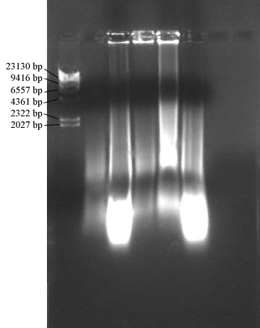
Fig. 3.1 – Total DNA from Pleopods of Five Penaeid Shrimps. Total DNA of Penaeus monodon, Metapenaeus enponious, Penaeus japonicus and two Metaponaeus ensis were extracted by phenol-chloroform extraction followed by ethanol precipitation as described in section 2.1.1. The extracted DNA (5μL) was then separated in 1% agarose gel.
The lanes from left to right are Lamda HindIII DNA marker, Metapenaeus ensis 1, Penaeus monodon, Metapenaeus ensis 2, Metapenaeus enponious and Penaeus japonicus.
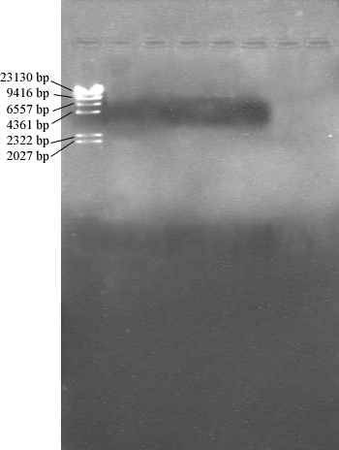
Fig. 3.2 – Total DNA from Pleopods of Five Penaeid Shrimps. Total DNA of Penaeus monodon, Metapenaeus enponious, Penaeus japonicus and two Metaponaeus ensis were extracted by DNA_{ZOL} Reagent as described in section 2.1.2. The extracted DNA (5μL) was then separated in a 1% agarose gel.
The lanes from left to right are Lamda HindIII DNA marker, Metapenaeus ensis 1, Metapenaeus ensis 2, Penaeus monodon, Metapenaeus enponious and Penaeus japonicus. The agarose gel used was 1% (w/v). The volume of sample loaded to each well was 5μL.
3. 1. 3 DNA Extraction by QIAamp DNA Mini Kit
The DNA samples extracted were obtained from Penaeus japonicus, Penaeus setiferus, two Penaeus monodon and two Metapenaeus ensis. As shown in the Fig. 3.3. The extractions gave out a smear with evenly brightness, the quality of the extraction was much better than the previous two methods. The extracted DNA was chosen for PCR to amplify the 16s ribosomal RNA gene.

3. 2 Polymerase Chain Reaction (PCR)
3. 2. 1 DNA Template Prepared by Phenol Extraction and Ethanol Precipitation
No PCR product was observed from DNA template prepared by phenol extraction and ethanol precipitation. As revealed in Fig. 3.4, only smears were seen in the gel. As indicated by the positive control, which is the DNA template extracted from Penaeus japonicus obtained from a research laboratory. A clear and single band was visualized in the gel with approximately 560 bps in size. Hence, the failure of PCR in our samples was not due to the problems of PCR programs and conditions.
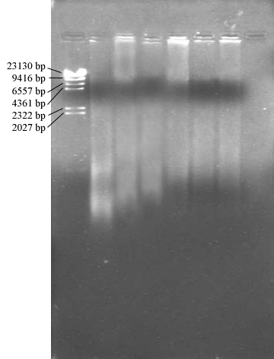
Fig. 3.3 – Total DNA from Pleopods of Six Penaeid Shrimps. Total DNA of Penaeus japonicus, Penaeus setiferus, two Penaeus monodon and two Metapenaeus ensis were extracted by QIAamp DNA Mini Kit as described in section 2.1.3. The extracted DNA (5μL) was then separated in a 1% agarose gel.
The lanes from left to right are Lamda HindIII DNA marker, Penaeus japonicus, Penaeus setiferus, Penaeus monodon 1, Penaeus monodon 2, Metapenaeus ensis 1 and Metapenaeus ensis 2.
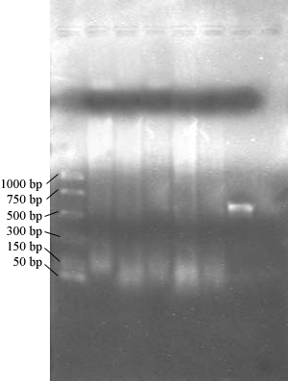
Fig. 3.4 – PCR Products of Five Penaeid Shrimps from DNA Template Prepared by Phenol Extraction and Ethanol Precipitation. 16s rRNA gene of Metapenaeus ensis 1, Metapenaeus enponious, Metapenaeus ensis 2, Penaeus monodon and Penaeus japonicus were amplified as described in section 2.2. The PCR product (5μL) was then separated in a 1% agarose gel.
The lanes from left to right are PCR marker, Metapenaeus ensis 1, Metapenaeus enponious, Metapenaeus ensis 2, Penaeus monodon and Penaeus japonicus and the positive control.
The positive is the 16s rRNA gene amplified from the total DNA of Penaeus japonicus obtained from a research laboratory.
3. 2. 2 DNA Template Prepared by DNA_{ZOL} Reagent
Similar to the result described in previous section, the positive control gave a clear and bright band. Most of the extractions cannot generate a PCR product during PCR, except in the Penaeus japonicus, which gave a blur band (Fig. 3.5).
3. 2. 3 DNA Template Prepared by QIAamp DNA Mini Kit
Different from the previous two methods, all of the extractions by QIAamp DNA Mini Kit showed a good result in the PCR. Bands with approximate molecular size of 558 bps were observed (Fig. 3.6 & 3.7), which was near our desired base number 520bps. However, a dim undesired sub-band was observed in sample Penaeus monodon 1, Penaeus monodon 2 and Metapenaeus ensis 1 revealing a minor non-specific amplification occurred.

3. 3 PCR Purification
3. 3. 1 Ethanol Precipitation
After PCR, the amplified DNA was purified for proceeding sequencing procedure. Three purification methods were utilized – traditional ethanol precipitation, StrataPrep® PCR Purification Kit and S.N.A.P.TM UV-Free Gel Purification Kit.
Some of our PCR products (Metapenaeus ensis 1, Metapenaeus ensis 2, Penaeus setiferus and Penaeus japonicus) were purified by the ethanol precipitation. As shown in the Fig. 3.8, the purification by this method was quite efficient that all of the products gave out a sharp band. However, many of them seemed to be lost during the purification process.
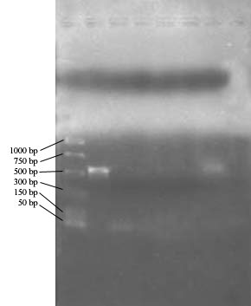
Fig. 3.5 – PCR Products of Five Penaeid Shrimps from DNA Template Prepared by DNA_{ZOL} Reagent. 16s rRNA gene of Metapenaeus ensis 1, Metapenaeus enponious, Metapenaeus ensis 2, Penaeus monodon and Penaeus japonicus were amplified as described as section 2.2. The PCR product (5μL) was then separated in a 1% agarose gel.
The lanes from left to right are the PCR marker, the positive control, Metapenaeus ensis, Metapenaeus enponious, Metapenaeus ensis II, Penaeus monodon and Penaeus japonicus.
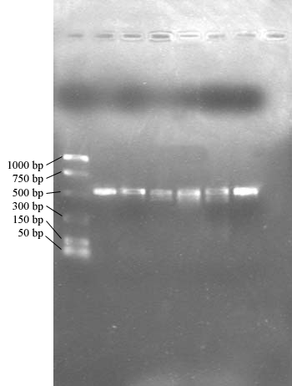
Fig. 3.6 – PCR Products of Six Penaeid Shrimps from DNA Template Prepared by QIAamp DNA Mini Kit. 16s rRNA gene of Penaeus setiferus, Penaeus japonicus, Penaeus monodon 1, Penaeus monodon 2, Metapenaeus ensis 1 and Metapenaeus ensis 2 were amplified as described in section 2.2. The PCR product (5μL) was then separated in a 1% agarose gel.
The lanes from left to right are PCR marker, Penaeus setiferus, Penaeus japonicus, Penaeus monodon 1, Penaeus monodon 2, Metapenaeus ensis 1 and Metapenaeus ensis 2.
Fig. 3.7 – PCR Marker Standard Curve
The blue line is the standard while the purple line indicates the molecular size of the PCR products; which had migrated away from the well for 31mm.

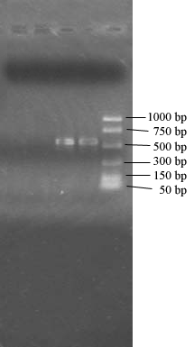
Fig. 3.8 – Purified PCR Products of Four Penaeid Shrimps. Sixteen s rRNA gene of Metapenaeus ensis 1, Metapenaeus ensis 2, Penaeus setiferus, Penaeus japonicus were purified using ethanol precipitation as described in section 2.3.1. The PCR product (5μL) was then separated in a 1% agarose gel.
Lanes from left to right are the Metapenaeus ensis 1, Metapenaeus ensis 2, Penaeus setiferus, Penaeus japonicus and PCR marker.

3. 3. 2 StrataPrep® PCR Purification Kit
The PCR products of Penaeus japonicus and Metapenaeus ensis 2 were purified by this method. The total DNA of these samples was extracted by QIAamp DNA Mini Kit (Section 3.1.3). As shown in the figure below, the bands of the purified products were very sharp and no smear or undesired band was observed (Fig. 3.9). These products were used for sequencing procedure.

3. 3. 3 S.N.A.P.TM UV-Free Gel Purification Kit
The PCR products of Penaeus japonicus, Penaeus setiferus and Metapenaeus ensis 2 were purified by this method. The total DNA of these samples was extracted by QIAamp DNA Mini Kit (Section 3.1.3). Before purification, the PCR products were visualized in a 1% agarose gel stained by crystal violet (Fig. 3.10).
The gel contained the PCR products were then excised and purified (refer section 2.3.3 for procedure). The purified products were checked by agarose gel electrophoresis again. As shown in the Fig. 3.11, the bands were very sharp and had no undesired band and smear. These products were used for sequencing procedure.
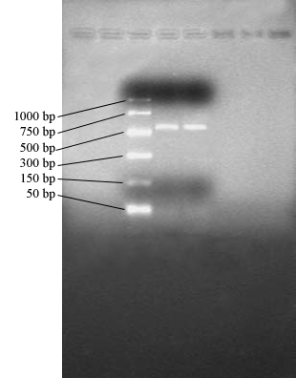
Fig. 3.9 – Purified PCR Products of Two Penaeid Shrimp. 16s rRNA gene of Penaeus japonicus and Metapenaeus ensis 2 were purified using S.N.A.P.TM UV-Free Gel Purification Kit as described in section 2.3.2. The PCR product (5μL) was then separated in a 1% agarose gel.
The lanes from left to right are PCR marker, Penaeus japonicus and Metapenaeus ensis 2.
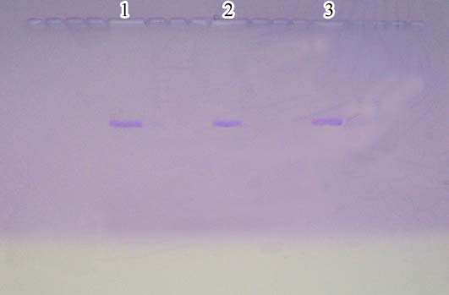
Fig. 3.10 – Crystal Violet Stained Agarose Gel Used to Purify the PCR Products.
The PCR product (25 to 30μL) (refer section 2.3.3 for procedure) was separated in a 0.8% agarose gel.
The bands from left to right are the Penaeus japonicus, Penaeus setiferus and Metapenaeus ensis 2.
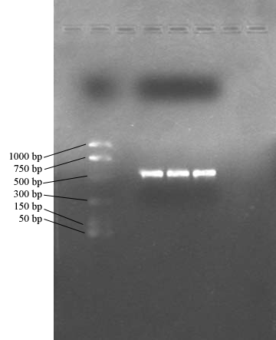
Fig. 3.11 – Purified PCR Products of Three Penaeid Shrimps. 16s rRNA gene of Penaeus japonicus, Penaeus setiferus and Metapenaeus ensis 2 were purified using S.N.A.P.TM UV-Free Gel Purification Kit as described in section 2.3.3. The PCR product (3 μL) was then separated in a 1% agarose gel.
The lanes from left to right are the PCR marker (5μL), a blank, Penaeus japonicus, Penaeus setiferus and Metapenaeus ensis 2.

3. 4 DNA Sequencing
3. 4. 1 PCR Products Purified by StrataPrep® PCR Purification Kit
After the cycle sequencing reaction and the subsequent purification, products of Penaeus japonicus and Metapenaeus ensis 2 were loaded into the automatic sequencer and the sequence had been read, the following absorbance curve was obtained (Fig. 3.12 and 3.13).
All the bases (adenine, guanine, cytosine and thymine) were detected by the automatic sequencer. However, as shown in the Fig. 3.12, some of the peaks were very close or even overlapped with each other. The sequence of Metapenaeus ensis 2 was failed to be read by the sequencer. As shown in Fig. 3.13, the peaks were closely packed together and overlapping. The DNA sequence of Penaeus japonicus was read and shown in the Fig. 3.14.
Because only one sequence can be detected and analyzed by the sequencer, the sequence was compared to all of the reported sequences in the GenBank (GenBank, <http://www.ncbi.nlm.nih.gov/entrez/query.fcgi?db=Nucleotide>, viewed 5 May 2004) of National Center for Biotechnology Information (NCBI) by program BlastN (Blast, <http://www.ncbi.nlm.nih.gov/BLAST/>, viewed 5 May 2004). All of the results belong the 16s rRNA gene sequence in shrimp of family Penaeidae or related family. Ten of the results are tabulated in Table 3.1. The highest sequence similarity (80%) belongs to Penaeus japonicus that was the same as the species we classified by traditional method. Then, by using the program ClustalW (ClustalW, <http://www.ebi.ac.uk/clustalw/index.html>, viewed 5 May 2004) alignment between our sequence and the one from P. japonicus (GI: 8919723) was done (Fig. 3.15).
By using software called MEGA2.1 (Kumar et al., <http://www.megasoftware.net/text/downloads.sht>, viewed 5 May 2004), the phylogenetic relationship was constructed among our sequence and the ten sequences in Table 3.1 plus another four 16s ribosomal RNA gene sequence from closely related shrimps (Penaeus monodon GI: 21665966, Penaeus japonicus GI: 21665957, Penaeus setiferus GI: 21665956, Metaenaeus ensis GI: 21665947) (Fig.3.16). As shown in the phylogram tree, the sequence obtained in present study became an outgroup revealing that our sequence was very different from all of the known 16s sequences in GenBank.
However, when we compared the corresponding alignment location between the sequence in present study with the other 16s rRNA sequences in GenBank (i.e. the result of BlastN), it was found that the alignment was actually done between base 65 to base 320 (Fig. 3.17). Therefore, the sequence in present study was truncated and a new phylogenetic tree was constructed (Fig. 3.18). It was found that the percent similarity were increased significantly that the sequence in present study has the highest sequence similarity (or the least evolutionary distance) with the same gene of Penaeus japonicus and another penaeid shrimp Melicertus canaliculatus.
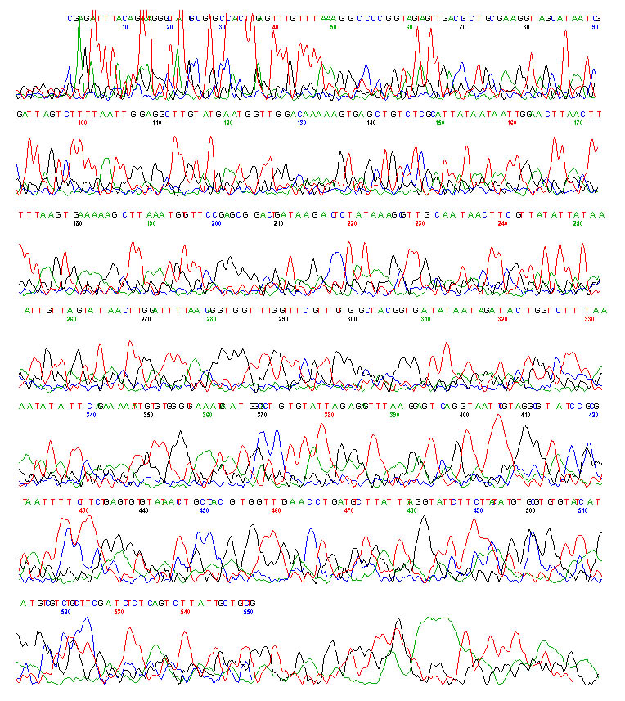
Fig. 3.12 – Absorbance Curve of Penaeus japonicus. 16s rRNA Gene purified by StrataPrep® PCR Purification Kit and read by automatic sequencer. Green curve represents Adenine, black curve represents Guanine, blue curve represents cytosine and red curve represents Thymine.
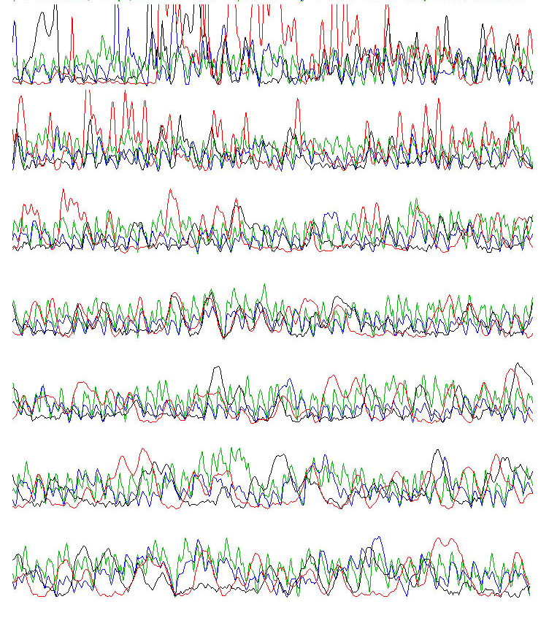
Fig. 3.13 – Absorbance Curve of Metapenaeus ensis 2. 16s rRNA Gene purified by StrataPrep® PCR Purification Kit and read by automatic sequencer. Green curve represents Adenine, black curve represents Guanine, blue curve represents cytosine and red curve represents Thymine.
1 CGAGATTTAC AGATATGGGC TATGCCGTGC CATCTTGAGT TTGTTTTAAA GGCCCCGGTA
61 GTAGTTGACG CCTGCGAAGG TAGCATAATC GATTAGTCTT TTAATTGGAG GCTTGTATGA
121 ATGGTTGGAC AAAAAGTGAG CTGTCTCGCA TTATAATAAT TGGAACTTAA CTTTTAAGTG
181 AAAAAGCTTA AATGGTTTCC GAGCGGACTG ATAAGACTCT ATAAAGCGTT GCAATAACTT
241 CGTTATATTA TAAATTGTTA GTATAACTTG GATTTTAACA GGTGGTTTGG TTTCGTTGTG
301 GCTACGGTGA TATAATAGAT ACTGGTCTTT AAATATATTC AGAAAAATTG TGTGGGGTAA
361 ATGAATGGCG ACTGTGTATT AGAGAGTTTA AGGAGTCAGG TAATTCGTAG GCGTATCCGC
421 GGTATTCTTC TTACTATGTG CGTGTGTATC ATATGTCGTC TGTCTTCGAT CTCTCAGTCT
481 GGTATTCTTC TTACTATGTG CGTGTGTATC ATATGTCGTC TGTCTTCGAT CTCTCAGTCT
541 TATTGCTGTC TG

Fig. 3.14 – Sequence of Penaeus japonicus

Name | Similarities (%) | Sequence Length (bp)
Penaeus japonicus; GI: 8919723 | 80 | 413
Melicertus canaliculatus; GI: 30315515 | 76 | 503
Melicertus longistylus; GI: 21665960 | 74 | 466
Melicertus latisulcatus; GI: 21665958 | 74 | 466
Melicertus plebejus; GI: 21665959 | 74 | 466
Penaeus semisulcatus; GI: 21665964 | 71 | 467
Fenneropenaeus merguiensis; GI: 21665951 | 71 | 467
Fenneropenaeus indicus; GI: 21665952 | 71 | 467
Fenneropenaeus penicillatus; GI: 30315520 | 70 | 504
Fenneropenaeus chinensis; GI: 30315516 | 69 | 505
Table 3.1 – The Similarity between the Ten Results Obtained by Comparing with All of the Reported Sequences in Genbank of NCBI by Program BlastN and the Sample Sequence. All of them are 16s ribosomal RNA gene, partial sequence of family Penaeidae. The percent similarities were calculated by program ClustalW.

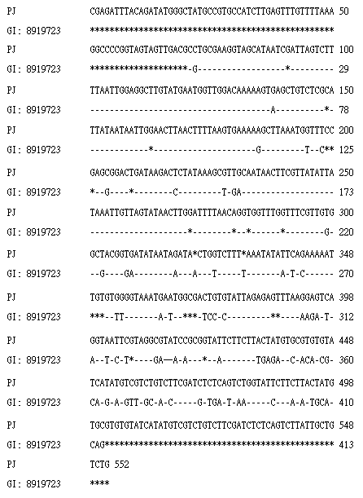
Fig. 3.15 – Alignment of the Penaeus japonicus Sequence in Present Study with the Penaeus japonicus partial mitochondrial 16S rRNA gene (GI: 8919723). PJ represents the sequence in present study and GI: 8919723 is the known sequence reported in GenBank. Dashes represent positions those are identical to the top sequence, whereas asterisks represent missing data.
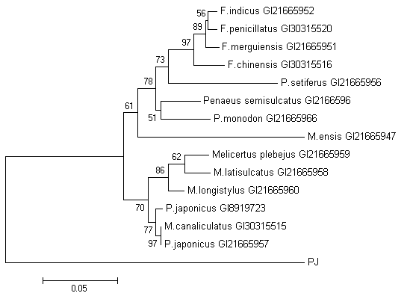
Fig. 3.16 –Phylogenetic Relationship of 16S rRNA Data among the 14 Known Sequences found in NCBI and the Sequence Obtained in Present Study (PJ). Numbers above branches indicate bootstrap values from neighbour-joining analysis. The bootstrap value is a confidence value, in which, the larger the value, the more reliable of the topology of the tree.
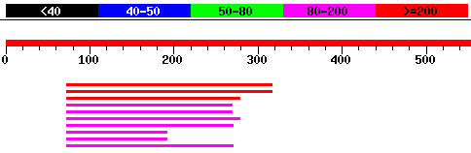
Fig. 3.17 – Corresponding Alignment Location of BlastN Result between the Known Sequence and the Sequence in Present Study. The upperest values are the statistical score given by BlastN, the higher the value, the more similar the sequence is, i.e. the red lines are the best, whereas the black are the worst. The red line with a scale represents the sample sequence, the value indicate the length of the sequence and the lines below represent the ten known sequences in an order same as in the Table 3.1.

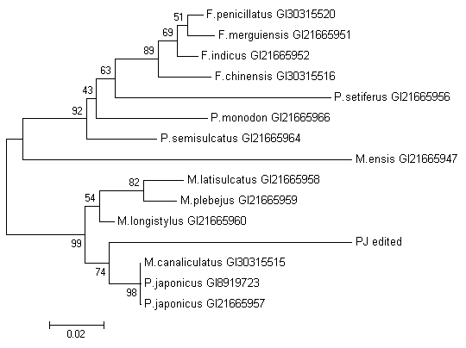
Fig. 3.18 – Phylogenetic Relationship of 16S rRNA Data of among 14 Known Sequences found in NCBI and the Truncated Sequence obtained in Present Study (PJ edited). Numbers above branches indicate bootstrap values from neighbour-joining analysis. The bootstrap value is a confidence value, in which, the larger the value, the more reliable of the topology of the tree.
3. 4. 2 PCR Products Purified S.N.A.P.TM UV-Free Gel Purification Kit
Because the absorbance peaks detected were not clear and sharp, and noise was significant that adversely affected the sequence to be read by the sequencer, another purification method S.N.A.P.TM UV-Free Gel Purification Kit was utilized. PCR products (Penaeus japonicus, Penaeus setiferus and Metapenaeus ensis 2) purified by this method were used for sequencing procedure again.
However, after the polyacrylamide gel electrophoresis, signal peak could not be found in the absorbance curve and sequence could not be read by the sequencer in the sequence in all samples (Fig. 3.19). The possible reasons were discussed in section 4.
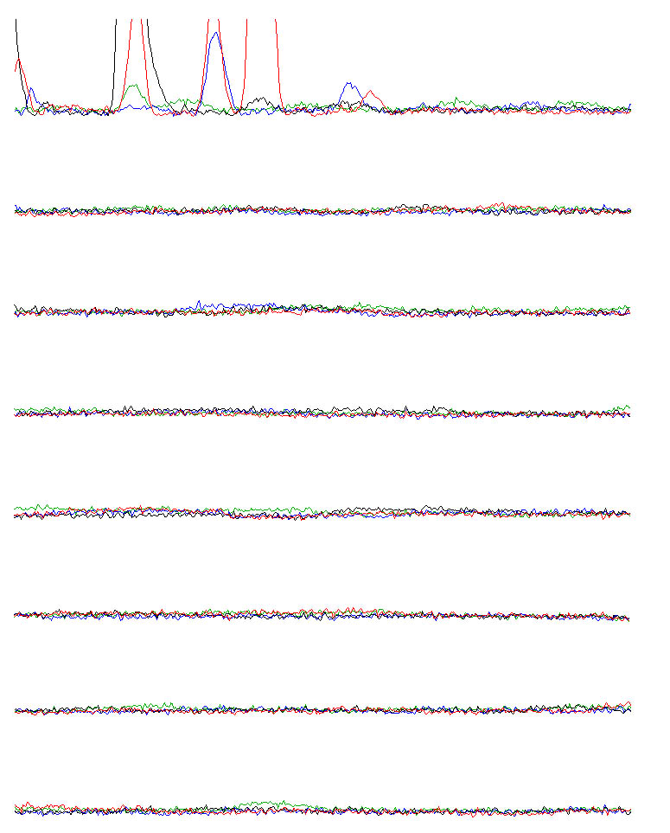
Fig. 3.19 –Absorbance Curve of Penaeus japonicus 16s rRNA Gene Purified by S.N.A.P.TM UV-Free Gel Purification Kit and Read by Automatic Sequencer. Green curve represents Adenine, black curve represents Guanine, blue curve represents cytosine and red curve represents Thymine.
Absorbance curve of Penaeus setiferus and Metapenaeus ensis 2 had similar result (data not shown).

Discussion: Ho Wing Han
A fast and reliable method of extracting mitochondrial DNA (mtDNA) is significantly essential in our study, however, the complex and time consuming step for mitochondria isolation had to be eliminated. Comparing the level on recovery of mtDNA and nuclear DNA (nDNA), the amount of mtDNA molecules is around hundreds to thousands per cells which is more easier to being found and extracted than nDNA (<http://www.mitotyping.com/dna.htm> May 2004). In addition of the abundance of mitochondria in muscle cells, we had done the total DNA extraction and instantly used mitochrondrial-specific primer to amplify our target mtDNA sequence. In our study, three extraction methods were being tested in order to achieve the highest yield of total DNA: the traditional phenol: chloroform extraction and ethanol precipitation, and the commercial DNA extraction kits, DNAzol® Reagent and QIAamp® DNA Mini Kit.
Referring to the figures 3.1, 3.2 and 3.3, the purification of total DNA from both traditional method and QIAamp® DNA Mini Kit is nice, since DNA molecules showed as a smear can be seen on the gels but not the DNAzol® Reagent. However, after running the total DNA templates in PCR, only QIAamp® DNA Mini Kit shows a successful quality and quantity extraction of nucleic acid that able to perform PCR and yield large amount of amplified product. The UV absorbance reading ratio, A₂₆₀/A_{280,} of DNA solutions obtained from traditional method and DNAzol® Reagent were significantly below 1.8 which indicated highly contamination of proteins, the potential inhibitors/repressors that blocking the binding of mitochondrial-specific primers or Taq polymerase onto the DNA template for DNA synthesis in PCR (<http://www.abo.fi/fak/mnf/biol/nni/lec_ndlr.htm#dna_pcr> May 2004). Besides, the quantity of DNA template is also a factor for successful amplification. The smear appeared in gel (fig3.4) showing no amplified product from the DNA temperate from the traditional method, this may be due to the unsuccessful mtDNA extraction that reduced the ratio of mtDNA and nDNA, thus lower the efficiency of PCR (<http://www.nih.go.jp/JJID/55/122.pdf> May 2004).
The sequencing result was not satisfactory, there was no recognizable sequence for Metapenaeus ensis 2, the absorbance curve of Penaeus japonicus also had many problems such as noises, boarding peaks throughout the sequence. A good sequencing resulting nice and high peaks, with well resolution and absence of noise background. However, in both of our samples, there were numbers of small peaks below the shape ones, and the baseline was not flatten along the curve. The only way to solve this problem is using another purification kit with higher efficiency. The multiple sequences may also appear in the curves, the overlapping of the major and secondary peaks can be the problem of templates contamination. Clearly, the performance of our DNA sequencing was very poor, if sufficient supplement of materials, like sequencing gel and gel plates, can be provided, more trials for improvements of DNA templates can enable a satisfy sequencing result (<http://core.biotech.hawaii.edu/g-dnatrb.htm>, <http://www.le.ac.uk/mrctox/pnacl/frames/fdnaseq/analysed.html>May 2004).
Furthermore, study can be continued, by collecting the shrimp larva of Penaeus japonicus from markets, doing the same procedures, DNA extraction, PCR and DNA sequencing. By comparing the similarity of the DNA sequences of the larvae and the adult shrimp, we can able to see whether our method for species identification is effective or not. However, again the unsatisfactory sequencing result cannot be a standard model of Penaeus japonicus DNA sequence, and the running out of time and cost, this confirming step cannot been done.
Discussion: Lau Ho Tak
The use of molecular method to identify penaeid shrimps is because of its ability to reveal the large genetic difference masked by morphological similarity of shrimps (Palumbi and Benzie, 1991), especially the species of shrimp larva, they are highly similar in their morphology. The study of shrimp larva helps scientist to understand the life cycle of the shrimp, their habitat and their role in the ecosystem.
The result of the present study was worse than expected. Out of the six shrimps chosen, only one sequence can be read and aligned, which was the shrimp identified as Penaeus japonicus by morphological method. The sequence obtained had 80% similarity to the reported Penaeus japonicus partial mitochondrial 16s rRNA gene sequence (GI: 8919723) from the GenBank of NCBI. Although it is already the highest similarity obtained among the entire reported genes in the GenBank, this percentage is still very low by using 16s rRNA as the marker. The 16s rRNA gene originated from mitochondrial genome, which is maternally inherited, haploid and present in multiple copies in most cells (Schubart et al., 2000), is relatively conserved within species. The sequence divergence of 16s rRNA gene within the Penaeus species is less than 2% (Lavery et al., 2004) and the mean sequence divergence of 16s rRNA gene between different shrimp species under the genus Metapenaeus in family Penaeidae is only 6.4% (Tong et al., 2000). Due to such a great difference with the known sequences, the sequence obtained from the present study was put into an outgroup in the phylogenetic tree (Fig. 3.16).
After the truncation of the sequence, the distance between our sequence with the other 14 sequences was reduced significantly resulted in a new grouping of our sequence with the 2 known sequences of P. japonicus (GI: 8919723 and GI: 21665957) and an additional known sequences of M. canaliculatus as revealed in the new phylogenetic tree (Fig. 3.18). However, the bootstrap value of the branch was only 74 indicating that the relationship constructed between the sequences was not so reliable. This value should be 95 or more to be considered as reliable relationship (Kumar and Nei, 2000).
Although the similarity between the sequences obtained in present study and that in the GenBank was low, they were already the most similar sequences and this sequence (GI: 8919723), Penaeus japonicus partial mitochondrial 16s rRNA gene, is the one that we aimed to identify. So it can be concluded that the desired gene was isolated successfully, although, we could not identify the penaeid shrimp species accurately based on the present results.
On the other hand, sequence could not be obtained by using the PCR product from Metapenaeus ensis and purified by the StrataPrep® PCR Purification Kit. It may due to the different sample loading technique by various operators. The sequencing procedure using the PCR products purified by the S.N.A.P.TM UV-Free Gel Purification Kit also gave no signal in the polyacrylomide gel electrophoresis (Fig. 3.19). However, the gel image showed that the purified products were good in quality (Fig. 3.11). It was suspected to be caused by poor sample loading technique too, but why the absorption peaks in Fig. 3.13 did not present? It was found that the gel solution had been accidentally stored under -20℃ instead of its normal storage temperature, 4℃. The polyacrylomide in the gel solution might be crystallized under such a low temperature, and thus reducing the performance of the gel (telephone query to manufacturer).
Among the three DNA isolation methods, only the DNA extracted by the QIAamp DNA Mini Kit could generate PCR product, thus it is the best extraction method used in present study. The DNA_{ZOL} Reagent seemed to give no extracted DNA. The phenol extraction and ethanol precipitation method gave a large amount of total DNA. Then why did the PCR using the DNA template from the phenol extraction and ethanol precipitation method was fail? It might because the drying time by vacuum was reduced to prevent the overdrying of the DNA pellet that will cause denaturing of DNA and alter its solubility in water (http://arbl.cvmbs.colostate.edu/, viewed 6 May 2004). Hence, it
was suspected that there was still a little amount of ethanol left in the DNA pellet after the vacuum dry. To override these, the DNA pellet can be dried by air. It also suspected that phenol might produce oxidation products that damaging the DNA molecule (Winfrey et al., 1997), as antioxidant was not added to the equilibrated phenol.

Discussion: Lee Wai Ping, Pinky
From the results obtained, the aim of our project was not achieved. Mitochondrial 16S ribosomal RNA gene is a relatively conserved gene within species as well as organisms within the same genus (<http://prion.bchs.uh.edu/>, viewed 6 May 2004). The divergence of the 16S rRNA sequence within the same geneus should be about 6.4% (Tong et al., 2000) and the genetic variation within species should be less than 2% (Shane et al., 2004) difference. This difference is mainly due to different populations of the same species of shrimps that live in different locations where the chance of inbreeding is blocked by environmental factors.
From Table 3.1, the result of the comparison between our sample sequence and all of the sequences from Genbank of NCBI, it showed that our sample sequence is most similar to the reported partial mitochondrial 16S rRNA sequence of Penaeus japonicus, and the similarity is 80%. Since the similarity is not high enough, we can only conclude that our sample is very similar to Penaeus japonicus and the sequence obtained is the mitochondrial 16S rRNA gene. The bootstrap value is a confidence value that the higher the value, the more reliable of the topology of the tree, i.e. the more reliable of the genetic relationship between our sample sequence and the Penaeus japonicus obtained from NCBI (Fig. 3.18). If the bootstrap is 95% or more, the relationship is reliable (Kumar and Nei, 2000). From the result of present study, the relationship was not reliable enough.
As shown in Fig. 3.1, DNA extracted by phenol and choloform extraction was small in molecular size since bright smears were found near the bottom of the gel. This low molecular size DNA extracted might be due to degradation of DNA during protein precipitation. The phenol used for nucleic acid purification must be high in purity as the oxidized products of phenol can damage DNA (Winfrey et at., 1997). So, there was no desired DNA band can be amplified in PCR as shown in Fig. 3.4. DNA extraction using DNAzol reagent was also failed as shown in Fig. 3.2 and there were no PCR product amplified as shown in Fig. 3.5. This might due to improper storage of the reagent since this reagent was a remainder of last year’s final year project.
Besides, the detection and reading of the DNA sequence by the automatic sequencer can be affected by different sorts of errors. As shown in the results of purified PCR products in agarose gel electrophoresis (Fig. 3.11), the bands of samples were very sharp but we still could not obtain a good result and most of the results were not detectable and read by the automatic sequencer. It might be due to the technique of sample loading and the quality of gel used in sequencing. The only one “good” sample was obtained in an earlier time of sequencing practice. Normally, the ready-to-use gel for sequencing should be stored at 4℃ but once the gel have put stored under -20℃ by mistake, the sequencing results started to be negative and no result could be obtained. This effect may be due to crystallization of acrylamide (the main component) in the gel (telephone query to manufacturer).
4.2 Discussion: Liu Wai Man
The sequence we got was edited manually, because of the noise from background had much affected the result read by computer. We adjusted the sequence based on the absorbance spectrum from the computer. The sequence was then put into the program BlastN provided by NCBI (<http://www.ncbi.nlm.nih.gov/BLAST/ >, viewed 01May 2004) for homology search. As sequence editing was done by man, it was time consuming. In the modification, we selected the sharp and narrow peak. As the noise from background was significant in our sequence, manual editing becomes critical and degree of edit had greatly affected the alignment result (Compare Fig.3.16 & 3.18)
Although totally 4 sequences were put for DNA sequencing in our project, not every sequence was good enough for analysis. For saving time, we chose the best one, which had the least noise contaminated, to do the homology search in the GenBank. The sequence before editing was about 550bp and had 80% similarity to the proved sequence, the partial 16s rRNA gene of Penaeus japonicus(GI:8919723). This percentage of similarity is not as good as our expected. Within species, the divergence should not more than 2% when using 16s rRNA gene marker. (Bouchon et al., 1994). Because of the great species divergence obtained in present study, the possible errors are detailly discussed in following from the earriest DNA extraction to the procedure of DNA sequencing.

DNA extraction
We had tried three different methods of DNA extraction. They were traditional method by phenol extraction and ethanol precipitation, DNAzol reagent and a fast kit QIAamp, manufactured by QIAGEN. Although the traditional method gave the most amount of DNA extract (Fig. 3.1), the quality is the worst. The DNA bands were bright at a very low position, it might representing the degradation of DNA into smaller fragments. DNA is digested by enzyme originated from the broken cell. For traditional method, we should carry out the extraction under low temperature on ice.
The DNA we aimed to amplify in present study was the mitochondrial DNA (mtDNA). In order to get more mtDNA, we used the muscle from swimming legs (pleopods) of the shrimp. Since it is the part for locomotion. Compare with the genomic DNA, mitochodrial DNA always have several copies in a cell. It lets the gene can be copied easier by PCR. Some reports have suggested to use ovary tissue to do DNA extraction because of larger mtDNA to genome DNA(Bouchon et al., 1994).
Regarding the duration of time for cell lysis, we had tried different incubation time for protease K. It is found that, 2-3 hours gave the best result in our project. The whole piece of tissue was digested and could be visible by eye observation. This step is important in our experiment. If the cell or tissue was not completely lysed, DNA extraction cannot do well.

PCR
Refer to our project result, although we did not have special selection step to isolate the mitochondria during DNA extraction, we got the right sequence in PCR. It is because the primers have high selectivity. So, when we compare the result to the reported sequence in GenBank, most of the sequences were 16sRNA sequences.
We had tried different annealing temperature and 50ºC was the best for us to operate. We used product from different extraction methods to do PCR. Referring the PCR result from DNA template prepared by phenol extraction (Fig.3.4), no PCR product but just smear-like pattern appeared. In contrast, DNA extract come from fast kit gave the best result in PCR. Bands were sharp and bright (Fig. 3.6). By comparing with the marker, it was clearly shown that the amplified sequence was a little bit heavier than 500 bp. That was the size we wanted.

Sequencing
In the sequencing, we got four sequences successfully. All the sequences were belonged to one individual of Penaeus japonicus. However, because of the significant background noise, four sequences were not identical to each other (30-70% similarity by ClustalW). Since only a small quantity of DNA was used for the cycle sequencing reaction, only 50-250 fmol, a little contamination can cause great noise. The specificity of cycle sequencing reaction depends on the primer sequence, the amount and the purity of template added to the reaction. The noise can be caused by the primer that generates non-specific annealing to the template. For improvement, we can try using a higher temperature to do the annealing step in cycle sequencing. If it is possible, we can use the ‘nested’ PCR for sequencing reaction that is a double PCR step to amplify the amplified sequence. Beside, the template used for sequencing may be impure. Re-pure the template and then re-isolate it can be helped. But there is a risk of getting less PCR product. Although the S.N.A.P. purification kit had significantly improved the purity (Fig ), there was still no recognizable sequence detected in the DNA sequencing (Fig. ).It is possibly due to the amount of template put into cycle sequencing was not optimized yet. Nevertheless, further study is needed to verify this because many procedures were involved.
To conclude, although we were not very successful to identify the species of the shrimp accurately and the phylogenetic tree did not show a precise genetic relationship, the sequence is 80% similar to that of the Penaeus japonicus which is the species being expected. Obviously, 16s rRNA is a useful tool for species identification. Success in species identification of shrimp can provide much useful information. Since the geographical barrier can isolate organisms, as the time go on, new species can be evolved. By tracing the time that the species appear, people can know the geographic change. Moreover, this technique can be applied to monitor the change of environment. As every species in the eco-community plays an important role, either domination or extinction by one species would adversely affect the harmony of the eco-systems.

Precaution
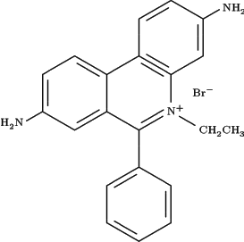
The stain we used in the DNA electrophoresis was ethidium bromide (EtBr) which has the lowest detection limit of 10 ng nucleic acid. Ethidium bromide is a strong mutagen. As we used EtBr so frequently, we should set up an area for loading EtBr containing gel to protect other people from touching careless or accidentally. EtBr area should be established.
In the electrophoresis of the DNA, there are always shown great bright and dark contrast when scanning the gel image. It may because the EtBr dye migrates during electrophoresis. We had tried another method to stain the DNA. We did not add EtBr when forming the agarose gel, but submerge the gel into diluted EtBr solution after electrophoresis. The time of submerge was about 30 minute. It could improve the great contrast problem. (http://www.ope-tech.com/products/SYBR_EN.htm, viewd 01May) ( http://www.sciencedaily.com/encyclopedia/ethidium_bromide_1, viewed 01May2004) ( http://www.wordiq.com/definition/Ethidium_bromide, veiwed 01May 2004)
Fig.4.1 Structure of ethidium bromide

Discussion: Wong Hei Wang
In our study, three methods were used for DNA extraction. They were the traditional method (Phenol extraction), DNAzol reagent and QIAamp DNA Mini kit. The QIAamp DNA Mini Kit gave the best result as revealed in the success in PCR that a sharp band was observed (Fig. 3.6). This method was fast, user-friendly and easy to use.
In the traditional method, proteinase K was used to break down the muscle tissue, then phenol-chloroform isoamyl alcohol was used to remove the protein, and ethanol was used to precipitate and concentrate the DNA. By this method, although the extracted DNA showed a smear at the electrophoresis (Fig. 3.1), the 16s rRNA gene cannot be amplified in PCR by using this DNA template (Fig. 3.4). It may because the DNA was degraded to small fragments during the extraction procedure.
The extraction method using DNAzol reagent, the reagent is a complete and ready-to-use reagent for the isoloation of genomic DNA from solid or liquid sample. The UV-spectrum showed that the yield of the extracted DNA was low. The reading of A₂₆₀ was about 0.02 only, which indicates 0.12 μg/mg of DNA was extracted from muscle tissue. Moreover, the purity of the sample was not good, that the ratio of A_{260/}A₂₈₀ was much lower than 1.5, which indicates a protein contamination. As revealed in agarose gel electrophoresis, no PCR product was detected on the gel (Fig. 3.5). It may because the concentration of the extracted DNA is lower than the PCR limit.
Three methods of purification were used after the PCR step and agarose gel electrophoresis was used to check the efficiency of purification. The first method utilized ethoanol to precipitate the DNA and the unwanted small fragments were removed at the same time. This method could purify DNA to a great extent. However, loss of DNA was likely to occur during the purification procedure. Twelve PCR products were purified using this method, but only five of which showed to have DNA left after purification.
Purification using column (Stratagene PCR purification kit) can purify DNA in a fast way without significant loss and is effectives to remove DNA with low molecular weight such as unbounded dNTPs and primers. However, non-specifically amplified fragments may also have a chance to be purified that affecting the sequencing procedure and smear was still occurred after purification in some sample (Fig. 4.2). The larger molecular size fragments such as DNA from non-specific amplification was still remained in the sample.
In order to get rid of the minor non-specific bands and so increase the purity of sample, the S.N.A.P.TM UV-Free Gel Purification Kit was used. DNA was loaded into a gel stained with crystal violet (Fig. 3.10), the single target band of DNA was cut and put into the column for purification. As shown in the result of agarose gel electrophoresis (Fig. 3.11), the band was much sharper and brighter then the other two methods. However, signal cannot be detected during DNA sequencing (Fig. 3.18). Possibly too large concentration of DNA was taken to do the cycle sequencing. It is because the DNA was concentrated by Speedvac before purification, as a result too much of DNA was added without diluting into the cycle sequencing procedure. As revealed in the sequence gel (Fig. 3.18), only several peaks were present in the first region and no other signal occurred after that. It was because most of the primer were used up by the DNA template and only first several base pairs can be sequenced.
In our study, two samples of Metapenaeus ensis (ME) and one sample of Penaeus japonicus (PJ) were undergone for DNA sequencing. However, only four sequences can be read by the sequencer and all of them are belonged to the same PJ individual. Because the sequencer may give out wrong bases due to the large number of overlapping peaks and the background noise, manual editing was carried out for each sequence after sequencing. Although the absorbance peaks were not clear and the sequence detected may come with error, all the sequences obtained in our studied were confirmed as 16s rRNA gene. We had checked the size of DNA by agarose gel electrophoresis before doing sequencing. By reading from the PCR marker, the molecular weight of DNA in our sample is about 560 bp which is similar to the size of 16s rRNA gene reported in many papers (Schubart et al, 1998). Moreover, when comparing our sequence with the known gene in GenBank using BlastN (<http://www.ncbi.nlm.nih.gov/BLAST/>, March 2004), all blast sequences are belonged to the 16s rRNA gene of shrimp from family Penaediae or other related families (Ten of the result shown in Table 3.1). So it is sure that the sequence obtained in our study is the 16s rRNA gene from shrimp origin.
In our study, the genetic relationship between our PJ sequence and other 16s sequences was constructed by two phylogenetic tree diagrams (Fig. 3.16, Fig. 3.17). By comparing these two diagrams which using PJ sequence before and after truncation, the sequence before truncation showed as an out group to all the shrimp, while the sequence after truncation had highest similarity with PJ. However, the genetic difference was still larger as indicated by the distance in clade, showing the poor quality of our sample.
To improve our experiment, more tests should be carried out for cycle sequencing, particularly using tested both 5’ and 3’ primer. Because these two sequences are complementary to each other, a more precise result could be obtained by comparing these tow sequences. Besides more practice on loading technique could definitely benefit our study but the problem is that huge amount of materials and money are needed for support. Each sequencing gel costs about HK$150 and HK$20 for each PCR reaction that frequent DNA sequencing could not be carried out. On the other hand, sample size should be increased. At least three samples for each species must be taken. More type of marker should be used too, for example the CQІ and the 12s rRNA marker.
For further study, we can investigate more species of shrimp and a genomic library for the 16s rRNA gene from all penaeid shrimp in Hong Kong can be constructed (<http://www.tufts.edu/vet/facpages/warren_aa.html>, April 2004). It will be a useful database for species identification when doing research on marine organism such as phylogenetic and population genetic studies on penaeid shrimp. As shrimp plays an important role in the food chain of marine habitat, by monitering the abundance and diversity of particular species, we can understand the interaction between environment and other marine organism. Also can study the effect of environment pollution on marine organism by using this technique.

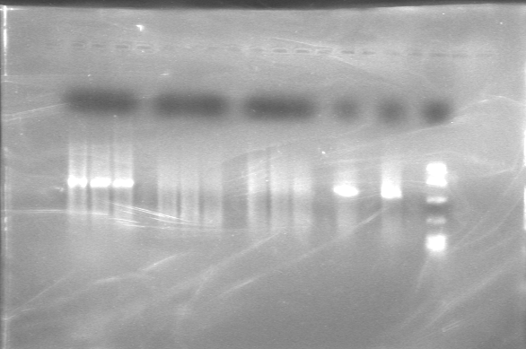  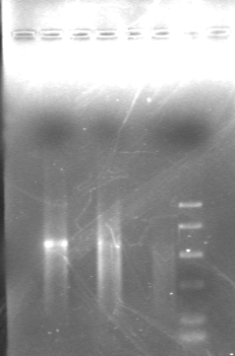  A1-3 | A2-6 | A7-9 | A10-11 | A12 | B1 | B2 | B3 | B12

Fig 4.2- A agarose gel electrophoresis result before (left ) and after (right ) purification by Stratagene PCR purification kit. A1-3: PCR product of P. japonicus. B1: PCR product of PJ after purification. A4-6: PCR product of P. monodon. B2: PCR product of PM after purification. A7-9, A10-11: PCR product of M .ensis. B3: PCR product of ME after purification. A11 and B12: PCR marker. It is clear that smear was still appeared after purification.
Bibliography:
Bouchon, D., Souty-Grosset, C. and Raimond, R. 1994. Mitochondrial DNA variation and markers of species identity in two penaeid shrimp species: Penaeus monodon Fabricius and P. japonicus Bate. Elsevier Science B.V.
Cheung T.S. 1960. A key identification of Hong Kong Penaeid prawns with comments on points of systematic interest. Hong Kong University Fisheries Journal, No.3, pp. 61-69
Cheung T.S. 1963. The natural history of the commercial species of Hong Kong Penaeidae (crustacea, decapoda). The annals and magazine of natural history. Ser. 13, 6:401-433
Fingerman, M. 1970. Comparative physiology: chromatophores. annual review of physiology, 32:345-372
Florey, E. 1966. Color change and the chromatophores. An introduction to general and comparative animal physiology. W. B. Saunders, Philadelphia, pp. 713.
Hoar, W.S. 1983. Electric discharges, light production, and color change. General and comparative physiology (Third Edition). Prentice Hall, Englewood Cliffs, New Jersey, pp. 851
Kumar, S., Nei, M., 2000. Accuracies and statistical tests of phylogenetic trees. Molecular Evolution and Phylogenetics. Oxford University Press, Inc., New York. pp. 165-186.
Lavery, S., Chan, T.Y., Tam, Y.K. and Chu, K.H., 2004. Phylogenetic replationships and evolutionary history of the shrimp genus Penaeus s.l. derived from mitochondrial DNA. Molecular Phylogenetics and Evolution. 31: 39-49.
Palumbi S.R. and Benzie J., 1991. Large mitochondrial DNA differences between morphologically similar Penaeid shrimp. Molecular marine biology and biotechnology, pp. 27 –34
Prosser, C.L. 1973. Chromatophores and color change. Comparative animal physiology (Third Edition). W. B. Saunders, Philadelphia, pp. 966.
Schubart, C.D., Neigel, J.E. and Felder, D.L. , 2000. The use of the mitochondrial 16S rRNA gene for phylogenetic and biogeographic studies of Crustacea. Crustacean Issues 12: 817-830.
Tong, J. G., Chan, T.-Y., Chu, K. H., 2000. A preliminary phylogenetic analysis of Metapenaeopsis (decaponda: Penaeidae) based on mitochondrial DNA sequences of selected species from the Indo-West Pacific. Journal of Crustacean Biology. 20: 541-549.
Winfrey, M.R., Rott, M.A. and Wortman, A, 1997. Appendix XV. Unraveling DNA: Molecular Biology for the Laboratory. Practice Hall, Upper Saddle River, N.J.. pp33
Electronic Bibliography:
Analysed data trouble shooting, viewed 1 May 2004 <http://www.le.ac.uk/mrctox/pnacl/frames/fdnaseq/analysed.html>
ClustalW, European bioinformatics institute, viewed 5 May 2004, <http://www.ebi.ac.uk/clustalw/index.html>
Commercial prawn in Hong Kong water (Fisheries and Conservation Department, HKSAR, China), viewed 20 October <http://www.hk-fish.net/eng/database/prawns/common.htm>
Coparison of different method for extraction of mitochondrial DNA from human pathogenic yeast, viewed 1 May 2004
<http://www.nih.go.jp/JJID/55/122.pdf>
DNA sequencing, viewed 10 December 2004 <http://encyclopedia.thefreedictionary.com/Gene+sequencing>
Dr. George E. Fox, The University Of Houston, Department of Biology and Biochemistry
<http://prion.bchs.uh.edu/Signature16S/Molecule.html>
Ethidium bromide, veiwed 01May 2004 <http://www.wordiq.com/definition/Ethidium_bromide>
Ethidium bromide, viewed 01May2004 <http://www.sciencedaily.com/encyclopedia/ethidium_bromide_1>
Ethidium bromide, viewed 28 April 2004 <http://bio.winona.msus.edu/berg/ILLUST/eth-br.JPG>
Food market exchange .com (© 2000-2003 Food Market Exchange.), viewed 20 April, 2004 <http://www.foodmarketexchange.com/datacenter/product/seafood/shrimp/dc_pi_sf_shrimp.php3>
GenBank, national center for biotechnology information, viewed 5 May 2004, <http://www.ncbi.nlm.nih.gov/entrez/query.fcgi?db=Nucleotide>
Kumar, S., Tamura, K., Jakobsen, I., Nei, M. 2001, Mega2.1, viewed 5 May 2004, <http://www.megasoftware.net/text/downloads.sht>
Mitochondrial DNA, 1 May 2004
<http://www.mitotyping.com/dna.htm>
Molecular methods and nematode systematics, 1 May 2004 <http://www.abo.fi/fak/mnf/biol/nni/lec_ndlr.htm#dna_pcr>
National center for biotechnology information, blast, viewed 5 May 2004, <http://www.ncbi.nlm.nih.gov/BLAST/>
PCR, viewed 21 November 2004
<http://encyclopedia.thefreedictionary.com/PCR>
SYBR® green gel stain, viewd 01May 2004 <http://www.ope-tech.com/products/SYBR_EN.htm>
Troubleshooting DNA sequencing data, viewed 1 May 2004 <http://core.biotech.hawaii.edu/g-dnatrb.htm>
Tufts university school of Veterinary medicine faculty, viewed 28 April 2004 <http://www.tufts.edu/vet/facpages/warren_aa.html>
US Colorado State University (3 March 2004), viewed 6 May 2004. Concentrating nucleic acids. <http://arbl.cvmbs.colostate.edu/hbooks/genetics/biotech/manip/conc.html>

