Compare the difference between station sketch value and surveyed value and list out the reasons for the difference.
For the trigonometrical heighting, we have:
Station sketch value | Surveyed value
88.8m | 88.912m

From the above table, we can see the there is a 0.112m difference between station sketch value and surveyed value. Our surveyed value is much bigger then the station sketch value.
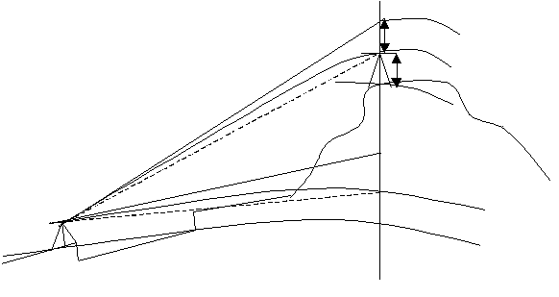
Why do we have this difference? This is because all the observation contains errors, so that the station sketch value and the surveyed value will be different.
r
ht
△H
α
hi
Refracted line of sight
c
Level Line
Level Line
Horizontal Line
Wan Chai
Trig 139
The main reason for the difference is the conditions of two observations are different. As I mentioned before, the curvature and refraction will bend the line of sight, so that it will affect the value of the observation. The line of sight between TBM B to trig 139 has to pass through the Victoria Harbor, the heat and water vapor will bend the line of sight, so that the will affected by the curvature and refraction. The weather changed every time, so we have different environment for each observation, if the conditions like temperature, pressure etc. are different, we should have different result.
And also, Distance measurement error will also affect to result. Since the working principle of the EDM is using the wave the determine the distance, so that the errors of the EDM, e.g. Zero error, Cyclic error and Scale error, can also affect the result. For example, the cross-talk error of the EDM make the waves transfer to the receiver directly, so that the distance will be affected.
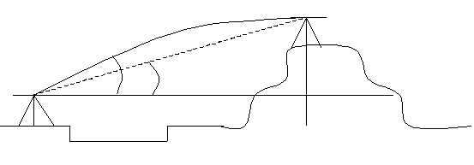
Also the elevation error can also affect the result. Since the curvature and refraction will bend the line of sight, so that the VCR reading may also be affected.
α
α’
Refracted Line of sight

In the above figure, we can see that the vertical angle was enlarged because of the curvature and refraction. The vertical angle will affect the vertical distance (ΔH) of trig 139.

