Working Diagram

Level Line From A
Refracted line of sight
X₁
d_{AB}
X₁
r
Horizontal Line
(c-r)
Instrument
Staff
X₂
A
B

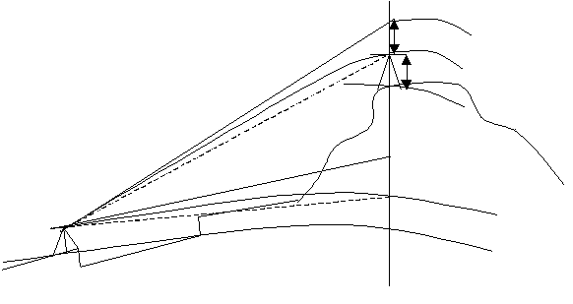
r
ht
△H
α
hi
Refracted line of sight
c
Level Line
Level Line
Horizontal Line
是原裝的~~~
from B to 139 :FL ~ HCR: 179-36-19 ~ VCR : 88-37-48 ~ SD: 3469.751
FR ~ HCR: 359-36-20 ~ VCR : 271-22-26 ~ SD: 3469.757
Hi = 1.528 , Ht = 0.282
from 139 to B :FL ~ HCR: 216-47-49 ~ VCR : 91-23-51 ~ SD: 3469.76
FR ~ HCR: 36-47-58 ~ VCR : 268-36-02 ~ SD: 3469.75
Hi = 0.263 , Ht = 1.635

