

CDE Company Limited

Course/Class
21916F/3 CAS3

Group Member

CHUNG Chun Pang | 050161110
HUNG Yuen Hei Ashely | 050599586
KO Wing Yan | 050360608
TANG Hoi Ki | 050353666

Presented to
Department of Business and services Management
Hong Kong Institute of Vocational Education (Tsing Yi)

Table of Content
1 Introduction | 3-4
2 System Definition | 5
3 Functional Requirement
3.1 Functions description | 6-7
4 Environment Requirement | 8-9
5 Feasibility Study
5.1 Economic Feasibility | 10-12
5.2 Technical Feasibility | 12-13
5.3 Organizational Feasibility | 13
6 Screen Design | 15-18
7 Database Design | 19
8 Project Plan and Control
8.1 Duration | 20
9 Bibliography | 21

1 Introduction
We are going to set up a recruitment system for CDE Company Limited’s Human resource department. CDE, Creditable Delivery Express is an international air express company to operate in Hong Kong in 2000 providing air express service.
In 2001, CDE’s Central Asia Hub at the Hong Kong International Airport began operation, covering more than 6,000 square meters and handling over 100 flights per day.
Through its international network linking more than 220 countries and territories worldwide, CDE, as part of the Deutsche Post World Net Group, is dedicated to offering customers fast, reliable, responsive and cost-effective express delivery, and transport and logistics solutions.
CDE has expanded at a phenomenal rate and this continued growth means that we are always looking for new people to embrace the CDE culture. There is a great variety of job opportunities at CDE, with openings in all areas of our Express and Logistics businesses.
CDE‘s Human resource department was employ the labour from posting employment advertisements in the newspaper and the Labour Department’s web-site. The disadvantages are the cost of the advertisement is so expensive and difficult to draw the potential employee attentions. Up to the development science and technology rapidly, most companies move to more high-tech communication. Our Human resource department also needs to update the recruitment system. These can let us easy to attract more potential employees and the cost of the advertisement can be economized.
The recruitment system gain benefits for the company are greater than the cost of the advertisement.
The recruitment system function include (1) Career opportunity (2) Position requirement (3) E-Form for the Career apply (4) Application data transfer to the date base.

2 System Definition
Our system is not a stand alone system. It included one sub-system by using html code to design. Our staff can use the sub-system to manage the database. Our system mainly got 8 components in the section. Post, Apply, Auto e-mail reply, Add, Modify, Delete, Searching and Reporting. We will post our job opportunities in our web site. People can click into and look about the job requirement and the details. If they confirm to apply, then they can click “Apply Now” to fill in their information and click “Apply”. After that, our system will send out the reply e-mail to applicants aim to inform them we received the applications. Then we will use the sub-system to add, modify, delete, search and Report. We need a server to be our database. And this server should be working 24hours. Some computers to manage the data and 1 printer with printer server use to print out the report.

3 Functional Requirement
We mainly got 8 components in the section. Post, Apply, Auto e-mail reply, Add, Modify, Delete, Searching and Reporting.
3.1 Function Description
Post
Our HRM manager will log in to our web site. And in the site will have the “Posting Job” function. They can post the job though this function. They can also delete and modify the post in the webpage.

Apply
When people found the job they want. They can click the job name. The page will show the job requirement and the details of the job. If want to apply the job. They just need to click the “Apply Now” icon, fill in the form details and apply the application. That information will transfer to our 24 working hour’s server.

Auto e-mail reply
After the server received the application, our system will send the e-mail to inform applicant than we have received their application automatically.

Add
We may ask some applicants to interview, after interview HRM manager may have some comment of him or her. They can add those comments in the remarks items.

Modify
They can also modify the comment or the marks of the applicants.

Delete
We will keep the applicants’ data until 3 months after we found a suitable person of the job.

Searching
HRM manger can search the applicants by using the searching function. They can sort by different items. Such as they can sort by name, age, sex, education, experience, skill and remarks

Reporting
At last, after we search we can print out a report by sort of different items, since that, we can find out the person what we are looking clearly. And that will be more efficiency of the employment.

4 Environment Requirement
In our company, the system can run on every computer which computers in Human Resources Department and had installed the system. Every staff has a password that can search the interviewers’ information. This system is a software which using in a web browser. The system should be able to fit in a pocket or purse. This system should be convenient for our user. It should be simple and clear, and the system can use for a long time. The system must be available for use 24 hours per day and 365 days per year. Because the recruited one is possible any time send their information to our serve, and then save the information to the system to analyses. In the company, only the managers have power to consult personnel records of the staffs whose information store not less then 3 months.
Nonfunctional Requirement:
- Operational Requirement: The system will operate on Window 2000 and XP only. And the system will able to read and write Word document, PDF and HTML. Also, the system will be able to import Gif and Jpeg graphics files.
- Performance Requirement: When the user run the system, the response times must be less then 5 seconds. Because use less times to response, the users will have more times to do the other works. The inventory database must be updated in real time, that the users will not miss any information.
- Security Requirement: There are no special security requirement are anticipated. All managers and staffs need to use their own password to log in the system.
- Cultural and Political Requirement: There are no special cultural and political requirements are anticipated. However, we are not permit the users use the system illegitimate.

5 Feasibility Study
5.1 Economic Feasibility
We would consider the financial viability before we build the system of recruitment, CDE. Economic feasibility addresses the economic justification of the project. Here, we attempt to determine if the value of the project's benefits justifies investing in the project's estimated costs. Due to we decided to build up a system, based on the development cost included development team salaries, consultant fees, development training, hardware and software, vendor installation, office space and equipment and data conversion costs. On the other hand, operational costs included software upgrades, software licensing fees, hardware repairs, hardware upgrades, operational team salaries, communications charges and user training. In the comparison between development costs and operational costs, development costs is cheaper than operational ones as we build up a system by ourselves, we just need to employ some professionals and even if the system was broke down, we also can repair it by ourselves, as it should be lower cost. Moreover, it will reduce in staff about human resources and the IT costs which are tangible benefits and also can improve our customer service which is intangible benefits since the system is fast.
We should determine the cash flow and assess the Net Present Value, Return on investment and Break Even point.

Cash flow of CDE about recruitment

 | Year 1 | Year 2 | Year 3 | Year 4 | Year 5 | Total
Costs | $ | $ | $ | $ | $ | $
Development | 800,000 | 750,000 | 700,000 | 500,000 | 550,000 | 3,300,000
Operational | 500,000 | 590,000 | 605,000 | 650,000 | 670,000 | 3,015,000
Total Costs | 1,300,000 | 1,340,000 | 1,305,000 | 1,150,000 | 1,220,000 | 6,315,000
Benefits
Tangible | 50,000 | 50,000 | 50,000 | 50,000 | 50,000 | 250,000
Total Benefits | 50,000 | 50,000 | 50,000 | 50,000 | 50,000 | 250,000
Costs-Benefits | 1,250,000 | 1,290,000 | 1,255,000 | 1,100,000 | 1,170,000 | 6,065,000

Determining the NPV, the interest rate is very important for the return. As our company is going to build up the system, it has to raise funds by debt and issuing shares. It is willing to build up the system only if the project's expected cash flows are sufficient to provide the required return on capital to the debt and equity investors (cost of capital). If NPV > 0, that is increasing our company value. However, if NPV < 0, that is unacceptable. This method can quantify the time value of money and the whole life of the project is considered. The other point is the most important which is break even. Since the longer it takes to break even, the project will take higher risk.
5.2 Technical Feasibility
In our project, we are going to create a system which helps our staffs arrange the information of the interviewer. We aim the users and analysts familiarity with the business application area. This system can lighten the work load of staffs. After use this system, all users and analysts will find that the efficiency is raised. This system will convenient our staffs, they will have leisure time to work other things. And now a day, many things are use higher technical. So I think that we should use the system to help our staffs.
About the system, we aim to follow the example of some soft wares which our staffs have an intimate knowledge. For example, Microsoft Word or Excel. Even like some television role play games. You can enter some information to the system to find something you want.
In this project, we need to have 3-5 people to work 1 month or 8-10 people to work 2 weeks. And we merely need one person has two computers and total 10-15 calculators. After we finish this project, we will check the system every year. We will find some improve to make the system go up a storey still higher.
And this system, it is compatibility with existing systems absolutely. Our system can compatible with other existing systems operate on Window 2000 and XP.
5.3 Organizational Feasibility
As the objectives of company, is dedicated to offering customers fast, reliable, responsive and cost-effective express delivery, and transport and logistics solutions.
The goal of our project is to set up a recruitment system to employ suitable and reliable staff to appropriate job vacancies. The other goal of project is to provide a fast, an economical way and a wide assessed system.
Our strategic alignment will be success, it is because of our recruitment system is base on the company benefit, the user’s demand and the customers needs.
Stakeholder analysis: (1) Project champions, they are also the Organizational management. Our company will employ some professional to make the system. Only the Organizational management group can have login name and password. In the system they can post job and select the most suitable applier. (2) System users, all the job seeker who is interested of our company position are the system users. Our company‘s customers are also the system users. They can glance at our site to look around our company background and services.
The recruitment system is only used by our company. It can’t used by other department of the company and the other express company.

6 Screen Design
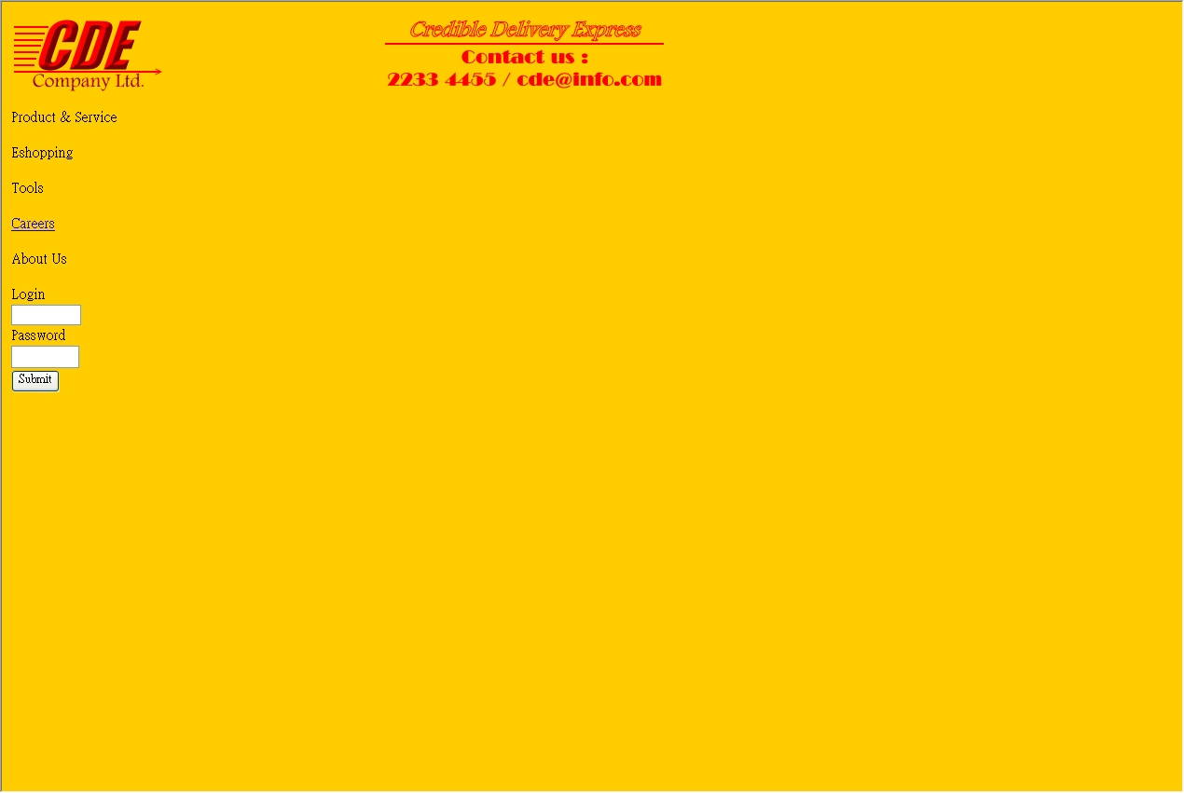
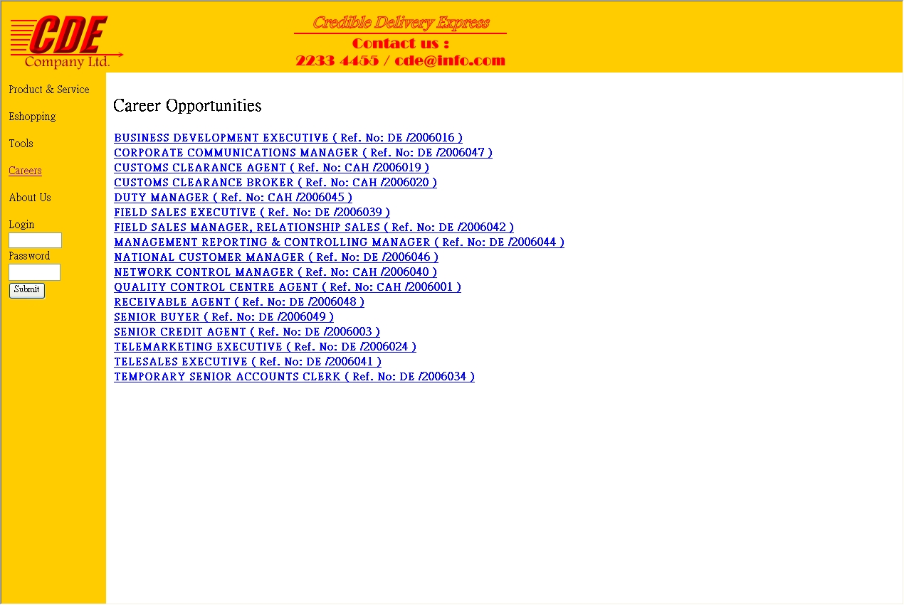
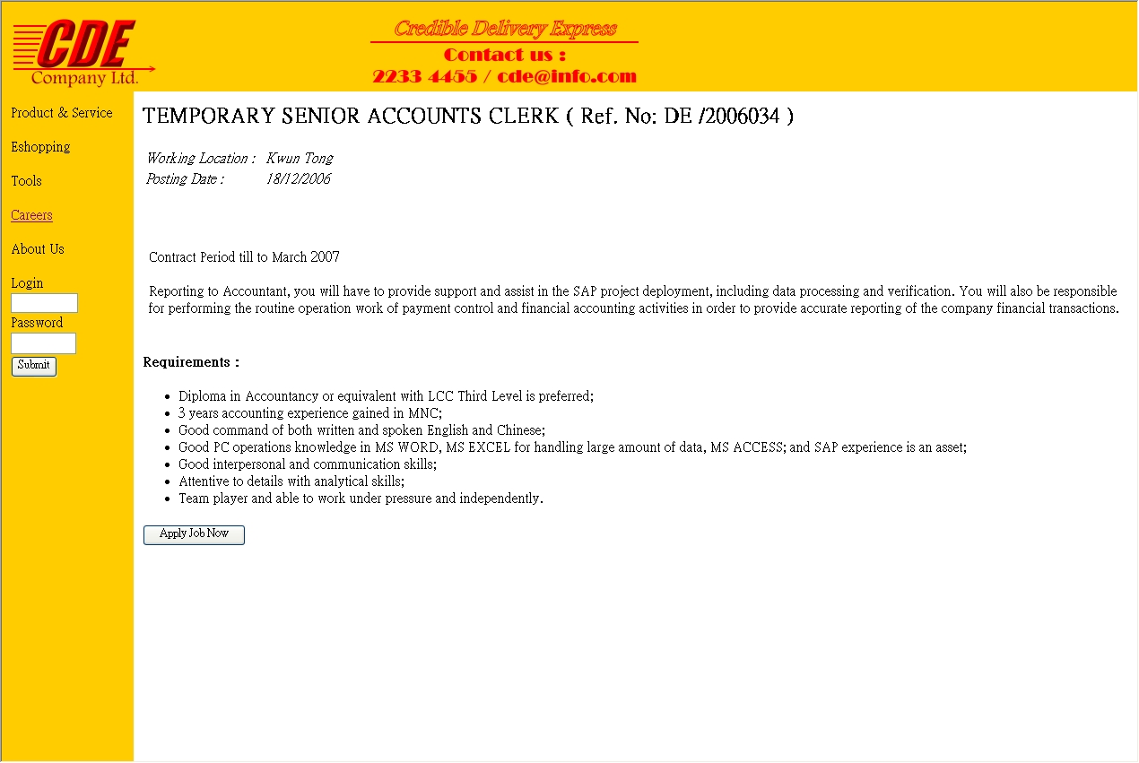
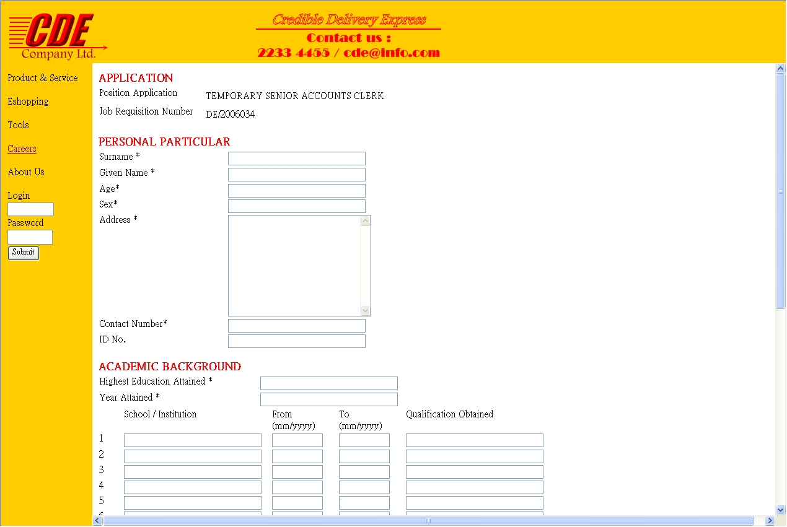
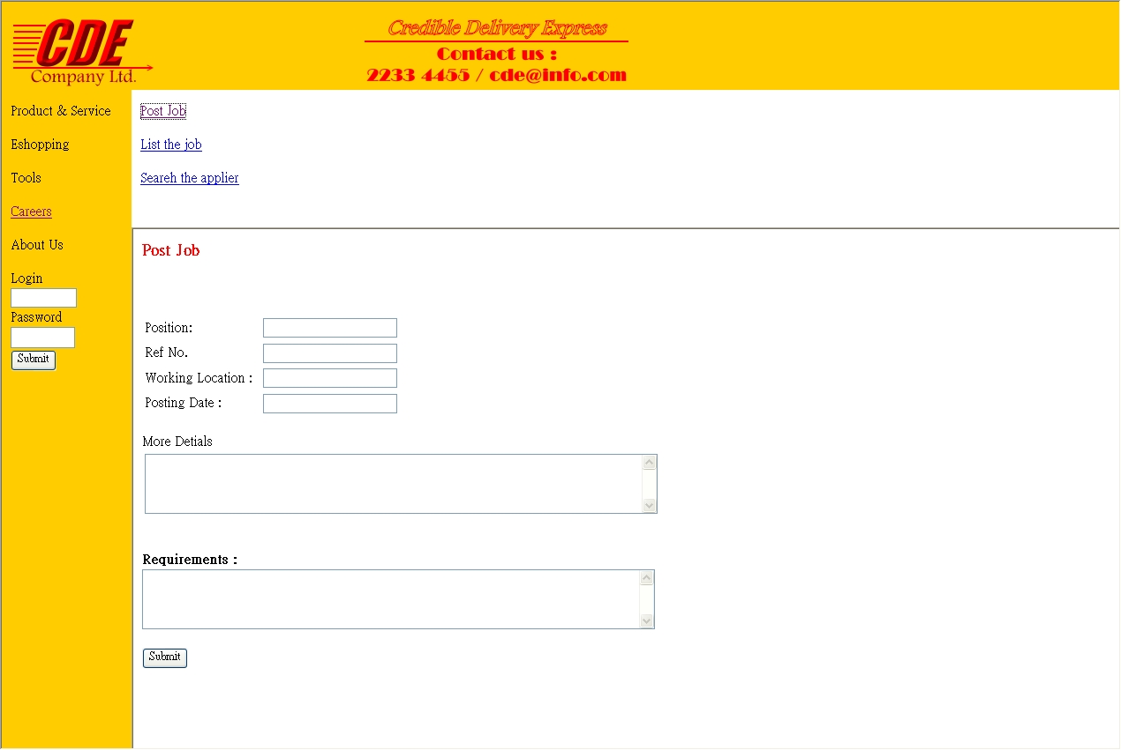
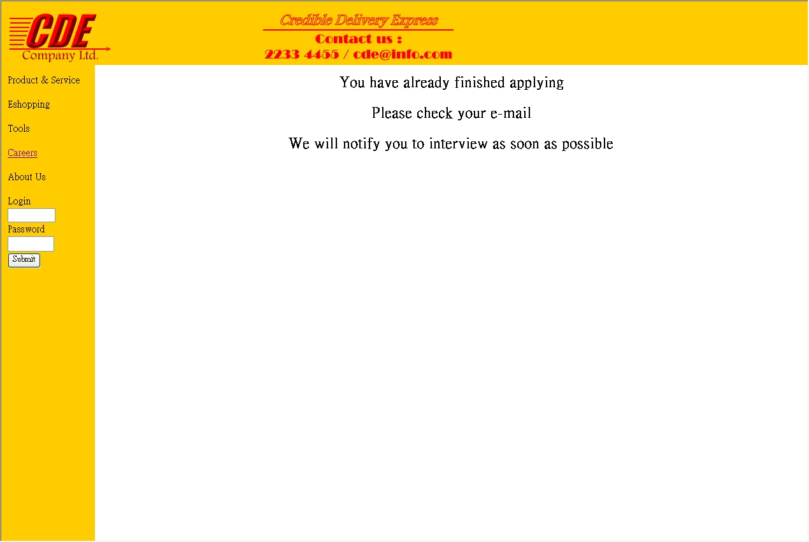
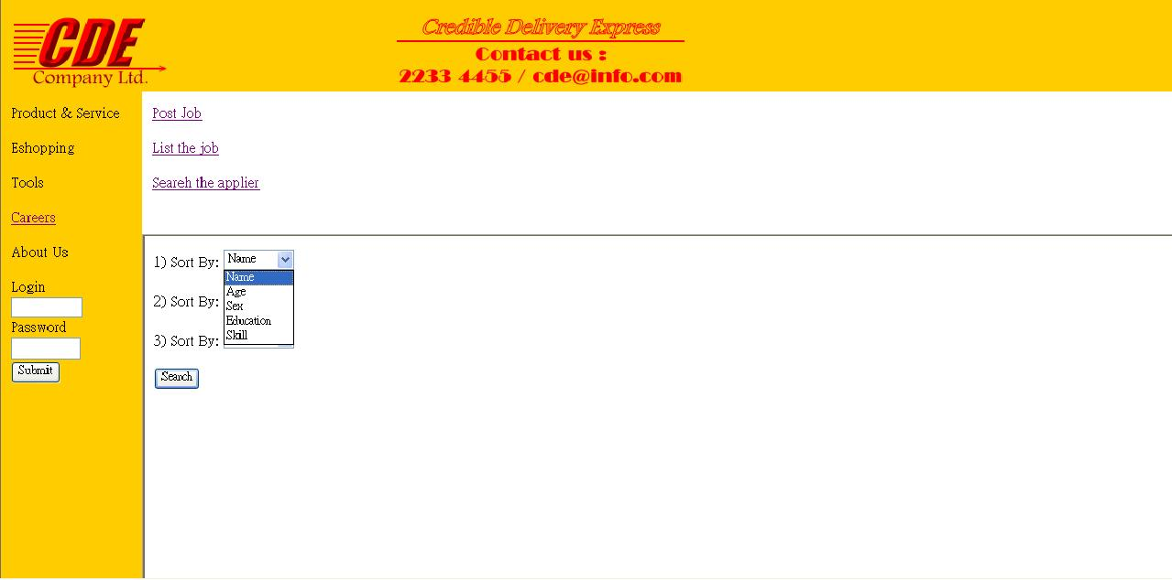
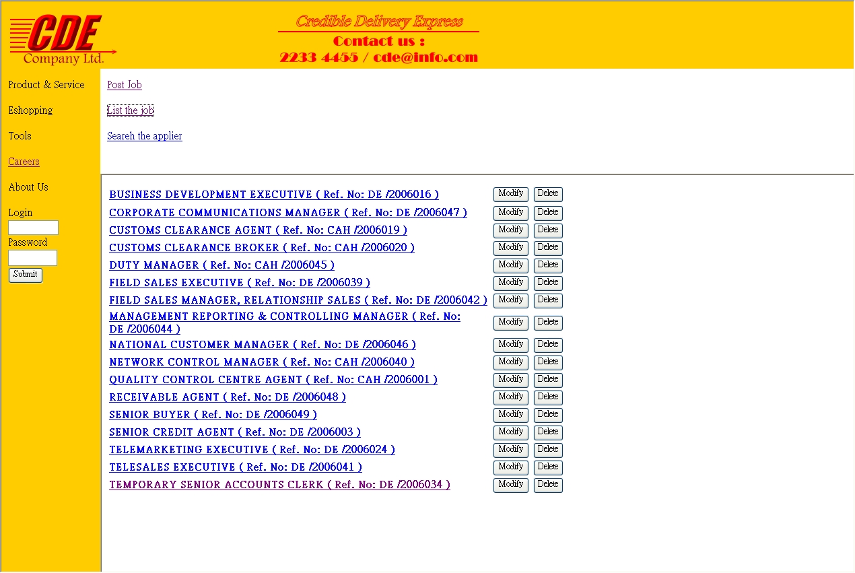

7 Database Design
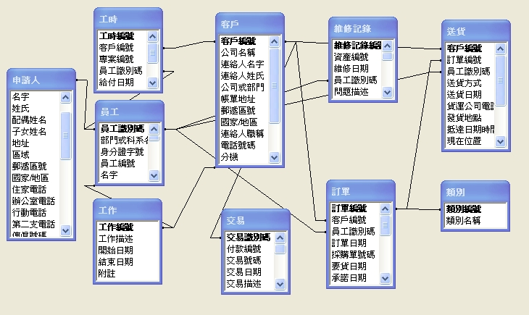

8 Project Plan and Control
8.1 Duration

Mission Name | Duration | Start | Finish | Name
Project Plan (rev.) | 118 days | Mon 11/9/2006 | Mon 08/01/2007
 | 118 days | Mon 11/9/2006 | Mon 08/01/2007
Project initiation | 90 days | Mon 11/9/2006 | Mon 11/12/2006
Marketing research | 90 days | Mon 11/9/2006 | Mon 11/12/2006 | All
Business Analysis | 94 days | Mon 11/9/2006 | Thu 14/12/2006
Review existing system | 99 days | Mon 11/9/2006 | Tue 19/12/2006 | All
Establish feasibility factors | 19 days | Thu 14/12/2006 | Mon 01/01/2007 | All
Group Meeting | 10 days | Tue 19/12/2006 | Thu 28/12/2006 | All
Problem analysis of the project | 10 days | Tue 19/12/2006 | Thu 28/12/2006 | All
Project Proposal | 6 days | Thu 28/12/2006 | Tue 02/01/2007
Distrubute parts to other member | 0 days | Thu 28/12/2006 | Thu 28/12/2006 | All
Group Meeting | 3 days | Sun 31/12/2006 | Tue 02/01/2007 | All
Doing the project proposal | 4 days | Sun 31/12/2006 | Wed 03/01/2007 | All
Revise proposal | 0 days | Mon 01/01/2007 | Mon 01/01/2007 | Yan
Systems Analysis | 20 days | Thu 14/12/2006 | Tue 02/01/2007
Site Map design | 12 days | Wed 20/12/2006 | Mon 01/01/2007 | Ashely, Ki
Database Design | 10 days | Fri 22/12/2006 | Mon 01/01/2007 | Ashely
Group Meeting | 3 days | Tue 02/01/2007 | Thu 04/01/2007 | All
Analysis the problem of system | 4 days | Tue 02/01/2007 | Fri 05/01/2007 | All
Web Design | 12 days | Mon 18/12/2006 | Fri 29/12/2006
Data Input | 6 days | Mon 18/12/2006 | Sat 23/12/2006 | All
Layout Design | 8 days | Thu 21/12/2006 | Thu 28/12/2006 | Ashely
Group Meeting | 4 days | Sat 30/12/2006 | Tue 02/01/2007 | All
Draft the initial system (Prototype) | 4 days | Sat 30/12/2006 | Tue 02/01/2007 | Pang
System Development | 7 days | Tue 02/01/2007 | Fri 05/01/2007
Group Meeting | 0 days | Tue 02/01/2007 | Tue 02/01/2007 | All
System Development | 4 days | Tue 02/01/2007 | Fri 05/01/2007 | All

9 Bibliography
- DHL Hong Kong
http://www.dhl.com.hk/publish/hk/en.high.html

