Company Summary
P&T Footcare is a Partnership Company set up at 2007. The name contains two elements. There are “P(Professional)” and “T(Trendy)”. We provide high quality healthy and trendy footwear under a competitive pries and our target customers are all people who need healthy footwear.

Our capital is come from our shareholders. We have four shareholders in our company, which includes Alice, Nicola, Candy and Frederick. The shareholders have budget in their bank. The capital is used to establish the company, afford some company’s expenditures and expand the business of the company.

Mission
Our mission ensures that our customers have healthy foot and care about their health of food. Customers will like our services and products. We think that the products are suitable and comfortable for our customers. We expect that our customers smile after they bought our products.
We will provide many kinds of products for our customers to chose. Our products are healthy and trendy, and then we would like to set a reasonable price for this. We ensure that they have enough purchasing power to buy our products. Besides, we hope that our shoes are suitable for our customers’ feet and satisfy our customers’ demand.

We will provide professional service for them. Customers can ask our staff some questions about protect feet. We will try our best to give them some professional opinions about foot care.

Also we will provide free assessment and consultation to the customers. It can let our customers to find what problem they have about their feet. We will give the best serve what we can do to the customers.

Objectives
We will set the targeting income for our company. We anticipate that we can sale$4,320,000 in first year. We use this income to pay the expenditure and all liabilities of the company. In the first year, we have the deficit about (-83,131). We want to decrease the current liabilities quickly in few years, so we will discount for our products in seasonal sale to improve our sales volume. After that, we hope that we can be breakeven within two years. Besides, we expect that we have profit in the third year.

Also, we want to attract more people to visit our shop and buy our product. We hope that our customers will come back whose visited our company before. We will give them good services when they coming. All of our company staffs will always improve themselves or accept some training course. We think that customers will feel happy after they came to our shop.

Key Success Factors
We believe that our company is successful, because our location is convenience. We will find a suitable location base on our target market. The location is traffic convenience. Customers can take on traffic vehicle or MTR to visit our shop. There have car park near the shop which provide for customers.

Nowadays, many people pay attention to healthy and trendy, so trendy and healthy are another successful factor such as stylish shoes. This is very important for the end-users. Some companies are sale healthy shoes in the market, but the style of shoes is unfashionable and the specific weight of health is not enough. People may not like these. Our shoes are attached important to trendy and health, thus attract more people to buy our products.

Also, we will provide free professional skills and technologies to our health conscious customers. It can make customer to pay more attention to their foot and know more about food care.

Marketing plan
Our company is a small size in the market. It is a new company. We only have one shop at this time. We hope that we can expand our company, so we will increase at least one branch store in following three years. We hope that our company can cover Hong Kong area

We will set the targeting sell is at least one hundred shoes per weeks. Nowadays, many people like shopping and buy shoes. We think that we have ability to sales more shoes to customers.

We anticipate that our company can make profit as fast as we can. We need to be break-even in short term first. We hope that our revenue and expenditure are balanced in the two years. Then, we can have profit after break-even.

Nurse shoes are necessity. It is because there are many nurses in Hong Kong. They need to use nurse shoes when they work in hospital or clinic. In the following two year, we will detrude nurse shoes.

We will give many kinds of products to customers to choose. So, our products are diversification. It is main ideas of our marketing plan.

We will design more shoes in the future and change in the period. It is because we want to make sure our product is trendy and give the customers to have fresh feeling. They will not feel boring from our products. It can make them to visit our shop continuously.

We will maintain good relationship with our customers. We would always improve our profession knowledge by ourselves. When customers go to our shop, we will give them a friendly smile to them. They will feel comfortable and kindly from our shop. We will give them some discount if they buy many products from our shop.
Management Team
Our company is a partnership company, so our scale is too small. We have four shareholders which should carry on all operation and jointly and liable for the debts. We only hired one manager to manage the staff, handle the general operation and report to the shareholders. Our shareholders holding meeting with the manager and staff in every Monday. After that, we hired six staff under the manager. They responsibilities handle some duties such as order the products and order the delivery company to deliver the products to our shop etc. We won’t establish our design department, logistic department and accounting department owing to decrease our expenditure. We will hire Logistic Company to deliver our products. We will hire Accounting Company to handle the problems of finance and accounting. We will hire Design Company to design our products base on our idea. Also, we will hire a Production Company to produce our products, thus our deficit will be release in the following two years.
Targeting
Our target customers are one year old to eighteen year old or above. The gender would be both male and female. We have five series for our customers. The first type is baby series, this target is from new born baby to two year old. The second is children series. We set this age range from three to twelve year old. The third is teenager. The age range is from thirteen to nineteen year old. We have a line designed specially for the lady. This line we target for sixteen to thirty years old lady. And the last one is an adult series. This is for eighteen to the above.
Marketing mix (4P)
Product
There are different kinds of shoes for our customers to choose. The shoes are healthy and trendy. We hope that our customers can choose suitable and comfortable shoes. The categories of our shoes have a great variety, including high-heeled shoes, wedgies, sandals, sports shoes and leather shoes. The customers can choose the shoes what they want in our shop.

Price
We will set suitable selling price for our customers. We hope that our customers will feel the price is reasonable. They will buy it happy. The wedgies is about $100 to $150, sandals is about $150 to $200, the leather shoes is about $200 to $250, high-heels shoes is about $250 to $300, sports shoes is about $300 to $350.

Promotion
We will make leaflets, posters, direct mailing, and website to promote our company.
We will make some leaflets and distribute to the people near our shop. The leaflet has been well designed and introduced our product features. We would also make attractive posters and displaying in our shops. We would also use direct mailing to attract customers coming. Moreover our website will show more details of our company. And then we would keep updating our information. It can let more people who like Internet to know more about us.
Then, we would do effective promotions like discount, giving premium, etc. In the first week of open, we will make 20% discount. After first week, we will make 10% discount if the customer buy two pairs of shoe.
Besides the above mentioned, we would issue member cards also. If our customers will buy our products valued $650 or above, they can join our VIP membership. Joining our membership, members could receive company information, coupons, premium, etc.

Place
Our shop will set up in Mong Kok. It is because the place is very convenient. People can take MTR, bus, mini bus, etc, to go our company. Customer flow there is very high also. It will be more people to know us. And we expect that our sales would be very good.

SWOT analysis
Regarding strength, since we have just one store, we could focus our idea on only one point. We can realize the customers’ opinion more. Also, we have professional skills and rich knowledge about foot care, communication and retail skills. So we could provide the professional opinion for the customers. Apart from these, as we mainly sell fashion style and healthy shoes at economical price, a lot of customers could be covered. We have the quality control to ensure the quality of product.

Regarding weakness, we have lower market share than our competitors like Dr. Kong and Next. Besides, because of newly open, our popularity is less.

Regarding opportunities, we have larger development room than other competitors because our company is just incorporated. Also, we can introduce our product to a lot of customers.

On the threats, we have some competitors like Dr. Kong. They sell similar products.

Quality Assurance
For product, we provide 7 days warranty. If any customer buying the product and find it have any damage or problem, we can refund full payment within 7 days. Also, we insist the rules of 5S, it include structure, systematize, sanitize, standardize and self-discipline. For service, we set the sales target to encourage salesman. If anyone passing sales target, they can earn attractive commission. We provide on the job training for employee. It includes communication skills and foot care knowledge. Also, we will do survey to collect customer opinion and to know their demand.

Organization Structure

Shareholder
Nicola Chan
Shareholder
Frederick
Shareholder
Alice
Shareholder
Candy
Manager
Staff
Staff
Staff
Staff
Staff
Staff

Invoice

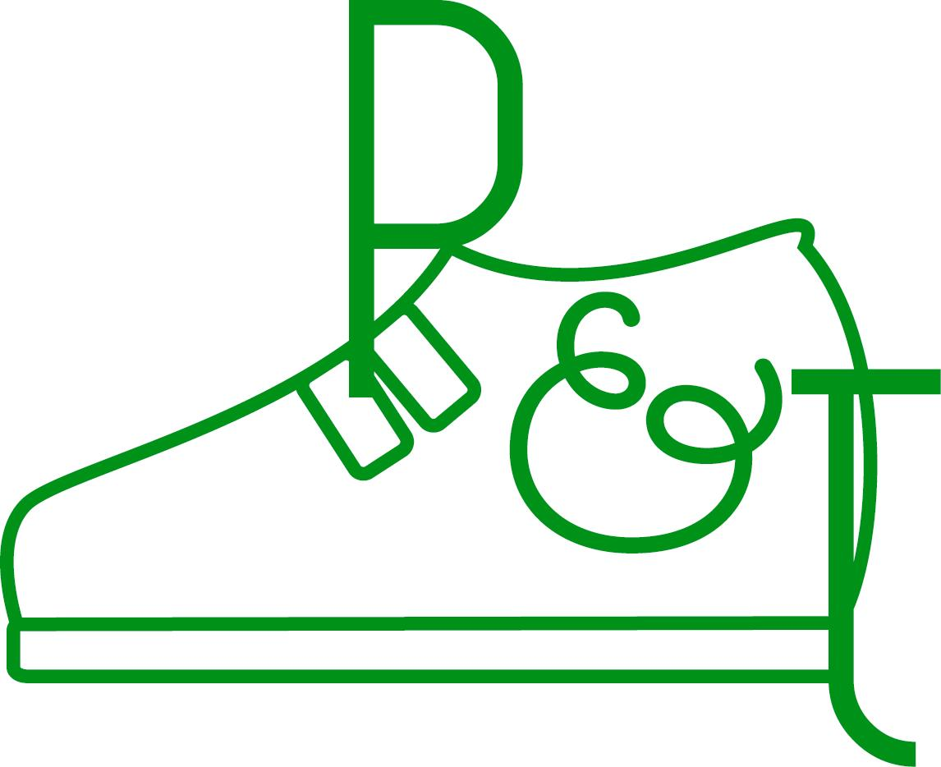P&T Footcare

Address: Shop 506, Longham Place. 8 Argyle Street, Mongkok, Kln.
Phone No: 22882288
Fax No: 22882289
Invoice No.:
Date:

INVOICE

CODE | ITEM | QUANTITY | UNIT PRICE | TOTAL  HK $
 |  | TOATAL (GROSS)
 |  | LESS: DISCOUNT (x%)
Signature: |  | TOTAL (NET)

Cheques should be crossed and made payable to “”.
Invitation Letter

Dear Sir,

We are third year students of the Higher Diploma in Corporate Administration and Systems at the Hong Kong Institute of Vocational Education (Tsing Yi). This year we need to do the Entrepreneurial Skills and Practice project related to set up a simulated business in food care field.

We know that the Dr.Kong is the famous brand in the foot care product market, so we would like to know more about your operation of the business. We will appreciate that your organization can provide useful information and share your experience regarding key successful factors in running a successful business.

All information and details are mainly kept confidential and all data gathered is for study purpose.
Finally, we would like to ask for your convenient time for interview which is normally last for half an hour. We would like to prefer the interview to be conducted in November at your workplace and at your preference timeslot. We appreciate that if you can give us a time for the interview.

Please do confirm your availability for the company visit. Please feel free to contact me through email (nicolachan_1904@yahoo.com.hk) if you have any questions.

Once again, thank you very much and hope we would be to hearing from you soon.

Best regards,

Nicola Chan
Profit & Loss Statement
 |  | 2007 |  |  |  | 2008 |  |  |  | 2009
 |  | $ | $ | $ |  | $ | $ | $ |  | $ | $ | $
Sales |  |  |  | 4,320,000 |  |  |  | 6,200,050 |  |  |  | 6,500,320
 | Less: Cost of goods sold
 | Inventory of finished goods (Opening) |  | 0 |  |  |  | 740,500 |  |  |  | 550,432
 | Add: Purchase |  | 2,500,631 |  |  |  | 1,708,993 |  |  |  | 1,803,267
 | Carriage Inwards |  | 100,500 |  |  |  | 98,500 |  |  |  | 97,000
 |  |  | 2,601,131 |  |  |  | 2,547,993 |  |  |  | 2,450,699
 | Less: Inventory of finished goods (Closing) |  | 740,500 | 1,860,631 |  |  | 550,432 | 1,997,561 |  |  | 432,050 | 2,018,649
 | Gross Profit |  |  | 2,459,369 |  |  |  | 4,202,489 |  |  |  | 4,481,671
Less: Expences:
 | Administrative expense:
 | Accountant's wages | 300,000 |  |  |  | 300,000 |  |  |  | 300,000
 | Rent | 1,056,000 |  |  |  | 1,600,000 |  |  |  | 1,750,000
 | Insurance | 105,000 |  |  |  | 201,050 |  |  |  | 201,050
 | Lighting | 120,000 |  |  |  | 155,000 |  |  |  | 180,020
 | General expense | 75,000 |  |  |  | 95,000 |  |  |  | 95,000
 | Depreciation on Computer | 6,500 | 1,662,500 |  |  | 7,500 | 2,358,550 |  |  | 7,500 | 2,533,570
 | Selling and distribution expense:
 | Sales representatives' salaries | 768,000 |  |  |  | 1,400,000 |  |  |  | 1,450,000
 | Carriage outwards | 96,000 | 864,000 |  |  | 84,000 | 1,484,000 |  |  | 83,000 | 1,533,000
 | Financial charges:
 | Discount allowed |  | 16,000 | 2,542,500 |  |  | 14,000 | 3,856,550 |  |  | 11,000 | 4,077,570
 | Net Profit |  |  | -83,131 |  |  |  | 345,939 |  |  |  | 404,101

Balance Sheet
 |  |  |  | 2007 |  |  |  | 2008 |  |  | 2009
 |  | $ | $ | $ |  | $ | $ | $ | $ | $ | $
Fixed Assets |  | Cost | Depreciation | NBV |  | Cost | Acc. Dep. | NBV | Cost | Acc. Dep. | NBV
Computer |  | 130,000 | 6,500 | 123,500 |  | 130,000 | 14,000 | 116,000 | 130,000 | 21,500 | 108,500
 |  | 130,000 | 6,500 | 123,500 |  | 130,000 | 14,000 | 116,000 | 130,000 | 21,500 | 108,500
Current Assets
Inventories:
Stock |  |  | 790,500 |  |  |  | 695,100 |  |  | 655,350
Trade debtors |  |  | 75,000 |  |  |  | 75,300 |  |  | 76,000
Cash in hand and bank |  |  | 65,000 |  |  |  | 70,000 |  |  | 75,000
 |  |  |  | 930,500 |  |  |  | 840,400 |  |  | 806,350
Less: Current Labilities
Trade Creditors |  |  |  | 2,000,000 |  |  |  | 1,500,000 |  |  | 1,000,000
Net Current Asset |  |  |  | -946,000 |  |  |  | -543,600 |  |  | -85,150
Financed by:
Opening Capital |  |  |  | 2,000,000 |  |  |  | 1,978,500 |  |  | 1,795,600
Add: Net profit |  |  |  | -83,131 |  |  |  | 345,939 |  |  | 404,101
 |  |  |  | 1,978,500 |  |  |  | 2,324,439 |  |  | 2,199,701
Less: Drawings |  |  |  | 0 |  |  |  | 320,000 |  |  | 465,000
Closing Capital |  |  |  | 1,978,500 |  |  |  | 2,004,439 |  |  | 1,734,701

