The Hong Kong Polytechnic University
Department of Electronic and Information Engineering
EIE331

COmmumication Fundmational

(Laboratory report)

CM071A

Frequency Modulation

Student name: | Wong Tang Paai
Student no: | 03906165D
Course no.: | 42070- Yr 2

CONTENT

- Title
- Objective
- Equipment
- Introduction
- Procedure
- Finding
- Question and answer
- Conclusion
- Reference

◆◆◆◆◆◆◆◆◆◆◆◆◆◆◆◆◆◆◆◆◆◆◆◆◆◆◆◆◆◆◆◆◆◆◆◆◆◆◆◆◆◆◆

1. Title

Frequency modulation

2. Objective

To study the operation of an FM Modulator

3. Equipment

- PC interface Box (RAT 53-100)
- FM Board 53-140
- Oscilloscope
- Feedback Power Supply 01-100
- PC with Discovery Software

4. Introduction

As in amplitude modulation, a carrier signal is modulated by the information that is being sent. The amplitude of the carrier is varied in time with the modulation source. Alternatively, as FM wave is a sine wave with a periodically varying instantaneous frequency and a constant amplitude. When no modulating signal is being applied, the carries is at its nominal frequency. The modulating signal causes the frequency to deviate. With the greatest possible deviation, the minimum frequency could be near zero and, the maximum frequency would then be about twice the carrier frequency. However, this would take a very large amount of frequency spectrum and the bandwidth would have no relationship to the modulating signal bandwidth. A set of limits is normally made on the amount that the carrier can deviate from its normal frequency and this is called the maximum deviation.

In practical 2 , a sine wave signal is used to frequency-modulate a carrier so that you can investigate the appearance of such signals in both the time and frequency domains. Notice that the appearance of an FM signal on the spectrum analyzer is similar to that of an AM signal when the modulation index is small.

In practical 3, the modulation frequency has been reduced to about 5kHz. Sine the maximum deviation is the same as the precvious practicals, the modulation index is much greater. From the equation B= 2(1+β)ω_{m,} β is small compared with f_{c}, then the modulation index is high and result B= 2(β)ω_{m}

5. Procedures

<Practical 1> <Concepts of Frequency Modulation>
In this practical the hardware is configured as shown. we have available an oscilloscope and a spectrum analyzer. Using the configuration you can see how the oscillator frequency can be controlled by an external signal. Set <Carrier level> to about half scale. Use the oscilloscope to observe that when the <manual frequency> control is moved the frequency changes. Monitor at <16> to see the voltage applied to the oscillator and <4> to see the output. Monitoring <4> use the large oscilloscope calibration to measure the total frequency range of the oscillator. Use the spectrum analyzer to confirm the frequency range measured on the oscilloscope.
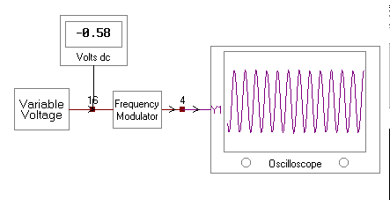

<Practical 2> (A Frequency Modulator)
In this practical, the variable voltage used to control the VCO frequency has been replaced by a sine wave oscillator. This sine wave frequency-modulates the carrier. Set <Carrier level> to about half scale. Look at the signal at <4> with the oscilloscope. Turn the <modulation level> up and down and observe the effected. Notice that the frequency is changing. Note where the output at <4> has a higher frequency. Change to monitor point <3> and observe how the instantaneous frequency depends on the instantaneous value of the modulating signal. Use the spectrum analyzer to examine the sidebands of the signal, Adjust the <modulation level> and observe that at low deviation, only the sidebands at Fc-Fm and Fc+Fm are present. At higher deviation, i.e. a larger modulation index, higher-order sidebands appear.

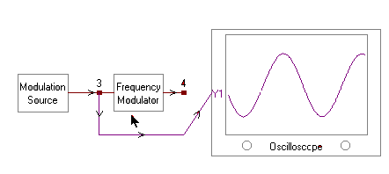
<Practical 3> (FM Spectrum with a Large Modulation Index)
In this practical, the modulation signal has been set to 5kHz. This means that the modulation index can be very high. This enables us to see that under these conditions the bandwidth of a FM signal is almost equal to twice the deviation. Set <Carrier level> to about half scale. Turn the <5kHz level> up and down and observe the bandwidth changing. Note that the bandwidth is almost proportional to the deviation.

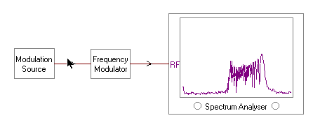

6. Finding

<Practical 1>
Pin 3 modulating input with –0.58V dc voltage | 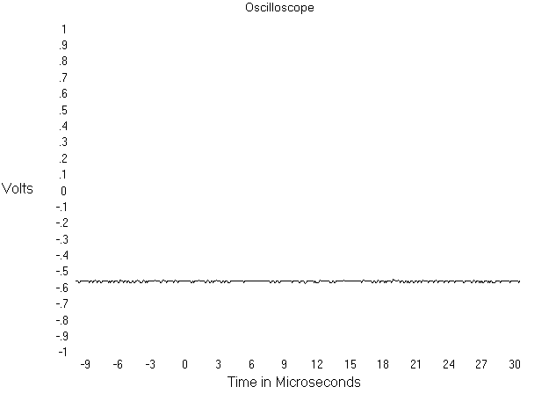
Pin 4 modulated signal output in frequency domain | 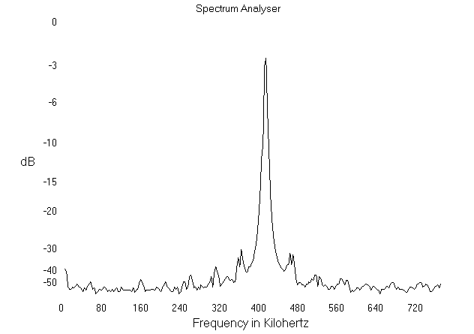
Pin 3 modulating input with Zero dc voltage | 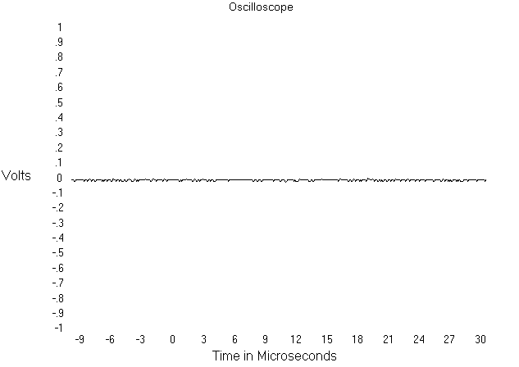
Pin 4 modulated signal output in frequency domain | 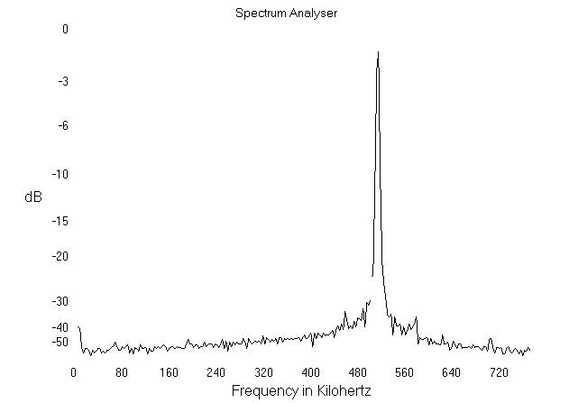
Pin 3 modulating input with 0  0.5 dc voltage | 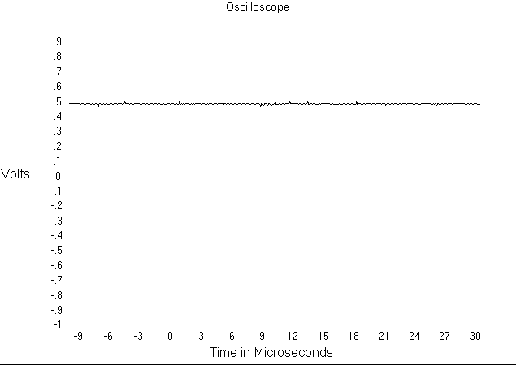
Pin 4 modulated signal output in frequency domain

d.c. Voltage at <16> | Time Period at <4> in us | Frequency at <4> in kHz | Amplitude <4> in dB
Min (-0.56V) | 2.5μs | 420kHz | -2.5dB
Half scale (0V) | 2μs | 520kHz | -2dB
Max (0.5V) | 1.6μs | 620kHz | -1dB

<Practical 2>
Pin 3 modulating input with zero d.c voltage | 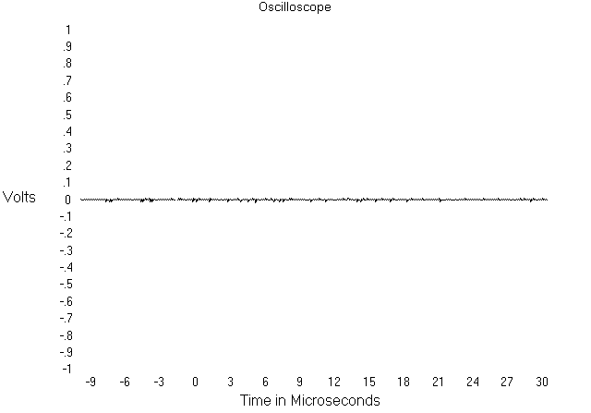
Pin 4 modulated signal output in time domain | 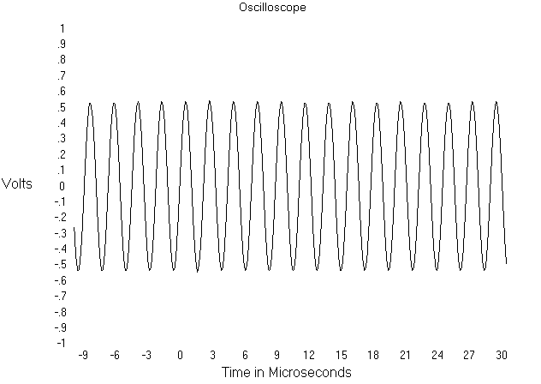
Pin 4 modulated signal output in frequency domain | 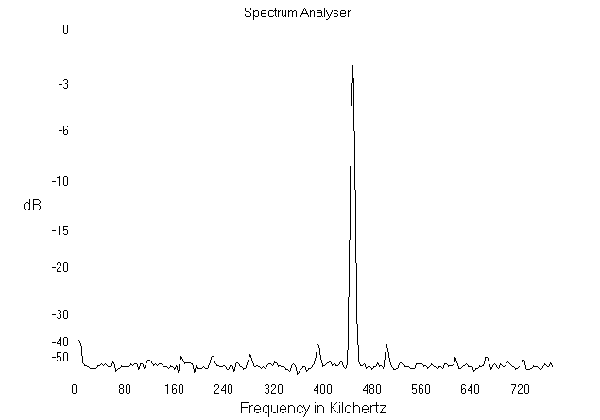
Pin 3 modulating input with peak voltage 0.5V and tone frequency 40kHz |  | 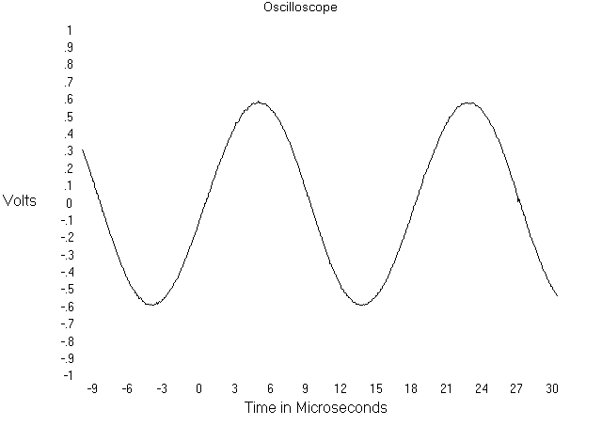
Pin 4 modulated signal output in time domain |  | 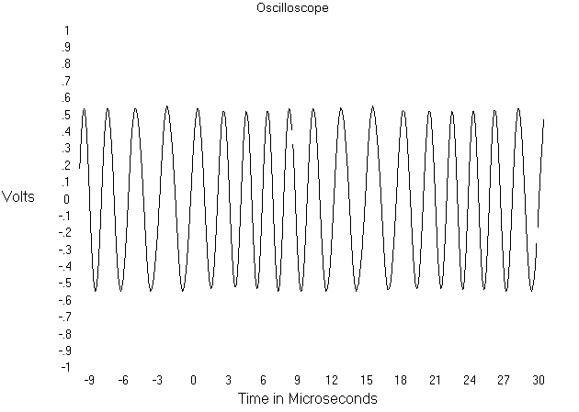
Pin 4 modulated signal output in frequency domain |  | 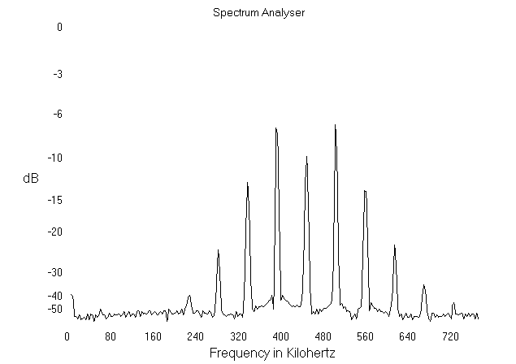

Pin 3 modulating input with peak voltage 1V and tone frequency 40kHz | 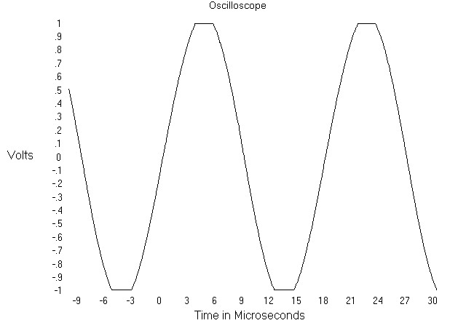
Pin 4 modulated signal output in time domain | 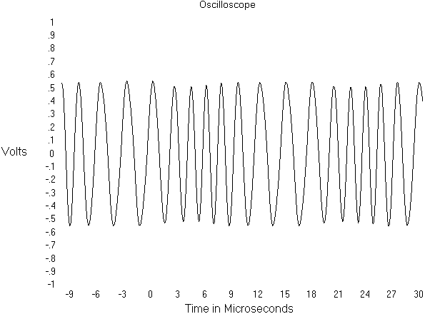
Pin 4 modulated signal output in frequency domain | 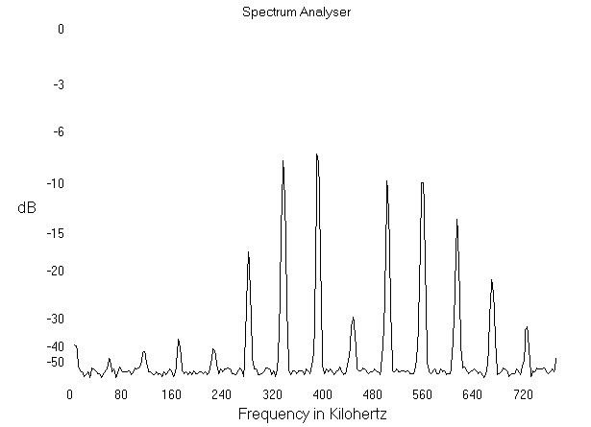

<Practical 3>
The modulated output for a zero peak voltage of modeling input | 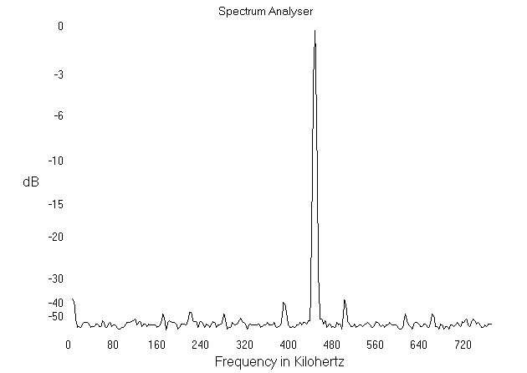
The modulated output for a min peak voltage of modeling input with frequency 5kHz | 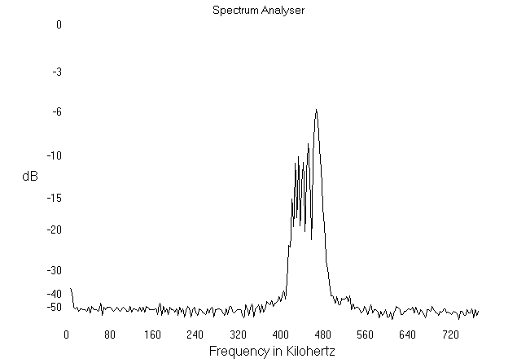
The modulated output for a middle peak voltage of modeling input with frequency 5kHz | 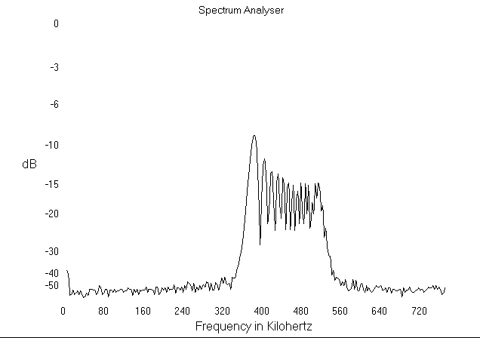
The modulated output for a Max peak voltage of modeling input with frequency 5kHz | 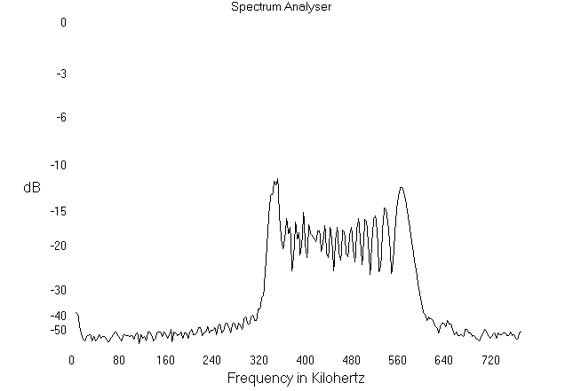

7. Question and answer

<Practical 1>
- Use the column 2 of the practical 1 table to calculate the total frequency range of the oscillator
f_{Max}-f_{Min} = 1/1.6μs - 1/2.5μs = 225kHz
- What is the total frequency range of the oscillator obtained in the column 3 of the practical 1 table?
f_{Max}-f_{Min} = 620-420 = 200kHz
- Is it easer to measure the frequency range on the oscillator or on the spectrum analyzer?
spectrum analyzer, as it can directly get the frequency by reading.
- Use the data obtained in the column 1 and the column 3 of the above table to calculate the “frequency slope” of the oscillator in kilohertz per volt.
frequency slope = 200kHz/(0.5+0.56) = 188.68kHz/V
- Can you see any amplitude variation over the frequency range from the column 4 of the above table? Should there be any?
No, as all the power is consumed by the carrier-frequency components.

<Practical 2>
- Draw the waveform observed and decide where has a higher frequency.
From the waveform in the practical 2 finding section, we find the peak of the modulating input tone frequency have a high frequency modulated output. The equation of the Fm signal is
$Φ_{\text{FM}}=A\text{cos}(w_{c}t+k_{f}\int_{0}^{t}{f(τ)dτ})$
$=A\text{cos}(w_{c}t+k_{f}\int_{0}^{t}{a\text{sin}ω_{m}dτ})$
$=A\text{cos}(w_{c}t+k_{f}a\text{cos}ω_{m}t)$
Because the modulating input frequency is fixed, cosω_{m} is also fixed. The Φ_{fm} output change it frequency only due to the change of the modeling input amplitude a. Increasing the amplitude a the modulated output frequency will increases and via verse.

- As the modulation level varies, how constant are:
a) the carrier-frequency component of the modulated signal?
b) The amplitude of the modulated signal?
Modulation index $β=\frac{{\text{ak}}_{f}}{ω_{m}}$, with the change of the input peak amplitude, β will also change. From Bessel equation we have Fm equation as following:
$Φ_{\text{FM}}=A\sum_{n=−∞}^{+∞}{J_{n}(β)}\text{cos}(ω_{c}+{nω}_{m})t$
Difference value of the modulation index, Difference power distribution of each sideband. Therefore, the change of the modulation level, will also change the power of the carrier-frequency component. However, the overall power dissipated in the modulated signal will keep unchanged. As $Φ_{\text{FM}}=A\text{cos}(w_{c}t+k_{f}a\text{cos}ω_{m}t)$, the difference of β can only change the power distribution.

- Conclude the observation from point <3> and point <4>
with the increase of the modulating input signal amplitude, the sideband of the modulated output will increased, and power consumed in the carrier frequency component decreased. The process of increase the modulation level, the output is not linear, the power distribution of each sideband and carrier is according the non-linear Bessel equation, the definition of FM modulated signal also indicate Fm is a non-linear function for a wide range of β, as the definition consist an integration. In the time domain, we find the peak of the input signal have a highest frequency in the modulated signal because of the instantaneous modulation index larger.

- Draw the spectrum with low frequency deviation and label Fc, Fc – Fm and Fc + Fm.
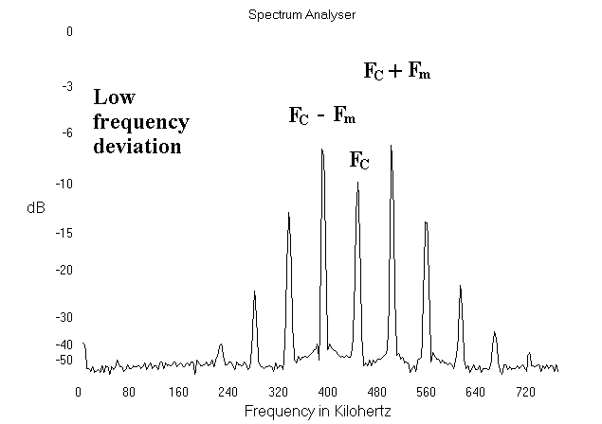

- Draw the spectrum with high frequency deviation and label Fc, Fc-Fm and Fc+Fm.
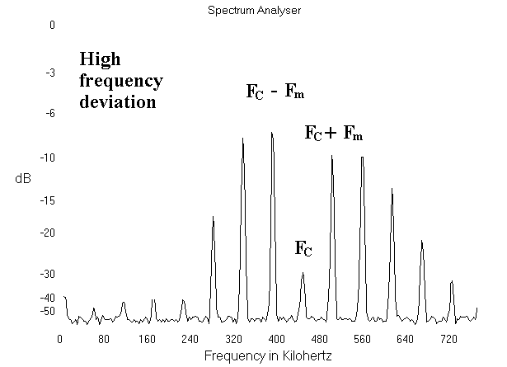

- Can you estimate the frequency of the modulating signal from the waveforms obtained? Explain briefly.
Yes, from the distribution of the power and the number of sidebands of the modulated output, we can estimate the modeling frequency. We first measure the input and output rms voltage using the voltmeter, convert it to peak value, from the spectrum output we convert the power to watt divided by the output peak voltage, we have a ratio of the power distribution of each sideband. By matching the term number and corresponding value we can find the modulation index. Because the system gain is fixed, and we measure the input peak voltage. $β=\frac{{\text{ak}}_{f}}{ω_{m}}$ we can estimate the input frequency, ω_{m}.
- Would it be equally easy to estimate the bandwidth of the modulating signal from the spectrum if the modulating signal were complex, having many frequencies?
Yes, we can adjust the modeling signal peak voltage, and result a large value of β. The bandwidth of the modulated signal can easily determined by the reading of the spectrum analysizer. For a large value β, the output bandwidth W = 2βω_{m}
<Practical 3>
- Draw the spectrum observed.
The observed spectrum output is draw in the finding section.
- If the modulating frequency is 5kHz and the frequency deviation is 50kHz, calculate the modulation index.
$β=\frac{Δω}{ω_{m}}=\frac{\text{50}\text{kHz}}{5\text{kHz}}=\text{10}$
- Calculate the signal bandwidth using Carson’s rule. Comment on the answer.
BW = 2(1+β)ω_{m} = 2(1+10)5kHz = 110kHz. Carson’s rule can calculate the approximate practical bandwidth for the circuit design. The actual number of significant sidebands for different values of β can be found from the Bessel function.
- If a bandpass filter were to be added at the input of a FM detector, what is the bandwidth required?
110kHz, otherwise part of the input frequency will be filtered and result distortion.

8. Conclusion

In this experiment, we are observed the FM modulated signal with difference modulating signal input. Because the gain K_{f} of the system is fixed, by varying the modulation level a, the modulation index β will also changed, as $β=\frac{{\text{ak}}_{f}}{ω_{m}}$. From Bessel equation $Φ_{\text{FM}}=A\sum_{n=−∞}^{+∞}{J_{n}(β)}\text{cos}(ω_{c}+{nω}_{m})t$, we find difference value of the modulation index, difference power distribution of each sideband and carrier-frequency component. The process of increase the modulation level, the output is not linear, the power distribution of each sideband and carrier is according the non-linear Bessel equation, the definition of FM modulated signal $Φ_{\text{FM}}=A\text{cos}(w_{c}t+k_{f}\int_{0}^{t}{f(τ)dτ})$ indicate Fm is a non-linear function for a wide range of β, as the definition consist an integration. In the time domain, we find the peak of the input signal have a highest frequency in the modulated signal because of the instantaneous modulation index larger. The value of β can also estimate the output signal bandwidth according the Carson rules. Carson’s rule can calculate the approximate practical bandwidth for the circuit design. The actual number of significant sidebands for different values of β can be found from the Bessel function.
<Practical 1 >, the input frequency is infinite as it is a d.c. input. Therefore, $Φ_{\text{FM}}=A\text{cos}(w_{c}t+k_{f}\int_{0}^{t}{f(τ)dτ})$ $=Φ_{\text{FM}}=A\text{cos}(w_{c}t+k_{f}\int_{0}^{t}{V_{\text{dc}}dτ})$ $=Φ_{\text{FM}}=A\text{cos}(w_{c}+k_{f}V_{\text{dc}})t$. With the increase of the modulation level, it only increases the one frequency component of the modulated output.

<Practical 2>, the input signal is a tone frequency, as the input is not d.c. voltage the output frequency component now is not linear. And it varies according the distribution of the FM Bessel equation, the channel space is ω_{m}.

<Practical 3>, the input signal frequency only 5kHz, the channel space is relative very small. Thus in the spectrum analyzer, we find the each sideband is very close. As $β=\frac{{\text{ak}}_{f}}{ω_{m}}$ this practical have a large modulation index β. By Carson rule, the modulated signal bandwidth approximately equal 2βω_{m.}

9. Reference

F.G. Stremler, Introduction to Communication Systems, Addison-Wesley, 1992.

