The Hong Kong Polytechnic University
Department of Electronic and Information Engineering
EIE303

Electronic circuit II

(Laboratory report)

EN015

The Wien Bridge Oscillator

Student name: | Wong Tang Paai
Student no: | 03906165D
Course no.: | 42070- Yr 2

CONTENT

- Title

Objective
- Apparatus
- Introduction

Oscillation principle

Wien Bridge Oscillators
- Procedure
- Data Measurement and procedure explaination
- Conclusion
- Reference

◆◆◆◆◆◆◆◆◆◆◆◆◆◆◆◆◆◆◆◆◆◆◆◆◆◆◆◆◆◆◆◆◆◆◆◆◆◆◆◆◆◆◆

1. Title

The Wien Bridge Oscillator

2. Objective

To measure the amplitude and phase response of the Wien Network and to use the network to form an oscillator.

3. Apparatus

- Audio signal generator
- C.R.O
- 10kΩ decade box
- Dual power supply ±6V

4. Introduction

This report I will illustrate the experiment result and the working principle of one popular oscillator; Wien bridge oscillators. The op-amp is capable of generating a variety of output waveforms. Basically, the function of an oscillator is to generate alternating current or voltage waveforms. More precisely, an oscillator is a circuit that generates a repetitive waveform of fixed amplitude and frequency without an external input signal.

An oscillator is a type of feedback amplifier in which part of the output is feedback to the input via a feedback circuit. If the feedback signal is in proper magnitude and phase, the circuit produces stable alternating currents or voltage, and self sustain it oscillation.

5. Oscillation principle

In this section I will try to explain why the op-amp can sustain it self-oscillation and illustrate what is happening in the two inputs of the op-amp. Because of the thermo effect in the conductor, the existence of the white noise within the whole circuit. When the op-amp is power on, the noise that appears in the input of the op-amp will regard as the input signal of the op-amp. The feedback circuit is designed that exist an oscillation frequency; this is in the transition frequency, there will be a 180-degree or more phase shift. The noise consist of all range of frequency, from 0Hz to infinite Hz, the noise signal in transition frequency will be amplified. The noise signal in transition frequency will be amplified each round of the close loop. Take a portion of the output to feed to the input, oscillation can self-sustained. Once the input signal disappears or changed, the feedback signal with appear in the input, and contribute it as the next input signal. Thus the input will have a constant or fixed input continuously.

For oscillation, the input will appear always have a signal. For a pure sinusoidal signal, tone frequency, the feedback signal must be equal to the input signal; that means the loop gain AB must be equal to one. For non-pure sinusoidal signal, the loop gain AB must be greater than one, as each round of the feedback signal will be amplified. Although, the signal will be amplified again and again, it is, however, will have a limitation, the output signal will become a square wave, because of the saturation. In this case, the fundamental frequency is the frequency that the op-amp give a phase response equal 180°. Note that this time, the oscillation frequency is not transition frequency.

In the above discussion, we will find in order to have an oscillation. There will have two criteria to fulfill. One is the loop gain, and other is the phase shift. Gain condition, the open-loop gain of the op-amp for particular frequencies must be equal of greater than one. Otherwise, the output signal will go decay. Phase condition, the phase shift of the output signal must be equal of greater than 180° for negative feedback; That means in the input of the op-amp, the previous input signal should in phase with the feedback signal, if only one feedback path applied to one input of the op-amp, the other input connected to ground. For two feedback paths, the inverting input must equal the non-inverting input. That means by subtraction, the differential input is very small. That so small signal will amplify for the next input signal by feedback.

What sustain the oscillator have a tone frequency output? One condition is the differential input of the amplifier with fixed amplitude. To ensure the fixed differential voltage, there are two approaches for the op-amp oscillator. Using one of the op-amp input, or using both op-amp inputs. For one input, the other should be directly grounded or connect a resistor and then connect to ground. This approach requires the input-output in-phase voltage. If we consider the input signal as a sequence discrete signal. In time t1 there is voltage A1, this A1 will produce output O1, through the feedback path A2 in time t2 will appear in the op-amp input. Now we see when the A2 appears in time t2, A1 will disappear in the input. If we consider the time interval very small, the input signal always continuous. (A1 disappear, A2 appear, A2 disappear, A3 appear……………) For two feedback path from the output and then apply it to both input of the amplifier. To ensure tone frequency, the inverting and non-inverting input must be the same. In fact, there is a very little different between two voltage. And this little differential voltage will be amplified and contribute it as the next inverting input and feedback voltage for the non-inverting input etc. This mechanism will continuous to sustain the stable solid oscillation.

Analyzing of the Blot Plots we have: If the frequency response plots indicate there is a frequency with gain equal or greater than one and with phase shift equal 180 degree, that circuit will have a oscillation when power on with no provided input signal.

6. Wien Bridge Oscillators

Theory

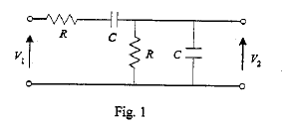

The Wien Network is shown in fig 1. It is easily shown that the transfer function V₂/V₁ is
$β=\frac{V_{2}}{V_{1}}=\frac{jω\text{RC}}{(1−ω^{2}R^{2}C^{2})+jω3\text{RC}}$
From this we deduce that when
$$1−ω^{2}R^{2}C^{2}=0$$
i.e.
$$ω=\frac{1}{\text{RC}}$$
or
$$f=\frac{1}{2π\text{RC}}$$
then
$$β=\frac{V_{2}}{V_{1}}=\frac{1}{3}$$
i.e. V₂ is in phase with V₁ and attenuated by a factor 1/3.

The Wien Oscillator

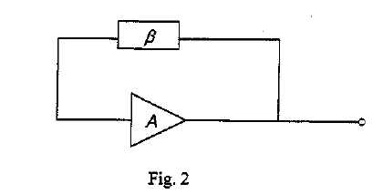
The condition for oscillation is |Aβ|=1, ∠(Aβ)=0°. These condition are fulfilled if is the Wien Network when $f=\frac{1}{2π\text{RC}}$ and A=3

The Amplifier
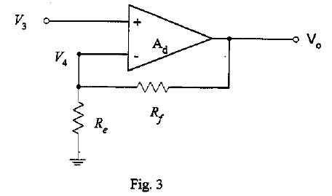
For the positive gain Op-Amp configuration shown in Fig.3. V₃≒V₄ as A_{d} →∞if Vo is finite

$$\begin{aligned}∴V_{3}=V_{o}\frac{R_{e}}{R_{e}+R_{f}} \\ ∴A=\frac{V_{o}}{V_{3}}=\frac{R_{e}+R_{f}}{R_{e}}\end{aligned}$$

7. Procedure

- Open-loop gain-phase Response
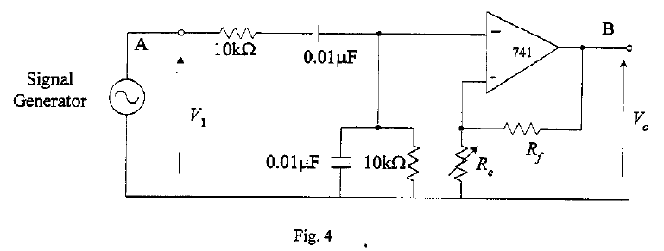
Connect the circuit as shown in Fig.4 putting:
R_{e} = 5kΩ and R_{f} = 10kΩ
Plot the magnitude, $\left|\frac{V_{o}}{V_{1}}\right|$, and phase angle $∠\left(\frac{V_{o}}{V_{1}}\right)$, of $\frac{V_{o}}{V_{1}}$ as a function of frequency from 100Hz to 10kHz. Note the frequency at which $∠\left(\frac{V_{o}}{V_{1}}\right)$=0° and magnitude of $\left|\frac{V_{o}}{V_{1}}\right|$ at this frequency.

- Closed-loop Response
- Disconnect the signal generator from the input. Complete the feedback loop in the circuit of Fig. 4 by connecting point A and Point B.
Record the output waveform with values of R_{e} = 10kΩ, 6kΩ, 5kΩ and 4.5kΩ
- Replace R_{f} by the thermistor. The resistance of the thermistor falls as its temperature rises, and the temperature rise is caused by self-heating due to the applied voltage. Observe the output voltage and explain why a thermistor is usually used for R_{f}.

8. Data Measruement and procedure explaination

In the previous section, we find the in phase output of the wien network will attenuated by a factor of 3; That is the non-inverting input of the op-amp will have 1/3 V_{i}. In order to produce a tone sinusoidal frequency, the feedback signal applies in the inverting input should be approximately equal the non-inverting input. To achieve it, the voltage divider configured by the resistor R_{e} and R_{f} should be properly selected. In this case R_{e}/R_{f} = 3, and we choose R_{e} = 5kΩ and R_{f} = 10kΩ. Thus the amplifier circuit should a close-loop gain equal 3, and the overall oscillation circuit will have a unity gain, so that the oscillation can sustain without any growing or decaying.

Open-loop gain-phase response

To plot the frequency response plots; we should measure the close-loop gain of the amplifier with respect to different frequencies input. Only the unity close-loop gain, the output can produce the tone frequency. By measurement we have following frequency response, and I found only input signal with frequency equal 1.53kHz, the phase shift is zero and unity gain.

Set $V_{i}=3V_{(p−p)}$ constant,
f | 100Hz | 300 Hz | 500 Hz | 700 Hz | 1k Hz | F₀ ₌ 1.53k Hz | 2k Hz | 5k Hz | 7k Hz | 10k Hz
$$V_{o_{(p−p)}}$$ | 0.6V | 1.5V | 2.2V | 2.5V | 2.75V | 3V | 2.8V | 2.2V | 1.7V | 1.3V
$$V_{o_{(p−p)}}$$ | 0.2 | 0.5 | 0.73 | 0.83 | 0.9 | 1 | 0.93 | 0.73 | 0.56 | 0.43
B | 1 _{Div} | 2.6 _{Div} | 2.8 _{Div} | 2.6 _{Div} | 1.6 _{Div} | 0 _{Div} | 0.4 _{Div} | 2.8 _{Div} | 2.8 _{Div} | 2.3 _{Div}
A | 1 _{Div} | 3 _{Div} | 4.2 _{Div} | 5 _{Div} | 5.6 _{Div} | 6 _{Div} | 5.9 _{Div} | 4.4 _{Div} | 3.4 _{Div} | 2.6 _{Div}
$$θ={\text{sin}}^{−1}\frac{B}{A}$$ | 90° | 60° | 41.8° | 31.3° | 16.6° | 0° | 3.89° | 39.5° | 55.4° | 62.2°

MathLab Script
>> f=[100,300,500,700,1000,1530,2000,5000,7000,10000];
>> g=[0.2,0.5,0.73,0.83,0.9,1,0.93,0.73,0.56,0.43];
>> semilogx(f,g)
>> xlabel('frequency/Hz')
>> ylabel('open loop gain')
>> title('Open-loop gain response')
>> grid
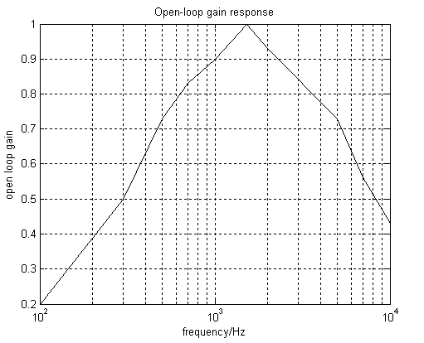

MathLab Script
>> f=[100,300,500,700,1000,1530,2000,5000,7000,10000];
>> p=[90,60,41.8,31.3,16.6,0,3.89,39.5,55.4,62.2];
>> semilogx(f.p)
>> xlabel('frequency/Hz')
>> ylabel('phase-shift/Deg')
>> tile('Open-loop phase response')
>> grid
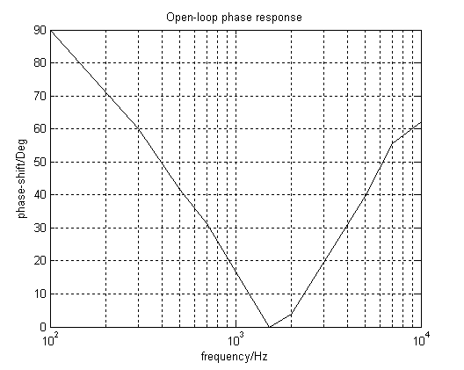

Closed loop response

The unity gain and input-output in-phase frequency is determined by varying the input signal frequency. Then we will illustrate the effect of the different feedback signal by changing the ratio of the potential divider. To achieve it, we will disconnect the signal generator from the input, the complete the feedback loop circuit. Then we vary the resistance R_{e}.

R_{e =} | 10kΩ | 6kΩ | 5kΩ | 4.98kΩ | 4.5kΩ
Oscillate | No | No | No | Yes | No

By measurement, we found only the resistance R_{e} equal 4.98kΩ, the wien bridge circuit can sustain oscillation. The reason is for this value of R_{e} , the potential divider have a ratio equal to 3, and it causes a unity close-loop gain.

Replace Rf By the thermistor

The resistance of the thermistor falls as its temperature rises. If R_{e} is too small, the flowing current will greater. The larger current will heat the thermistor causes it resistance rise in order to reduce it flowing current. Thus by properly select the thermistor, the output current will be controlled and its also control the feedback signal in a wide range of resistance R_{e}. It is very important features, as the resistance tolerant of R_{e} is increased, for the designer, he or she will no need to care the accuracy value of feedback resistance. Easier to design and more stable of the oscillation.

By varies the resistance of R_{e}, we found the following phenomenon:

- When is R_{e} 0-3kΩ, oscillation will quickly appear and the output waveform is clipped. For lower R_{e}, the waveform more like a square waveform.

- When from R_{e} 3kΩ change to 4kΩ, oscillation come out after a short period of time period. The output this time with little clipped.

- Increase R_{e} gradually, oscillation appear need more time. When resistance just change, the output have a little fluctuates, after a short period of time the output will go stable and it is a tone frequency. In this case, the output voltage swing will less than the supply voltage. For higher resistance of R_{e} the lower output voltage appear in the output. And the time required to oscillation is longer.

- When R_{e} equal 4.8kΩ, $V_{o_{(p−p)}}=3\text{.}8V$. Further increase R_{e} resistance, circuit need very long time to produce a oscillation. (longer than 10sec)

- For R_{e} ≧ 4.3kΩ, the output is tone frequency output. For R_{e} ≦ 4.3kΩ, the output waveform is clipped.

Form above phenomenon we can conclude using the thermistor to replace R_{f} circuit will go oscillate very stable in a wide range of resistance R_{e}; That is 0Ω-4.8Ω in this experiment.

9. Conclusion

In this experiment we are measure the amplitude and phase response of the wien network and to use the network to form an oscillator. By measurement, we find that in order the have a oscillation, there are certain criteria need to fulfill. The first is the gain condition, and the second is the phase condition. The feedback circuit must be designed to have frequencies that with the loop gain greater than one, and it corresponding phase shift equal 180 degree. As I mention in the oscillation principal, to produce a pure sinusoidal tone frequency, the input signal from the output thought the wien network applied to the inverting input must be equal the feedback signal that applied in the non-inverting input. In fact, there is a very little different between two voltage. And this little constant differential voltage will be amplified and contribute it as the next inverting input and feedback voltage for the non-inverting input. This mechanism will continuous to sustain the stable solid oscillation.

Because the oscillation criteria require a accurate gain condition for pure sinusoidal, the electronic components must very accurately. However, in real physical circuit, there must exist certain tolerance. Therefore, the oscillation criteria may not fulfill in some case due to the temperature change or different environment. To reduce the uncertain parameter that induced by the physical situation. Some technique will be introduced in order to modify the circuit and make the circuit more stable in a wide range of different condition. In this experiment, we are introduced the usage of the thermistor. Using the thermistor to replace one of the feedback resistor R_{f}. The circuit will go oscillate very stable in a wide range of resistance R_{e}, the other feedback resistor. R_{f} and R_{e} form the voltage divider for the non-inverting input.

10. Reference

- Op-amps and linear integrated circuits, Fourth Edition, Ramakant A. Gayakwad, Prentice-Hall
- Linear Electronic circuits and systems, G.D.Bishop, The Macmillan press LTD
- Lecture Note of Electronic circuit II, Prof. Michael Tse, Polytechnic university.

