Using Telephone Line as a DTMF Transceiver

By Dillian Wong, 13/2/04

Abstract

The primarily target of this project is to provide the interface for the telecommunication. When the sensor detects something from one side, user can send the data via the telephone line, and the other side can extract the corresponding data, analysis it, create/ update the related database.

The development of the project is target for the digitalization of the clinics or hospitals. When the devices extract the patients body data, data will stored in the devices with the ID code indicate the patients. Those devices can automatically update the patients’ database without involving any handwriting or human type in to the computer database. In this project, I implement the remote communicate, so that the patients can go out for their work and the health institution can monitor their patients condition by the DTMF Transceiver.

There have many channels available for the data transfer 1. Telephone line. 2. Internet 3. Mobile communication network, MSM. 4. Memory-stick, flopped disk, cd-rom 5. Direct line connection. Type of body data can be Body temperature, Heartbeat, Blood pressure etc.

I chose telephone line as the demonstration project is because it widely covers telecommunication. Almost every home have a telephone. The transmitter and sensor is standalone, which means no PC is require to operate the devices. Patients can measure their body data, and send this data via telephone.

Electronic Product

DTMF Transmitter:
DTMF Transmitter can transmit the phone number that stored in Eeprom. Put the tone generator's speaker next to the mouthpiece of your phone, and will try dialing a phone number! There have the PC adapted used for the data communication using the standard RS232 protocol. Via this com port, the Eeprom phone number can be modified. Two key for the user to press, one for sending the phone number stored in Eeprom, others is sending the digit that represent user ID code and following is the temperature reading from the sensor. When the phone call is connected, user can press key for the sending of tone digit represent his/her ID code and current temperature reading of the sensor.

DTMF Receiver:
When the there is a phone ring, the telephone line will pickup, the DTMF decoder circuit can receive DTMF tone. Fetch the DTMF tone to the receiver; the corresponding tone digit will be display on the LCD screen. If com port is connected to the PC, tone digit will also send to the PC instantaneously. Thus, the related software can extract the tone data that transmit via phone line. After 30sec suppose all the tone data is transmitted, and the phone line will pick down disconnect the phone line connection.

Introduction

DTMF stands for dual tone multiple frequency. When you press a button on a telephone keypad, the telephone will generate two sine waves with different frequency at the same time, the audible sounds that you hear. Eg. Press 1 is sending a tone with 1209Hz and 697Hz to the telephone line. These frequencies are called DTMF. DTMF is the signal to the phone company for phone dialing. It's also known as "Touchtone" phone and generally has replaced loop disconnect ("pulse") dialing.

With DTMF, each key you press on your phone generates two tones of specific frequencies. So that a voice cannot imitate the tones, one tone is generated from a high-frequency group of tones and the other from a low frequency group, thus the name Dual Tone Multi Frequency. Here are the signals you send when you press your Touchtone phone keys:

Hz | 1209 | 1336 | 1477 | 1633
697 | 1 | 2 | 3 | A
770 | 4 | 5 | 6 | B
852 | 7 | 8 | 9 | C
941 | * | 0 | # | D

Ring detection circuits

In computer modems the logical signal from ringing is needed instead of ringing tone. The ring circuit must pass the ring signal information to modem electronics and still provide electrical isolation between telephone line and modem electronics. This ring detection is usually done using one optoisolator circuit, which replaces the traditional ring circuit. The optoisolator output an be easily connected digital electronics, but the optoisolator input sides needs more electronics: one capacitor for not letting DC to pass through optoisolator, one resistor to limit the current passing through optoisolator LED and one reverse connected diode in parallel with optoisolator LED to prevent negative voltages from damaging the LED. This is the basic ring detection circuit.

Usually there is also two zener diodes(usually 10-20V models ) to make sure that the ring detection circuit does not detect too small AC signals in the line as ring signal. In the picture below you see a very typical ring detector circuit for modems. The circuit just gives the idea how modems ring detector circuit work. The actual component values selection must be so that the circuit meets the national telephone regulations (this can be usually easily done by using suitable zener diodes and maybe changing the resistor values a little).
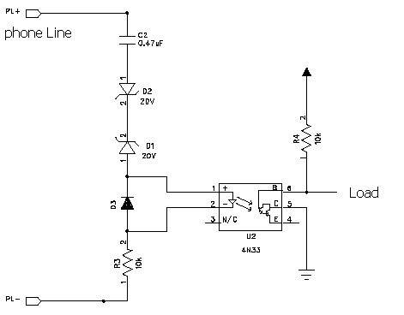
Note: you can get the circuit work by taking out D1 and D2 and replacing them with a short circuit. The circuit works after then, but it is possible that in this case some low voltage noise on the line can causes the telephone to ring at all.

PS: if you are interested in using this circuit as basic for controlling some circuit take a look at
1. http://www.aaroncake.net/circuits/pflash.htm
2. http://www.hut.fi/Misc/Electronics/circuits/telephone_ringer.html

Auto phone pickup and pick down

When the there is a phone ring, the phone line will have about ±110V voltage swing. Use two zener diodes to clip the voltage swing about ±20V and this voltage will drive the optoisolator circuit. Then microprocessor will be triggered when there is a phone ring. After several pulses (3 pulses in my program) of trigger, the processor will active the relay and causes the telephone in off hook status. After 30sec, suppose all the tone data have been transmitted, then processor will inactive the relay and causes the phone line in on Hook statues.

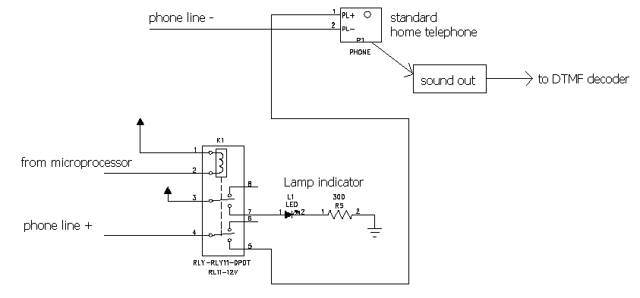

Phone chips interfacing (MT8880C)

The MT8880C/C-1 is a monolithic DTMF transceiver with call progress filter. It is fabricated in Mitel’sISO2-CMOS technology. The DTMF receiver is based upon the industry standard MT8870 monolithic DTMF receiver; the transmitter utilizes a switched capacitor D/A converter for low distortion, high accuracy DTMF signaling. Internal counters provide a burst mode such that tone bursts can be transmitted with precise timing. A call progress filter can be selected allowing a microprocessor to analyze call progress tones. A standard microprocessor bus is provided.

a) DTMF Decoder

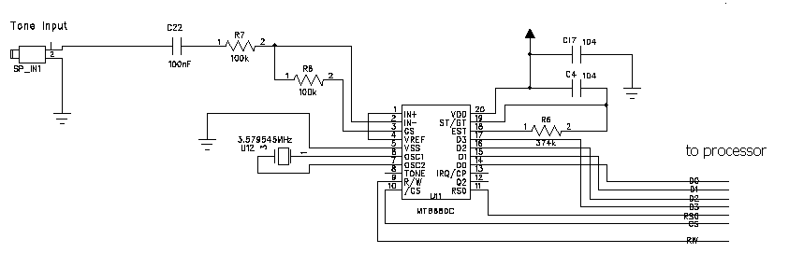
The input arrangement of the MT8880C provides a differential-input operational amplifier as well as a bias source (VRef) which is used to bias the inputs at VDD/2. Provision is made for connection of a feedback resistor to the op-amp output (GS) for adjustment of gain. In my circuit, I use two 100kΩ resistors to take a gain equal to one for simplicity. 100nF is use to block any DC signal.

Steering Circuit (Check the valid duration of DTMF tone input). Before registration of a decoded tone pair, the receiver checks for valid signal duration. This check is performed by an external RC time constant driven by ESt. A logic high on ESt causes vc to rise as the capacitor discharges. Provided that the signal condition is maintained (ESt remains high) for the validation period, vc reaches the threshold of the steering logic to register the tone pair, latching its corresponding 4-bit code into the Receive Data Register. At this point the GT output is activated and drives vc to VDD. GT continues to drive high as long as ESt remains high. Finally, after a short delay to allow the output latch to settle, the delayed steering output flag goes high, signaling that a received tone pair has been registered. The status of the delayed steering flag can be monitored by checking the appropriate bit in the status register. If Interrupt mode has been selected, the IRQ/CP pin will pull low when the delayed steering flag is active.

When the valid tone is received. The tone will be decoded. The separation of the low and high group tones is achieved by applying the DTMF signal to the inputs of two bandpass filter. Following the filter section is a decoder employing digital counting techniques to determine the frequencies of the incoming tones and to verify that they correspond to standard DTMF frequencies. When the detector recognizes the presence of two valid tones the Early Steering output will go to an active state. Any subsequent loss of signal condition will cause Est to assume an inactive state.

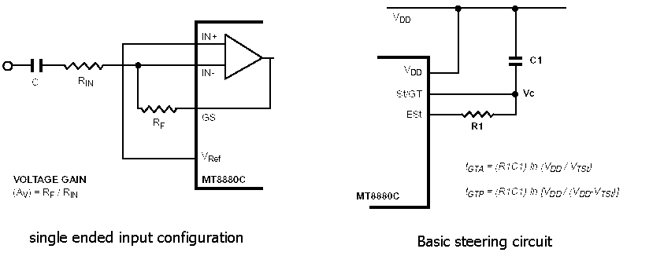

b) DTMF Generator

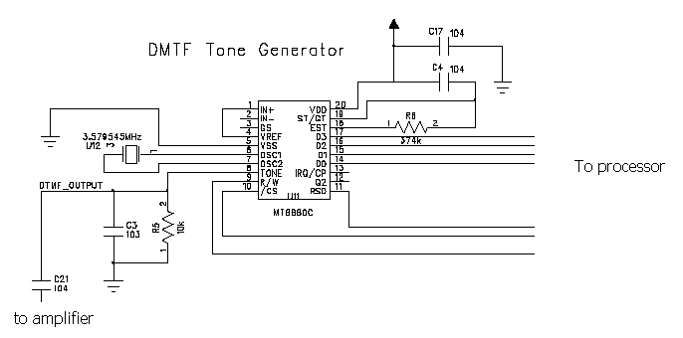
The MT880C telephone dialer from MITEL can generate the standard telephone tones. The chip can generates dial tone to make a phone call over 2-wire telephone line, tip and ring, connection. All frequencies are derived from an external 3.579545MHz crystal. The sinusoidal waveforms for the individual tones are digitally synthesized using row and column programmable dividers and switched capacitor D/A converters. The row and column tones are mixed and filtered providing a DTMF signal with low total harmonic distortion and high accuracy.

Burst Mode (Generate the standard DTMF signal timing) In certain telephony applications it is required that DTMF signals being generated are of a specific duration determined either by the particular application or by any one of the exchange transmitter specifications currently existing. Standard DTMF signal timing can be accomplished by making use of the Burst Mode. The transmitter is capable of issuing symmetric bursts/pauses of predetermined duration. This burst/pause duration is 51 ms±1 ms which is a standard interval for autodialer and central office applications.

When the tone is generated, the signal should be amplified and then we can use these sound to dial a phone. Following is the circuit for audio amplifier.

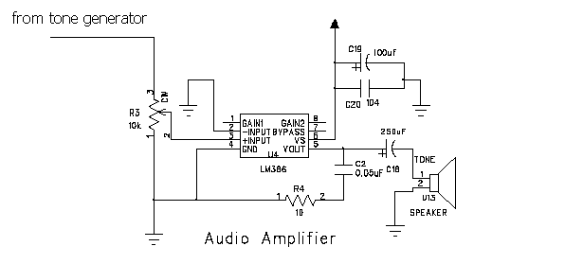

Problem encounter

Floating at the 4 bits bus output.
If pin 5 Vss of MT8880C is unconnected. The 4 bits bus output will be floating. The logic high in this case, is approximately 1V and logic low is zero. The problems quite similar with the missing of the pull up resistor, however, when I add a pull up resistor for the 4 bits bus, the problems do not solve. Then I think that may be the loading problem of MPU port. After careful checking of the logic flow, MPU port as input before the MT8880C 4 bits as output, the problem still exist. Then, I find the 4 bits bus will float with the MPU port. When MPU port that connect with the 4 bits data bus is high, the logic high of bus is 5V, and the logic low of bus is 4V. When MPU port is Low, the logic high of bus is 1V and logic low of bus is zero. The data bus is floated to 4V. Finally, I find the problem is because the pin5 of MT8880C leave unconnected. Because the reference voltage is unconnected, there may have floating problems in the output stage. I do not notice that problem is because the transmit function of MT8880C act correctly. Therefore, I conclude that if the reference voltage is unconnected, when the output stage involve the large current drawing, the floating will exist.

Power supply not ideal
When I develop the audio amplifier for the DTMF signal transmitter, the audio amplifier cannot amplify the pure sinusoidal wave, the output is not pure sinusoidal. There have some fluctuation near the peak of the output signal. Finally, I find the problem is because the current supply is not enough for the amplifier, that is reason of having some fluctuation near the peak. Place a large energy storage device in the power supply VCC (470uF capacitor), can eliminate the problem.

Conclusion

DTMF tone signal have many application, mainly target on the remote control or the data transmission. In this project I have demonstration how to build simple auto phone pickup/pickdown circuit and how to use the MT8880C as a DTMF Transceiver. Using the public phone line s a transmission medium, which is almost free, and exist everywhere. Although the tone transmission capacity is low, for many applications, however, is quite enough.

The ring detect circuit is standardize, the electrical isolator between main circuit and phone line is necessary for the protection of the key circuit. The trigger pulse that generated by the optoisolator circuit can identify ringing signal. The phone pickup can fetch the required tone data to the decode circuit. After decoding the valid tone signal, information can be extracted and transmit this data through the LCD output and RS232 output via PC COM Port line.

In the view of the transmitter sides, the necessary part is generating the DTMF tone accuracy. As the tone represent the information.

EXTEND

DTMF Transceiver as a simple phone controller. The phone controller acts as a controller for the household electronic applications, the security system can be implement. The user will call the device, which will be connected to a particular phone line. When the devices answers the incoming call, the user must enter a password that stored in Eeprom. Once a correct password is keyed, user can turn on/off any assigned electronic application or even arm/disarm the house. The devices can also be expanded to call the user to notify him/her of the changing status of a certain switch. For instance, if the house is armed and a door switch I is opened when it should be closed.

Part List

