Executive summary

Description of the Business Concept and the Business
We are going to set up a company called Bright&Charming which is targeting at modern personal cosmetology. We found that the cosmetology is one of fastest growth industries in Hong Kong even during the economic downturn. The personal care market is composed of “pale” products very largely. Our business is supplying a trusted device for personal measurement which is no substitute one the recent market.
The first product of our company is Bright on Faith. (BoF). BoF is an small size portable electronic device using the theory of light absorption and reflection then return an indicator to consumer, and BoF has storage capacity that let consumer keep track on the their skin color tone and provides high accurate resolution of the change of skin color that human eyes might not distinguish that kind of small differences. The appearance of BoF is cell phone size, colorful and printed with cute cartoon characters.
The Opportunity and the Strategy
We found that the standard advertisement of “pale” products is “stars”, they usually show up on TV ads, then sell the products by implicitly connoting the effect after using the products will be as good as what you can see on TV. Then people buy. The “pale” products available on the market are cream, lotion and mask etc. which mostly claim that they can regulate and pale skin in short time. Nonetheless that, they never present how it improvements skin after using their products in term of comprehensive data. We can see that there are many “pale” products on stock without any clinical experience support. In the mean time the market research showed that consumers cannot sure the gradual change of skin color tone while in the treatment period. We are focusing on the market gap and provide a simple solution for those who are using “pale” product but curios the “pale” level they improved.
Furthermore, consumer is able to know how their skin color changed after the sun light, should they go out for a walk under high UV index sunshine day? How long should they take a sunbath that would not be too much or too less? Xxx
The future development of BoF is that we expect the product will integrate with timer, alarm, and infrared thermometer. Since the body temperature is a common concern about health, the storage capacity of BoF is an excellent media to watch sudden change of body temperature.
The overall strategy is that we are going to strike the market by selling our products to reputable retailers at the price of $xxx for each BoF. This is a fair price to such useful and functional product while at the same time this price can also build up an image that this is an high technological product on personal cosmetology. Then we will let the potential consumers and the public knows our product BoF by advertising on mainly Roadshow, direct sale, MTR, KCRC and supplemented by TV. These are the best way as they can reach a large scale of potential consumer. In the same time, we try to establish a trustful image by showing the experimental sample. Then we will reach the retailers by the partners instead of salesman in order to save marketing cost.
On the other hand, we will try to entry Mainland market. There is many fake personal care products on the market which has become a serious problems for Mainland consumer. Mainland consumer is very concerned their expenditure is worth or not. We can see much news reported that the products made of so-called modern technology are nothing special or even useless. Our product BoF is an easy way for those Mainland consumers tries to distinguish what is the effect of their “pale” product. We will try to seek partnership with Mainland company as joint venture. Our advertisement will on public transportation station and large-scale shopping malls.

Target Market and the Projection
The turnover of Hong Kong cosmetology last year is $xxx and Mainland China is HK$223.2million and they are fast growing. As we have just discussed, our visions is the gap of “pale” products and effect of consumer, we provide a trustful continuous high-resolution measurement for consumer. Therefore, we will target our markets on mainly 3 segments of people, age15 to 23 male and female, periodic cosmetic product consumers, frequently doing outdoor activities female. The sum of these segments of people in HK is xxxxx., China is about xxxx.
As shown in the field market research done by ourselves, we can see 57% of respondents (34% female, and 26%male) do care about their skin color tone. Our market is divided into 3 segments, about 80% of respondents fall into these segments are willing to buy a trustful device like BoF. Therefore, we can see that the, from the projection of the percentage, about xxxx people will buy product. Added to the advertising effort and the further design of the apparent of BoF, we are confident that BoF will be successful in the foreseeable future.
The Competition
After conducting field-marketing research, we discovered that there are no close substitutes of BoF available in Hong Kong, that means there is no product with similar function in the personal care market. Admittedly, there are few portable personal skin care products that help to measure skin. They are

- Skin Color Balance Sensor (e.g. Japan S-Color)
- Moisture & Sebum Sensor (e.g. LaPrope)
But we have analyzed several competitive criteria which can compare their competitiveness in the following table.
 | Skin Color Balance Sensor | Moisture & Sebum Sensor | Bright on Faith
Storage ability | No | No | Yes
Testing sample | Hemoglobin  Melanin | Moisture  Sebum | Triplet RGB color on skin
Price | xxx | xxx | $xxx
Resolution | 12 | 225 | 10million
display Interface | Few LEDs | 5 digits numeric LCD display | 8x4 ASCII character B/W LCD display
As BoF is more trustful as its high resolution, and it measured data (RGB components) is more direct measurement for our human vision on skin color tone. Moreover, it’s LCD display is able to show sentences that makes the analyzed data more comprehensive.
The Economics of the Plan
At the very beginning, we have to use $xxxxxx for the investment of the first season, as we project $xxxxx sales revenue for the following 7 months, therefore, we need about 9 million as initial fund, then we would produce by using the revenue over gained by the last months so that the initial fund need not be so large as the production cost shown in the profit and loss account. When it comes to the sources of funding, we will mainly contribute by partners of the company and bank loan. On the other hand, we assume the stocks bought by each retail outlets for the 1st to 4th increase 300%, 200%, 150% respectively. The stocks increse tremendously because we have continuously using Roadshow, direct sale, MTR and KCRC stations advertisements and we expect, estimated by market research, that about xxxxxx people will buy the product first year because 10% potential customers say they will buy. After calculation, we attained a net profit of $xxxxxx with sales of $xxxxxx

We also anticipated that the breakeven point would be achieved at the xxx^{th} months after the initial fund has been used to produced and run the business.

Company Summary

Company summary
Bright&Charming is the name of our company. The company is targeting at the young and cosmetic product consumers. “Bright” not only the on the skin, also meaning clever and intelligent, our company offers a clever way to personal care market. We aim at firstly, making products specification and analyze the technological and markey feasibility of the products and then assign factories to manufacture the product.
Company ownership
The company would initially be owned by 2 people, they are CHAN Man Chit, WONG Tang Paai in partnership form. Further observation on the company’s product performance would decide the business ownership in the later stage. That is, switch our company to limited company form to attract more shareholders for Bright&Charming. The start up capital will be financed mainly by partner capital contribution and supplemented by bank loan. Then the company will use the retained capital to put into the developmental and operational cost.
Start up Summary
In the first year, we prepare to hire one system administrator to work on the computer system and web-server of the computer, one clerk to handle the clerical duties. Chan, Mak, Wan and Wong will be responsible for planning and organizing activities of the company. We decided that the stocks will be directly stored into our office so that we can save some of the warehouse cost.

Legal and business registration | $2000
Office rent (20000*14) | $280000
Computer and web server | $100000
System analyst (8500*12) | $102000
Clerk (7000*12) | $84000
Production cost (sub-contraction) (175*131250*154) | $24255000
Operating expenses | $40000
Patent | $200000
Advertising expenses | $3000000
Total | $28181000

Company Missions
There are mainly 4 missions of our company:
    - Looking for the miss of cosmetic products in technological way.
    - Help consumers to choose suitable cosmetic products by our products.
    - Make use of existing low-cost technology to substitute non-portable and expensive cosmetic instruments.
    - Breakeven in the first year.
Superficial Product Description
Bring on Faith is an electronic device using the light reflection and absorption theory to measure the color on the skin, than analyze the data by internal microcomputer. User hold BoF attached to the skin, it will take 3 second to get the skin color data then the microcomputer will store the measured data to flash memory. In case the battery fails, the pervious data will not be lost. BoF will compare every new data to pervious data and the analyzed result will be on the screen.
Key to Success (Bright on Faith):
- Firstly, the market potential is very large, the turnover of cosmetic product, “pale” product is $xxxxxx and it is increasing every year.
- Many pale product alleges their effect, but without trusted data or clinical experiments support. Human eyes distinguish the effect on the product mainly even though that is not trustful way. The small and slow changes on the skin color tone are cannot easily be detected my human eyes.
- The Hi-tech color tone analyzers are expensive not portable, these machine, available on cosmetic centers/shops, are not designed for personal daily use. BoF is the best way to do the measurement daily.

General Environmental Analysis
Political/Legal environment
- Hong Kong is practicing a free trade system which allows anyone to start his business whenever he can fulfill the basic requirements of the business registration, whoever wants to start any business should apply for a business registration form. For those who want to start a partnership, they may have to specify the partner’s types, work and profit distribution in the partnership deed which is to be done probably in the witness of an attorney.
- Hong Kong law, Chapter 362 TRADE DESCRIPTIONS ORDINANCE, section 6 “FALSE TRADE DESCRIPTIONS OR REPRESENTATIONS
AND FORGED TRADE MARKS”, we should describe BoF right on the retail box and user manual.
- Bright on Faith will be tested by Consumer Council before going to market.
Economic environment
- Hong Kong is now suffering in economic downturn or economic recession after the financial turmoil in 1997. This year, 2004, financial analyzers predict Hong Kong economy will recovery gradually.
- With the low interest rates, people are getting more and more conservative on spending their money, so they tend to choose to buy products which are durable and some time luxurious. On the other hand, with the low interest rates, entrepreneurs can borrow money easier as the repayment amount will not be so great that they cannot afford.
Socio-cultural environment
- The forged cosmetic products is more and more serious in Hong Kong, the production line of these cosmetic products, especially “pale” products, are in Mainland China, their quality control is worse than in other Asian countries. Consumers have begun to aware the allegation of these products and the true effect of such products.
- The increasing number of “pale” product on the market saying that they are the fastest and most effective way to turn skin white. No one knows which one is the fastest effective, so BoF is a solution.
- Products which are portable is being developed smaller and smaller, for sliminess and small in size is the attractions of the product itself, so BoF should be accepted in appearance.

Technological environment
- Electronic components used in BoF can be purchased easily in pacific Asia. The expected productions cost is not high.
- There are many electronic factories in Shen Zhen and Dong Guan, many of them are managed by Hong Kong people. We can produce BoF in those factories.
SWOT(specific) Analysis
Strengths:
- As the production is using existing technology, it can be produced at low cost and it need very less development at the beginning stage.
- The product is user friendly and most of procedure is completed by internal microcomputer. By reading on the LCD display everyone can use it without long time learning.
- The high resolution and the storage capacity of BoF are great advantages than the other near products.
- By changing the program inside the microcomputer, the more functions on BoF can be added easily on further development.
- BoF is small size (cell phone size) and colorful that are attractive to young people.
- Power consumption is low, BoF can operate long time without replacing battery.

Weaknesses:
- BoF is very high resolution, we need much more statistic data on skin color that help us to tune BoF accurately. And the data now we setup in our database may not enough so a series of survey may need to be conducted
- Self-calibration is needed on BoF every time used that use extra time.
- The internal 2kbtyes flash memory is not enough for long term trace of change on skin color tune.
Opportunity:
- We find that there is not such similar product existing in the market, that means there are still many opportunities for its growth. Our product is on microcomputer base so the design is upgradeable for the further equipments in the market.
- Greater market potential can be reached after we improve the appearance, that is, we printed cartoon characters on BoF. Actually, this require further investment and we will implement it after first stage revenue.
- The market of cosmetic products is growing rapidly, number of “pale” product user will rise. The BoF market will further grow.

Threats:
- Our technology can be easily imitated by other company and then push into the market.
- As our one our target markets is the aged 15~23 female, the price of BoF cannot be too high because their income normally no enough to afford.

Contingencies Measures
- We can try to find out potential entrepreneurship fund offered by the Government and obtain loan from banks or investors.
- We will, if possible, use the profit earned for paying cartoon character printing copyright.
- Use larger storage capacity flash memory that is suitable for year long data storage.
- Try to seek partnership as joint venture to entry Mainland China market.
- We will try to educate public to use trustful device to gain objective data rather than using subjective measurement.
- We will also apply patent which last for 5 years so that others cannot copy the product, by the way, we will try our best to publicize it so that people recognize it as a trustful device.
- If the sales of HM are not so good as expected, the production level will decrease according to the percentage decrease of the previous month.

Marketing Plans
Our market is divided into 3 segments. Followed by is then the marketing mix strategy which means the product, price, place and promotion.

Market Targeting
Our 3 markets is, age15 to 23 male and female, periodic cosmetic product consumers, frequently doing outdoor activities female. 3 segments constitutes about 500 thousand HK people.

Marketing Research Studies
After conducting a market research by using questionnaire on xxx people, we know that about 80% respondents in our market segments said that they like the device BoF, 40% of them are using “pale” products. 70% of them spend over $100 on “pale” product monthly. We anticipate 10% will buy in the 1st year, 23% in 2nd year, 46% in the 3rd year.
80% of potential group is aged 15~23. 40% of potential group is using cosmetic products and 38% potential customers like doing outdoor activities. The customers fall in our 3 marketing segments and are willing to buy BoF is 87%. 10% 1st year, 23% 2nd year, 46% 3rd year.

Product

Usage
Bright on Faith is designed for measure skin color tone easily. The data will be analyzed and than displayer an indicator to user showing how is their skin color tone looked and how is the change of this tone compare to pervious data. BoF can help them to plan their “pale” strategy and give them a feedback of their existing cosmetic products.

Product size and shape
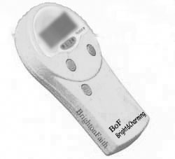 | The size of BoF is small, about 4cm x 5 cm x 1.5 cm. It would be smaller after a deeply development. The sensor is on the back, and the display is supplemented by led back light.

Functions and Working principle
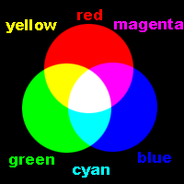
The amount of light reflection and absorption on surface is the properties of color. The basic color science is that, the triplet primitive color RGB are 3 source of visible light which in different intensity gives different colors. Our skin is a sample that absorbs a fixed amount of RGB light. So, by measuring the amount of RGB light intensity that reflects from the skin, theoretically we can determine the skin color.

We use 3 bright LEDs, red, blue and green to generate the light source. These 3 sources emit light in a sequence. We can determine the color coordinates.

Skin has its absorption specification. For example, if the skin is purely red, no blue and green that means that skin absorbs blue and green light. And if a skin is purely cyan, that means the skin absorbs red light only. | 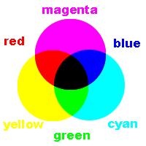  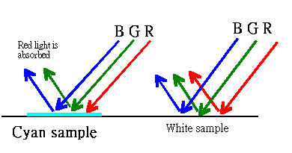

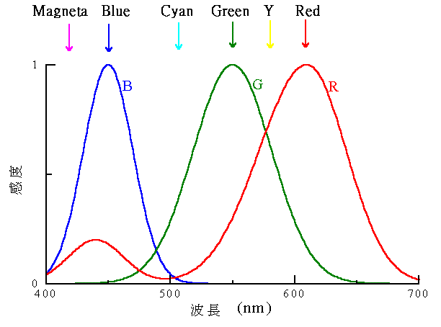  Intensity | The wavelength of RGB LEDs emit in corresponding color

We use Cadmium Sulfide (CdS) Photocells as the sensor component. CdS photocell has excellent correlation with human eye spectral response. In other words, cadmium sulfide sees a color spectrum of light very similar to that seen by most people's eyes. Thus CdS cells can measure the useful light that is illuminating the roadway and being seen by people
Usage example:

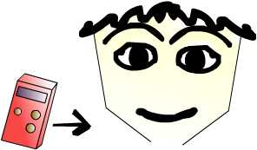  Attach to face, press start | 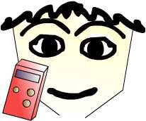  the BoF will starts automatically.

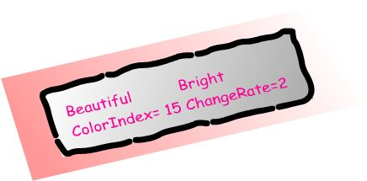 | The data will display on the LCD screen. The analyzed result is “Beautiful” and “Bright”
The ChangeRate is the indicator represents how is the skin improved compared to last time.
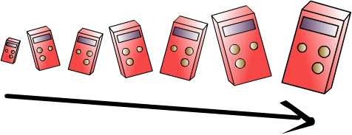
Continuously use BoF, the data stored in it will help to give a more accurate result.

Product manufacturing
BoF has LCD display, a few buttons, flash memory, microcomputer and a battery. Its size can be as small as a cell phone or even smaller.
Price
The pricing objective of the marketing BoF is profit-oriented, that means we are going to achieve target. We plan to set the market price of BoF at $xxx, which means that customers will buy it at this price, as it is a new product raid into the market, $xxx is a price sufficient to create an image of trustful-technological product. At the same time, we expect the price we sell to retailers like Fortress and Broadway is $xxx, $xxx is enough for the retailers to absorb profit when they sell BoF to our target customers, as the product cost of BoF is ($140*(1+0.1)) $154, that means we are going to earn about 49% of the intermediate price from the sales to retailers.

Place
The distribution channel of us is that start off from the manufacturer producing the HMs, they will then be transported to our office, then after contacting retailers in HK, they will take the product by themselves, so the HM will finally reach our target customers in the retail outlets of retailers.
Manufacturer
Retailers

Customers
The retailers we are going to distribute the product via which are large electrical appliances retailers like Broadway, Fortress and telephone network companies outlets like Orange (47 outlets), People(49 outlets), One2free(12 outlets), New World Mobility(36 outlets) and Sunday(31 outlets).
Promotion
The main promotion campaign used by us is personal selling, advertising and cooperation with cosmetic product retailers

Cooperation with cosmetic product retailers
The market of BoF is connected to cosmetic products, we will try to cooperate to cosmetic retailers and offer a lower price or pack BoF into a special gift with other cosmetic products in package sold in discount. We want to establish an image that BoF is trustful and reasonable so we will convince retailers to put our product near the best-buy “pale” product.

Advertising:
We planned to boost the name of BoF through out the territory, let the public knows what BoF is and how it is trustful. Therefore, the advertisement must be reaching the size of the public as large as possible. Therefore, we will use advertisement at the peak hours like 7:00pm to 10:00pm in MTR platform LCD TVs, besides, we will also use the largest outdoor broadcasting media- Roadshow to advertise BoF at the same time in order to reach as many as target customers as possible.

Personal Selling
We planned to direct sale BoF. We will rent a counter or kiosk in shopping mall and cosmetic retails. The first and foremost reason is that we have a better understanding of the product, we can tell customer our product will help them. Latter, we will see where is a better selling point and then start to promote BoF there as a promotion location. We will not hire salesman in the first stage, this is for cost saving.

Financial Plan
Assumptions:
All stocks will be sold by retailers as we sell BoF to them on their request, that’s why we keep no inventory.
At the very beginning, we have to use $8875500 for the investment of the first season, as we project $10500000 sales revenue for the following 7 months, therefore, we need about 9 million as initial fund, then we would produce by using the revenue over gained by the last months so that the initial fund need not be so large as the production cost shown in the profit and loss account. When it comes to the sources of funding, we will mainly contribute by partners of the company and bank loan. On the other hand, we assume the stocks bought by each retail outlets for the 1st to 4th seasons are 50, 150, 300 and 350 respectively. The stocks increase tremendously because we have continuously using television and Roadshow to advertise and we expect, estimated by market research, that about 199000 people will buy the product in the first year because 80% people say that they will buy and 23% people say that function is the most important. After calculation, we attained a net profit of $16160500 with sales of $44625000.

We also anticipated that the breakeven point will be achieved at the 7th months after the initial fund has been used to produced and run the business.
Note that though the investors only invest $8875500, but this is not the initial capital shown in the pro-forma balance, this is because the revenue we gained in the first 6 months will be retained and be invested in the project, that’s why investors need not pay so much money in the very beginning.

