Executive summary

Description of the Business Concept and the Business
We are to set up a company called Needy Heaven which is targeting at the needy of the society. As we found that poor of grassroots level of the society may not be able to consume useful high technological products, so we aim at firstly, making products specification and analyze the technological and market feasibility of the products and then assign factories to manufacture the product.
The first product of our company is Helpless Messiah (HM). Helpless Messiah is an electronic device using telephone network to transmit signals telling the device to activate the sound, light and emergency dialing system inside the device. Whenever the carrier of the device is lost or in danger, his/her parents or friends can activate the device by which can raise the awareness of others surrounding and then save the victim from dangers.

The Opportunity and the Strategy
We discovered that more and more missing cases in HK and even the world tend to frustrate the victims and their families, on this aspect, Yu Man Hon case is the easily memorable one. Whenever the people, who are not able to take care of themselves due to any kinds of physical or mental disabilities and obsoletes, they must be having a higher probability of get lost in the street. In view of such unsolvable dangers in the community, we share the mission of using HM to help them to get help from others.
The future development of HM is that we expect the product will sooner or later by used on pets of people such as cats and dogs. On the other hands, the second generation of HM will surely be using LCD monitor to display the information of the victim and Global Positioning System to locate the victim when GPS is being commonly used.
The overall strategy is that we are going to strike the market by selling our products to reputable retailers at the price of $400 for each HM. This is a fair price to such useful and functional product while at the same time this price can also build up an image that this is an high technological product. Then we will let the potential customers and the public know our product HM by advertising on mainly Roadshow supplemented by Television. These two avenues are the best two as they can reach as large the public as possible. Then we will reach the retailers by the partners instead of salesman in order to save marketing cost. On the other hand, we will try to create HM as a publicly recognized safety product by publicize our cooperation with the Police Department.

Target Market and the Projection
As we have just discussed, we create HM because of the visions of sympathizing the lamentable facts of missing persons. Therefore, we will target our markets on mainly six groups of people, namely elderly, child of younger than 5, MR (mentally retarded people), physical disability, Parkinson Diseases and Alzheimer’s Diseases. It is because we can see that they have more difficulties to take care of themselves and get help by themselves when they are on the street. The sum of these groups of people in HK is 1 million.

As shown in the field market research done by ourselves, we can see that most of the respondents do care about their family members and at the same time, most of them are afraid of losing them in large, crowd public area. In the research, about 80% of them think that they will by the product and 23% of the people think that function of the product which has HM’s functions is the most important thing to think of. 38% think that it is the more important than the price. Therefore, we can see that the, from the projection of the percentage, about 200000 people will by our product. Added to the advertising effort, we are confident that HM will be successful in the foreseeable future.
The Competition
After conducting field marketing research, we discovered that there are no close substitutes of HM, that means there is no product with similar function in the market. But admittedly, there are mainly two substitutes which can also help a person when he/she has got a situation. They are

- Peace Alarm installed in the home of elderly living alone
- Cellular phone
But we have analyzed several competitive criteria which can compare their competitiveness in the following table.
 | Peace Alarm | Mobile Phone | Helpless Messiah
User’s Ability required | Yes | Yes | No
Portable | No | Yes | Yes
Price | $2000 | $600 or above | $450
Monthly fee | Yes | Yes | Yes
Locating function | Yes | No | yes
As HM is more user friendly as it is portable, no need user’s intelligence, lower price and locating function, we possess better competitive advantages when comparing with the Peace Alarm System and cellular phone.

The Economics of the Plan
At the very beginning, we have to use $8875500 for the investment of the first season, as we project $10500000 sales revenue for the following 7 months, therefore, we need about 9 million as initial fund, then we would produce by using the revenue over gained by the last months so that the initial fund need not be so large as the production cost shown in the profit and loss account. When it comes to the sources of funding, we will mainly contribute by partners of the company and bank loan. On the other hand, we assume the stocks bought by each retail outlets for the 1st to 4th seasons are 50, 150, 300 and 350 respectively. The stocks increase tremendously because we have continuously using television and Roadshow to advertise and we expect, estimated by market research, that about 199000 people will buy the product in the first year because 80% people say that they will buy and 23% people say that function is the most important. After calculation, we attained a net profit of $16160500 with sales of $44625000.

We also anticipated that the breakeven point will be achieved at the 7th months after the initial fund has been used to produced and run the business.
Company Summary

Company summary
Needy Heaven is the name of our company. We know that, from the name, the company is targeting at the needy of the society. As we found that poor of grassroots level of the society may not be able to consume useful high technological products, so we aim at firstly, making products specification and analyze the technological and market feasibility of the products and then assign factories to manufacture the product.

Company ownership
The company would initially be owned by 4 people, they are Chan Ka Ho, Mak Tze Yuk, Wan Jo Wah and Wong Kwok Yuen in partnership form. Further observation on the company’s product performance would decide the business ownership in the later stage, that is, if it is run successfully, it would then be switched to limited company form to attract more shareholders for the Needy Heaven. The start up capital will be financed mainly by partner capital contribution (assumed we have) and supplemented by long term bank loan. Then the company will use the retained capital to pay for the development and operation of the firm.
Start up Summary
In the first year, we prepare to hire one system administrator to work on the computer system and web-server of the computer, one clerk to handle the clerical duties. Chan, Mak, Wan and Wong will be responsible for planning and organizing activities of the company. We decided that the stocks will be directly stored into our office so that we can save some of the warehouse cost.

Legal and business registration | $2000
Office rent (20000*14) | $280000
Computer and web server | $100000
System analyst (8500*12) | $102000
Clerk (7000*12) | $84000
Production cost (sub-contraction) (175*131250*154) | $24255000
Operating expenses | $40000
Patent | $200000
Advertising expenses | $3000000
Total | $28181000

Company Missions
There are mainly 4 missions of our company:
- Attempt to create new ideas and products to serve groups ignored by the public, e.g. elderly, Mentally Retarded (MR) people, in a business sensitive view
- Use existing technology to create new product in the infant state
- Use cost-effective method to product high-technological product as substitution to expensive high-technological products.
- Fulfill social responsibility instead of solely focusing on profit.
Our Mission statement is “To Create a heaven for the Poor”, we are going to do this by producing the first product of our company –HELPLESS MESSIAH which is to save those who are helpless or unable to be looked after by others all the time with simple technology and low price.
- Breakeven in the first year.

Superficial Product Description
Helpless Messiah is an electronic device using telephone network to transmit signals telling the device to activate the sound, light and emergency dialing system inside the device. Whenever the carrier of the device is lost or in danger, his/her parents or friends can activate the device by which can raise the awareness of others surrounding and then save the victim from dangers.

Key to Success (Helpless Messiah):
- Firstly, the market potential is very large that accidents on mentally retarded people, kids and the elderly are increasing and easily getting lost. Love and affection is an ever-winning tools in this world.
- Secondly, there is no close substitute of this product.
- The production of Helpless Messiah is using existing technology by which no research and development cost is needed, therefore, in another words, it can also be produced in low cost.
- Unlike other hi-tech devices like mobile phone, HM can be activated by third party who is willing to save that person, that provides benefits to those who cannot even take care of themselves.

General Environmental Analysis
Political/Legal environment
  - Hong Kong is practicing a free trade system which allows anyone to start his business whenever he can fulfill the basic requirements of the business registration, whoever wants to start any business should apply for a business registration form. For those who want to start a partnership, they may have to specify the partner’s types, work and profit distribution in the partnership deed which is to be done probably in the witness of an attorney.
  - For any company wants to start a business concerning the wireless transmission, it has to obtain a wireless transmission license so as to start the business. As the Helpless Messiah can be applied with any “Sim Card” of any telephone company, so Needy Heaven need not to apply for this license.
  - As everyone has the responsibility to take care of their family members, so we have to prevent the abusive use of the emergency dialing system of the device. It is because it is illegal in the eyes of the law if the user has used this function of the device abusively.
  - As only the police department can locate the emission point of the telephone signal, so the function can only be used by police.
  - Products using on kids will be tested by the Consumer Council, so Helpless Messiah will be tested of its safety before going to the market.
  - The China WTO accession and the free trade policies are telling us that the market potential of the products is quite good and the logistical cost of it can be saved.
  - The Chief Executive of HK Mr Tung Chee Wah has announced in the recent policy address that the profit tax of the business will be raise a little bit, but it doesn’t matter as after the implementation of the policy HK is still the one region of the lowest profit tax rate.

Economic environment

  - Hong Kong is now suffering in economic downturn or economic recession after the financial turmoil in 1997.
  - With the low interest rates, people are getting more and more conservative on spending their money, so they tend to choose to buy products which are durable and which they really need rather than luxurious products. On the other hand, with the low interest rates, entrepreneurs can borrow money easier as the repayment amount will not be so great that they cannot afford.

Socio-cultural environment

  - The aging problem is more and more serious in HK, even kindergartens and primary schools are cutting down their class size. With the growth in general society and education level, care on elderly is really a main focus of social value and trend.
  - Being urged by many social groups and increasing educational level of the general public, both the public and the Government are getting more aware on the security, rights and benefits of those mentally retarded (MR) people. Especially after the stunning case of Yu Man Hon, people are more concerning about this type of people and their kids. HM is exactly giving them a hope of taking care of them.
  - Materialism is spreading all over the territory that innovative products are entering into the market second by second.
  - Products which are portable is being developed smaller and smaller, for sliminess and small in size is the attractions of the product itself, so Helpless Messiah should be accepted in appearance.
  - As the society is profound on material, people are turning to the essence and security of life, something which can protect the life of their family members must be attractive.

Technological environment
  - In HK, the telephone network is so mature that nearly all families do have one telephone line on their own. The same situation can also be described in cell phone market. Not only do those middle class people possess a cell phone, but also lower class people. It has become one kind of necessities of HK people. Moreover, the mobile network is covering almost every part of HK, whenever we go, we can contact others conveniently.
  - HK police department possesses a technology that can trace the location of the person who calls police department. It means that if a person recklessly uses the emergency hotline, it can locate the coordination of the caller in one minute.
  - As so many people own mobile phones, it is not difficult to produce some common components of cellular phones and the expect production cost is expectedly low.

SWOT(specific) Analysis
Strengths:
- As the production is using existing technology, it can be produced at low cost and it doesn’t need any development at the beginning stage.
- The product is user-friendly that it can be activated by family members by using any ordinary phone.
- As the threat of missing persons always exists, especially for those people who cannot take care of themselves, so there is a great market on Helpless Messiah.
Weaknesses:
- Even though the production cost is not high, the company still needs more funds as the products is going to be produced in mass production form. The company may not have enough financial sources.
- As the product is using the existing technology, the development is also limited.
- If the carrier of the HM is captured by trial members, it may be de-activated by them deliberately.
- The HM must be working area covered in telephone network and/or the carrier should be surrounded by other people.
- The battery may not be able to last for a week long.

Opportunity:
- Even though there must be something to prevent missing happening, they cannot serve as close competitors, after conducting field research, we find that there is not such similar product existing in the market, that means there are still many opportunities for its growth.
- As the development is now limited by existing and cost, greater market potential can be reached after the global positioning system has been commonly used.
- As cultivated by the current education and the happening of the Yu Man Hon incident, HK people are more concerning about mentally retarded people.

Threats:
- Every coin has its 2 sides, existing technology can be easily imitated by other company and then push into the market.
- The product will be refused by elderly or MR people because it may affect their appearance or dignity.
- It may trigger abusive use of itself as it is so convenient to activate.
- As hard as it is to admit, the weaknesses and threats are not easy to solve, but we have already proposed some contingency measures which are useful in addressing them.

Contingencies Measures
- We can try to find out potential entrepreneurship fund offered by the Government and obtain loan from banks or investors.
- We will, if possible, use the profit earned for research and development of that product with new technology.
- The product will be designed or hidden by accessories or any other protectors in order to avoid violence deactivation.
- We can use battery which are rechargeable and can last for a week.
- The enlarging telephone network will solve the network covering limit problem by itself.
- In view of the threat of abusive use of the device, we will try to educate the public while doing our promotion process.
- We will also apply Patent which last for 5 years so that others cannot copy the product, by the way, we will try our best to publicize it so that people recognize it as the best HM in the world.
- If the sales of HM are not so good as expected, the production level will decrease according to the percentage decrease of the previous month.
Marketing Plans
When it comes to the marketing plan of the company, we will first segment the market and then choose one to two targets to join. Followed by is then the marketing mix strategy which means the product, price, place and promotion.

Market Targeting
Before talking about the marketing mix strategies, we have to select which markets we are going to target at. After considering the demand of the community, we discovered that elderly, child, MR (mentally retarded people), physical disability, Parkinson Diseases and Alzheimer’s Diseases. We have to note that these people are not going to buy HM, but their family members do. After checking out from the HK annual statistics, these 5 groups of people constitutes about 1 million HK people.

Marketing Research Studies
After conducting a market research by using questionnaire on 100 people, we know that over 60% people shows that they care about their mums and dads very much, about 88% respondents say that they will use device which has functions HM possesses, 61% of people think that function of this product is more important than price while 33% of them think that it must be balance. 84% of the people afraid that their children will get lost when they are in a crowd of people and 75% of them say that they will use device which contains HM functions. The above figures show us that about 80% of people will buy HM (we anticipated), but only 23% will buy in the first year and 38% will buy in the 2nd year, followed by the remaining people will buy in the 3rd year.
Product

Usage
HM is design for elderly, child, MR (mentally retarded people), physical disability, Parkinson Diseases and Alzheimer’s Diseases to bring out home because they may in trouble at anytime in anywhere. HM can help them to seek help.

Product size and shape
The size of HM is small, about 4cm x 5 cm x 1.5 cm. 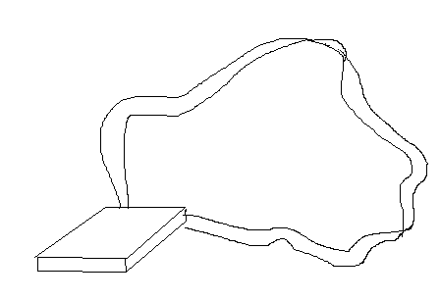It would be smaller after a deeply development. It can be wore on the necks or arms. The contact information of host is marked on HM.

Functions and Working principle
HM can be activated by:
Case 1. Self-activate by pressing a button
Case 2. A phone call through the existing mobile phone network.
Case 3. The Police

In case 1, when HM is self-activated by pressing a button, it does the following 2 functions continuously and repeatedly in order to arouse the people nearly to get help by:
- emitting bright flashing light
- emitting loud and attractive alarm sound

This can attract the people awareness and get help. It is useful in case of the victim is being threatened or beat for money or something.

In case 2, when HM is activated by a phone call through the existing mobile phone network. The working principle is shown below:
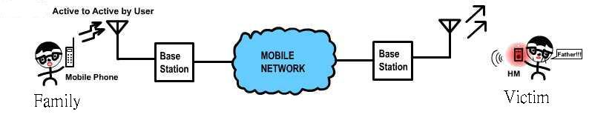
When HM is activated, it does the same function as case 1 above and do the same purpose—to attract people awareness and get help.
This case is applied for the victim who has Alzheimer's disease or someone have difficulties to get help. So that their families can activate HM when they are lost. Just like the case of Yu Man Hon! The contact information is marked at on the HM so the helper knows how to contact the victim’s family.

In case 3, the Police can activated the HM to generate a special function because the Police has the password to do that when the Police ‘phone’ to HM and enter the password.
The special function is that HM will give out a mobile phone call signal of ‘999’. So the Police can find the exact position of the victim. This technology is mature and is using in Hong Kong and other countries nowadays.
The working principle is shown below: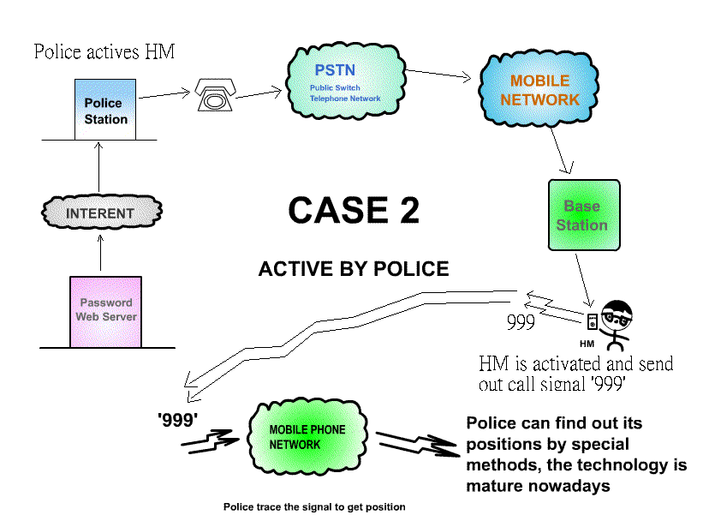
We set a password for this function in order to prevent people abuse it.

And HM can be deactivated by pressing a small button 3 times within 5 seconds.

Product manufacturing
HM is as simple as a mobile and minus the LCD display, keypad and a smaller battery. So it size can be smaller than the smallest mobile phone in the world. And the manufacture is simple and quick as a mobile phone.

Price
The pricing objective of the marketing HM is profit-oriented, that means we are going to achieve target. We plan to set the market price of HM at $400, which means that customers will buy it at this price, as it is a new product raid into the market, $400 is a price sufficient to create an image of high-technological product. At the same time, we expect the price we sell to retailers like Fortress and Broadway is $300, $300 is enough for the retailers to absorb profit when they sell HM to our target customers, as the product cost of HM is ($140*(1+0.1)) $154, that means we are going to earn about 49% of the intermediate price from the sales to retailers.

Place
The distribution channel of us is that start off from the manufacturer producing the HMs, they will then be transported to our office, then after contacting retailers in HK, they will take the product by themselves, so the HM will finally reach our target customers in the retail outlets of retailers.
Manufacturer
Retailers

Customers
The retailers we are going to distribute the product via which are large electrical appliances retailers like Broadway, Fortress and telephone network companies outlets like Orange (47 outlets), People(49 outlets), One2free(12 outlets), New World Mobility(36 outlets) and Sunday(31 outlets).
Promotion
The main promotion campaign used by us is personal selling, advertising and public relations.

Public relationship:
We know that when the locating function of HM is being used, it must be cooperated with the HK Police Department. It is because the HM has to re-dial to the police station activated by cops with pre-set password of each particular HM stored in the database in the web-server of the company. So, on this aspect, we would like to highly publicize the cooperative relationship with Police Department so that HM will be recognized as a common and governmentally accepted safety product.

Advertising:
We planned to boost the name of HM through out the territory, let the public knows what HM is and how it is used. Therefore, the advertisement must be reaching the size of the public as large as possible. Therefore, we will use Television broadcasting at the peak hours like 7:00pm to 10:00pm, besides, we will also use the largest outdoor broadcasting media- Roadshow to advertise HM at the same time in order to reach as many as target customers as possible. We will try to create a message, by the Yu Man Hon case, that HM is necessary for ensuring the safety of their family members.

Personal Selling
In order to save marketing cost, we planned to selling HM to them by ourselves instead of hiring professional salesmen to sell our product. The first and foremost reason is that we have a better understanding of the product, we can tell orange and Broadway or Fortress that how good HM is and how to use it. Another advantage which is of parallel importance is that hiring salesmen will cost us up to 10% of the market price, we are not going use them until we plan to distribute our product via little shops selling electrical appliances.

Competition
After conducting field marketing research, we discovered that there are no close substitutes of HM, that means there is no product with similar function in the market. But admittedly, there are mainly two substitutes which can also help a person when he/she has got a situation. They are

- Peace Alarm installed in the home of elderly living alone
- Cellular phone

However, Helpless Messiah has the following competitive advantages over the above 2 products.
- Firstly, HM is portable, but the Peace Alarm must be installed in home.
- Secondly, peace Alarm is mainly installed for elderly dwelling alone, but HM can be used for any family which has elderly. .
- Thirdly, Peace Alarm and cell phones must be activated by the carrier, HM can be activated by third party remotely.
- Fourthly, the carrier can be found by the police whenever he/she is still carrying HM, but even though the carrier of cell phone is still holding the phone, those disabled may not be able to tell where he/she is.
 | Peace Alarm | Mobile Phone | Helpless Messiah
User’s Ability required | Yes | Yes | No
Portable | No | Yes | Yes
Price | $2000 | $600 or above | $450
Monthly fee | Yes | Yes | Yes
Locating function | Yes | No | yes
Financial Plan
Assumptions:
All stocks will be sold by retailers as we sell HM to them on their request, that’s why we keep no inventory.
At the very beginning, we have to use $8875500 for the investment of the first season, as we project $10500000 sales revenue for the following 7 months, therefore, we need about 9 million as initial fund, then we would produce by using the revenue over gained by the last months so that the initial fund need not be so large as the production cost shown in the profit and loss account. When it comes to the sources of funding, we will mainly contribute by partners of the company and bank loan. On the other hand, we assume the stocks bought by each retail outlets for the 1st to 4th seasons are 50, 150, 300 and 350 respectively. The stocks increase tremendously because we have continuously using television and Roadshow to advertise and we expect, estimated by market research, that about 199000 people will buy the product in the first year because 80% people say that they will buy and 23% people say that function is the most important. After calculation, we attained a net profit of $16160500 with sales of $44625000.

We also anticipated that the breakeven point will be achieved at the 7th months after the initial fund has been used to produced and run the business.
Note that though the investors only invest $8875500, but this is not the initial capital shown in the pro-forma balance, this is because the revenue we gained in the first 6 months will be retained and be invested in the project, that’s why investors need not pay so much money in the very beginning.

