Company Summary

Company summary
Needy Heaven is the name of our company. We know that, from the name, the company is targeting at the needy of the society. As we found that poor of grassroots level of the society may not be able to consume useful high technological products, so we aim at firstly, making products specification and analyze the technological and market feasibility of the products and then assign factories to manufacture the product.

Company ownership
The company would initially be owned by 4 people, they are Chan Ka Ho, Fong Wai Kit, Kwong Kai Yin and Wong Tang Paai in partnership form. They will contribute the same amount $1,500,000 (total $6,000,000) and borrow $1200000 bank loan to satisfy the initial cost and business investment for the first year. Then the company will use the retained capital to pay for the development and operation of the firm. Further observation on the company’s product performance would decide the business ownership in the later stage, that is, if it is run successfully, it would then be switched to limited company form to attract more shareholders for the Needy Heaven.

Start up Summary
In the first year, we prepare to hire one system administrator to work on the computer system and web-server of the computer, two clerks to handle the clerical duties.
Chan Ka Ho, Kwong Kai Yin Winston, Fong Wai Kit Alvis will be responsible for planning and organizing business activities of the company since they are graduate at The Hong Kong Polytechnic University with major at Business Studies. Whilst Chan Ka Ho will be further specialized at organizing and coordinating staffs’ works since he is skilled at manpower management, Kwong Kai Yin Winston is familiar with accounting so he will deal with company’s accounting work as well and Fong Wai Kit Alvis will mainly focus on daily affairs. On the other hand, Wong Tang Paai will be specialized at researching and developing company products because he is a graduate with major at Electronic and Information Engineering. We decided that the stocks will be directly stored into our office so that we can save some of the warehousing cost.

Legal and business registration | $2000
Office rent (20000*3) | $60000
Computer and web server | $100000
System analyst (9000*1) | $9000
Clerk (6000*2) | $12000
Salesperson (7000*5) | $35000
Installation Technician (9000*6) | $54000
Production cost (sub-contraction) | $6178221
Logistics expenses | $10000
Operating expenses | $7000
Patent | $200000
Advertising expenses | $379200
Total | $7046533

Mission
There are mainly five missions of our company:
- Use existing technology to digitalize our life in whatever area we found possible.
- Promote hi-tech product to grass-rooted level so that all people from different income levels can enjoy the benefit of technology.
- Utilize cost-effective method to produce hi-tech commodity in order to substitute expensive hi-tech product.
- Fulfill social responsibility instead of solely focus on profit making.
- By establishing an universal medical data management system in Hong Kong, medical departments, like government health department, hospitals, clinics, can make immediate responses to the patients situation by checking the data system at anytime and elsewhere.
- Breakeven within 24 months

Product Description
The first product of our company is Smart Body-check System. Here is simple description of SBS.
- Processed by 2 parts a) use by individual, b) use by hospital/ clinic
- Telephone network is utilized as transition means.
- SBS measures a range of human’s body characteristics, including heartbeat rate, body temperature, blood pressure and blood glucose
- As SBS recognize the patient’s situation which may be problematic, it shortlists those figures out and inform individual by the predetermined hospital/ clinics.
The system can decrease the frequency of doctor consultation as well as let the healthcare providers to keep track on patient’s medical situation.

Key to Success (Smart Body-check System):
- Firstly, the market potential is very large that people having chronic diseases are getting more and more as the society is improving and people always neglect their health.
- Secondly, there is no close substitute of this product in Hong Kong. Those products which can measure the same figures cannot transmit data to healthcare providers and they cannot measure more than one type of figure.
- The production of Smart Body-check System is using existing technology by which no research and development cost is needed, therefore, in another words, it can also be produced in low cost.
- Unlike such other hi-tech devices as mobile phone, family members of the patients would like to buy one for their loved members. Even if those conservative elderly do not want to spend extra money, with the virtues of providing convenience of the patient and saving time and miscellaneous cost, their family members are still willing to buy.
- SBS provides a win-win situation for both patients and healthcare providers (hospitals and clinics). For patients, they do not need to waste their time when their medical situation is stable. On the other hand, hospitals and clinics can have a comprehensive medical data management system which can shortlist those with medical data outside normal range. It is good for private clinics and hospitals to earn more money while at the same time public hospitals can take close care on patients.

Critical Risk and Opportunities by Environmental Analysis

PEST (External)
Political/Legal environment
  - Hong Kong is practicing a free trade system which allows anyone to start his business whenever he can fulfill the basic requirements of the business registration, whoever wants to start any business should apply for a business registration form. For those who want to start a partnership, they may have to specify the partner’s types, work and profit distribution in the partnership deed which is to be done probably in the witness of an attorney.
  - As the Smart Body-check System (SBS) is using ordinary telephone line, it need not apply any license concerning transmission of data, only those businesses concerning wireless transmission would have to apply special license for usage of those channels.
  - Products using on patients will be tested by the Consumer Council, so SBS will be tested of its safety before going to the market.
  - The China WTO accession and the free trade policies are telling us that the market potential of the products is quite good and the logistical cost of it can be saved.
  - The Chief Executive of HK Mr Tung Chee Wah has announced in the recent policy address that the profit tax of the business will be raise a little bit, but it doesn’t matter as after the implementation of the policy HK is still the one region of the lowest profit tax rate.

Economic environment

  - Hong Kong is now getting up form the economic downturn because the free traveling scheme of Mainland Chinese and the Closer Economic Partnership Arrangement (CEPA) has been launched.
  - With the low interest rates, people are getting more and more conservative on spending their money, so they tend to choose to buy products which are durable and which they really need rather than luxurious products. On the other hand, with the low interest rates, entrepreneurs can borrow money easier as the repayment amount will not be so great that they cannot afford.

Socio-cultural environment

  - The aging problem is more and more serious in HK, even kindergartens and primary schools are cutting down their class size. With the growth in general society and education level, care on elderly and patients is really a main focus of social value and trend.
  - People of HK and many other developed countries are too busy to take care of their parents or family members, even patients do not want to see doctors for routine consultation. With SBS, patients with chronic disease can only see the doctor if the healthcare providers (hospitals or clinics) find necessary.
  - Materialism is spreading all over the territory that innovative products are entering into the market second by second.
  - Products which are portable is being developed smaller and smaller, for sliminess and small in size is the attractions of the product itself, so SBS should be accepted in appearance. The medical data transmitted by SBS can be used by every telephone line without limitation on the geographical location.

Technological environment
  - As SBS can use telephone network everywhere, so no matter the user is in MTR, office or home, with mobile phone or ordinary phone, he can still use. And in HK, the telephone network is so mature that nearly all families do have one telephone line on their own. The same situation can also be described in cell phone market. Not only do those middle class people possess a cell phone, but also lower class people. It has become one kind of necessities of HK people.
  - Even hospitals and some clinics are using some sort of data base to store those medical data, they are not using it systemically. The measurement of things like blood pressure (BP), Blood sugar and so on is done by machine, but are recorded manually and then be uploaded to the database. With SBS, the process is fully digitalized from the measurement to the database, avoidance of manual mistake can be achieved.
  - There are more and more products which help patients measuring their medical data like heart beat. However, neither could they transmit the data wirelessly anywhere to the servers of healthcare providers nor could they measure more than one figure.

SWOT (Internal)

Strength
- As the production is using existing technology, it can be produced at low cost and it doesn’t need any development at the beginning stage.
- It is user-friendly that it can be used by either individual or hospital/ clinic.
- Since SBS is portable so user can use it everywhere.
- Telephone network in Hong Kong have been well-established and is mature enough, it is highly-reliable that people can transit the data to hospital or clinic freely via the network.
- By using the device, hospital or clinic themselves can keep an eye on their patients’ situation, in case of troubles, hospital or clinic can take an initiative to inform patients.
- SBS can resolve the hospital congestion due to large numbers of doctor consultation bookings.

Weaknesses
- Even though the production cost is not high, the company still needs more funds as the products is going to be produced in mass production form. The company may not have enough financial sources.
- Some external environmental factors may affect the human body’s characteristics, thus those figures, i.e. heartbeat rates, blood pressure and blood glucose, which can be measured by SBS may not be able to reflect the real situation of patients.
- As SBS can measure only three types of human body’s characteristics, i.e. heartbeat rates, blood pressure and blood glucose, so others suffered with diseases of lung and respiratory, diseases of digestive system cannot be benefited at the mean time.
- SBS is not work under the area not covered by telephone network.
- SBS cannot substitute the face-to-face doctor consultation even it is a good supplement at all.

Opportunities
- Based on Hong Kong Statistics, the trend of people suffered with chronic diseases is increasing.
- Due to high workload and keen competition in our society, people with great pressure increase recently, so the likeliness of getting chronic diseases is increasing, it provides a huge market for our product.
- After SARS incident, people recognize the importance of life and they concern more health care, so the demand for our product increases sharply.
- SBS is a hi-tech product sold at a low price, it is competitive all over the world, so we can expand it to overseas in near future.
- As the level of technology is innovating day by day, we will add value SBS by equipping more product features through our R&D.
- Since the literate standards of people are better from time to time, we expect that more and more people should be able to know how to use Internet in future, so it can facilitate the development of online doctor consultation.
- With the use of SBS, hospital or clinic can monitor patients continuously, thus in the sense that SBS also can help to undergo medical experiments in the future.

Threats
- Existing technology can be easily imitated by other company at other countries, it increase the difficulties to expand overseas.
- Normally, elderly are more conservative than younger people, they are less willing to try hi-tech products.
- Similar competitors are present in U.S., for example, Blood Pressure Monitors with Monitor Pro Software, costs a price at about HKD$4000.
- Hospital or clinic may not be willing to install the receiver at the early stage because the installation of receiver costs a sum of money.

Contingency Measures
- We can try to find out potential entrepreneurship fund offered by the Government and obtain loan from banks or investors.
- We will, if possible, use the profit earned for research and development of that product with new technology.
- We will supply and deliver the receiver to all hospitals and clinics free of charge in order to establish networking.
- We will also apply Patent which last for 5 years so that others cannot copy the product, by the way, we will try our best to publicize it so that people recognize it as the best SBS in the world.
- Broad advertising by mass media will be conducted so as to promote and persuade people suffered with chronic diseases as well as their relatives and friends to try SBS.
- If the sales of SBS are not so good as expected, the production level will decrease according to the percentage decrease of the previous month.

Marketing Research and Analysis

After conducting a market research by using questionnaire on 110 people, we know that middle aged and elderly contribute over 70% of the population with chronic diseases. Most of them have to attend doctor consultation periodically, some of them may even need family members or friends to accompany them during their consultation. In addition, 50% of the patients spent 2-4 hours for each consultation. How much time would people have to spend on the time-consuming but simple procedures? The results of the questionnaire explain the money cost and time cost arose from consultation. It means that if we can minimize the frequency of consultation, we would consequently save the relevant money and time.
Having recognized the need of the market, we firstly determine how much people in the market. As we have discussed, about 650000 HK people with such chronic diseases. We consecutively assumed that only respondents positive intentions to buy (refer to last question of the questionnaire) are classified as our potential buyers. By conservationism, sales in the first 18 months would be contributed by the early adopters(10.9%) who show the greatest intention to buy with 70% of conservative rate. It is because we only assume 70% of those who said they must buy will really buy SBS eventually. In other words, the estimated sales in the first 18 months is [653300*10.9%*70%] = 49888units

The Competition
Having recognized how large the market is, the competition of the industry must be of investors’ concern. On the subject, we have conduct field marketing research. We discovered that there are no close substitutes of SBS. That means there is no product with exact function of SBS in the HK market. But admittedly, there are mainly some substitutes outside HK which can also help a person to measure their medical data and transmit to their healthcare providers but we only choose two closest products to make comparison. However, none of them are being sold in HK. They are
- Auto wrist Monitor with data transfer – OMRON http://www.mortonhealthcare.com/omron_673IT.htm
- Blood Pressure Monitor with Monitor Pro Software - Westons Internet http://www.westons.com/acatalog/Online_Catalogue_Home_Health_520.html#aBLO124E
( But we have analyzed several competitive criteria which can compare their competitiveness in the following table.

 | 1) Auto Wrist Monitor | 2) UA-767PC | Smart Body-check System
User’s intelligence | high | high | Very low
Portable | No | No | Yes
Price | $1400 | $4000 | $600
Way of transmission | Internet | Internet | Telephone Line
Physiological Measurement | Blood Pressure | Blood Pressure | Blood pressure  Thermometer  Pulse Rate  Blood Sugar Level
Special care in view of outranged parameters | No | No | Yes
Main buyers | Individuals | Hospitals | Individuals

As SBS is more user friendly as it is portable, involves low level user’s intelligence, lower price and locating function, we possess better competitive advantages when comparing with the Auto Wrist Monitor and UA-767PC. There may be other devices which can measures other physiological parameters like blood sugar and so on and they are popular overseas, but the reason why we do not put it in comparison because they cannot transmit data to healthcare providers.
The main competitive advantages are:
- SBS is using low level of technology to do the transmission. (Cost leading)
- It can be bought outside home and used outdoors or offices (differentiation )
- Comprehensive connection with hospital and clinics (Focus)
- Low price attract patients with low level of income (Cost leading)

Marketing Plans
When it comes to the marketing plan of the company, we will first segment the market and then choose one to two targets to join. Followed by is then the marketing mix strategy which means the product, price, place and promotion.

Market Targeting

Before talking about the marketing mix strategies, we have to select which markets we are going to target at. After considering the demand of the community, we discovered that people with chronic diseases, especially Hypertension, Diabetes Mellitus and Heart Diseases are those people need SBS most. We have to note that these people may not buy SBS, but their family members do. After checking out from the HK annual statistics, these 5 groups of people constitutes about 653300 HK people.

Marketing Mix Strategies

Product
The primarily target of this product is to provide the interface for the telecommunication. When the sensor detects something from one side, user can send the data via the telephone line, and the other side can extract the corresponding data, analysis it, create/ update the related database.

The development of the product is target for the digitalization of the clinics or hospitals. When the devices extract the patients physiological data, data will be stored in the devices with the ID code indicate the patients. Those devices can automatically update the patients’ database without involving any handwriting or human type in to the computer database. In this product, we implement the remote communicate, so that the patients can go out for their work and the health institution can monitor their patients condition by the DTMF Transceiver.

There have many channels available for the data transfer 1. Telephone line. 2. Internet 3. Mobile communication network, MSM. 4. Memory-stick, flopped disk, cd-rom 5. Direct line connection. Type of physiological data can be Body temperature, Heartbeat, Blood pressure and Blood Glucose etc.

We choose telephone line as the demonstration project is because it widely covers telecommunication. Almost every home has a telephone. The transmitter and sensor is standalone, which means no PC is require to operate the devices. Patients can measure their body data, and send this data via telephone.

Technology Employed

DTMF Transmitter:
DTMF Transmitter can transmit the phone number that stored in Eeprom. Put the tone generator's speaker next to the mouthpiece of your phone, and will try dialing a phone number! There have the PC adapted used for the data communication using the standard RS232 protocol. Via this com port, the Eeprom phone number can be modified. Two key for the user to press, one for sending the phone number stored in Eeprom, others is sending the digit that represent user ID code and following is the temperature reading from the sensor. When the phone call is connected, user can press key for the sending of tone digit represent his/her ID code and current temperature reading of the sensor.

DTMF Receiver:
When the there is a phone ring, the telephone line will pickup, the DTMF decoder circuit can receive DTMF tone. Fetch the DTMF tone to the receiver; the corresponding tone digit will be display on the LCD screen. If com port is connected to the PC, tone digit will also send to the PC instantaneously. Thus, the related software can extract the tone data that transmit via phone line. After 30sec suppose all the tone data is transmitted, and the phone line will pick down disconnect the phone line connection.

Working principle

DTMF stands for dual tone multiple frequencies. When you press a button on a telephone keypad, the telephone will generate two sine waves with different frequency at the same time, the audible sounds that you hear. Eg. Press 1 is sending a tone with 1209Hz and 697Hz to the telephone line. These frequencies are called DTMF. DTMF is the signal to the phone company for phone dialing. It's also known as "Touchtone" phone and generally has replaced loop disconnect ("pulse") dialing.

With DTMF, each key you press on your phone generates two tones of specific frequencies. So that a voice cannot imitate the tones, one tone is generated from a high-frequency group of tones and the other from a low frequency group, thus the name Dual Tone Multi Frequency. Here are the signals you send when you press your Touchtone phone keys:

Hz | 1209 | 1336 | 1477 | 1633
697 | 1 | 2 | 3 | A
770 | 4 | 5 | 6 | B
852 | 7 | 8 | 9 | C
941 | * | 0 | # | D

Simple working process
The patient presses a button to measure the physiological medical data and then pick up a phone anywhere. The patient can then press the button to activate the transmitter, the transmitter will emit some sort of tone voice. Through the picked up telephone, the data will be transmitted to the other side which is the receiver. The receiver will then decode the tone voices and update the server.
After the hospital or clinics get the data, there would be a pre-set range of those medical data namely
- Thermometer 35.8- 38
- Blood Pressure (upper) 100-140 / (lower) 70-90
- Blood Glucose 4-7 mml/L
- Heart rate 60-100
In case the patients’ date outside normal range mentioned above, that particular patient will be short listed. As normally speaking, he may not need to have the routine doctor consultation. Under such circumstances, the hospitals or clinics will call him/her to have the doctor consultation and give him/her special healthcare services.

Diagram Description
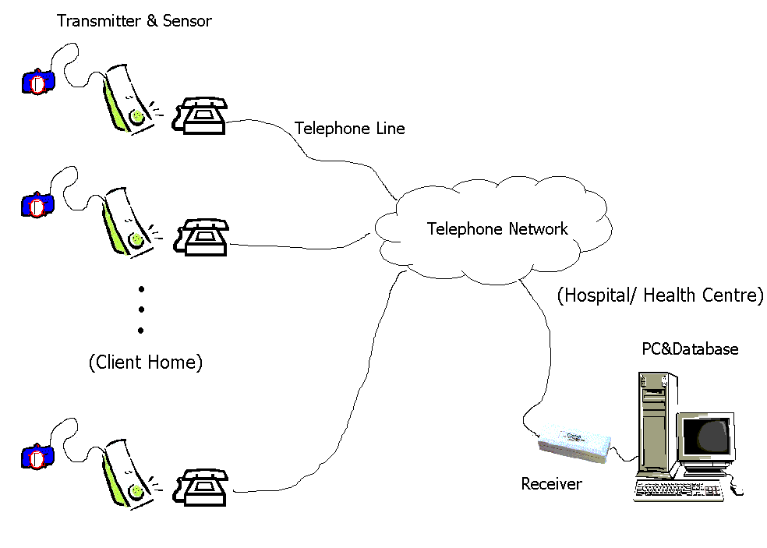
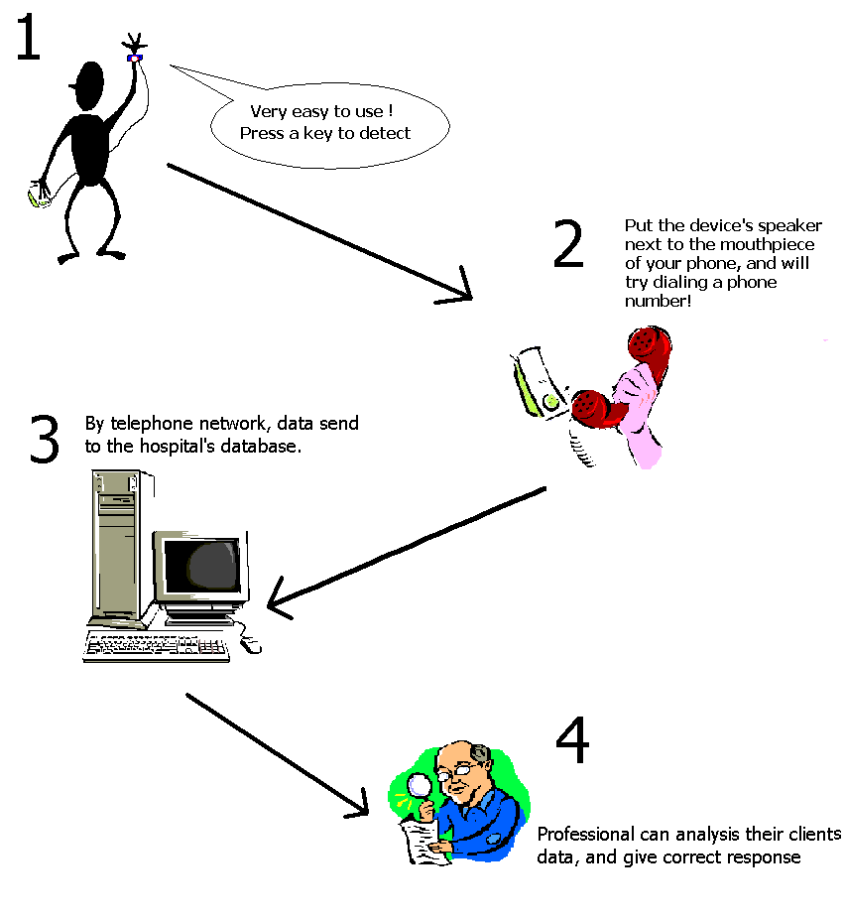
Price
The pricing objective of the marketing SBS is profit-oriented, that means we are going to achieve target. We plan to set the market price of SBS at $600, which means that customers will buy it at this price, as it is a new product raid into the market, $600 is a price sufficient to create an image of high-technological product. As the doctors and nurses in hospitals and clinics are not salesperson, they will not absorb profits from selling SBS, they only serve as agents selling medical necessities to patients like listening assisting device. On the other hand, we offer the receiver and the software for medical data free of charge to all healthcare providers (hospitals and clinics) so as to build up a comprehensive medical data system to support our market. As we expect the cost of manufacturing SBS is $400, therefore we will possibly earn $600-$337/$337 * 100%= 78% for producing each SBS.

Place
The distribution channel of us is that start off from the manufacturer producing the SBSs, they will then be transported to our office, then after contacting hospitals and clinics in HK, they will take the product by themselves, so the SBS will finally reach our target customers in the retail outlets of retailers. We also sell SBS via our office, customers can come to our office and buy the SBS. We will also do the registration for them by accessing SBS of each hospital online.
Manufacturer
Healthcare Providers

SBS sender

Customers
SBS receiver

Registration Technicians
Our office

The hospitals and clinics we are going to distribute our SBS to are those public hospitals (32 suitable), private hospitals (12) and private clinics (around 1700).

Promotion
The main promotion campaign used by us is personal selling, advertising and public relations.

Public relationship:
We know that the SBS can only be used when the hospitals and clinics are using the system. It is because the SBS has to send medical data measured by the patient to the pre-determined hospital or clinic. So, on this aspect, we would like to highly publicize the cooperative relationship with all the hospitals so that SBS will be recognized as a common and governmentally accepted medical product.

Advertising:
We planned to boost the name of SBS through out the territory, let the public knows what SBS is and how it is used. Therefore, the advertisement must be reaching the size of the public as large as possible because the number of people having chronic disease is so large. Therefore, we will use Television broadcasting at the peak hours like 7:00pm to 10:00pm (each time 30 seconds and 10 times a month) of TVB after 1 year of launching SBS because TV advertising cost is really high and it takes time to install SBS receivers into hospital. Therefore, we will firstly try to use Ming Pao and Oriental Daily to advertise SBS once a week in the first 12 months in order to reach as many as target customers as possible. We use newspaper to advertise because we need time to persuade and install SBS to every hospitals and clinics. We will try to create a message that SBS can provide convenience to the individual patients and comprehensive medical data system to hospitals and clinics.

Personal Selling
In order to save marketing cost, we planned to sell SBS by using doctors and nurses. It is true that they will try to persuade patients to buy because of their professional knowledge, so we only use their place to sell but not to use them to sell. Nurses are used for registration of personal data before patients use the SBS. On the other hand, the salespersons we use are to provide registration process in our office and handle customers’ enquiry after patients reach the advertisement. They will also deliver talks or seminars at community and elderly centre to let our target customers know what SBS is and may even successfully buy business contracts from those places.

The Economics of the Plan
Supported by the marketing plans we have just discussed, we now proposed the economics of the plan.
At the very beginning, we have to use $6808200 for the investment of the first month, as we project $12908239.63 total sales revenue for the first 12months, therefore, we need about 7 million as initial fund, then we would produce by using the revenue over gained by the last months so that the initial fund need not be so large as the production cost shown in the profit and loss account. When it comes to the sources of funding, we will mainly contribute by partners of the company and bank loan. To explain the growth of the sales, we have to resort it to newspaper advertisements on MingPao and Oriental Daily. Therefore the growth rate is very slow. Then the stocks increase tremendously because we have continuously using television and to advertise and we expect, estimated by market research, that about 49888 people will buy the product in the first 18 months because 10.9% people say that they will buy and 75% people say that function is the useful for them and their families. After calculation, we attained a net loss of $ 284258 with sales of $ 12908239.6 in the first year, but net profit of $ 13115060 with sales of $ 51327103 in the second year and net profit of $ 21064758 with sales of $ 71456720.8 in the third year.

We also anticipated that, from the figure below, the breakeven point will be achieved at the 22nd month after the initial fund has been used to produced and run the business.

Profit potential and durability

As stated in the research report, our conservative estimated sales is 49888 units. With a relatively low cost ($337) against the competitors, though there is not perfect competitor, we can enjoy a more fruitful per unit revenue. Moreover, due to our free receivers promotion to the hospitals, we are the sole player who can direct access the customers in the hospitals and occupy such distribution channel. Hence, the profitability and sales volume can be ensured.

After the 18th month, the early adopters in the market will be saturated and the sales would growth at a slower rate. The sales after the 18th month will then be supported by the customer with second greatest purchasing intention. Once again, a lower conservative rate (60%) will be used. Beside, there will be more and more new patients suffering form chronic diseases since the life expectancy increases. Consequently, the sales will be stable after the first two business years.

Manufacturing

Cost and Delivery Estimation Form

Project Name: |  | Smart Body Check systems

A. Direct Materials Cost
Item No. | Material / Part Description |  | Qty | Unit |  | Unit Price  (HK $) |  | Amount  (HK $k)
Electronic Components
1 | Transmitter |  | 12,000 | Pc |  | 34.62 |  | 415,440.00
2 | Receiver |  | 1,800 | Pc |  | 61.82 |  | 111,276.00
3 | Basic Sensor (Temperature, Blood Pressure, Heart Rate) |  | 12,000 | pc |  | 68.72 |  | 824,640.00
4 | Extra Sensor (Blood Glucose Sensor) |  | 12,000 | Pc |  | 133.78 |  | 1,605,360.00
Plastic Casing
5 | Plastic Casing + Packing (Transmitter) |  | 12,000 | Pc |  | 28.00 |  | 336,000.00
6 | Plastic Casing + Packing (Receiver) |  | 1,800 | pc |  | 35.00 |  | 63,000.00
PCB layout
7 | Pcb |  | 13,800 | Pc |  | 10.00 |  | 138,000.00
 |  |  |  |  |  | Sub-Total |  | 3,541,716.00

B. Direct Labour Cost
Item No. | Material / Part Description |  | Unit Price  (HK $) | Qty |  |  |  | Amount  (HK $k)
1 | Manufacturing/ Fabrication |  | 1.9 | 12,000 |  |  |  | 22,800.00
2 | Measuring / Inspection/ Test |  | 0.49 | 12,000 |  |  |  | 5,880.00
 |  |  |  |  |  | Sub-Total: |  | 25,794.00

C. | Tooling Cost (special tools, machines, jigs & fixtures used for this project)
 | Tools description : All machinery and tools for testing |  |  | HK$ | 80,000.00
D. | Factory Overhead Cost
 | Plastic & Metal Mould, Films |  |  | HK$ | 400,000.00
E. | Manufacturing Cost (Factory Cost)
 | Manufacturing Cost = A + B + C + D |  |  | HK$ | 4,002,396.00
F. | Operation Cost (Operating Expenses)
 | Operating Cost (say) = 50% of Direct Labour Cost = 0.5 x B |  |  | HK$ | 14,340.00
G. | Delivery Cost
 | Beijing to Hong Kong |  |  | HK$ | 30,000.00
H. | Total Cost
 | Total Cost = Manufacturing Cost + Operating Cost + Delivery Cost = E + F +G |  |  | HK$ | 4,046,736.00
I. | Unit Price
 | Unit Price = Total Cost/ No. Of transmitter |  |  | HK$ | 337.23
J. | Estimated Delivery Date: 3 Month
 | * upon confirmation accepatance of quotation

Operating Cycle

Item No. | Product/ Process Description |  | Estimated man-hours
A. | Process for PCB |  | 77.71 | days
 | Preparation of artworks & films |  | 8 | hrs
 | Hole Drilling |  | 80.1 | hrs
 | Silk screen printing of PCB layout |  | 170 | hrs
 | Electroplating and etching |  | 9 | hrs
 | Electroplating and etching |  | 260 | hrs
 | Printing of Solder Mask & Marking |  | 4.5 | hrs
 | Cut to size |  | 2.97 | hrs
 | Forming of size |  | 2.3 | hrs
 | Short & Open Test |  | 7 | hrs
B. | Process for PCBA |  | 17.38 | days
 | Incoming inspection |  | 15 | hrs
 | Component preparation |  | 1.35 | hrs
 | Component insertion |  | 47 | hrs
 | In-process inspection |  | 10 | hrs
 | Wave soldering & cleaning |  | 11.5 | hrs
 | Touch-up |  | 12 | hrs
 | Add-on |  | 8.3 | hrs
 | Functional Test |  | 9.5 | hrs
 | Final inspection |  | 7 | hrs
C. | Process for Casing |  | 65.16 |  | days
 | Fabrication of Mould |  | 160 |  | hrs
 | Injection Moulding ( For Plastic Case ) |  | 84 |  | hrs
 | Forming( For metal Case ) |  | 168 |  | hrs
 | Silk screen printing |  | 4.5 |  | hrs
 | Inspection |  | 39.6 |  | hrs
D. | Final Assembly |  | 4.29 |  | days
 | Assembly PCBA to the case |  | 11 |  | hrs
 | Functional Test |  | 8 |  | hrs
 | Packaging |  | 8 |  | hrs
 | Final inspection |  | 3 |  | hrs
 |  | Total man-Days | 162.96 days
 |  | Total man-Hours | 1140.75 hrs

Estimated Duration:
Total man-Days * 0.5
= 81.48 days

Sub-conclusion

In this project of manufacturing 12000 sets of Smart Body Checks System, the manufacturing cost is $ 4,002,396.00 and the operating cost is $ 14,340.00 which gives the total cost of $4,046,736.00 and has the final unit prices of each transmitter with basic and extra sensor is $337.23

The whole manufacturing process is divided into 4 parts that are PCB, PCBA, Casing and Final Assembly, the total production time among those four process is 1140.75 man-hours. During the process, the most time-taking procedures are electroplating and etching of the PCB board and the fabrication of mould.

With allocating the work process suitably by managing out man-hour in different workshop, the delivery data of the 12000 products is estimated about three months later.

Financial Plan
As far as the financial plan is concerned, we have the proposed Income statement / Profit and Loss Account and the Balance sheet of the coming 3 year supported by our anticipated sales growth and market situation as well as the estimated cost and the marketing strategy proposed by our company. As we have discussed in the part Economics of the Plan that we will breakeven in the 18th month. The Breakeven is calculated by using the accumulated positive cash flows minus the accumulated negative cash flows.
When it comes to the question of how we make such a large number of production with that low level of initial investment. We will do so by using the positive cash flow generated in the first 6 months and put it back into the investment, that is why we only require 7 million to start the business. That is also good when the business is unexpectedly run badly, we can cease it without extra loss.

Profit & Loss Account for the year 2004, 2005, 2006
 | 2004 | 2005 | 2006
 | $ | $ | $
Sales | 12,908,400 | 51,327,000 | 71,457,000
Less cost of good sold :
Opening stock |  | 5,106,224 | 698,211
Purchases | 12,356,442 | 23,792,200 | 40,103,000
Closing stock | 5,106,224 | 698,211 | 37,744
cost of good sold | 7,250,218 | 28,200,213 | 40,763,467
gross profit | 5,658,182 | 23,126,787 | 30,693,533
Less Expenses :
Legal and business registration | 2,000
Office rent ($20000X12) | 240,000 | 240,000 | 240,000
Advertisement:
TV advertisement |  | 4,172,400
Newspaper advertisement | 4,550,440 | 2,275,220 | 4,550,440
system analyst salaries ($9000 X12) | 108,000 | 108,000 | 108,000
salesman salaries (5X$7000X12) | 420,000 | 420,000 | 420,000
clerk salaries (2X$6000X12) | 144,000 | 144,000 | 144,000
installation technicians (6X$9000X6) | 324,000
logistics expenses | 20,000 | 20,000 | 20,000
overhead in office | 84,000 | 84,000 | 84,000
Depreciation :
computer and web server (10%p.a.) | 10,000 | 10,000 | 10,000
Amortization of patent (5 years) | 40,000 | 40,000 | 40,000
Profit before tax | (284,258) | 15,613,167 | 25,077,093
Taxation (16%) |  | 2,498,107 | 4,012,335
Profit after tax | (284,258) | 13,115,060 | 21,064,758

Balance Sheet
 |  | 2,004 |  | 2,005 |  | 2,006
 | $ | $ | $ | $ | $ | $
Fixed Assets
computer and server | 200,000 |  | 150,000 |  | 100,000
Less: depreciation | (50,000) |  | (50,000) |  | (50,000)
Net Book Value |  | 150,000 |  | 100,000 |  | 50,000
Intangible: pantent | 200,000 |  | 160,000 |  | 120,000
Less : Amortization | (40,000) |  | (40,000) |  | (40,000)
Net Book Value |  | 160,000 |  | 120,000 |  | 80,000
 |  | 310,000 |  | 220,000 |  | 130,000
Current Asset
Stock | 5,106,224 |  | 698,211 |  | 37,744
Prepaymet: office rent | 40,000
Cash and Bank | 5,578,332 |  | 27,327,582 |  | 41,464,681
 | 10,724,556 |  | 28,025,793 |  | 41,502,425
Less : Current Liabilities
Creditors | 4,118,814 |  | 7,930,733 |  | 13,367,667
Working capital |  | 6,605,742 |  | 20,095,060 |  | 28,134,758
 |  | 6,915,742 |  | 20,315,060 |  | 28,264,758
Financied by:
Capital
opening balance | 6,000,000 |  | 6,000,000 |  | 6,000,000
Net Profit/Loss | (284,258) | 5,715,742 | 13,115,060 | 19,115,060 | 21,064,758 | 27,064,758
Long-term Liabilities
Bank Loan |  | 1,200,000 |  | 1,200,000 |  | 1,200,000
 |  | 6,915,742 |  | 20,315,060 |  | 28,264,758

