A remote control system

I this section I will explained how radio transmitter and receiver modules can be used to send the ascii signals and control the remote car. The RF modules I adopted in this project was an AM on/off keying (OOK) The signal from the receiver modules was capable of switching on and off one device. So how can we make it control more than one? The answer is to send a train of pulses using the transmitter receive them using the receiver and decode them in order to switch on and off several devices. This is what the Holtek HT12E and HT 12D IC’s do- then HT12E is an encoder and HT12D is a matching decoder. The oscillator resistor values chosen for HT12E and HT12D must be match the supply voltage and the oscillate frequency.

HT12E 4 bits encoder

(Circuit diagram)

The pinout diagram of the HT12E is shown in figure 2. The D0-D3 Data input (Pin10 to 13) to the encoder have been connected to MPU. So that require ascii protocol can be send to the encoder. There are eight inputs to the IC called the Address inputs. These tell the encoder which address to send. The decoder IC HT12D also has these inputs – the address on both ICs must match for the Data to be valid.

Each Address pin may be connected to 0V or 5V. In this project I have connected them all to 0V. so the address is set to 0x00 on both ICs. If you were to connect all the address pins to 5V, then the address would be 0xff – thus there are 256 possible addresses available. So, if you wanted to, you could set up switches to control one or more of the encoder Address pins, and then have several decoders, each set to a different address.

There are two more pins on the encoder. Pin 14 is an input called Transmit Enable (/TE). Only when it is connected to 0V will the encoder send a transmission. We always want it to send a transmission, so it is permanently connected to 0V. The final pin, Pin 17 is data out(Dout) which is the serial stream of pulses containing the address and data. This is connected to the data input of the radio transmitter module.

HT12D 4 bits decoder

(Circuit Diagram)

The pinout diagram of the HT12D is shown in figure 3 and is in many ways the opposite of the HT12E pinout. As mentioned previously, the eight address inputs are present. Pin 14 now data in (DIN) and is connected to the data output of the radio receiver module.

Pin 17 is now called valid transmission (VT) and goes high when ever there has been a valid transmission received by the IC. This will be useful in some cases. Especially, when there is losing of signal. Suppose the decoder output is used to drive the car motor. When it is high, the remote car will go forward. The data output of the HT12D are known as ‘latching output’ because even if there is not a valid transmission, they will stay in the same states as they were from the previous valid transmission. This behavior causes a problem in the remote control application: supposing you have just turned on the power to your mini monster truck. The motor turns and the car moves away from you. The car moves out of range and the radio receiver cannot pick up the radio signal. You transmit the ‘stop’ signal, but the receiver cannot pick it up and the HT12D output the motors stays latched on. The car will crash! What is needed in these cases is a way to cut the power to the motor if there is no valid transmission. This can be achieved by used the VT as a trigger signal to trigger the MPU, out of some certain period, if no driving signal of the motor, receiver side MPU will cut the motor power automatically.

RF Modules

In this section I will introduce the RF modules I selected for our remote control car. Usually Fm modules have a best transmission range, and less suspicious of error. Considering the cost, I decide to use AM modules, AM modules or FM modules in term of their function are basically at the same, the difference between them is AM have a shorter transmission range and its power consumption is not a constant. The AM modules is use the ON/OFF key technique which is suitable for the digital communication, and therefore the error is not serious in our application. I had measure the valid working range between the Tx and Rx in the industrial centre, there are many benches and equipment in the transmission path, the guarantee valid range is 20m. That range is enough for many remote control applications, especially in toy, and so in our project.

RF modules, AM. Transmitter Hybrid, AM-RT4-433

The R.F solution Ltd. AM hybrid transmitter module provides a complete RF transmitter which can be used to transmit data up to 4kHz from any standard CMOS/TTL source. Simple to integrate into any system. It may be connected directly from a microprocessor or encoding device, keeping component count down.
The module is very simple to operate and offers low current consumption (typ. 4mA). Data can be supplied directly from a microprocessor or encoding device, thus keeping the component count down and ensuring a low hardware cost.
The module exhibits extremely stable electronic characteristic due to the used of ‘Thick-Film’ hybrid technology, which used no adjustable components and ensures very reliable operation.
The modules are compatible with R.F solution Ltd. Range of AM receivers to provide a complete solution.

Feature:
• Complete radio transmitter
• Transmit range up to 100m
• CMOS/TTL input
• No adjustable components
• Very stable operating frequency
• Wide operating voltage, 2-14V
• Applications include:- short range wireless datacomms, wireless security systems, vehicle alarms, remote gates, remote sensing, etc.

Following is the typical application circuit.
(Circuit diagram)

RF modules, AM super regenerative receivers, AM-HRRn-433

The R.F. Solutions range of AM ‘Super Regen’ Receiver modules are compact miniature hybrid RF receivers. Can be used to capture any undecoded data from any 433MHz AM Transmitter.
The modules contain no adjustable components for ultimate reliability. The manufacturing process employs laser trimmed components for increased sensitivity and reliability. Hence these modules show a very high frequency stability over a wide operating temperature even when subjected to mechanical vibrations or manual handling.

Feature:
• Miniature hybrid R.F. receivers to capture data from 433MHz A.M. transmitters
• Low current consumption
• Laser trimmed inductor gives extremely high frequency sensitivity and stability
• Front end pre-amplifier reduces EMC emissions from the antenna
• CMOS/TTL compatible output
• Receiving range:- Super Regenerative 45m
• Requires no radio license to operate
• ETSI300-220 Compliance (Super Heterodyne)
The super-heterodyne receiver manufactured on a ceramic substrate incorporates a SAW Filter front end for reduced EMC emissions, and uses an IF stage at 500kHz.

Following is the typical application circuit.
(Circuit diagram)

Antenna Design

The design and positioning of the antenna is as crucial as the module performance itself in achieving a good wireless system range. The following will assist the designer in maximizing system performance.

The antenna should be kept as far away from sources of electrical interference as physically possible. If necessary, additional power line decoupling capacitors should be placed close to the module.

The antenna ‘hot end’ should be kept clear of any objects, especially any metal as this can severely restrict the efficiency of the antenna to receive power. Any earth planes restricting the radiation path to the antenna will also have the same effect.

Best range is achieved with either a straight piece of wire, rod or PCB track @ ¼ wave length (15.5cm @ 433.92MHz). Further range may be achieved if the ¼ wave antenna is placed perpendicular in the middle of a solid earth plane measuring at least 16cm radius. In this case, the antenna should be connected to the module via some 50 ohm characteristic impedance coax.

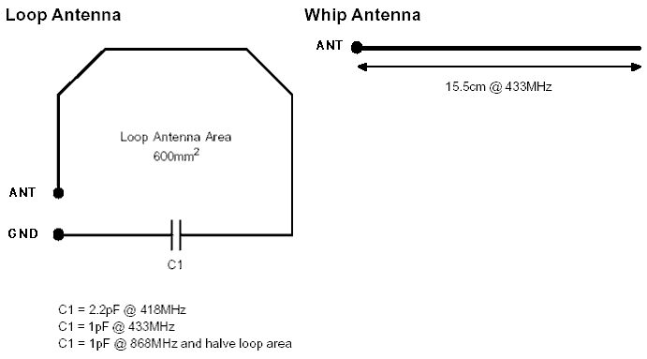

Problems encountered

- The mistake of mechanical placement. At the beginning I made a mistake of wrong mechanical placement, I regard the Top view of the AM Hybrid Transmitter as the components side, and in fact Top view means components underneath in this case. I was not easy to tackle the problem, because even I place a wrong direction ( Vcc->ant, gnd->in, ant->Vcc, in->gnd ), the transmitter still work! I fetch the data input to the transmitter input that I think I made a right pin connection at that time. The receiver can receive and decode and extract the original data correctly! But the input I found not TTL, the valid High is –ve. After carefully read the datasheet, I correct the pin connection, and final the valid High is +ve, and that is TTL.
My question is why I made a wrong pin connection, the transmitter still work? The only difference is the Logic high in this case is –ve.
The following is my explanation:
The pin “IN” connect to 0V, when pin “GND” is –ve, the voltage in pin “IN” is higher than that in pin “GND”. Therefore, pin “IN” relatively like a logic high +ve in normal operation.
The pin “IN” connect to 0V, when pin “GND” is +ve or 0V, the voltage in pin “IN” is lower or equal than that in pin “GND”. Therefore, pin “IN” relatively like a logic low in normal operation.
How about the Pin “VCC” and Pin “ANT”.

