Goal

In the product development cycle, industries are common adopted the “prototype early” approach to product development. A prototype is used as a proof of concept, as the consumer testing, or to aid in strength the product feature, cost reduction etc. In this industrial training, we are experience the developing test procedures, test circuits and test fixtures. We are invested a significant amount of time researching and souring the most commonly used electronic components, and material for product casing so that we can quickly integrate them into the applications. This IC project specializes in the development and manufacture of microcontroller-based consumer and electrical drive machine motion products. We hope we can move the new product from prototype to manufacturing successfully in our future.

Member List

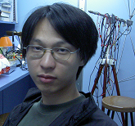 | Mr. Wong Tang Paai, Dillian was responsible for leading the team that designed and produced IC project titled “remote car”, a monster truck with machine arm that can be used to pick up something. He has experience in radio frequency wireless communication, DTMF Transceiver, RGB skin color tone sensor, microcontroller programming and electronic circuit design. He has received his high diploma in Electronic and Information Engineering from Hong Kong Polytechnic university in 2003 and entry the degree program of the same firm in HK Polytechnic University in 2003.  Mr. Dillian Wong also acts as an position of R&D for the development of the remote control system of the remote car, He was establish car-motion control protocol and build the RF transmission circuit that use asynchronous mode for sending the control code
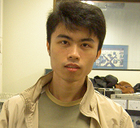 | Mr. Hui Chiu Wai, Wilson. An R&D of the motor control. He worked for the design and development of the motor control system. Main contribution was build the circuits and write an software to program the microcontroller that used to drive, control and integrate the machine arm motion with the monster truck basic movement. He made the remote car can move.  Mr. Wilson Hui has experience in ultrasonic, motor control system, infrared application, microcontroller programming and electronic circuit design. He has received his high diploma in Electronic and Information Engineering from Hong Kong Polytechnic university in 2003 and entry the degree program of the same firm in HK Polytechnic University in 2003.
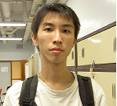 | Mr. Fung Tin zheng, Jason. An R&D was responsible for the design and builds the machine arm of the monster truck. He works for searching and selecting difference type of motors, metal material purchasing, that suitable for the machine arm, also he design, build, and test the prototype version of the machine arm. He also acts as an assistant of the product casing development, website development and video recording.  Mr. Jason Fung was experience in ……………….. He has received his high diploma in Electronic and Information Engineering from Hong Kong Polytechnic university in 2003 and entry the degree program of the same firm in HK Polytechnic University in 2003.
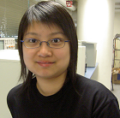 | Miss. Cheung Ying, Rachel. A project assistant. She has particular expertise in Film development, Fixing and PCB Fabrication. For the past four weeks, she has been in charge of fabricating the motor driving broad, RF receiver circuit board, and monster truck main control board. She also assists the casing design and building.  Miss Rachel, a student of Electronic and Information Engineering in Hong Kong Polytechnic University, she join the team in 2004 June.
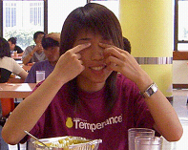 | Miss Wong yuk man, Sharon. A product designer and web designer. She was responsible for the design and development of the product casing. Main contribution was design and builds a product casing of the monster truck. Her sense in product designing was acquainted by the teammates. Miss Sharon, also worked for the video recording and website developing, she could identify and strengthen the possible impressive feature or performance of the monster truck.  Miss Sharon, was experience in thermal system design, analogy switch implementation and web site development. She has received his high diploma in Electronic and Information Engineering from Hong Kong Polytechnic university in 2003 and entry the degree program of the same firm in HK Polytechnic University in 2003.

