Individual Report

Project Title: | Remote Car  “IC Mini- Giant Monster Truck”
Project Group: | 04N05
Supervisor Name: | Jasper Wong
Name: | Wong Tang Paai, Dillian
Student ID: | 03906165D

Nature of the project

The project title is “remote car”. It does not a simple remote car. In our project planning, we design the remote car with many functions, and these functions can make our remote car outweigh the existing remote car in the market. We had implemented a research towards the toys of remote car, remote boat and remote airplane, we found that most of them they control panel are very simple, and thus what the user really can control only the motion motor. Maybe some remote toys with the speed level control, and several level controls, but they all does not like our remote car with a “machine arm”. That is the significance difference between our remote car and the general remote toys. The machine arm is our main feature, we equip the arm not enhance the interest of play our remote car, it does designed to promote the green message to protect our environment. The wheel is designed to run in the beach, with that machine arm, player can pickup something from the grounds. Generally, we build a video to demonstrate how to use the remote car to pick up a can and put it to the trash.

The role in the project group

A teamleader. I was responsible for leading the team that designed and produced IC project titled “remote car”, a monster truck with machine arm that can be used to pick up something. I also acts as an position of R&D for the development of the remote control system of the remote car.

The technical work

I was establish car-motion control protocol and build the RF transmission and Receiption circuit that use asynchronous mode for sending and receiving the control code to the receiver circuit.

I have written a program that can directly drive the RF modules without any assist of the encoder and decoder pair IC. Saving the cost of implementing complex remote control and the transmission capacity, the data rate always can be enhance, as we access the RF modules pair directly without the overhead that existed in common encoder and decoder pair.

The following diagram is the semantics that I used in the transmitter and receiver side programming. The semantics describes how the byte data can be transmitted in the transmitter side and received in the received side. The bit duration is 1.085ms, so the time for sending a semantics is about (1+8+2) x 1.085ms = 11.935ms. Further detail can be found in the program code section.

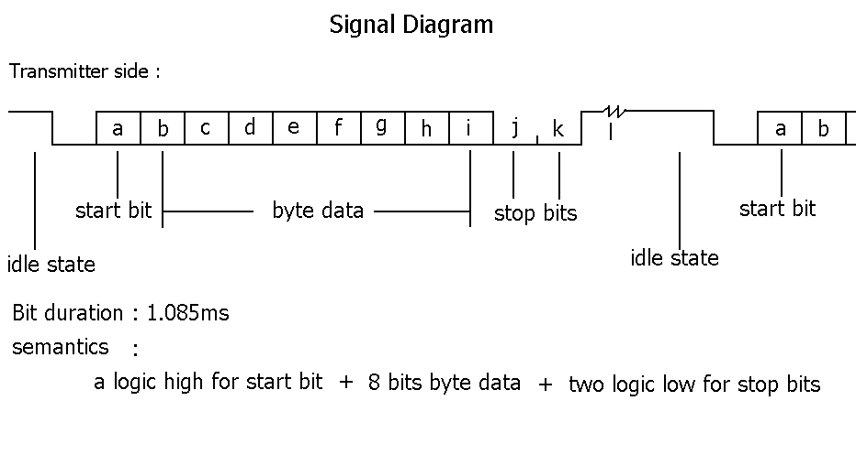
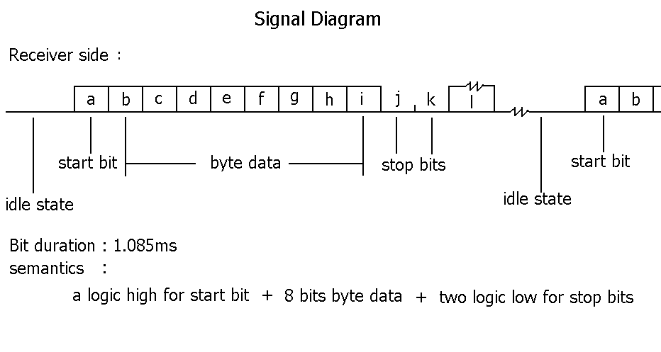

The management work

The assigned project requires to be completed within six scheduled weeks. That training workshop not only requires us to invest a significant amount of time on project development, it also training our ability on cooperation, we need to schedule different work to suitable teammates, teammates need to be self discipline, to be make technical decision alone and share their working experience to each other, so that we can get the better performance.

The establish a control code table also important. With these interface or committed standard, the remote control part and motor motion control part can develop it own section individually. The establishment of the common interface is important in our project. Without the common interface, all the work may very confuses

Problems and solutions in both technical and management aspects

Background: | The mistake of mechanical placement. At the beginning I made a mistake of wrong mechanical placement, I regard the Top view of the AM Hybrid Transmitter as the components side, and in fact Top view means components underneath in this case. I was not easy to tackle the problem, because even I place a wrong direction ( Vcc->ant, gnd->in, ant->Vcc, in->gnd ), the transmitter still work! I fetch the data input to the transmitter input that I think I made a right pin connection at that time. The receiver can receive, decode and extract the original data correctly! But the input I found not TTL, the valid High is –ve. After carefully read the datasheet, I correct the pin connection, and final the valid High is +ve, and that is TTL.
Question: | My question is why I made a wrong pin connection, the transmitter still work? The only difference is the Logic high in this case become –ve.
ANS: | The following is my explanation:  The pin “IN” connect to 0V, when pin “GND” is –ve, the voltage in pin “IN” is higher than that in pin “GND”. Therefore, pin “IN” relatively like a logic high +ve in normal operation.  The pin “IN” connect to 0V, when pin “GND” is +ve or 0V, the voltage in pin “IN” is lower or equal than that in pin “GND”. Therefore, pin “IN” relatively like a logic low in normal operation.  How about the Pin “VCC” and Pin “ANT”?  I think that mostly because of the luckly, ANT with voltage dived by Vcc, so if ANT connected Vcc, ANT can shared some voltage to the Vcc pin by voltage divider.  Actually every wire on the RF broad can be used to emit the signal, connect Vcc with a long rod wire, surely can radiate the magnetic fields.
Conclusion and recommendations
The project seems not difficult to implement, because it seems only involve the control of the motors, and simple casing design. To enhance the features, we establish the seven speed level and seven direction controls. There are also four motors in the machine arm. Because there are many controllable motors, the possible combination of the motors action is very large. We use 8 bits control code to control the remote car, and we establish a control code table. With these interface or committed standard, the remote control part and motor motion control part can develop it own section individually. The establishment of the common interface is important in our project. Without the common interface, all the work may very confuses.

The design and positioning of the antenna is as crucial as the module performance itself in achieving a good wireless system range. To maximize the system performance. The antenna should be kept as far away from sources of electrical interference as physically possible. If necessary, additional power line decoupling capacitors should be placed close to the module.

I use a straight piece of wire (15.5cm @ 433.92MHz, ¼ wave length) as our antenna. The antenna is connected to the modele via some 50ohm impedance, to maximum the signal power.

