COMP201
Principles of Programming

Assignment one

Student Name : Wong Tang Paai
Student Number : 01111911D

Submission date : 26-9-2002
Lecturer : Sau-Ming LAU

- Design an object class appointment by listing the instance variables and the methods that the class should have.
- Examples are data and changeDate()
- You should at least give four examples for each.
ANS:
Instance Variables : | time, location, person, phone, company, description, background, position
Methods : | setTime, setLocation, setPerson, setPhone, setCompany, setDescription, setBackground, setPosition.

- “Encapsulation” is regarded as one of the most fundamental and important concepts in the object-oriented approach to software development.
- Explain why
- you may use examples to illustrate your idea.
ANS:
In the object-oriented approach, Encapsulation of an object is the packing of its related data (variables) and procedures (method) together. By this way, Objects have the property of information hiding. This means that, although objects may know how to communicate with one another across well-defined interfaces, the data inside an object is accessed only by the object’s method for getting or setting the objects instance variable indirectly, objects normally are not allowed to know how other objects are implemented. This protects the instance variables of an object from being in an inconsistent or unreasonable state. An object’s internal working can also be modified independently without affecting other cooperating objects, as long as the way to call the methods remain unchanged. Surely, it is possible to drive a car effectively without knowing the details of how engines, transmissions, and exhaust systems work internally.

- “Overloading” is regarded as another fundamental and important concepts in the object-oriented approach to software development.
- Explain its benefit in terms of extensibility of the application programs.
- Give an example to illustrate your explanation
ANS:
Overloading simplifies programs because it allows programmer to use the same name for the same operation to perform different actions depending on parameters everywhere in a program. For instance, a programmer is required to design the interface for a system to run mock exams. An answer may come in as an integer, a Boolean or a text string. He /she could create a version of the method for each parameter type and give it a matching name. This would work but it means that future users of your classes have to be aware of more method names than is strictly necessary. It would be more useful if it could use a single method name and the compiler would resolve what actual code to call according to the type and number of parameters in the call. This can be achieved in Java language by creating multiple methods with the same name but different numbers and or types of parameters in a class.

- “Inheritance” is regarded as another fundamental and important concepts in the object-oriented approach to software development.
- Explain its benefits
- Draw a class hierarchy to help your explanation.
ANS:
Inheritance enable programmer to customize existing software. When programmer use inheritance to create a new class from an existing class definition, the new class inherits the attributes and behaviors of an existing class; then programmer can add attributes and behaviors to customize the class to meet his/ her need. It is the availability of substantial and a useful class library that delivers the maximum benefits of software reuse through inheritance.
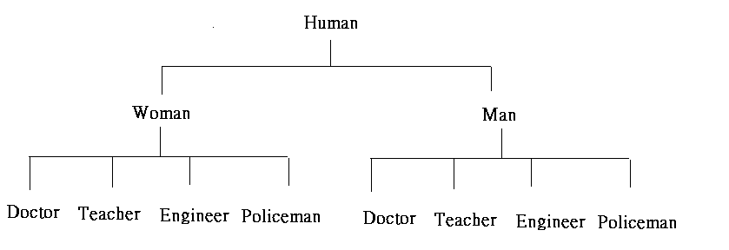
In this example Woman and Man are inherits the attributes and behaviors from Human. The subclass of Woman and Man are quite similar, however, their internal attributes are different resulted by the difference inheritance. It appears that programmers can add and modify the attributes and behaviors to customize the class to meet his/ her need. The subclasses can provide the similar methods toward others, however, the internal working can totally different.
- Differentiate between “object class” and “object instance”. You may use an example to illustrate your idea.
ANS:
Classes are the heart of Java, all Java code occurs within a class. There is no concept of freestanding code and even the simplest HelloWorld application involves the creation of a class. Object instance is the most crucial elements of using classes, the use of the key word is “new”. It indicates the creation of a new instance of a class. To sum up, Object class is a creation, and object instance is the using of created class. Therefore, once programmer have defined a class, he/ she can create any number of unique instances of the class, and the class defines the characteristics shared by all the instances. A class definition is a blueprint for making object instances.
public class HelloWorld2{
public static void main(String argv[]){
HelloWorld2 hw = new HelloWorld2();
hw.amethod();
}
public void amethod(){
System.out.println("Hello world");
}
}
This code creates a new instance of itself with the line
HelloWorld2 hw = new HelloWorld2();

- Suppose that you want to request the service payTuitionFee() from an object instance named peter. Write down the message that you will send to peter. Assume that the amount of tuition fee s 14000.
ANS:
[class peter = new class]
Peter.payTuitionFee(14000)

- “Reusability” of software components is one of the most important benefits contributed by the object-oriented approach.
- Explain why.
- Hint: Refer to Part IV of your OOT notes:
- You may even quote some examples from the Java online documentation.
ANS:
Object-oriented approach regard objects as the building blocks of a software, it will allow the programmers using the outcome of pre-programmers. Because Programs are expensive and time-consuming to build, and the quality of program is highly dependent on the skills of the analysts and programmers, if the program cannot reuse for further development. Maintenance is difficult and it will block the forward of development. In Java, developing a piece of software requires developing and composing object classes. A class may be reused in different software and it avoids the reinvention of the wheel.

