The Hong Kong Polytechnic University
Department of Electronic and Information Engineering
EIE351

Analogue and digital integrated circuits

(Laboratory report)

Mini Project:

D/A Converter

Student name: | Wong Tang Paai
Student no: | 01111911D
Course no.: | 42075- Yr 2

CONTENT

- Title
- Objective
- Specification

Introduce

RAMP-TYPE A/D CONVERTER

Problem:

Improvement:

DESIGN PROCEDURE, COMPONENT SELECTION
- CIRCUIT DIAGRAM

CONNECTION DESCRIPTION

CHECKING PROCEDURE

8 BIT COUNTER

DAC

COMPARATOR

CONVERSION TIME

ALIASING

No need of sample and hold

CLOCK

REGULATOR

MEASUREMENT

ADDING AN OUTPUT DIGITAL STORAGE REGISTER

CONCLUSION

◆◆◆◆◆◆◆◆◆◆◆◆◆◆◆◆◆◆◆◆◆◆◆◆◆◆◆◆◆◆◆◆◆◆◆◆◆◆◆◆◆◆◆

1. TiTle

D/A Converter

2. Objective

To design and construct an analog-to-digital converter

3. Specification
Synchronize D/A converter
5 Chip required
Input frequency ≦ 4KHz (For 1M Hz CLK)

4. Introduce

The combination of the quantizer and encoder is often called an analog to digital (A/D converter. The combination of the sample and hold device and the A/D converter accepts analog signals and replaces it with a sequence of code symbols. A more detailed diagram of this combination, sometime called a digitizer, a ramp encoder, feedback encoder etc. in this project, I am use the ramp-type D/A converter.

The general circuit technique underlying the operation of a feedback A/D converter is illustrated by the block schematic below; the system consist of a D/A converter, a comparator and digital logic counter. The digital logic counter increments up the digital input number applied to the D/A converter and the comparator senses then the analog input signal produced by the D/A converter becomes equal in values to the analog input signal which is applied to the A/D converter system. Conversion is complete when this equality occurs and the digital number which is then present at the DAC input represents the digitally encoded value of the analog input signal.

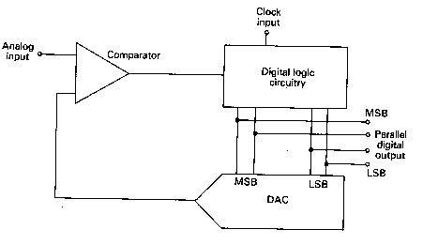

5. Ramp-Type A/D converter

The ramp-type A/D converter (count up A/D converter) is probably the simplest in concept; in this design the digital logic circuit consists essentially of a counter. At the start of a conversion the counter is set to zero, it then counts up clock pulses and the digital logic levels representing the count are applied to the logic inputs of the D/A converter. The count is stopped by the comparator when the D/A converter output becomes equal to the externally applied analog input signal and the stored count then constitutes the digital output of the A/D converter system.

Problem:

If the analog input now decreases, the digital output remains constant or ‘hold’; if the analog input increases the counter increments up again until equality of analog input and DAC output is again reached. The digital output in a ramp-type ADC thus represents the maximum value of the analog input during the time between counter resets.

Improvement:

One can repeat count the digital output, by reset and count up, VDC is change of value for a new hold, the analog input is equal of DAC output. At this time we can store the digit output by SAR.

6. Design procedure, component selection

In the beginning of the design procedure, I already want to build an synchronize AD counter. For a shorter conversation time, I select successive approximation first, the IC AM25L02 are no stock in Hong Kong, for a ensure I can complete the project within the time limit, I change the design for DA converter by using an 8 bit count up /down counter, and I select IC chip LS74191 (synchronous up/down counter with down/up mode control).

The concept I use can be illustrate by follow table:

VDAC ≦ Vin | Count up
VDAC ≧ Vin | Count down
VDAC = Vin | hold

Because the input Vin is analog signal and the VDAC is discrete step voltage, very often, condition VDAC = Vin is not hold, and the digital output bits may flashes in the way of count up and down. To avoid the uncertain or possible error occur, I abandons the count up/down mode for synchronize. And change the ideal as following:

VDAC ≦ Vin | Count up
VDAC ≧ Vin | hold

To ensure the accuracy of DAC output, I should make sure that once the VDAC just greater than Vin the counter must hold. To perform the synchronization, one can repeat counting the input and reset ( count the next Vin ).

For valid digital data can continuously available, one can use an output digital storage register or output buffer. This output store is updated with new data when the next conversion cycle take place.

Successive approximation

8 bit up/down counter

Repeat count up and reset
+
Digital storage register

7. CIRCUIT DIAGRAM

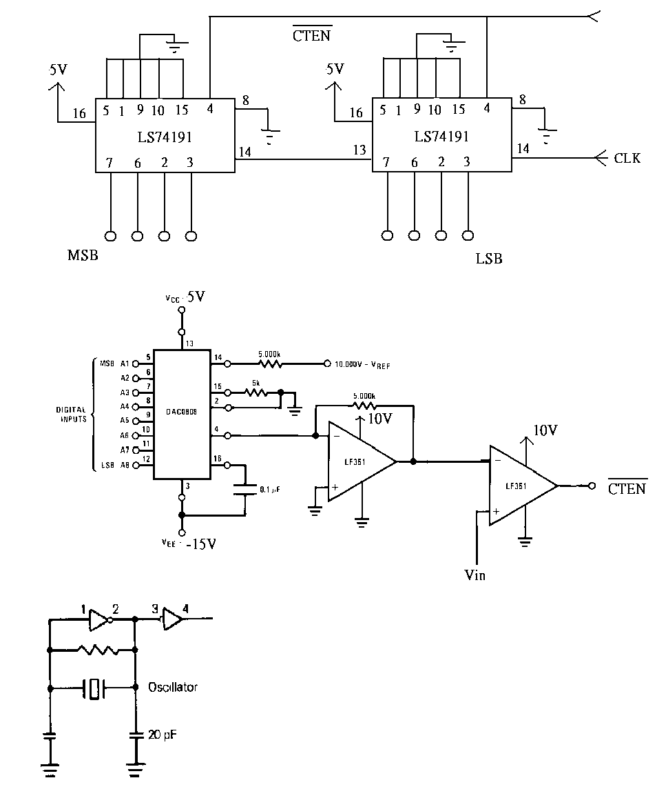

8. Connection description

74Ls193

The outputs of 4 flip-flops of LS74191 are triggered on a low-to-high transition of the clock input if the enable input is low. A High at the enable input (Pin4) inhibits counting, and low at the enable input run the counter. The direction of the count is determined by the level of the down/ up input (Pin5). When Low, the counter count up and when high, it counts down. Pin15,1,10,9 are grounded, so that counter will start counting from 0 up to 2^4 = 16. While the counter is overflow it will count from zero again and generate a one complete cycle clock pulses in $\overline{\text{ROC}}$ (pin 13 ripple clock). And this ripple clock can be used to perform the cascading function, At this project we connect ripple clock (pin13) of one synchronous up/down counter to the clk (pin 14) of another one to reach the cascading function with 8 bit counter.

Pin | Description
$D/{\overline{U}}$ pin 5 | High for count down  Low for count up
$\overline{\text{CTEN}}$ pin 4 | Low for run the counter  High for hold
$\overline{\text{ROC}}$ pin 13 | A clk pulse will generate when the counter overflow

9. Checking procedure

8 bit Counter

To illustrate the digital output, one can use a lamp for a sign. We can rewire the lamp position for an appropriate order MSB – LSB. Set the counter count from zero and count up mode, when the pin 4 is applied by an Low, the counter will count up, overflow, reset and count up again forever. For a better measurement, we can reduce the clock frequency to left more time available, or even turn off the clock and pause the conversation process. If the 8 bit counter circuit is workable, the output bits should be count up, overflow, reset and count up again forever.

The checking procedure above is using a trick, but convenient. For a formal or regular, one should use an electronic equipment for measurement, but not base on the sense of human eyes. CRO is commonly used for regular measurement. The LSB pin should be with frequency equal the frequency of CLK divided by 2, and the MSB pin with the frequency of CLK frequency divided by 8 etc. flip-flop is an divider.

DAC

Figure 1. illustrate +10V output digital to analog converter, it is the typical application circuit with $V_{0}=\text{10}V(\frac{A_{1}}{2}+\frac{A_{2}}{4}+\frac{A_{3}}{8}+\text{.}\text{.}\text{.}\text{.}\text{.}\text{.}\text{.}+\frac{A_{8}}{\text{256}})$
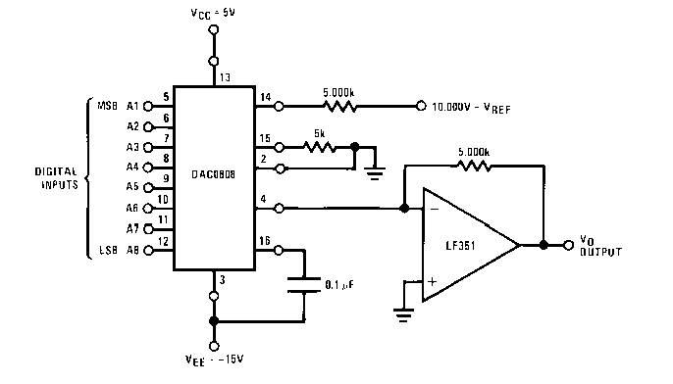
while the 8 bit counter correctly count from 0 to 256, the DAC output will have the voltage from 0 to 10V. Because the counter is counter repeat, the DAC output will also with voltage rising from 0 to +10V again and again.

Comparator

For hold the counter, pin4 of 74LS191 must be high, hence, when the counter start counting, Pin4 is Low for running, while the VDAC just greater then Vin comparator will have an high output inhabits the counting.

10. Conversion Time

The conversion time in a ramp-type A/D converter is not fixed but depends on the size of the analog input expressed as a fraction of the full scale.

Conversion time = $\frac{V_{\text{in}}}{V_{\text{DAC}}}×2^{n}T_{C}$
Where n is the number of logic bits in the DAC (8 bits in this project) and Tc is the period of the clock pules.

11. Aliasing
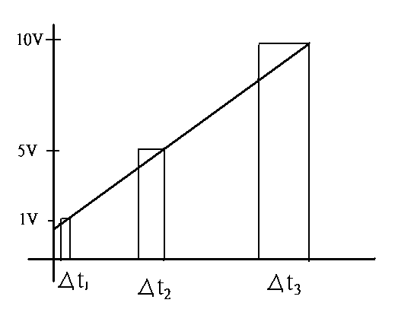
Taking the CLK = 1MHz, the conversation time for difference voltage will be difference
$$\begin{aligned}{Δt}_{1}=\frac{1}{\text{10}}2^{8}\frac{1}{1M}=\text{25}\text{.}6μ \\ {Δt}_{2}=\frac{5}{\text{10}}2^{8}\frac{1}{1M}=\text{128}μ=5{Δt}_{1} \\ {Δt}_{3}=\frac{\text{10}}{\text{10}}2^{8}\frac{1}{1M}=\text{256}μ=\text{10}{Δt}_{1}\end{aligned}$$

Because the conversation time is varied, the digital bits output will have a varies baud rate ruining it compatible with the other applications. If the receivers have a fixed sampling time, an error may be occurring. Receive still can receive data correctly provided that the circuit can synchronous bit changing. To avoid the possible aliasing, it is better to have a fixed conversation time.

12. No need of sample and hold

An analog variable can take on a continuum of values whereas a discontinuous variation is inherent in a numerical or digital representation of analog quantity. The ramp-type converter system seeks to establish equality between the analog input voltage and the voltage developed by the DAC. Vin can vary continuously, but the DAC output voltage varies in steps. The system cannot therefore establish the exact equality $V_{\text{in}}=V_{\text{DAC}}$. The system stops the DAC’s output from incrementing up when $V_{\text{DAC}}$ first exceeds $V_{\text{in}}$.
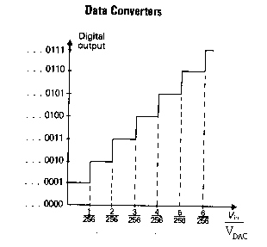

Because the conversion time is different, the discrete $V_{\text{DAC}}$output voltage, in term of constant separate time, will have possible error and uncertain. When this error voltage converted into bits form, the decoder ( convert digital bit to analog voltage) will not know what should be the sampling frequency for decoding. Therefore simple and hold circuit is nessary to fixed the

13. Clock

For a easier implement the development of the DAC circuit, one can use a external clock to take a control of the processing time. By decrease the clock frequency, more time will be available for the detection of the circuit, to stop the conversation process, it simply turn off the clock and get the required data. Once the development of the circuit is completed, internal clock can be applied, for amplification of the time signal, one can use two inverter, using its properties of cut off and saturation to achieve the amplification.
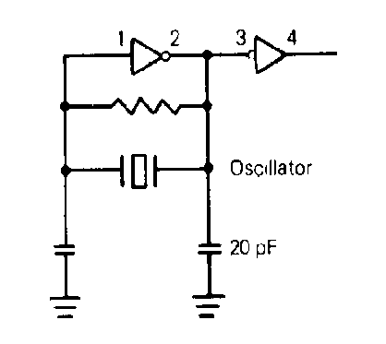

14. Regulator
AD converter involves many different voltage supply source. If the number of power supply equipment is restricted, voltage regulator is a necessary. The power supply for some point is not critical, so the regulator only for match the appropriate voltage range. Some point, however, is very critical; the reference voltage +10V for the DAC0808 pin 15 is a critical point or hot point. It is necessary to apply a steady voltage, to achieve this requirement; one can add a regulator, like 7810, to fixed the voltage supply. A large capacitance capacitor is needed to connect the output to ground, and another large capacitance capacitor is also need to connect the input to ground. Because the time constant may too large for the large capacitance capacitor, it is necessary to reduce the time constant and meanwhile have an ability for storage a large amount of charge, a extra small capacitor say 103 is parallel to the large capacitance capacitor to minimize the ripple voltage.

15. Measurement
To find the real voltage step, one can record the input voltage verse the output digital bits. For 5V input the digital bits should be 128/256 = 1000 0000. And calculated voltage step = 10/2^8 = 0.0039V

Procedure:
Increasing the Vin gradually, record the lamp condition that represent the digital bits
DATA SET1:
VCC | 4.5V
VEE | -14.96V
Vref | 10.15V
VCC(op-amp) | -10.87
CLK | 1.82KHz

Analog Vin input (V) | Digital Bit output | Voltage step number | Unit Voltage step x Voltage step number - Vin | Unit Voltage step
0.049 | 0000 0001 | 1 | -0.01 | 0.039
0.412 | 0000 1011 | 11 | 0.017
0.541 | 0001 0001 | 17 | 0.122
0.859 | 0001 1010 | 26 | 0.155
0.894 | 0001 1010 | 26 | 0.12
1.295 | 0010 0010 | 34 | 0.031
1.478 | 0010 0011 | 35 | -0.113
2.104 | 0011 0011 | 51 | -0.115
3.021 | 0101 0011 | 83 | 0.216
4.623 | 0111 1000 | 120 | 0.057
5.034 | 1000 0011 | 131 | 0.075
6.032 | 1010 0001 | 161 | 0.247
7.036 | 1011 0011 | 179 | -0.055
7.979 | 1101 0001 | 209 | 0.172
8.402 | 1101 1000 | 216 | 0.022
8.512 | 1101 1001 | 217 | -0.049
8.710 | 1110 0010 | 226 | 0.104
8.852 | 1110 1010 | 234 | 0.274

Higher voltage is uncertain, as the output lamp flashing

DATA SET2:
VCC | 5.05V
VEE | -15.15V
Vref | 10.18V
VCC(op-amp) | -10.54V
CLK | 26.162KHz

Analog Vin input (V) | Digital Bit output | Voltage step number | Unit Voltage step x Voltage step number - Vin | Unit Voltage step
0.79 | 0001 0100 | 20 | -0.01 | 0.039
1.82 | 0011 0001 | 49 | 0.091
2.28 | 0100 1001 | 73 | 0.567
3.62 | 0101 1101 | 93 | 0.007
4.93 | 1000 0000 | 128 | 0.062
5.59 | 1001 0001 | 145 | 0.065
6.53 | 1010 1000 | 168 | 0.022
7.68 | 1100 0101 | 197 | 0.003
7.89 | 1100 1001 | 201 | -0.051
8.26 | 1101 0011 | 211 | -0.031
8.64 | 1110 0001 | 225 | 0.135
9.15 | 1110 1010 | 234 | -0.024

Higher voltage is uncertain, as the output lamp flashing

The four column represent the VDAC – Vin, it should be greater than 0 and less than unit voltage step = 0.039. Data, however, indicate that some parts are not within the regain 0≦ VDAC – Vin ≦0.039V, the reasons is the voltage ripple exceed the unit voltage step = 0.039 or the human mistake of turn the voltage larger and then decrease it without attention. Ignoring the invalid data, measurement result still clearly indicates the conversation process is well-working. For Vin greater than 8.852V the digital output is not valid, because of the saturation of the amplifier. To eliminate this problem, one can increase the supply voltage of amplifier from ±10V to ±12V.

16. Adding an output digital storage register

The parallel digital data which is present at the output of a AD converter is valid representation of the analog input signal only when a conversion has been completed. While a conversion is in progress the digital data is changing. In order that valid digital data should be continuously available, one can use an output digital storage register or output buffer. This output store is updated with new data when the next conversion cycle take place.

The conversion system’s conversion complete signal going high, it can be inverter and is used to trigger a monostable. The monostable generates a single positive going pulse which acts as the enable signal for the storage latch. The data present at the output is unaffected by input data changes when the enable input goes low. The 74LS363 device has 3-state bus-driving outputs. Outputs are inactive in their high impedance states when the logic level applied to the device output control (pin 1) is high.
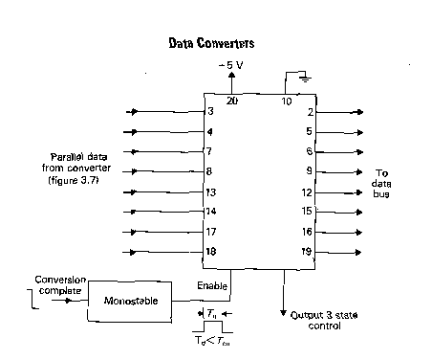

17. Conclusion

Ramp-type counter is not an effective counter and there even have many disadvantage, simplex, however, is the better for understand the general ideal of DA converter. Because the conversion time is varied with the input voltage, the receiver for this DA converter will contrast more complexity, as it is necessary to synchronize the bit change. With no fixed baud rate, ramp-type DA counter is not compatible for many application, like the communication of computer.

The suggested DA coveter is successive approximation DA converter. It with a fixed and faster conversation cycle (8 clock period), or simply using a 256 comparator for 8 bit counter. The later one is the fastest, it only require one complete clock cycle. The difficult to implement the later circuit, is the requirement of accuracy of resistance and larger amount of amplifier. Using the teaching of fabricating semiconductor, however, that is not the concerned problem.

For a cheaper DA converter, Ramp-type is better, if the application is not restricted to fixed baud rate, for a easier designation ramp-type DA converter is fine.

