The Hong Kong Polytechnic University
Department of Electronic and Information Engineering
EIE381
COMMUNICATION FUNDAMENTALS

(Laboratory report)

CM077A

SAMPLING AND TIME DIVISION MULTIPLEXING

Student name: | Wong Tang Paai
Student no: | 01111911D
Course no.: | 42075- Yr 2

CONTENT
- TILE
- OBJECTIVE
- APPARATUS
- Sample and Hold
- Aliasing
- Time-Division Multiplexing
- The PCM systeM
A/D converter
D/A converter
Advantage of binary PCM
- PRACTICAL EXPERIMENT
<1> Practical 1 (Sample and Hold)
<2>practical 2 (aliasing)
<3>practical 3 (analogue tdm)
<4> Practical 4 (Time and Frequency Domain)
<5> Practical 5 (Digital Multiplexed Signal)
<6>Practical 6 (D/A Conversion)
<7>practical 7 (demultiplexing)
- CONCLUSION

1. Title

Sampling and Time Division Multiplexing

2. Objective

- To investigate sampling and sample and hold techniques
- To investigate the effects of aliasing on sampled waveforms
- Introduces the concept of the time-division multiplexing
- Introduces the concept of A/D and D/A converter
- Introduces the concept of demultiplexing

3. Apparatus

- Computer
- Interface RAT 53-100
- Digital Data Formatting 53-150
- Oscilloscope
- Power Supply 01-100

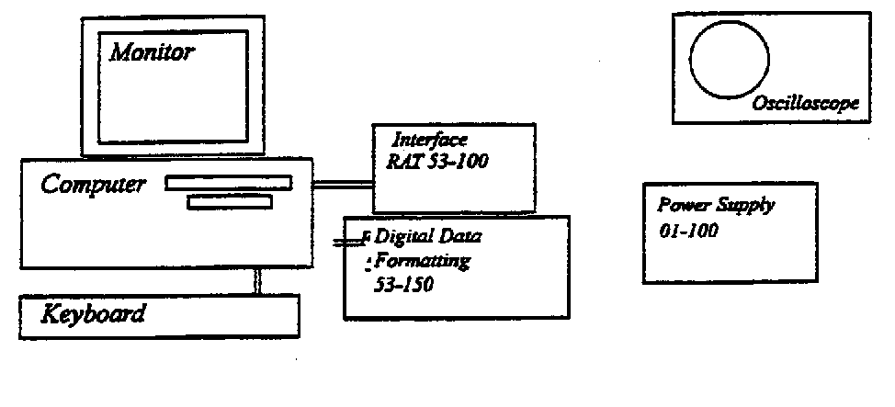

4. Sample and Hold

A sequence of pulses, snapshots of the waveform can represent a waveform at equally spaced intervals. These pulses are known as samples. Provided that there are enough samples, ie. That the sample frequency is high enough, the original signal can be completely recovered from its sampled equivalent. To restore a PAM signal, it is only necessary to sample the PAM waveform when it is non-zero, and then filter the sampled waveform to reproduce the original signal. To make the recovered signal less vulnerable to noise it is useful to hold the last sample until the next one is taken. This is known as sample and hold.

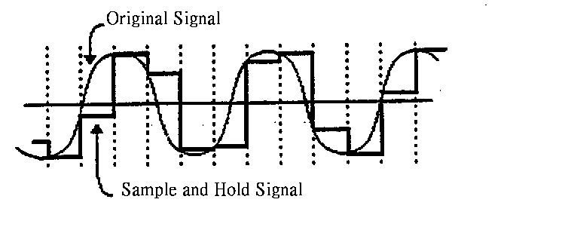
A signal is sampled by connecting it quickly to a capacitor via a switch. While the signal is connected, the capacitor is charged until is soon reaches the level of the signal. The time constant of the charging circuit is made as small as possible so that the time taken to reach the signal level is minimal.

When the switch disconnects the signal from the capacitor, the level that the capacitor had reached at that point is held due to the high impedance input of the buffer amplifier. The waveform that is seen at the output of the buffer amplifier resembles a series of steps, the leading edges of which are rounded off due to the capacitor being charged to the next level at this point.

5. Aliasing

A waveform can be represented by a sampled waveform made up of samples of the original signal taken at equally spaced intervals.

Provided that there are enough samples, ie.that the sample frequency is high enough, the original signal can be completely recovered from its sampled equivalent. If the samples are not taken at a high enough rate, the original waveform cannot be recovered because aliasing occurs.

To ensure that the sampled signal contains enough information to enable the original signal to be regenerated without distortion, the frequency at which samples are taken needs to be at least twice that of the highest frequency component in the original signal. This miniumum sampling frequency is called the Nyquist frequency.

If samples are taken at slightly less than the Nyquist frequency, aliasing occurs. The result of this is that the recovered signal appears to be one of much lower frequency.

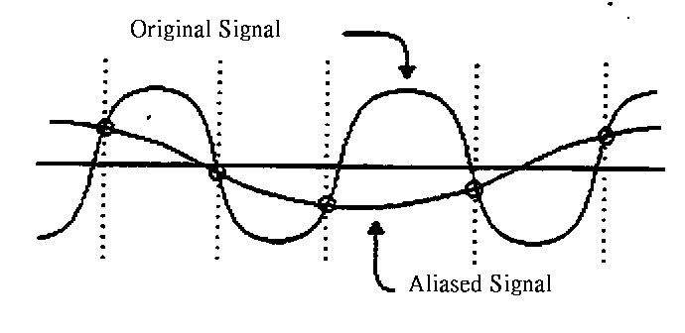

6. Time-Division Multiplexing

Time-Division Multiplexing (TDM) is a technique used for transmitting several analog message signals over a communication channel by dividing the time frame into slots, one slot for each message signal. In comparison, frequency division multiplexing (FDM) divides the available bandwidth into slots, one slot for each message signal.

Multiplexing

Four input signals, all bandlimited by the input filters, are sequentially sampled at the transmitter by a rotary switch or commutator. The switch makes f_{s} revolutions per second and extracts one sample from each input during each revolution. The output of the switch is a PAM waveform containing samples of the input signals periodically interlaced in time. The samples from adjacent input message channels are separated by Ts/M, where M is the number of input channels. A set of M pulses consisting of one sample from each of the M-input channels is called a frame.

Demultiplexing

At the receiver, the samples from individual channels are separated and distributed by another rotary switch called a distributor or decommutator. The samples from each channel are filtered to reproduce the original message signal. The rotary switches at the transmitter and receiver are usually electronic circuits that are carefully synchronized. Synchronizing is perhaps the most critical aspect of TDM. There are two levels of synchronization in TDM: frame synchronization and sample (or word) synchronization. Frame synchronization is necessary to establish when each group of samples begin and word synchronization is necessary to properly separate the samples within each frame.

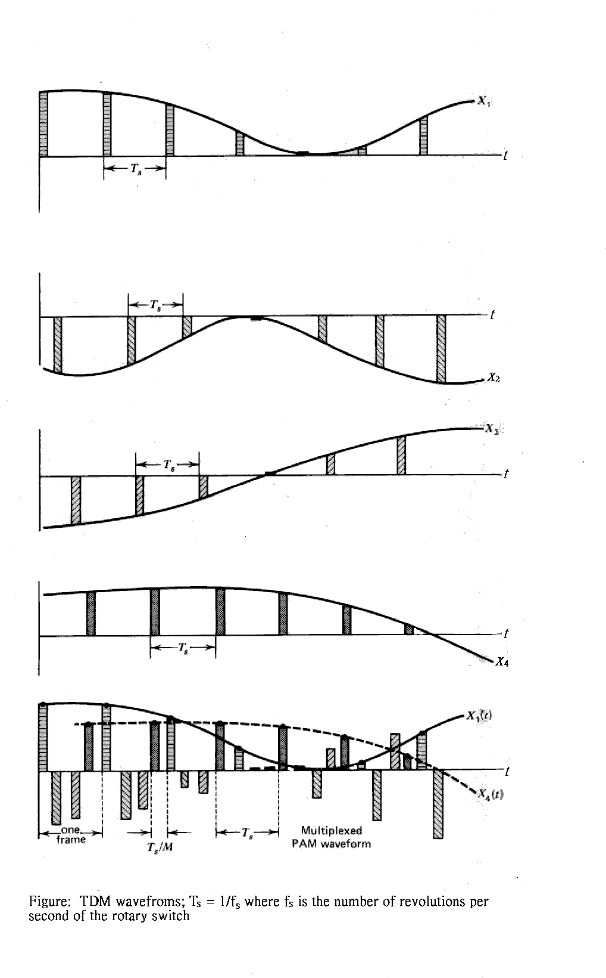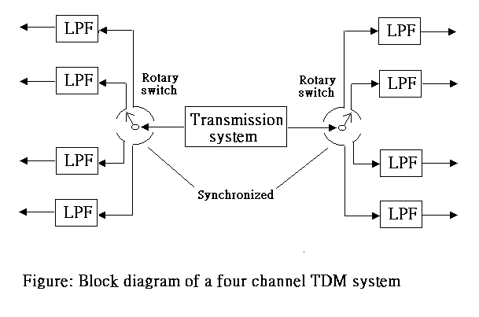

The interlaced sequence of samples may be transmitted by direct PAM or the sample values may be quantized and transmitted using PCM. Time-division multiplexed PCM is used in a variety of applications, the most important one is PCM telephone systems where voice and other signals are multiplexed and transmitted over a variety of transmission media including pairs of wires, wave guides, and optical fibers.

7. The PCM system

The analog signal is sampled and then the samples are quantized and encoded. Assume that the encoder output is a binary sequence, and the binary code has a numerical significance that is the same as the order assigned to the quantized levels. We could have used arbitrary ordering and codeword assignment as long as the receiver knows the quantized sample value associated with each code word.

A/D converter

The combination of the quantizer and encoder is often called an analog to digital (A to D or A/D) converter. The sampler in practical system is usually a sample and hold device. The combination of the sample and hold device and the A/D converter accepts analog signals and replaces it with a sequence of code symbols. A more detailed diagram of this combination, sometime called a digitizer, a ramp encoder, feedback encoder etc.

D/A converter

After decoding a group of binary digits representing the codeword for the quantized value of the sample, the receiver has to assign a signal level to the codeword. The functional block that performs this task of accepting sequences of binary digits and generating appropriate sequences of levels is called a digital to analog (D/A) converter as a Q-level PAM waveform is then filtered to reject any frequency components lying outside of the baseband. The reconstructed signal is identical with the input except for the quantization noise and another noise component that results from decoding errors due to the channel noise.

Advantage of binary PCM

The digitally encoded signal is transmitted over the communication channel to receiver. When the noisy version of this signal arrives at the receiver, the first operation performed is the separation of the signal from the noise. Such separation is possible because of the quantization of the signal. A feature that eases this task of separating signal and noise is that during each bit interval the receiver has only to make the simple decision of whether a 0 or a 1 has been received. The relative reliability of this decision in binary PCM over the multivalued decision required for direct Q-ary PAM is an important advantage for binary PCM.

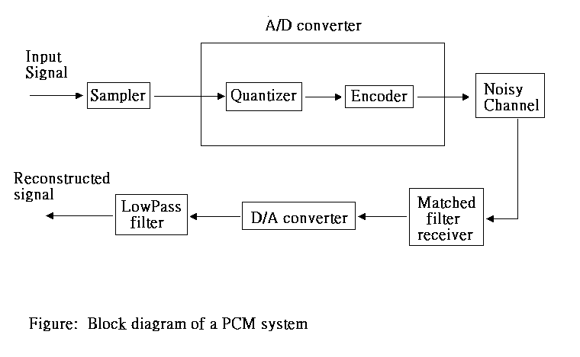

9. pRACTICAL EXPERIMENT

<1> Practical 1 (Sample and Hold)

PAM

Pulse-amplitude modulation, the amplitude of a train of constant-width pulses is varied in proportion to the sample values of the modulating signal. The pulses are usually taken at equally spaced intervals of time.

Operation

The switch closes only when that particular channel is to be sampled. If the source impedance r is small, the capacitor voltage changes to the input voltage within the time that the switch is closed. The load impedance R is arranged to be high so that the capacitor retains the voltage level until the switch is closed again. Therefore the sample-and-hold circuit accepts only those values of the input that occur at the sampling times and then holds them until the next sampling time. To make the recovered signal less vulnerable to noise it is useful to hold the last sample until the next one is taken.

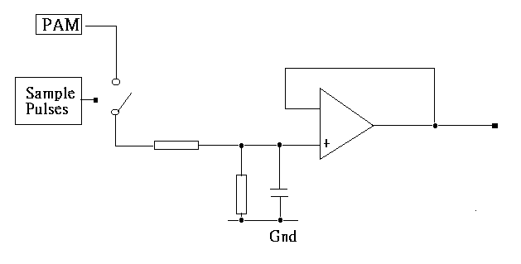

Ideal requirements

Sample time:
To restore a PAM signal, it is only necessary to sample the PAM waveform when it is non-zero. Synchronization of the sample time regarding the PAM spaced interval of time and constant-width pulses, hence, became critical for the sample and hold circuit. If the sample time is to long, some information may be missed; if the sample time to short, extra error information, zero level, may be induced.

Sample pulse:
The sample pulses is go high, the output of sample and hold will vary with the PAM signal; The sample pulses is go low, the output of sample and hold will go low regardless the PAM signal. For ideal case, the sample pulse is high all the time, it, however, is no contribution on increase the efficient and is a waste of power.

Time constant:
The time constant of the charging circuit is made as small as possible so that the time taken to reach the signal level is minimal.
<2>Practical 2 (Aliasing)

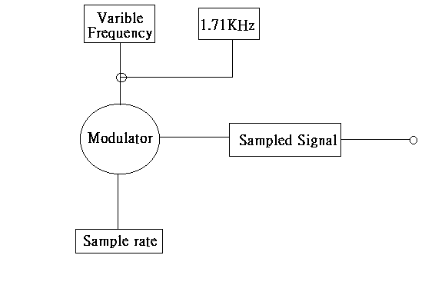
- By increasing the sample rate, the sampled signal will trend to similar the input signal of variable frequency.
- By decreasing the sample rate, the sampled signal will deteriorate it complexity on different stage of level.
- While the sample rate frequency is half of the signal input frequency, output signal appear to become a square wave with input signal amplitude, the circuit samples the maximum and minimum values of the input signal.

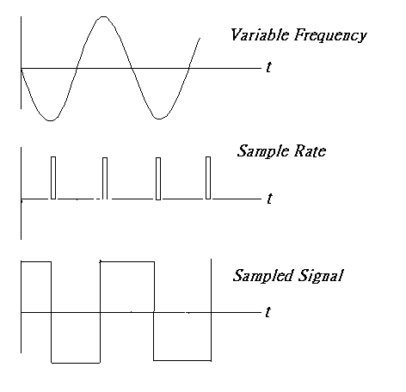

<3> Practical 3 (Analogue TDM)

- Multiplexing is the term given to describe the transmission of two or more signals down a common channel.

- Time division Multiplexing (TDM) is the process of switching between two, or more, signals serially in time.

- When the clock pulse is high level, multiplexer switch the input as signal 2, when the clock pulse is low level, multiplexer switch the input as signal 1.

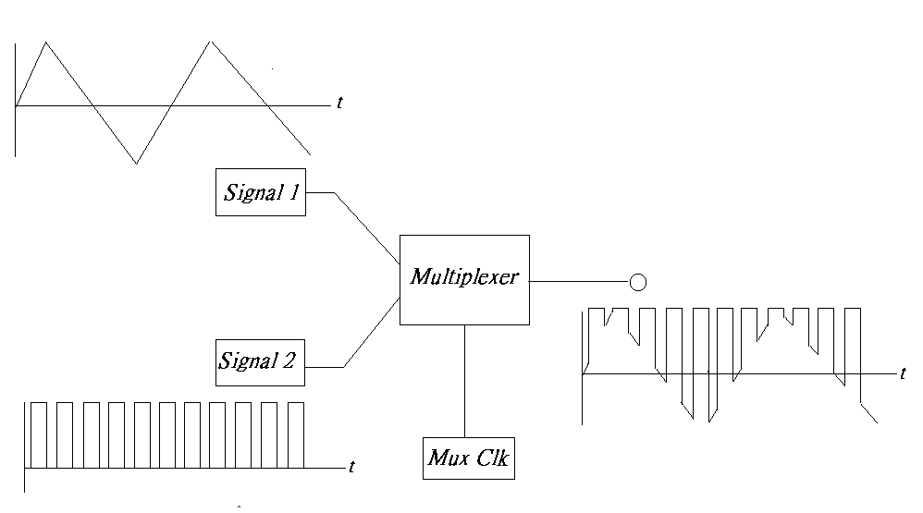
<4> Practical 4 (Time and Frequency Domain)

The combination of the quantizer and encoder is often called an analog to digital (A to D or A/D) converter. The sampler in practical system is usually a sample and hold device. The combination of the sample and hold device and the A/D converter accepts analog signals and replaces it with a sequence of code symbols. A steady dc input will convert to binary pulse code output in a way of interleaved in time.

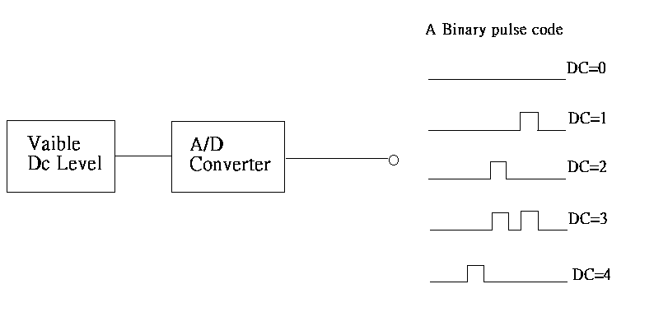
<5> Practical 5 (Digital Multiplexed Signal)

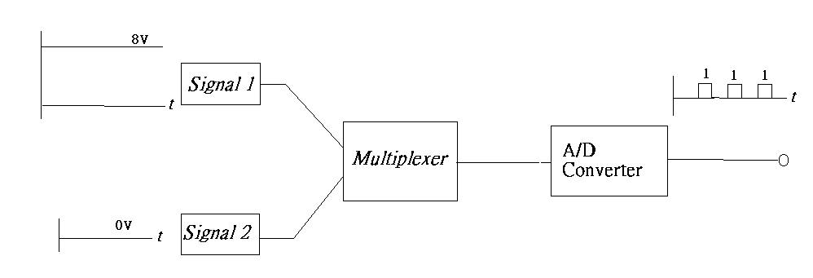

<6> Practical 6 (D/A Conversion)

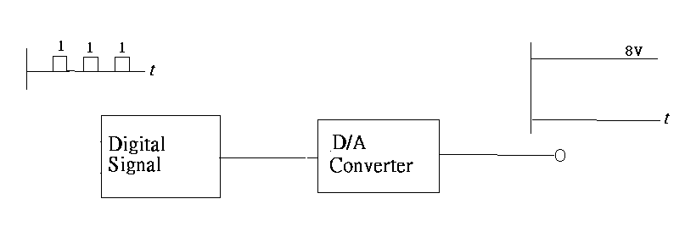

<7> Practical 7 (Demultiplexing)

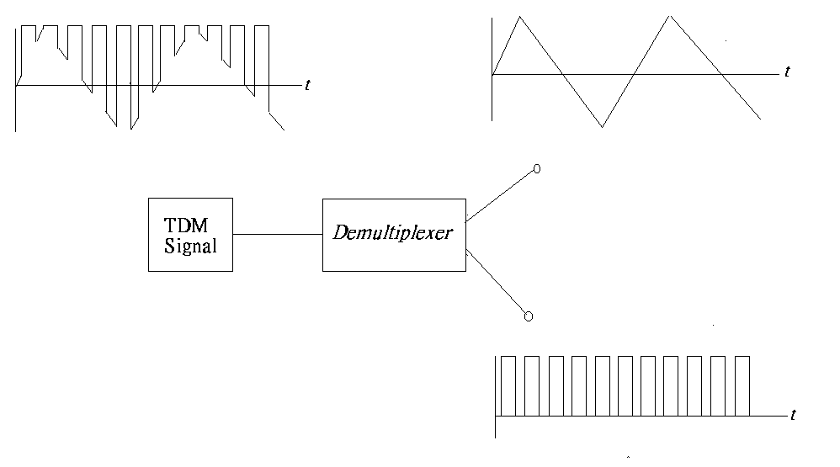
9. CONCLUSION

The many functions required for communicating analog information in digital format are combined to form a complete system, the analog signal is sampled and then the samples are quantized and encoded into a number of discrete levels, use a code to designate each level at each sample time. The simplest approach to this requires only an analog-to-digital converter at the information source, and a corresponding digital-to-analog converter at the receiver.

A complete system for pulse code modulation (sending analog information in digital form) must make sure that the bits are received with the proper timing and that the receiver can determine where the overall digital byte or word representing the analog value actually begins. One method used is to periodically send a pulse that is known to exceed the height of any other pulses in the transmission. These can be identified by the receiver and used for synchronization. Another possibility is to use a pilot tone that is shifted in frequency from the time-multiplexed transmission. There are various techniques used to pass both bit and byte or word timing information to the receiver or derive it at the receiver, so that the receiver is properly synchronized with the activity of the transmitter.

Since PCM requires the transmission of several digits for each message sample, it is apparent that the PCM bandwidth will be much greater than the message bandwidth. A lower bound on the bandwidth can be obtains by filtering, it, however, generally is not possible to build such a filter over a wide range of frequencies, particularly if Q(w) goes to zero. But because message is band-limited, it is sufficient to synthesize the inverse filter over only a very limited frequency range. This technique of correcting the frequency response of a system for a known distortion is called equalization.

Time-Division Multiplexing (TDM) is a technique used for transmitting several analog message signals over a communication channel by dividing the time frame into slots, one slot for each message signal. When a large number of signals are time-multiplexed together in a PAM system, the width of the sampling pulses must be made very narrow in comparison to the sampling interval. Under these conditions the signal power at the final low-pass filter in the receiver decreases to the point where large amplification factors are needed.

Advantages in the use of pulse modulation with time-division multiplexing (TDM) include the fact that the circuitry required is digital, thus affording high reliability and efficient operation. This circuitry is simpler. Another advantage of TDM systems is the relatively small interchannel cross-talk arising from nonlinearities. Disadvantages of TDM include pulses accuracy and timing jitter become a major problem at high frequency, and hence, TDM system normally operate at clock frequencies below 100MHz.

After time multiplexing and filtering, the pulse-modulated waveform may be transmitted directly on a pair of wire lines, For long-distance transmission, however, it is more convenient to use higher frequencies and transmit the signal using electromagnetic radiation. The PAM spectrum may be translated to these higher frequencies using the CW modulation techniques.

