Name: __LeeKanChuen__________ Student ID#: __050165551__
Course: BIS / CAS* Class: A / B/ C / D* Date: ____29-5-2006______
* Please circle an appropriate one.
Site Visit Report

Date of Visit: ________20-5-2006______
Organization that I visited: _The IC Design/Development Support Centre
, The Photonic Centre and The Bio-Informatics Centre

How do I feel about the visit?
So excite because in there let me know many new thing and the place so beautiful.

1. Name of Place/Center that I visited: IC Design/Development Support Centre
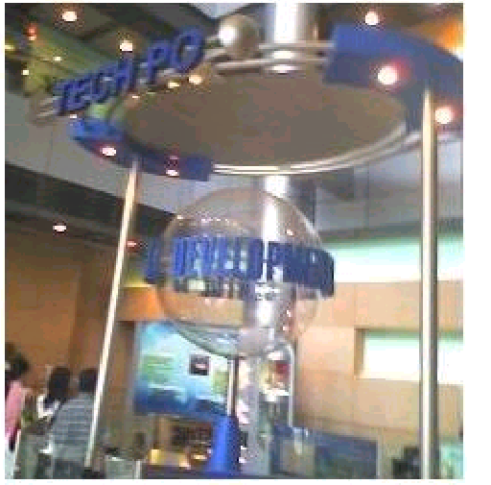
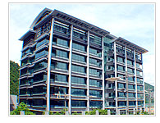
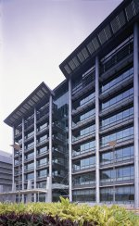
(a photo can be put here together with a few paragraphs)
The IC Design/Development Support Centre at HKSP provides a total one-stop service to companies engaged in Integrated Circuit (IC) design - one of the most important technological foundations of the high value-added electronics industry. The Centre will support IC companies throughout the entire IC product development cycle from initial design to production release. The shared support services are designed to strengthen local IC companies and attract international IC design firms to Hong Kong.
2. Name of Place/Center that I visited: _The Photonic Centre___

(a photo can be put here together with a few paragraphs)
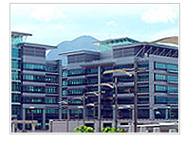
The Photonic Centre, one of the most vital physical infrastructures located within HKSP, is designed to provide a multi-disciplinary research and development facility for the benefit of the Science Park community and society as a whole. The major facilities include:
Photonics Development Support Centre
To provide a one-stop service to companies for design and simulation, test and measurement, fabrication and processing, prototype assembly and integration, product qualification and education & training for photonics.
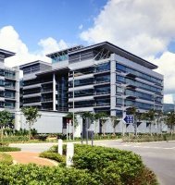
Product Analysis Lab
To provide nano-scale design, debug, evaluation and qualification services for photonics sub-components and components, materials characterization and analysis including nano-metrology. As a shared support service, the laboratories are also available for use by local universities, Science Park's incubatees and tenants as well as industries in Hong Kong.

3. Name of Place/Center that I visited: ____ The Bio-Informatics Centre _______

(a photo can be put here together with a few paragraphs)
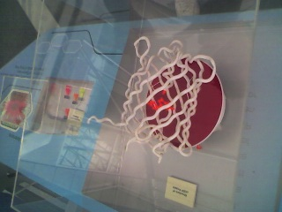
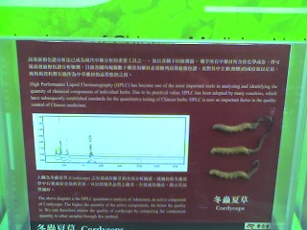
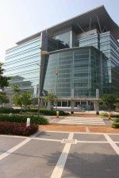
The Bio-Informatics Centre which opens today will facilitate support for the biotechnology sector. It will also facilitate co-operation and collaboration in research and development among industry players, universities and research institutions in this very important science-based sector. The centre will help synergise existing strengths and infrastructural support in biotechnology and open up new opportunities for Hong Kong's biotechnology industry.

With Science Park's unique advantages in providing a state-of-the-art "hard" infrastructure of technical facilities, a progressive "soft" infrastructure of support services, and its ease of access to the manufacturing centres in the Pearl River Delta, we are confident that the Science Park will continue to attract both local and multinational innovative enterprises. The Science Park will continue to offer advanced yet practical support to enable enterprises to pursue their research and development initiatives and business opportunities.

Remarks:
- The total number of pages should be at least two but not more than three.
- The deadline of submission is 29 May 2006.
- Your report must be a typed and formatted one.
- You are required to submit a hard copy only.

