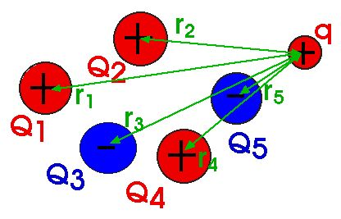

Electrostatics

by
Enrico Lorenzo

Submitted to
Mr. Clarence Queza
Physics II

1.0 ELECTROSTATICS

Study of charges at “rest”

Electrostatics deals with the study of any effect resulting from the existence of stationary electric charges. Electric charges (q) is the fundamental quantity of electricity. The SI Unit of charge is the coulomb (C) in honor of Charles Augustin del Coulomb. 1 C = charge of $6\text{.}\text{25}×{\text{10}}^{\text{18}}$ protons/electrons.

“Like charges repel” “Unlike charges attract”

Figure 1.1 Basic Law of charges

Static electricity may have been noticed first around 600 B.C. by Thales of Miletus. He conducted experiments with amber, the fossilized resine of pin sap. He noticed that amber, which had been rubbed with wool cloth, attracted to bits of straw. Since then, the Greek word for amber, electron has been used to describe this invisible force of attraction.

In 1500, Sir William Gilbert devised an apparatus called a versorium consisting of a tiny metal arrow that pivoted freely on a needle. He discovered that rubbing some materials, such as amber, gems, and certain rocks with wool cloth induced them to exert a force of attraction on the arrow of his versorium. When he held one of these charged objects near the versorium, the arrow pivoted in the directions of the object. These materials he called “electrics” or what we know now as conductors. He also discovered that certain other materials, especially metals, could not be induced to attract the arrow no matter how hard or how long they were rubbed. These materials he called “nonelectrics”, which we know now as insulators.

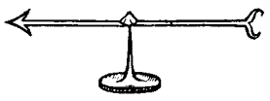

Figure 1.2 Versorium

During the sixteenth century, researchers theorized that some invisible substance must flow into “electrics” when they are rubbed with cloth. This invisible “fluid” was called electricity.

The force of electric repulsion was noted in 1733 by French scientist Charles Francois Du Fay. He charged a glass rod by rubbing it with silk cloth. The charged glass attracted tiny bits of cork. When the cork touched the glass rod, the electrostatic charge flowed into the cork. Then, when the charged glass rod was held near the charged bits of cork, the glass rod repelled the cork.

In 1750, Benjamin Franklin attempted to explain electric attraction and repulsion in this manner: Electric “fluid” like water, seeks its own level. Surplus electric “fluid” flows towards a deficit of “fluid” until the two “fluids” balance at the same level. Franklin indicated the surplus with a (+) sign and the deficit charge with a (-) sign. His research laid the foundation for the law of electrostatic attraction and repulsion, which consists of three statements:

- An electrostatically charged object attracts objects that are electrostatically neutral.
- Objects with like electrostatics charges repel each other.
- Objects with unlike electrostatics charges attract each other.

1.1 ELECTROSTATIC CHARGE

Smallest unit of electricity held at rest

Any electrostatics charge can be detected with an instrument called electroscope. A very simple electroscope can be made by suspending a small ball of styrofoam by a thread. If a charged rod is brought near the ball, it will be noticeably attracted or repelled by the electrostatic charged. Even a thin stream of running water can be used as an electroscope since it will be deflected by an electrostatic charge. (You can try it at home!)

Charging/Ionization is the process that involves transfer of electron from one body to another. The object that loses electrons is said to be positively charged while the object that gains electrons is said to be negatively charged. An electrostatic charge may be generated in an object by one of these three methods: friction (rubbing), conduction or induction.

By rubbing a glass rod with a fur cloth, the loosely held particles of fur cloth will likely to transfer to the glass rod. Thus, the glass rod becomes negatively charged.
In conduction process, as the word implies, a neutrally charged object will gain a charge if it is in direct contact with a charged object.

On the other hand, in induction process, the charged will just be induces if a charged object is brought near it, but without direct contact between the two.
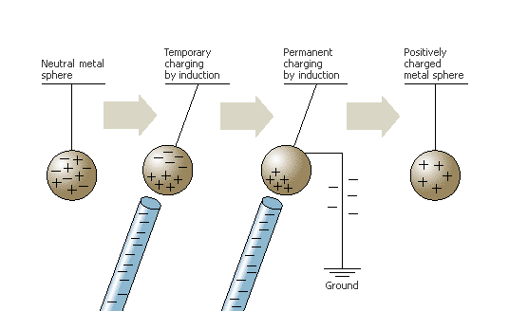

Figure 1.3 Charging by induction

1.2 ATOMIC STRUCTURE

What atoms look like

Atoms consist of a small dense nucleus (containing protons and neutrons) surrounded by moving electrons. At normal condition, the number of electrons equals the number of protons so the net charge is zero.

The electrons may be thought of as moving in circular or elliptical orbits (Bohr theory), or more accurately, in regions of space around the nucleus (orbitals). Electrons and proton has the same magnitude of a charge only with different sign (-) and (+) 1.6 x ${\text{10}}^{−\text{19}}$C, respectively.

The mass of the atom is concentrated within its nucleus because proton and neutron are more massive compared with electron: $m_{p}=m_{n}=1\text{.}\text{67}×{\text{10}}^{−\text{27}}$kg; while $m_{e}=9\text{.}1×{\text{10}}^{−\text{31}}$kg.

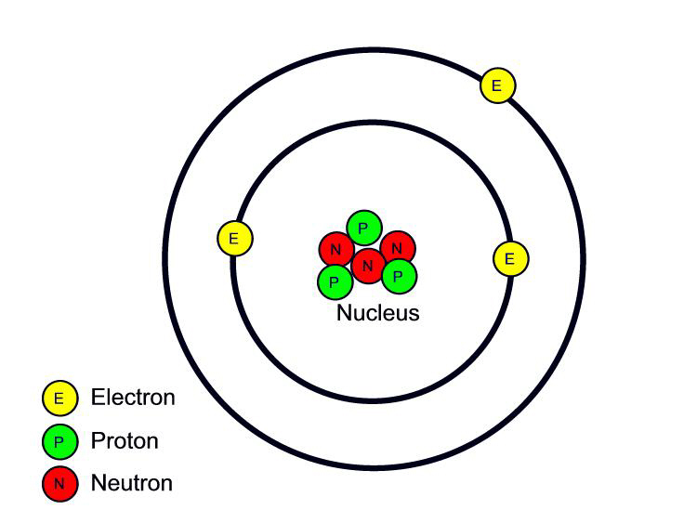

Figure 1.4 Atomic Structures

Electrons are not permanently bound to the atom. It is being shared or transferred to another atom if there is enough energy that “pushes” it.

1.3 CONDUCTORS & INSULATORS

Materials that allow or do not allow passage of electron through them

Matter may be classified as conductors, insulators and nowadays semi-conductors.
Certain materials, especially metals, are electric conductors. The nuclei of metal atoms are tightly bound into crystals structures, but the electrons circulate around and between the nuclei making up the crystal. These electrons are called free electrons because they easily move from one atom to another within the crystal. Good conductors are substances, which have fewer than four valence electrons, e.g. Copper atom (1 valence electron).

Insulators are any material, such as amber, glass, sulfur, mica, paraffin, hard rubber, silk and dry air, which do not easily conduct electricity. They have more than four valence electrons, e.g. Phosphorus (5 valence electrons).
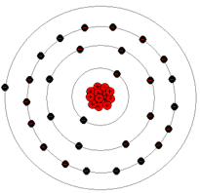

Figure 1.5 Valence Electrons

Semiconductors are materials that are normally an insulator, but may become a conductor under certain conditions. They exactly have four valence electron (e.g. Germanium).

1.4 COULOMB’S LAW

Determines magnitude of electric force

Charles Augustin de Coulomb observed static charged particles. He realized that when the magnitude of two charged particles is increased, they attract/repel each other greater than before. And when he brought near each other those two charged particles such that their distance of separation(r) is decreased, the force of attraction/repulsion is increased to the square of its initial value.

Thus, he concluded and stated into a law that:

The force of attraction or repulsion between twoelectrostatic charges is directly proportional to the product of the charges and inversely proportional to the square of the distance between them.

$F_{e}α\frac{q^{1}q}{r^{2}}$ $⇒$ $F_{e}\frac{{\text{kq}}^{1}q}{r^{2}}$ and $k=\frac{1}{4{\text{πε}}_{0}}$

where: $F_{e}$ = electrical or coulomb’s force
$k$ = Coulomb’s constant = $9×{\text{10}}^{9}{{\text{Nm}}^{2}}/{C^{2}}$
$q^{1}$ = test charge; observed to be charged experiencing the effect of the other charge/s near it
$q$ = the one charge exerting force on the test charge
$r$ = radial distance between the two chages
$ε_{0}$ = $8\text{.}\text{85}×{\text{10}}^{−\text{12}}{C^{2}}/{{\text{Nm}}^{2}}$, permittivity of free space, property of the medium to permit passage of electric flux lines through the medium

Sample Problems

1. Two small plastic balls are given positive electric charges. When they are 10-cm apart. The repulsive forces between them have magnitude 0.10-N. What is the charge on each ball (a) if the two charges are equal; (b) if one has thrice the charge of the other?

Given: r = 10-cm
F = 0.10-N

Required: Charge on each ball (a) if the two charges are equal

Solution:

(a) $q=\sqrt{\frac{F_{e}r^{2}}{k}}=\sqrt{\frac{(0\text{.}\text{10}−N)(0\text{.}\text{10}−m)^{2}}{9×{\text{10}}^{9}{{\text{Nm}}^{2}}/{C^{2}}}}=3\text{.}\text{33}×{\text{10}}^{−7}$C

(b) $q=\sqrt{\frac{F_{e}r^{2}}{3k}}=\sqrt{\frac{(0\text{.}\text{10}−N)(0\text{.}\text{10}−m)^{2}}{3(9×{\text{10}}^{9}{{\text{Nm}}^{2}}/{C^{2}})}}=1\text{.}\text{92}×{\text{10}}^{−7}$C; $5\text{.}\text{77}×{\text{10}}^{−7}$C

2. Two charges are located on the positive x-axis of a coordinate system as shown. Charge $q_{1}=3×{\text{10}}^{−9}$C and $q_{2}=−5×{\text{10}}^{−9}$C. What is the total force exerted by these two charges on a charge $q_{3}=2×{\text{10}}^{−9}$C located at the origin?

$q_{3}$ $q_{1}$ $q_{2}$
+ + -

0 2cm 4cm

Given: $q_{1}=3×{\text{10}}^{−9}$C
$q_{2}=−5×{\text{10}}^{−9}$C
$q_{3}=2×{\text{10}}^{−9}$C

Required: $F_{\text{net}}$ on $q_{3}$
Solution:

Step 1: Determine directions of electrical forces acting on the test charge due to
the other charges

$F_{1}$ $F_{2}$
+ + -

0 2cm 4cm
$q^{1}$ $q_{1}$ $q_{2}$

Step 2: apply Coulomb’s formula to determine magnitude of $F_{1}$ and $F_{2}$ then solve
$F_{\text{net}}=−F_{1}+F_{2}$

$F_{1}=\frac{(9×{\text{10}}^{9}{{\text{Nm}}^{2}}/{c^{2}})(3×{\text{10}}^{−9}C)(2×{\text{10}}^{−9}C)}{(0\text{.}\text{02}m)^{2}}=1\text{.}\text{35}×{\text{10}}^{−4}N$ , to the left
$F_{2}=\frac{(9×{\text{10}}^{9}{{\text{Nm}}^{2}}/{C^{2}})(5×{\text{10}}^{−9}C)(2×{\text{10}}^{−9}C)}{(0\text{.}\text{04}m)^{2}}=5\text{.}\text{625}×{\text{10}}^{−5}N$, to the right

$F_{\text{net}}=7\text{.}\text{875}×{\text{10}}^{−5}N$, to the left

3. Given the figure, calculate the net electrical force of charges $q_{2}(−2×{\text{10}}^{−5}C)$and $q_{3}(4×{\text{10}}^{−5}C)$ on $q_{1}(3×{\text{10}}^{−5}C)$.

2m $q_{3}$+ $F_{3}$
$q_{1}$ + +

1m

$q_{2}$ - $F_{\text{net}}$ $F_{2}$

Given: $q_{1}=3×{\text{10}}^{−5}$C
$q_{2}=−2×{\text{10}}^{−5}$C
$q_{3}=4×{\text{10}}^{−5}$C

Required: $F_{\text{net}}$ on $q_{1}$
Solution:

$F_{2}=\frac{(9×{\text{10}}^{9}{{\text{Nm}}^{2}}/{c^{2}})(3×{\text{10}}^{−5}C)(2×{\text{10}}^{−5}C)}{(1m)^{2}}=5\text{.}4$ N, to the -x
$F_{3}=\frac{(9×{\text{10}}^{9}{{\text{Nm}}^{2}}/{C^{2}})(3×{\text{10}}^{−5}C)(4×{\text{10}}^{−5}C)}{(2m)^{2}}=2\text{.}7$N, to the -y

$F_{{\text{net}}^{2}}=F_{2^{2}}+F_{3^{2}}$
$F_{\text{net}}=6\text{.}\text{04}$ N
$0={\text{Tan}}^{−1}\frac{F_{2}}{F_{3}}=\text{63}$º below –x
$F_{\text{net}}=6\text{.}\text{04}$ N, 63° below –x

4. Charges of 2,3 and -8-µC are placed at the vertices of an equilateral triangle of side 10-cm. What is the net force on the -8µC charge due to the other two charges.

+

_ + +
10cm

Given: $q^{1}=−8−μ$C
$q_{2}=2−μ$C
$q_{3}=3−μ$C

Required: $F_{\text{net}}$ on $q^{1}$
Solution:
$F_{2}=\frac{{\text{kq}}^{1}q_{2}}{r_{2^{2}}}=\text{14}\text{.}4$ N, to the right $\text{sin}0=\frac{F_{3}\text{sin}\text{120}}{F_{\text{net}}}$°
$F_{3}=\frac{{\text{kq}}^{1}q_{3}}{r_{3^{2}}}=\text{21}\text{.}6$N, 60° from $F_{2}$ 0 = 36.6°

$F_{{\text{net}}^{2}}=F_{2^{2}}+F_{3^{2}}−2F_{2}F_{3}\text{cos}\text{120}$°
$F_{\text{net}}=\text{31}\text{.}4$ N, 36.6° from $F_{2}$

5. Four equal point charges, $+5μ$C, are placed at the four corners of a square that is 40-cm on a side. Find the force on the charge located at the right bottom corner of the square.

Given: $q^{1}\text{=+}5−μ$C
$q_{1}\text{=+}5−μ$
$q_{2}\text{=+}5−μ$C
$q_{3}\text{=+}5−μ$C

Required: $F_{\text{net}}$ on $q^{1}$
Solution:
$F_{1}=\frac{{\text{kq}}^{1}q_{1}}{r_{1^{2}}}=1\text{.}\text{41}$ N, to the -y
$F_{2}=\frac{{\text{kq}}^{1}q_{2}}{r_{2^{2}}}=0\text{.}\text{702}$N, 45° below +x
$F_{3}=\frac{{\text{kq}}^{1}q_{3}}{r_{3^{2}}}=1\text{.}\text{741}$ N , to the +x

$F_{{\text{net}}^{2}}={ΣF}_{x^{2}}+{ΣF}_{y^{2}}$
$F_{\text{net}}=2\text{.}7$ N
$0={\text{tan}}^{−1}\frac{R_{y}}{R_{x}}=\text{45}$° below +x
$F_{\text{net}}=2\text{.}7$N, 45° below +x

6. Two charges are placed on the x-axis; 6-µC at x=0, and -10-µC at x=40-cm. Where must a third charge $q^{1}$ be placed if the force it experiences is to be zero?

Given: $q^{1}=6−μ$C at the origin
$q^{2}=−\text{10}−μ$C at x = 40-cm

Required:
position of $q^{1}$ along the line containing $q^{1}$ and $q^{2}$ where it will experience zero net force

Solution:
$F_{1}$=$F_{2}$
$$\frac{{\text{kq}}^{1}q_{1}}{r_{1^{2}}}=\frac{{\text{kq}}^{1}q_{2}}{r_{2}}$$
$$\frac{6×{\text{10}}^{−6}}{x^{2}}=\frac{\text{10}×{\text{10}}^{−6}}{(x+0\text{.}4)^{2}}$$
$$4x^{2}−4\text{.}8x−0\text{.}\text{96}=0$$
By quadratic equation:
$x=\frac{−b±\sqrt{b^{2}−4\text{ac}}}{2a}$ $x_{1}=1\text{.}\text{38}$-m
$x_{2}=−0\text{.}\text{175}$-m

The test charge is positive; it is more appropriate to be placed at the left of the origin, thus -0.175-m is the answer.

1.5 ELECTRIC FIELD

Electric fields cannot be seen by our naked eyes, it can only be manifested. We can only detect the presence of an electric field if after placing in that space a test charge, that charge will experience a force either attraction or repulsion.

Electric fields are represented by Electric field lines, which emanate in all directions outward from a positive charge and inward to a negative charge.

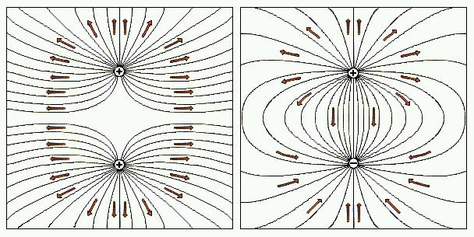
Figure 1.6 Electric field lines of charges

Electric field intensity (E) equals the electric force (F${}_{e}$) acting on a small positive test charge (q) placed at that point, divided by the magnitude of the test charge. Thus,

$E=\frac{F_{e}}{q^{1}}$ $E=\frac{\text{kq}}{r^{2}}$

Sample Problems

1. A carbon nucleus has 12 protons. (a) Calculate the magnitude of the electric field at a distance of $0\text{.}\text{58}×{\text{10}}^{−\text{12}}$m from the nucleus. (b) What is the magnitude of the force on an electron due to this electric field?

Given: q of cardbon = $\text{12}q_{e}$
Required: (a) E at r = $0\text{.}\text{58}×{\text{10}}^{−\text{12}}$m from the nucleus
(b) F on an electron at r=$0\text{.}\text{58}×{\text{10}}^{−\text{12}}$m from the nucleus

Solution:
a.) $E=\frac{\text{kg}}{r^{2}}=\frac{(9×{\text{10}}^{9}{{\text{Nm}}^{2}}/{C^{2}})(\text{12})(1\text{.}6×{\text{10}}^{−\text{19}}C)}{(0\text{.}\text{58}×{\text{10}}^{−\text{12}}m)^{2}}=5\text{.}\text{14}×{\text{10}}^{\text{16}}N/C$
b.) $F_{e}={\text{Eq}}^{1}=(3\text{.}\text{94}×{\text{10}}^{\text{12}}N/C)(−1\text{.}6×{\text{10}}^{−\text{19}}C)=−8\text{.}\text{22}×{\text{10}}^{−3}N$

2. A 2-µC charge is $1×{\text{10}}^{4}$m to the right of a -4-µC charge. Calculate the electric field (magnitude and direction) at a point $2×{\text{10}}^{4}$m to the right of the positive charge and along a line passing the two charges.

$q_{3}$ $q_{1}$
- + P
•
$1×{\text{10}}^{4}$ $2×{\text{10}}^{4}$

Given: $q_{1}=−4μC$
$q_{2}=2μC$
Required: $E_{\text{net}}$ at point P
Solution:

$E_{1}=\frac{{\text{kq}}_{1}}{r_{1^{2}}}=\frac{(9×{\text{10}}^{9}{{\text{Nm}}^{2}}/{C^{2}})(4×{\text{10}}^{−6}C)}{(3×{\text{10}}^{4}m)^{2}}=4×{\text{10}}^{−5}N/C$, to the left
$E_{2}=\frac{{\text{kq}}_{2}}{r_{2^{2}}}=\frac{(9×{\text{10}}^{9}{{\text{Nm}}^{2}}/{C^{2}})(2×{\text{10}}^{−6}C)}{(2×{\text{10}}^{4}m)^{2}}=4\text{.}5×{\text{10}}^{−5}N/C$, to the right

$E_{\text{net}}=E_{1}+E_{2}=5×{\text{10}}^{−6}N$, to the right

3. Consider the situation of the figure below. Find (a) the electric field intensity at point P, (b) the force on a $−3×{\text{10}}^{−8}$C charge placed at point P, (c) where in the region the electric field would be zero.

+ P 5cm -
5cm •
$\text{20}×{\text{10}}^{−8}$C $5×{\text{10}}^{−8}$

Given: $q_{1}=\text{20}×{\text{10}}^{−8}C$
$q_{2}=5×{\text{10}}^{−8}C$

Required: (a)$E_{\text{net}}$ at point P
(b) F on a $−3×{\text{10}}^{−8}$C charge placed at point P
(c) position along the line where $E_{\text{net}}$=0

Solution:
(a) $E_{1}=\frac{{\text{kq}}_{1}}{r_{1^{2}}}=\frac{(9×{\text{10}}^{9}{{\text{Nm}}^{2}}/{C^{2}})(\text{20}×{\text{10}}^{−8}C)}{(0\text{.}\text{05}m)^{2}}=7\text{.}2×{\text{10}}^{4}N/C$, to the right
$E_{2}=\frac{{\text{kq}}_{2}}{r_{2^{2}}}=\frac{(9×{\text{10}}^{9}{{\text{Nm}}^{2}}/{C^{2}})(5×{\text{10}}^{−8}C)}{(0\text{.}\text{05}m)^{2}}=1\text{.}8×{\text{10}}^{5}N/C$, to the right

$E_{\text{net}}=E_{1}+E_{2}=2\text{.}\text{52}×{\text{10}}^{5}N/C$, to the right
(b) $F_{e}=E_{q^{1}}=(2\text{.}\text{52}×{\text{10}}^{5}N/C)(−3×{\text{10}}^{−8}C)=−7\text{.}\text{56}×{\text{10}}^{−\text{13}}N$
(c) $E_{1}=E_{2}$
$\frac{{\text{kq}}_{1}}{r_{1^{2}}}=\frac{{\text{kq}}_{2}}{r_{2^{2}}}$
$$\frac{5×{\text{10}}^{−8}C}{x^{2}}=\frac{\text{20}×{\text{10}}^{−8}C}{(x+0\text{.}1m)^{2}}$$
$$\text{15}x^{2}−x−0\text{.}\text{05}=0$$
Using quadratic equation, it must be deduced that the appropriate answer is x = 0.1-m to the right of $5×{\text{10}}^{−8}C$

4. The tiny ball at the end of the thread as shown has a mass of 0.10-g and is in a horizontal electrical field intensity 500 N/C. If its in equilibrium, what are the magnitude and sign of the charge on the ball?

20°
E = 500 N/C

Given: m = 0.10-g
E = 500 N/C, to the right
Required: charge of the ball (magnitude and sign)

Solution:
tan 20° = F = Eq
W mg
q = mg tan 20°
E
q = $−7\text{.}\text{13}×{\text{10}}^{−7}$C

5. Four equal magnitude (4-µC) charges are placed at the four corners of a square that is 20-cm on each side. Find the electric field intensity at the center of the square if the charges are all positive.

Given: $q_{1}=q_{2}=q_{3}=q_{4}=4−μ$C
Side of the square = 20-cm
Required: $E_{\text{net}}$ at the center of the square
Solution:
$E_{1}=E_{2}=E_{3}=E_{4}=\frac{\text{kq}}{r^{2}}−1\text{.}\text{84}×{\text{10}}^{6}$N/C
x-component y-component
$$−1\text{.}3×{\text{10}}^{6}$$ | $$−1\text{.}3×{\text{10}}^{6}$$
$$+1\text{.}3×{\text{10}}^{6}$$ | $$−1\text{.}3×{\text{10}}^{6}$$
$$+1\text{.}3×{\text{10}}^{6}$$ | $$+1\text{.}3×{\text{10}}^{6}$$
$$−1\text{.}3×{\text{10}}^{6}$$ | $$+1\text{.}3×{\text{10}}^{6}$$

1.6 ELECTRICAL POTENTIAL ENERGY

Work done against the electrical force in moving a charge

In mechanics, you had learned that an object has gravitational potential energy because of its position in a gravitational field. Similarly, a charged particle can also have electrical potential energy because of its location in an electric field. You also learned that work has to be done against the force of gravity when an object is lifted vertically. Like wise, work has to be done against electric forces when a charged particle is moved in an external electric field. Just as the work done in lifting an object in a gravitational field is equal to the charge in its gravitational field, the work done in moving a charge in an external electric field is equal to the change in its potential energy.
Thus,
$U=\text{Fr}=\frac{{\text{kq}}^{1}q(r)}{r^{2}}=\frac{{\text{kq}}^{1}}{r}=({\text{Eq}}^{1})r$

The electrical potential energy of like charges increases as they are forced nearer each other and decrease as they are moved apart. The electrical potential energy of unlike charges increases, as they are pulled apart and decrease as they are moved closer.

Sample Problems

1. A 7-µC point charge is located 15-cm from a -2µC point charge. What is the electrical potential energy stored in this system of two point charges?

Given: $q^{1}=7−μ$C
$q=−2μ$C
r = 15-cm

Required: U between $q^{1}$ and q
Solution:
U = $\frac{{\text{kq}}^{1}q}{r}=\frac{(9×{\text{10}}^{9}{{\text{Nm}}^{2}}/{C^{2}})(7×{\text{10}}^{−6}C)(−2×{\text{10}}^{−6}C)}{0\text{.}\text{15}m}=−0\text{.}\text{84}$J

2. The magnitude of the electric field between parallel metal plates, which are separated by 2.5-cm, is $8\text{.}6×{\text{10}}^{5}$N/C. What is the potential energy of a 12.6-µC charge, which is moved through the electric field from the positive plate to the negative plate?

Given: E = $8\text{.}6×{\text{10}}^{5}$N/C
q = 12.6-µC
r = 2.5-cm
Required: U of the 12.6-µC charge
Solution:
U = (Eq) r = $(8\text{.}6×{\text{10}}^{5}N/C)(\text{12}\text{.}6×{\text{10}}^{−6}C)(0\text{.}\text{025}m)=0\text{.}\text{271}$ J

1.7 POTENTIAL DIFFERENCE

“pushes” electrons so they will move along a conductor

When describing a charged particle in an electrical field, we often consider the electrical potential energy per unit charge (or the potential difference between two poins) rather than just the electrical potential energy.
The electrical potential difference between two points is the work done per unit charge when a charge is moved from one point to another. It is the actual moving factor that enables the electrons to flow across a conductor. It is also known as emf (electromotive force), which the potential that causes the electrons to flow.
Mathematically,
$$V=\frac{W}{q^{1}}=\frac{\text{kq}}{r}=\text{Er}$$
If several charges exist, their net potential difference equals their algebraic sum:
$$V_{\text{net}}=Σ{\text{kq}}/r$$

But there is what is being called an Equipotential surface which is a surface on which all points have the same potential. Charges that are placed on this surface cannot move each other and therefore cannot produce current.

Sample Problems

1. A Van de Graaf generator is noted to have a potential of 15-MV. What is the work done in moving an electron in this machine?

Given: V = 15-MV
$q_{e}=−1\text{.}6×{\text{10}}^{−\text{19}}$C
Required: W done on an electron
Solution:
$W={\text{Vq}}^{1}=(\text{15}×{\text{10}}^{6}V)(−1\text{.}6×{\text{10}}^{−\text{19}}C)=2\text{.}4×{\text{10}}^{−\text{12}}$ J

2. The spherical shell on top of a small electrostatic generator in air has charge of 6-µC. What is the potential at a point 6-cm from the center of the sphere?

Given: q = 6-µ
r = 6-cm
Required: V at r = 6-cm from the center of the sphere
Solution:
$\frac{V=\text{kq}}{r}=\frac{(9×\text{10}{{\text{Nm}}^{2}}/{C^{2}})(6×{\text{10}}^{−6})}{0\text{.}\text{05}m}=1\text{.}8×{\text{10}}^{6}$V

3. A charged particle remains stationary between the two charged horizontal plates. The plate separation is 3-cm and the particle has mass $4×{\text{10}}^{−\text{13}}$kg and charge $2\text{.}5×{\text{10}}^{−\text{18}}$C. Find the potential difference between the plates.

Given: q = $2\text{.}5×{\text{10}}^{−\text{18}}$C
m = $4×{\text{10}}^{−\text{13}}$ kg
r = 3-cm
Required: V between the plates
Solution:
Since the particle is in the state of balance, therefore: $F_{e}=\text{mg}$
$V=\frac{W}{q^{1}}=\frac{\text{mgr}}{q^{1}}=\frac{(4×{\text{10}}^{−\text{13}}\text{kg})(9\text{.}8m/{s^{2}})(0\text{.}\text{03}m)}{2\text{.}5×{\text{10}}^{−\text{18}}C}=4\text{.}7×{\text{10}}^{4}$V

1.8 GAUSS’ LAW

An alternative formulation relaing electric charge with electric field

Karl Friedrich Gauss provides an alternative formulation of the relationship
between the electric charge and the electric field known as Gauss’ Law.

It assumed that electric field lines emanates in all direction from a source (an electric charge) and surrounded by a spherical surface (Gaussian surface) with radius r and the source is at its center.

Mathematically, Gauss’ Law is define as:
$E=\frac{1}{4{\text{πε}}_{0}}⋅\frac{q}{r^{2}}$
$\text{EA}=\frac{q}{ε_{0}}$

where : EA = electric flux $(ψ)$= total number of electric force on a unit area
q = the charge which is the source of electric field
$ε_{0}$ = permittivity in free space = $8\text{.}\text{85}×{\text{10}}^{−\text{12}}{C^{2}}/{{\text{Nm}}^{2}}$
r = radius of the gaussian surface

Sample Problems

1. What is the electric field intensity of a 2-C charge over an area of 2-m${}^{2}$?

Given: q = 2-C
A = 2-m${}^{2}$
Required: E
Solution:
E = $\frac{q}{ε_{0}A}=1\text{.}\text{13}×{\text{10}}^{\text{11}}$ N/C

2. What is the charge that provides an electric field of 5 N/C over an area of 1-m${}^{2}$?
Given: E = 5 N/C
A = 1-m${}^{2}$
Required: q
Solution:
Q = EA$ε_{0}=4\text{.}\text{43}×{\text{10}}^{−\text{11}}$ C

1.9 VAN DE GRAAF GENERATOR

An electronic machine that provides equipotential surface

The Van de Graaf generator, invented in 1931 by Robert J. Van de Graaf, an American physicist, is the most efficient electrostatic generator. A basic Van de Graaf generator, consisting of a hollow metal sphere supported by an insulating cylinder, resembles a mushroom. An electric motor power a continious belt made of some insulating material (usually fabric coated with rubber).

At the bottom of the insulating cylinder, the belt rubs against a glass cylinder. The friction of the belt against the glass produces a negative charge (electron surplus) on the belt. As the belt moves upward, the electrons are carried with it. At the top of the belt, an electron collector conducts the surplus electrons to the metal sphere. Electrons cannot collect inside a hollow sphere so they immediately move to the outside where they induce a positive charge on the inside of the sphere. The positive charge attracts more electrons from the belt and sends them to the outside of the sphere.

In this manner, the Van de Graaf generator produces an enourmous negative electrostatic charge on the outside of the sphere.

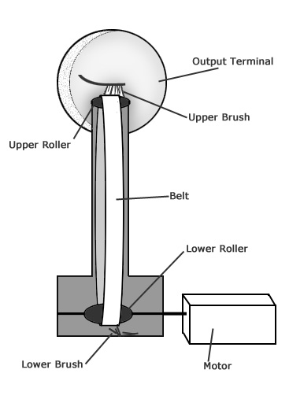
Figure 1.8 Van de Graaf Generator

Physics in Action

(If there is a Van de Graaf generator in your school, don’t ever let it pass that you did not try it!)

Switch on the Van de Graaf generator and a slight hum will be heard from inside the generator. Volunteer to step onto an insulated mat beside the generator and slowly, cautiously reaches out your hand and touch the globe of generator.

As you make contact with the globe of the generator, thousand of volts of static electricity are conducted into your body. Although you fee nothing unusual, something strange happens. The static electricity flowing into your body gives each hair on your head a negative electrostatic charge. Since each hair has the same charge, the hairs repel one another and stand straight out from your head!

What do you thik causes the hairs to stand straight out from one’s head when touching a Van de Graaf generator?

Think about this!
- It is the current that can electrocute a person. Why is it that in a power station we often read “Danger High Voltage”, instead of “Danger High Current”?
- Some electricians can work on “live” wirers and touch them without being electrocuted. Do you know how did they do it?

Practice Exercise 1.1 Coulomb’s Law

1. A -3.0-pC charge is placed halfway between a 20-µC charge which are separated by 1.0-m. Find the total electrostatic force acting on the -2.0-µC charge. [Ans: 0.216N towards the 4.0-µC charge]

2. Assume that you want to hold two spherical objects together with an electrostatic force having magnitude of $2\text{.}0×{\text{10}}^{6}$N, and they are separated by 1.0-m. If each sphere holds an equal charge, how much should each have? [Ans. 15-mC]

3. We have two charges, one of -2.0-µC and the other of -3.0-µC. Where should we place a charge of +2.0µC on a 1-meter line containing the other charges in order that the resultant force on it be zero? [Ans. 0.45 m from -2-µC]

4. Two identical pith balls with masses of 0.8-g are suspended from the same point by light threads 40-cm long. When equal charges are placed on the pith balls they repel each other so that their strings make an angle of 16º at the point of their support. Determine the charge on the pithballs. [Ans. 38.9-nC]

Practice Exercise 1.2 Electric Field

1. Find (a) the magnitude of the electric field 0.5-m from a 2.5-µC point charge, and (b) the magnitude and direction of the electrostatic force acting on an electron placed at that point. [Ans: $8\text{.}\text{99}×{\text{10}}^{4}$N/C, $+1\text{.}\text{44}×{\text{10}}^{−\text{14}}$N]

2. Find the electric field midway between a 2.0-µC point charge and a -3.0µC point charge which are 2.5 m apart. [Ans: $2\text{.}\text{88}×{\text{10}}^{4}$N/C, towards the -3.0µC charge]

3. Four equal magnitude (4-µC) charged are placed at the four corners of a square that is 20-cm on each side. Find the electric field intensity at the center of the square (a) if the charges alternate in sign as one goes around the perimeter of the square. (b) if the charges have the following sequence around the square: (+), (+), (-), (-). [Ans. 0; $5\text{.}\text{09}×{\text{10}}^{6}$N/C towards the negative side]

Practice Exercise 1.3 Potential Energy

1. The magnitude of the electric field between two charged, parallel places is $3\text{.}\text{65}×{\text{10}}^{7}$N/C. If the potential energy of a 2.35µC charge, which is located between plates, is 0.25-J what is the separation of the plates? [Ans. 2.9-mm]

2. An electric field of $2\text{.}\text{56}×{\text{10}}^{5}$N/C is set up between two parallel plates. What is
the potential energy if the separation is 1.5-cm and the charge of the plate is 3.25-µC? [ans. 0.012-J]

3. A potential energy 12.5-kJ is noted at the midpoint of two point charges: 3.65-nC and 7.82-nC. Find the distance between the charges. [Ans. 16.5-mm]

Practice Exercise 1.4 Potential Difference

1. A potential difference of 12.0-V exists between the terminals of an automobile battery. How much work must be done to transfer 3.5-C of charge from the negative terminal to the positive terminal? [Ans. 42-J]

2. Determine the potential difference between two points which are 20-cm and 30-cm from an isolated $3\text{.}0×{\text{10}}^{−8}$C point charge in a vacuum [Ans: 450-V]

3. Point charges $q_{1}=2\text{.}0×{\text{10}}^{−8}$ and $q_{2}=1\text{.}5×{\text{10}}^{−8}$C are 50-cm apart in a vacuum.Determine the potential difference at a point midway between the charges [Ans: $1\text{.}8×{\text{10}}^{2}$V]

4. A potential difference of 1.5-kV exists between two points, 2.5-m apart, in a uniform electric field. What is the magnitude of the field? [Ans. 600 N/C]

