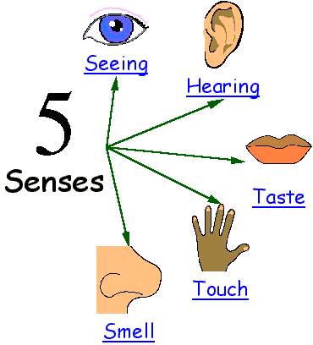

by
Enrico Lorenzo

Submitted to
Mr. Francis Lambojon
Psychology

STI College Cubao
SEEING

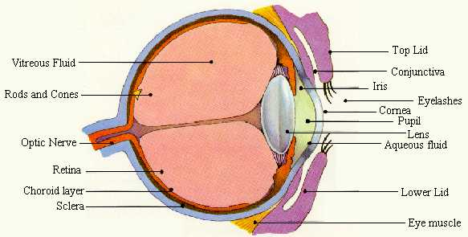

To see what we do now, the light bounces off the object you are looking at, into the pupil. The light crosses your lens and the images gets focused. The object you are looking at turns upside down. The object you are looking at shines on the back of the eye. The part is called the retina. A retina contains two types of photoreceptors called rod cells and cone cells. Rod and cone cells helps you to see colors and sharp details. Then, the optic nerve carries the picture you see and your message goes to the brain. What the brain does after the message goes to the brain is that it turns the picture the right side up. The second thing the brain does is that it figures out what you are seeing and what you should do. Images are processed in the occiptal lobe of the brain.

We have two eyes because having two eyes increases your angle of vision. It helps you to judge depth. Having two eyes allows us to see 180 degrees and three-dimensional objects.

When people grow older, their lens loses its elasticity. The flattened shape and the viewing of the near objects get difficult when distance objects are still clear. This condition is called presbyopia (or farsightedness). You can use corrective glasses. They bring near objects to focus. There is another type of farsightedness called hypermetropia. Hypermetropia can be caused by having an eye ball that is shorter than normal. People with myopia (or nearsightedness) have eye balls that are longer than normal. A nearsighted person has difficulty seeing distant objects but can read books easily. Nearsightedness is caused by the stress of working for a long period of close work. Nearsightedness usually begins when you are a kid. When you have nearsightedness or farsightedness, there is a way to cure you. Most older people wear contact lens to make them see better. You can use glasses when you are younger. For contact lens or glasses, there are certain types. For correcting nearsightedness, you use concave lens and for farsighted people, they use convex lens.
HEARING

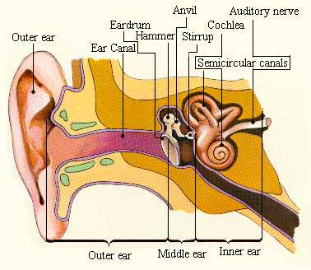

Your ears pick up and send information about sounds to your brain in the form of nerve impulses. Sounds are collected in the outer ear and are sent into the ear canal to the eardrum (the eardrum is a thin tissue which separates the outer ear from the middle part of the ear). Three small bones in the middle part of the ear make sounds louder. In the inner part of the ear, there are spaces filled with liquid. One of the liquid-hearing receptor cells inside are like tiny hairs. Sounds from the middle part of your ear cause liquid inside the cochlea to move around. The Mocemanet of this liquid bends like hair-like receptor cells. The receptor cells send impulses to the auditory nerve which goes to the brain. The brain receives impulses from the auditory nerve and gives meaning to the sound impulses.

We have two ears because the sounds hits one ear a fraction of a second before the other and produces stronger vibrations. It helps you tell what direction the sounds come from.

If the vestibular organs are damaged or diseased, they send too many or too few impulses to the brain. The brain interprets these abnormal messages as an imbalance of the body. The person then has a false feeling of motion or dizziness. This condition is called vertigo. A person whose vestibular organs have been destroyed by gradually learn to depend entirely on eye sight and other senses to maintain balance.

TASTE

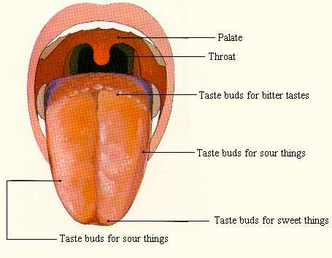

Taste is when you determine the flavor and palatability of food. Taste gives you signals of dangerous gases and toxic food. All over your tongue, there are little bumps called taste buds. There are four different types of taste buds. You can taste sweets in the front of your tongue and sour taste at both sides of your tongue At the back, you taste bitter things. All over your tongue, you taste salty things.

There are many tongue disorders. Lumps or ulcers on your tongue can be a problem for people of all ages. It is caused by a papillae disorder. When you have lumps or ulcers on your tongue, you can get tumors if they aren't treated quickly. Glossitis and a geographical tongue are also cause by papillae disorder. It affects all people and results in inflammation of the tongue. It is caused by bacteria build-up and leads to fungal infection and a dark-colored tongue.

TOUCH

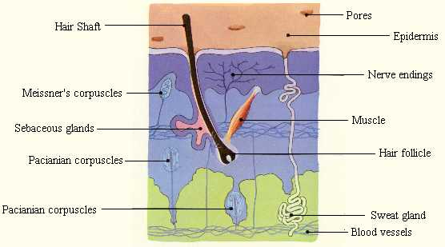

Touch is to use your skin to have physical contact with another object. Touch receptors are located in clusters around your skin. They look like onions or jelly material. When the are squeezed, the layers rub against each other causing an electrical nerve impulse. The most sensitive touch receptors are located at your face, back of your neck, chest, arm (upper), fingers, soles of your feet, and between your legs.

Skin works with the hypothalamus. Regions of the hypothalamus contain heat and cold sensitive cells. The hypothalamus responds by increasing the number of nerve impulses transmitted by the brain. That lets the skin adjust.
When you get hot, it is called hyperthemia. Your skin tries to prevent it from going over 37 degrees Celsius (99 degrees Fahrenheit). Sweat glands in your skin are activated which cools the skin and body (after the sweat evaporates). The arteriovenous anastomis also opens which causes the flow of blood the increase. It's basically used as a cooling system. The good thing about blood is that it also adjusts according to the skin temperature. If it is too hot, blood can be used for cooling. If it is too cold, blood is used for warming up. Another thing that also changes is that the arrector pilli relaxes, letting hair stick holding the water down onto the skin, which allows the water to cool. Finally, your blood vessels open so that more blood can enter.

SMELL

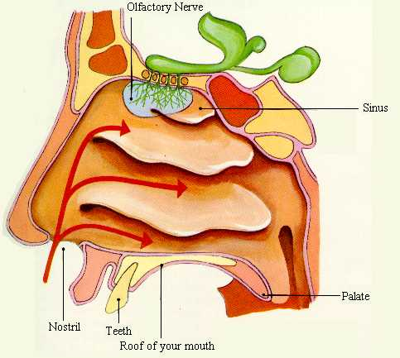

Every time we breathe, air flows through the nasal cavity. The turbinates (shelves of bones) makes the air flow down through the back of the mouth into the throat. Some air that flows into your mouth passes the olfactory organs. Any odor molecules in the air will past by and get stuck to the mucus in your nose. The sensory hairs sense the odor and transmit messages to your brain. Your brain, therefore knows the odor. The smell receptor cell is located high up behind your nose. The receptor is sensitive to chemicals in the mucus in your nose.

